大地ABCmouse小班上Hello课时8
复习素材内容：
- What we say:Hello,Goodbye
- Hello Animation Part 2
- Hello Animation
- Practice Page:What is your name?
- Hello cutout puzzle
- Practice Page:My name is Raj.
- Goodbye listen and learn
素材截图：
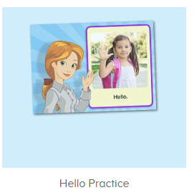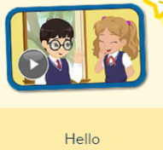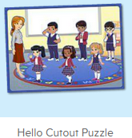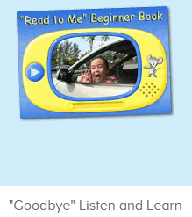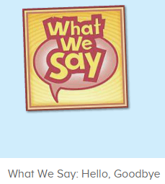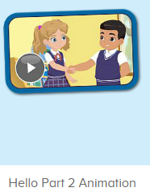
年龄段： 小班上
教学目标：
1.能完整唱出歌曲what we say并表演相应律动。
2.能自如使用Hello!What is your name?/Hello!My name is...来进行对话。
教具准备：1.口语动画视频人物图卡或头饰
使用游戏：
1.TPR 2.Team match
教学步骤： | 备注
- 成果公布及展示：  T: Hello kids,good morning.  S:Good morning Yama.  T:Today let's welcome our friend "ABCmouse".  Wow, Say hello to ABCmouse.（教师边说边引导幼生挥手说hello）  S:Hello,hello.  T: Now,please follow me "A,B,C,mouse"(ABCmouse TPR)  Excellent!Let's go to ABCmouse.  Wow,look!What can you see?  S:........  T:Listen,what is it?  S:About me...  T:Very nice.Follow it.  S:About me.....  T:Let's see what can we find in "About me".  First,listen.  Follow it.（引导幼生仔细听并跟读关于我板块内容，让幼生粗略了解关于我的组成部分）  S:Change my avatar/go to my room/the pet park/my hamster/my aquarium/my tickets....  T:Very nice.What is this?This is....  S: This is change my avatar/go to my room/the pet park/my hamster/my aquarium/my tickets....  T:What is this?Who can try?  S:Let me try.  T:Lily/Peter/Sam please.What is this?This is.....（邀请单个幼生回答）  S:This is change my avatar/go to my room/the pet park/my hamster/my aquarium/my tickets....  T:Very nice. | 引入ABCmouse并简略介绍关于我板块内容
- 集体活动：  T:Let's sing a song.  Everybody stand up please,let's sing and dance.(播放图1歌曲，请幼生边唱边做动作)  S:When we see people we say hello,wave hello,to all we know.  When we see people we say hello to all our friends and family.  When we go home we say goodbye,wave goodbye, bye bye bye.  When we go home we say goodbye to all our friends and family.  T:Let's add some actions.(使用暂停播放键逐句跟唱，引导幼生加上动作边唱边跳，可进行1-2遍)  S:When we see people we say hello,wave hello,to all we know.  When we see people we say hello to all our friends and family.  When we go home we say goodbye,wave goodbye, bye bye bye.  When we go home we say goodbye to all our friends and family.  T:Let's have a match,I will sing first,then you sing next,ok?  S:OK.  T/S:When we see people we say hello,wave hello,to all we know/When we go home we say goodbye,wave goodbye, bye bye bye.  T/S:When we see people we say hello to all our friends and family./When we go home we say goodbye to all our friends and family.  T:Good job!You win the match.Now let's listen and repeat.(打开图2素材，请幼生跟读发音)  S:Goodbye......  T:Very good!If I say goodbye kids,what should you say?  S:Goodbye,Yama.  T:Nice,let's say goodbye to Pam/Sam/Micky.....  S:Goodbye Pam/Sam/Micky.....  T:What can try?  S:Let me try.  T:Sue/Sally/Jerry...,please.  S/S/J:Goodbye Sue/Sally/Jerry....  T:When you leave home,you can say goodbye mommy/daddy....  Say it together.  S:Goodbye mommy/daddy....  T:Very good!Now let's be the little recorder(打开图3素材，邀请幼生自主操作录音功能，教师引导其余幼生跟读发音)  Peter/Molly come and click it,everybody listen and record.  S:Hello/What is your name/My name is Kate.  T:Listen!Is it the same?  S:Yes!  T:Who wants to try?  S:Let me try.  T:Lily/Lucy...please,everybody listen carefully.  Good!Hear Lily's/Lucy's..voice,is it nice?  S:Yes.  T:Thank you Lily/Lucy....,sit down please.  Now let's enjoy the video,listen and repeat.(打开图4素材，请幼生跟读)  S:S:What is your name?.......  T:Let's repeat it by boys and girls,are you ready?  S:Yes,we are ready.  Bs/Gs:What is your name?........  T:Now who wants to be Ken/Nico/Carmen/Sara?（教师把口语视频人物头饰分发给单个幼生，请其扮演视频中人物进行对话演练）  S:Let me try.  T:Tom/Susan/Kitty/Jim,you will be Ken/Nico/Carmen/Sara.Are you ready?  T:What is your name?  T1:Ken  T:Very good!Next team,who can try?  S:Let me try.  T:Very nice,let's play a puzzle.  Look,who is this?（打开图5拼图素材，复习巩固口语动画人物姓名）  S:This is Miss Jones/Ken......  T:Right?Let's check,please listen and repeat.  S:Hello,my name is Miss Jones......  T:Very good!Who can try?  S:Let me try.  T:Susan/Tim/Lily.... please.Everybody listen and repeat.(拼图数量较多可请3-4位幼生轮流上前协作完成，其余幼生跟读发音)  S:Hello,my name is Miss Jones......  T:Who is this?This is....(询问幼生拼图人物的名字，让幼生记住视频中人物的名字)  S:This is Miss Jones/Ken.......  T:Let's say hello to Miss Jones/Ken....  S:Hello,Miss Jones/Ken.....  T:Good,everybody,hello,what is your name?(教师配合肢体语言引导幼生使用Hello!What is your name?和Hello!My name is进行对话)  S:Hello,my name is....  T:Once again.Hello,what is your name?  S:Hello,my name is....  T:Who can try?  T:Yuki/Tina/Eric/Wendy.....please.  Y/T/E/W:Hello,what is your name?(单独请几位幼生上前使用Hello,what is your name?来提问，教师引导其余幼生使用Hello!My name is...来回答)  S:Hello,my name is......  T:Wonderful!Henry and Wing come here please.（请幼生上前使用Hello!What is your name?和Hello!My name is与幼生进行对话）  H/W:Hello,what is your name?  H/W:Hello,my name is Henry/Wing.  T:Great job!Next team,who wants to try?  S:Let me try.  T:Great job!Now,let's enjoy Hello Animation video.Listen and no voice.(打开图6口语视频动画，请幼生观看完整视频不跟读)  This time,listen and repeat by boys and girls,are you ready?（再次播放视频，请幼生跟读，视频较长，教师可进行分组跟读，分散难度，可使用暂停播放键逐句跟读）  S:Yes,we are ready.  Bs/Gs:Hello,children/Hello.......  T:Now,I am miss Jones,you are the children,are you ready?  S:Yes,we are ready.  T:Hello children....  S:Hello....  T:Great job!Now let's count our tickets.(总结回顾完毕后带领幼生到我的奖励票去数奖票)  Where can we find our tickets?Who can try?  S:Let me try.  T:Everybody look,is it right?  S:Yes.  T:What is this?This is...  S:This is "My tickets"  T:Good!Listen and repeat.  S:My tickets.(跟读2-3遍)  T:Nice job!Let's count how many tickets do we have today.（选择数票模式，引导幼生跟随网站一起数数）  S&ABCmouse:one,two.......  T:Wow,great job! | 图1  图2  图3  图4  图5  图6
三、家庭游戏活动布置
T:Look,here is your homework.
Where can we find our homework?
S:About me/my lesson.
T:Who can try?
S:Let me try.
T:Tom,please.Look,is he right?
S:Yes.
T:Very good!There are 6 activities,let's count,one,two......
S:One,two......
T:Very nice!Now look at me and I will show you how to do it.
Are you clear?
S:Yes.
T:Who can show us how to do it?
S:Let me try.
T:Tom please.
T1:Go to My lesson.......
T:Great!Thank you Tom,class is over, goodbye everyone.
S:Goodbye Yama.

