ABCmouse中班上Classroom part-课时5
素材内容：1. Classroom, part 2 Animation
2. Classroom, part 2 Practice
3. Classroom, part 2 Quiz
4. Listen to Ms.Jones
5.Words in the classroom cutout puzzle
6.What we say
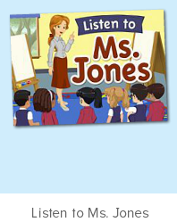
年龄段： 中班上
教学目标：1.能跟着音乐哼唱表演歌曲"What we say"。
2.能流利说出listen,quiet,loud,go,stop等词汇。
3.会应用完整的句子回答问题。
4.会说I can touch .../Can you touch the ... Touch my/your ...
教具准备：1.对应单词图卡2.不同角色的人物头饰
使用游戏：1.Guessing game 2.Role play 3.TPR 4.Fast reaction.
教学步骤： | 备注
- 成果公布及展示：
T: Hello kids. Glad to see you.
S:Glad to see you,too.
T:First,Let's praise Lisa,Molly,Jason.... They all finished their homework.
Jason, come here please, Let's go to "about me".（请一位幼生上前展示关于我的部分，掌握简短的介绍语句）
T:Jason , What's this part?
J:This is "my avatar/pets/room/hamster/aquarium/tickets"
T:Let's listen and follow.（点击对应版块）
S:Go to "my avatar/pets/room/hamster/aquarium/tickets"
T:Nicely,what's this part?Lucy/Mary/Gorge...
L/M/G:This is "my avatar/pets/room/hamster/aquarium/tickets"
S:This is "my avatar/pets/room/hamster/aquarium/tickets"
T:Pretty good.The next time you can have a try, come on.
二、集体学习活动：  T:Now,It's ABCmouse time. Hello,everyone.  S:Hello, xxx  T:How are you,today?/How is the weather?  S:I am happy/so so/tired... /It's sunny/rainy/cloudy/windy....  T:I am ...I am a teacher.How about you?  S:I am ... I am a boy/girl.  T:Very good,now,look and say.（教师使用单词卡，请幼生看图读单词）  S:touch,stand up,sit down,come here,listen,whiteboard（请幼生看图跟读）  T:May  M:touch/stand up/sit down/come here/listen/whiteboard  T:Good  T:Now.Who can be the little teacher?（教师做动作，幼生看动作说英语，分组或单个积分表扬）  S:Let me try.  T:Mandy/John..  1S:Teacher says:stand up/sit down/touch your...（一位幼生喊口令，其余幼生做动作，请2-3位）  T:Petty good.Now,let's enjoy the video.（进入素材图1，教师播放素材，请幼生仔细看，同步关键词汇渗入TPR，）  T:One more time.What do you hear in this video?（第二遍，请幼生仔细听，听完以后说出关键词汇）  T:Lisa/Peter/Henry ...  L/P/H:listen,quiet,loud,go,stop...  T:Let's check.（播放第三遍，引导核对并跟读关键字）  T:Follow it.  S&1S:listen,quiet,loud,go,stop...  T:Good,Let's continue.Listen and repeat.（进入素材图2，让幼生仔细听，跟着说，录音并核对）  S:listen/quiet/loud/go/stop...  T:Now,it's your turn.（完成第一张图片的聆听，请幼生跟读,点击左边老师的图像，可多次聆听）  S:listen/quiet/loud/go/stop...  T:Good,let's record.Ready!Go.（引导孩子多次跟读录音，直到红色录音圈结束）  S:listen/quiet/loud/go/stop...  T:Let's check（听一听自己录制的声音）  T:What do you hear?  S:listen/quiet/loud/go/stop...（抽选3-5位回答）  T:Terrific.The next.Listen.（完成第二张图片的聆听，请幼生跟读,点击左边老师的图像，可多次聆听）  T:Repeat,please.  S:listen/quiet/loud/go/stop...  T:Mandy,come here.Have a try.（录音）  M:listen/quiet/loud/go/stop...  T:Thank you,go back to your seat.  T:Let's follow.  S:listen/quiet/loud/go/stop...  T:Look and say.（教师做动作，幼生说词汇，请说得好的做小老师）  B:Quiet  T:High five.Now,you are the teacher.（一位幼生做动作，其余幼生说）  B:Ruby,come here,high five.（击掌完毕，第一名幼生回到自己的座位，第二名幼生继续，以此类推，共计3-5名幼生参与）  T:Let's continue.Repeat,please.（进入第三个内容，sit down 跟读操作与前面一致）  S:loud ...  T:Let's record.  S:loud ...  T:How many times?Let's count.（请幼生一起听，并数一数读的遍数）  S:1,2,3,4  T:Your turn.ready!Go.  S:loud ...  T:Wonderful!One more time.Ready!Go.  S:loud ...  T:Nice job.Next.（进入第4-5个内容，跟读操作与前面一致）  S:Go/stop  T:Listen,follow and choose.（进入素材图3，第一轮，请幼生跟读，跟读得好的，来选择）  S:listen/quiet/loud/go/stop...  T:Peter,come here,click it.  T:The next,listen  S:Stand up/sit down/touch/whiteboard  T:Wonderful,look and say.（拿出对应的卡片，给幼生做线下练习,说对了的幼生上来拿卡片，依次排开）  S:listen/quiet/loud/go/stop...  T:Ken/Cathy/Louis....  K/C/L:listen/quiet/loud/go/stop...  T:Bend down game.Let's have a try.（教师站在某一位举卡片幼生的后面，其余幼生根据教师的提示，说出该幼生手持卡片的内容，该幼生听到后蹲下，以此类推，教师主要操练幼生不太熟练的词汇）  S:listen/quiet/loud/go/stop......  T:Game time.listen and choose（教师进入素材图4，幼生观看动画，下放会出现3个小喇叭，点击声音请幼生聆听并选择正确的声音，拖到图片上去）  S:listen to me/ be quiet/be loud/go/stop...  T:Which one is right?  S:the second.  T:Let's have a try.Bingo.（教师拖动小喇叭到图片的位置）  T:together.  S:listen to me  T:Rita/Victory...  1S:listen to me  T:Let's do the action.  S:Listen to me.（幼生看图做动作，说词组）  T:Let's continue.The next（依照第一个的操作方式依次进行后面4个内容的操作）  S:listen to me/ be quiet/be loud/go/stop...  T:Gary/Danny...  1S:listen to me/ be quiet/be loud/go/stop...  T:Petty good.Let's play a puzzle（进入素材图5，）Listen and do.  （教师选择级别1，点击拼图素材，幼生根据听到的内容做对应的动作，说对应的词汇）  S:listen/quiet/loud/go/stop ...  T:Lisa,follow it.  L:listen/quiet/loud/go/stop ...  T:Level 2,who can try?（看教师的动作最快说出词汇的幼生上来完成拼图活动）  T:Look and say.  S:listen/quiet/loud/go/stop ...  T:You please.  1S:...（一位幼生点击拼图，其余幼生跟读）  S:listen/quiet/loud/go/stop ...  T:Wonderful.Let's do fast reaction.（请幼生说词汇，做动作）  S:listen/quiet/loud/go/stop ...  T:Let's play "Teacher says",（请幼生上来担任小老师，进行teacher says的游戏 2-3位）  S:Let me try.  T:Ben/Carol...  1S:Teacher says :"listen/quiet ...  T:Well done.Let's sing and dance.（播放素材图6，请幼生一起跟唱表演）  S:We say good morning when we wake up...  T:Let's enjoy the video.(播放素材图1，请幼生会观看)  T:Look and say.（出示卡片复习词汇）  S:listen/quiet/loud/go/stop ...  T:So nice.Let's count the tickets.  S:1,2,3,4...  T:How many tickets have we got?  S:...  T:All of you did a good job.（总结课堂比赛结果及孩子情况）  G1,you are the winner,G2,come on!  And,Lucy,Ken,Rita,you are wonderful | 图1:  图2：  图3：  图4：  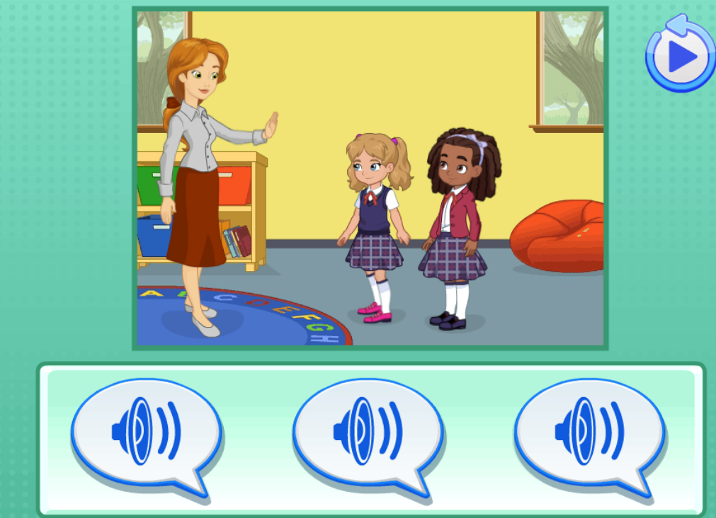  备注;此素材需要点击拖动小喇叭到图片的位置  图5：  图6：
- 家庭游戏活动布置：
T:All of you did a good job. I'll show you the homework/activities. （将已放入功课的作业界面打开）
T:Look,how many activities do you need to play?
S:Four.
T:How to get a yellow star?
S:Play 5 times
T:Very well.Now Jason, come here and show us how to do the activities.
J:...
T:Good job!Thank you Jason!
T:So ,How many activities you need to play?
S:...
T:How to play?
S:...
T:Class is over, Goodbye everyone.
S:Goodbye Teacher.

