ABCmouse中班上Classroom part-课时9
素材内容：1.Classroom, part 1 Animation
2.Classroom, part 2 Animation
3.Teacher says,Let's play
4.Words in the classroom Memory match
5.Listen to me
6.Teacher says Memory match
7.What we say
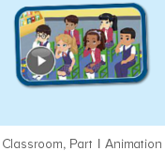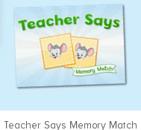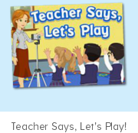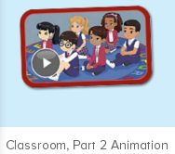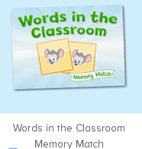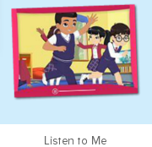
年龄段： 中班上
教学目标：1.能跟着音乐跟唱表演歌曲"What we say"。
2.能应用Teacher says ...结合已学词汇及句子进行互动游戏
3.能灵活运用句型：Teacher says: ...并理解意思所学的全部句子。
4.会应用完整的句子回答问题。
5.会自己用英语进行10句以上的表达。
教具准备：1.指令语的对应图片 2.单词卡 3.Memory match 4.Fast reaction
使用游戏：1.Guessing game 2.Role play 3.TPR 4.Fast reaction
教学步骤： | 备注
- 成果公布及展示：
T: Hello kids. Glad to see you.
S:Glad to see you,too.
T:First,Let's praise Lisa,Molly,Jason.... They all finished their homework.
Jason, come here please, Let's go to "about me".（请一位幼生上前展示关于我的部分，掌握简短的介绍语句）
T:Jason, What's this part?
J:This is "my avatar/pets/room/hamster/aquarium/tickets"
T:Let's listen and follow.（点击对应版块）
S:Go to "my avatar/pets/room/hamster/aquarium/tickets"
T:Nicely,what's this part?Lucy/Mary/Gorge...
L/M/G:This is "my avatar/pets/room/hamster/aquarium/tickets"
S:This is "my avatar/pets/room/hamster/aquarium/tickets"
T:Pretty good.Tomorrow I'll invite you, come on.
二、集体学习活动：  T:Now,It's ABCmouse time. Hello,everyone.  S:Hello, xxx  T:How are you,today?/How is the weather?  S:I am happy/so so/tired... /It's sunny/rainy/cloudy/windy....  T:Wow,wonderful.Now,look,who is this?（平台中老师和五个小朋友的头饰）  S:This is Miss Jones/Nico/Carmen/Lina/Raj/Sara/Ken  T:I am ...,I am a teacher.How about you?  S:I am ... I am a boy/girl.  T:Very good,now,look and say.（教师出示词汇卡片复习）  S:listen/quiet/loud/go/stop/Stand up/sit down/touch/whiteboard  （请幼生看图跟读）  T:May  M:listen/quiet/loud/go/stop/Stand up/sit down/touch/whiteboard  T:I do you say.（教师做动作，幼生说，并跟着一起做动作）  S:listen/quiet/loud/go/stop/Stand up/sit down/touch/whiteboard  T:Good,do the action.  T:Let's make sentences.（幼生根据幼动作提示说句子，）  S&1S:... is being loud/quiet./Listen to me./Go back./Touch your ...  T:Petty good.Now,let's enjoy the video.（进入素材图1，）Sentence by sentence.  （教师播放素材，请幼生跟着逐句说关键句子,每个方位的幼生都要照顾到）  T:Lisa,/Peter/Henry ...  L/P/H:Stand up/sit down/I am standing up/sitting down/ Touch my/your.../come here...  T:Pretty good.Let's do memory match.（教师进入素材图2）  S:Hello/I am a teacher/touching my head/arm/face.../stand up  T:The next.Rita/Victory...  1S:Touch my head/arm/face...（请一位幼生说出听到的内容并上来翻出另一张相同的图片，以此类推，）  T:Bingo.The next.  S:S:Hello/I am a teacher/touching my head/arm/face.../stand up  T:Peter...  P:Hello/I am a teacher/touching my head/arm/face.../stand up  T:Come on.  S:...（找出另一张相同的图片，以此类推，指导完成配对活动）  T:Good,Let's continue.Look and listen carefully.（进入素材图2，让幼生先看动画）  T:Let's play"three legged running".Listen and do.Are you ready?（第二遍，请幼生听视频里讲的规则，进行游戏活动，此轮活动进行2-3次）  S:Yes,I'm ready.  T:Very good.One more time.（继续进行2次跟着视频做游戏）  T:This time.Look,listen do and say.（进入素材图3请幼生根据听到的做动作，挑选做的好的说出句子，说对了请他上来点击选择正确的图片，以此类推进行游戏活动）  T:Kate/Mike...  1S:Teacher says...  T:Excellent.Let's play "teacher says".Who can try?（请2-3位幼生上来担任小老师进行该游戏活动）  S:I can try.  T:First,look and say.（教师做动作，幼生说，说得又好又准确的上来）  S:Touch your ...  T:Daniel/Jimmy...  1S:Teacher says...  T:Well done.Let's sing and dance.（播放素材图4，请幼生一起跟唱表演）  S:We say good morning when we wake up...  T:Good.sentence by sentence.  S:....  T:Mark/Kitty...  1S:...  T:"Wood man",sing and dance together.（教师请幼生继续跟唱表演歌曲，中间暂停，幼生保持一个姿势不动，动了的幼生则需要唱出上一句歌曲内容）  T:Peter...  P:wave good bye...  T:Nice.Let's continue...  T:Nice.Now,let's enjoy the video.（进入素材图5，）Sentence by sentence.  （教师播放素材，请幼生跟着逐句说关键句子,每个方位的幼生都要照顾到）  T:Lisa,/Peter/Henry ...  L/P/H:listen to me/I am being loud/stop/three legged running ...  T:Wonderful.Let's do memory match.Look and say.（教师进入素材图6）  S:go/stop/loud/quiet/listen/touch/stand up/sit down/come here...  T:Rita/Victory...  1S:go/stop/loud/quiet/listen/touch/stand up/sit down/come here...  T:Find another one,please.  1S&S:...（幼生找出对应的另一张图片，并说出词汇，每组请3名幼生，共计3组）  T:Petty good.Now,let's play.（进入素材图7，）Listen and do.  （教师播放素材，幼生根据听到的内容做对应的动作,第一轮全体一起做，第二轮幼生代表带领大家一起做动作）  T:Again,.Lisa,Ben,Nico,you are the little teacher.  S&1S:Stand up/sit down/listen to me...  T:Excellent.Let's review.（教师拿出本单元所有词汇图卡复习）  S:go/stop/loud/quiet/listen/touch/stand up/sit down/come here...  T:What can you see in the picture?  S:I can see...  T:Good,let's together.（教师再次出示卡片，请幼生跟读）  S:go/stop/loud/quiet/listen/touch/stand up/sit down/come here...  T:Bingo.Let's make sentences（教师出示图片，示例，然后结合造句）  S:I am being .../Touch your head/arm/face/nose...  T:Gary/Danny...  1S:I am being .../Touch your head/arm/face/nose...  T:Let's play teacher says,Who can be the teacher?（请幼生上来担任小老师，进行teacher says的游戏 2-3位）  S:Let me try.  T:Ben/Carol...  1S:Teacher says :"touch your .../listen to me...（对学过的内容进行一次整合的复习）  T:So nice.Let's count the tickets.  S:1,2,3,4...  T:How many tickets have we got?  S:...  T:All of you did a good job.（总结课堂比赛结果及孩子情况）  G1,you are the winner,G2,come on!  And,Lucy,Ken,Rita,you are wonderful | 图1:  图2：  图3：  图4：  图5：  图6：  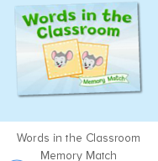  图7：  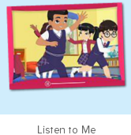
- 家庭游戏活动布置：
T:All of you did a good job. I'll show you the homework/activities. （将已放入功课的作业界面打开）
T:Look,how many activities do you need to play?
S:Four.
T:How to get a yellow star?
S:Play 5 times
T:Very well.Now Jason, come here and show us how to do the activities.
J:...
T:Good job!Thank you Jason!
T:So ,How many activities you need to play?
S:...
T:How to play?
S:...
T:Class is over, Goodbye everyone.
S:Goodbye Teacher.

