ABCmouse小班上字母C课时10
复习内容：
- Simple letter story:C.
- The sound of letter c song.
- The letter c chant.
- Letter c cutout puzzle.
- The letter c book.
- About me-My Aquarium.
素材截图：
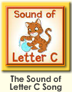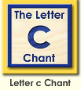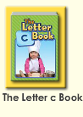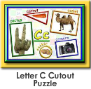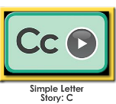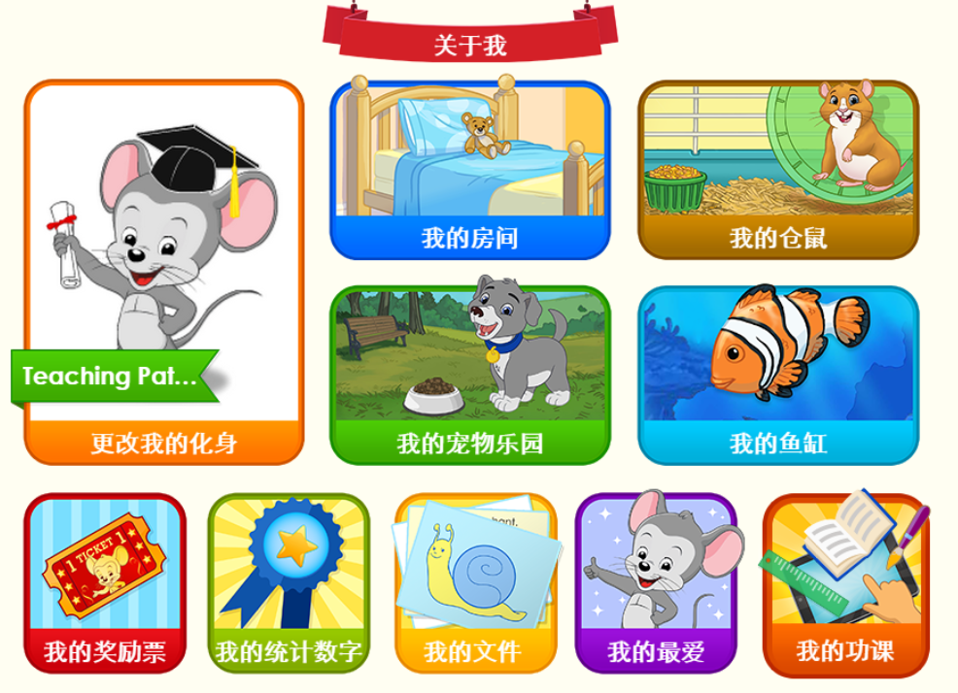
年龄段： 小班上
教学目标：
- 复习字母故事，能完整地看图说故事并表演整个字母故事。
- 复习字母歌曲和诗歌并能表演对应律动。
- 复习单词图书，并用C is for.....,The....is.......,Where is the......,Look at the.....固定句型造句。
教具准备：1.字母故事卡片 2.字母故事相关头饰和图片 3.图书卡片
使用游戏：
1.Team match 2.Role play.3.TPR
教学步骤： | 备注
一、成果公布及展示  T: Hello kids,good morning.  S:Good morning Yama.  T:Before class,let’s check your homework.Sandy,Coco,Jason...have finished their homework,let's praise for they.Jimmy come here please,can you show us your activities?  J:Yes.  T:Ok, show us please.(请完成家庭活动的幼生上前自主操作网站，向其他幼生展示家庭活动成果)  Everybody look,how many activities have Jimmy finished?  S:Four.  T:How many yellow stars did Jimmy get?  S:Four.  T:Wow,very good thank you Jimmy.  Coco,come here please,can you show us your room?  C:Yes.  T:Is this your room?  C:Yes.This is my room.  T:Everybody look,what is this?  S:This is a bed.  T:So Coco,what is this?This is my....  C:This is my bed.  T:Wonderful!What color is you bed?  C:It is pink/blue/yellow.  T:Everybody,what color is Coco's bed?  S:It is pink/blue/yellow.  T:Is it beautiful?  S:Yes.  T:Coco,is your room beautiful?Yes,my room is....  S:Yes.My room is beautiful.  T:Coco,can you introduce your room again?This is my......  C:This is my room,this is my bed,it is pink,my room is beautiful. | 公布家庭活动成果并展示我的房间
二、集体学习活动：  谁是大歌星  T:Good job!Now let's sing c song/letter c chant..(复习图1-图2字母C歌曲和单词诗歌，教师可轮流邀请几名幼生上前当小老师，带领幼生清唱并表演对应律动)  Who can sing?  S:Let me try.  T:Lily/Paul/Jimmy/Lucy come here,you will be the little teacher.  Everybody stand up please.  Let's sing and dance.Ready?  S:Yes,go go go!  T:I know the sound of letter c/Letter c says "c",go!  S:I know the sound of letter c......./Letter c says "c".......  配音达人  T:Pretty good!Now let's read letter c book.（教师点击播放图3单词图书，请幼生跟读）  S:Cake,c,c,c,cake....  T:So good,now I will turn off the sound,let's be the little recorder.(请幼生一个接一个给图书配音，检验幼生掌握程度，遇到不会读的及时打开声音让其跟读)  Lily you will be the first then say it one by one.Are you ready?  S:Yes,we are ready.  L:Cake,c,c,c,cake  P:Cup,c,c,c,cup.  换乐无穷  T:Now let's play I do you say.Look at my actions,what is the sentence?(教师出示图书卡片，利用单词图书词汇进行C is for.....,The....is.......,Where is the......,Look at the.....固定句型造句，不能用动作表示的，教师可用问题提示幼生）  S:C is for cake/cup/cookie/cupcake.......  Look at the cake/cup/cookie/cupcake.......  T:What color is the cake/cup/cookie/cupcake.......?  S:The cake/cup/cookie/cupcake.......is brown/white/brown/blue.....  图块拼拼乐  T:Terrific!Puzzle time!Who can try?  S:Let me try.  T:Susan/Tom/Coco/Molly come here please.Everybody listen and repeat.(教师打开图4图块拼图，轮流请幼生上前操作一块，引导其他幼生跟读发音)  S:Camel,c,c,carrot,cookie,camera,cactus.  T:Terrific,thank you Susan/Tom/Coco/Molly.  看图说故事  T:Now let's enjoy simple letter story c.Please listen and repeat.(教师点击播放图5字母故事，请幼生跟读)  S:This is Connor.Connor has a cat.Connor sits on a couch.Oh,no!Connor sat on his cat.(跟读2次)  T:Let's look and say.(教师出示字母故事图片，请幼生看图说故事)  S:This is Connor.Connor has a cat.Connor sits on a couch.Oh,no!Connor sat on his cat.  T:Now,boys/girls look and say.  Bs/Gs:This is Connor.Connor has a cat.Connor sits on a couch.Oh,no! Connor sat on his cat.  T:Very good!Let's perform the story,are you ready?（加上动作，边说句子边做动作进行表演）  S:Yes,we are ready.  S:This is Connor.Connor has a cat.Connor sits on a couch.Oh,no!Connor sat on his cat.  小小表演家  T:Terrific!Let’s role play,who can try?(轮流邀请若干幼生上前当Connor和cat，其他幼生说句子，表演整个字母故事)  S:Let me try.  记忆对对碰  T:Wonderful!Now let's play a memory match game.Who can try?(教师点击图6进入memory match游戏，一共可玩三轮，教师可邀请几位幼生上前操作，其他幼生跟读发音)  S:Let me try.  T:Tom/Lily/Monica/Louis/Jim please.Everybody listen and repeat.  S:Cow,chipmunk.........  T:Good job!  ABCmouse游园会  T:You all did a good job today,let's go to "About me" to have some fun.Who can try?  S:Let me try.  T:Coco come here please,can you show us your aquarium?  C:Yes.  T:Is this your aquarium?  C:Yes.This is my aquarium.  T:Everybody look,how many fish does Coco have?Coco has....  S:Coco has 2 fish.  T:So Coco,how many fish do you have?I have....  C:I have 2 fish.  T:Wonderful!What color is you fish?  C:This one is blue,this one is orange.  T:Everybody,what color is Coco's fish?  S:This one is blue,this one is orange.  T:Do you feed your fish everyday?  S:Yes.I feed my fish everyday.  T:Very good.Coco,can you introduce your aquarium again?This is my......  C:This is my aquarium,I have 2 fish,this one is blue,this one is orange.I feed my fish everyday.  T:So good!Thank you Coco,sit down please. | 图1  图2  图3  应用单词图书词汇活用C is for.....,The....is.......,Where is the......,Look at the.....固定句型造句。  图4  图5  图6  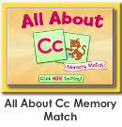  图7
三、家庭活动布置：
T:Now I'll show you the activities.（将已放入功课的作业界面打开）
Look,today we have to do 3 activities.Who can show us how to do it.
S:Let me try.
T:Jason come here please.
Good job!Thank you Jason!
Class is over.Goodbye everyone.
S:Goodbye Yama.

