ABCmouse小班上字母D课时10
复习内容：
- Simple letter story:D.
- The sound of letter d song.
- The letter d chant.
- Letter d cutout puzzle.
- The letter d book.
- About me-My Aquarium.
素材截图：
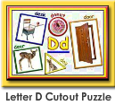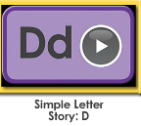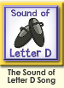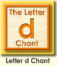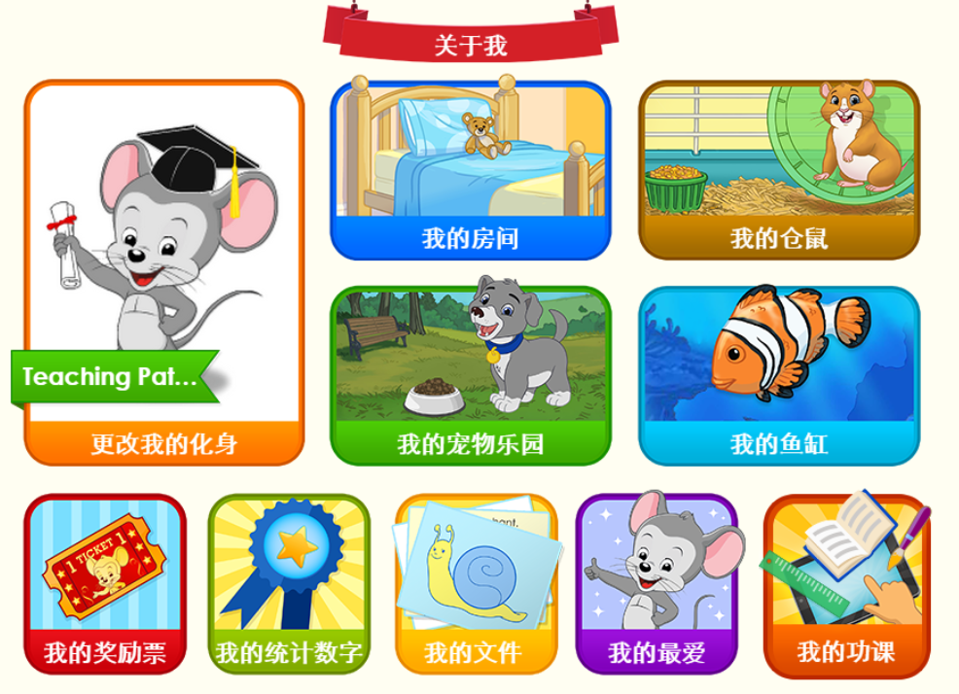
年龄段： 小班上
教学目标：
- 复习字母故事，能完整地看图说故事并表演整个字母故事。
- 复习字母歌曲和诗歌并能表演对应律动。
- 复习单词图书，并用D is for.....,The.....runs fast.A duck says: "Quack"!I am .....固定句型造句。
教具准备：1.字母故事卡片 2.字母故事相关头饰和图片 3.图书卡片
使用游戏：
1.Team match 2.Role play.3.TPR
教学步骤： | 备注
一、成果公布及展示  T: Hello kids,good morning.  S:Good morning Yama.  T:Before class,I would like to say that Sandy,Coco,Jason....have finished their homework,let's praise for they.Jason come here please,can you show us your activities?  J:Yes.  T:Ok, show us please.(请完成家庭活动的幼生上前自主操作网站，向其他幼生展示家庭活动成果)  Everybody look,how many activities have Jason finished?  S:Four.  T:Jason,can you tell us what did you do last night?I read....(请幼生说出所完成的家庭活动)  J:I read letter D book.  T:Now everybody read it together.  T:Wow,very good thank you Jason.  Coco come here please,can you show us your aquarium?  C:Yes.  T:Is this your aquarium?  C:Yes.This is my aquarium.  T:Everybody,what is this?This is...  S:This is Coco's aquarium.  T:Good!How many fish do you have,Coco?  S:I have two fish.  T:What color are they?This one is...  S:This one is blue.This one is yellow.  T:Kids,what color are the fish?  S:This one is blue.This one is yellow.  T:Very nice!Coco,do you feed your fish everyday?  S:Yes.I feed my fish everyday.  T:Coco,can you introduce your aquarium again?This is my....  C:This is my aquarium,I have two fish,this one is blue,this one is yellow.I feed my fish everyday.  T:So good!Thank you Coco,sit down please. | 公布家庭活动成果并展示我的鱼缸
二、集体学习活动：  谁是大歌星  T:Good job!Now let's sing c song/letter c chant..(复习图1-图2字母C歌曲和单词诗歌，教师可轮流邀请几名幼生上前当小老师，带领幼生清唱并表演对应律动)  Who can sing?  S:Let me try.  T:Lily/Paul/Jimmy/Lucy come here,you will be the little teacher.  Everybody stand up please.  Let's sing and dance.Ready?  S:Yes,go go go!  T:"d""d""d""d"letter d......  S:"d""d""d""d"letter d........  配音达人  T:Pretty good!Now let's read letter d book.（教师点击播放图3单词图书，请幼生跟读）  S:The letter d book.....  T:So good,now I will turn off the sound,let's be the little recorder.(请幼生一个接一个给图书配音，检验幼生掌握程度，遇到不会读的及时打开声音让其跟读)  Lily you will be the first then say it one by one.Are you ready?  S:Yes,we are ready.  L:The letter d book.  P:Dancer.....  换乐无穷  T:Now let's play I do you say.Look at my actions,what is the sentence?(教师出示图书卡片，利用单词图书词汇进行D is for.....,The.....runs fast.A duck says: "Quack"!I am .....固定句型造句，不能用动作表示的，教师可用问题提示幼生）  图块拼拼乐  T:Terrific!Puzzle time!Who can try?  S:Let me try.  T:Susan/Tom/Coco/Molly come here please.Everybody listen and repeat.(教师打开图4图块拼图，轮流请幼生上前操作一块，引导其他幼生跟读发音)  S:D,d,deer.......  T:Terrific,thank you Susan/Tom/Coco/Molly.  看图说故事  T:Wonderful!Now let's repeat the story.(教师点击播放字母故事，请幼生跟读整个故事)  S:This is Deedee. Deedee has a dog.Here is Darla. Darla can dance. Look!Deedee's dog can dance,too!(跟读2次)  T:Let's look and say.(教师出示字母故事图片，请幼生看图说故事)  S:This is Deedee. Deedee has a dog.Here is Darla. Darla can dance. Look!Deedee's dog can dance,too!  T:Very good!Let's perform the story,are you ready?（加上动作，边说句子边做动作进行表演）  S:Yes,we are ready.  S:This is Deedee. Deedee has a dog.Here is Darla. Darla can dance. Look!Deedee's dog can dance,too!  小小表演家  T:Terrific!Let's role play,who can try?(轮流邀请若干幼生上前当Deedee、dog和Darla，其他幼生说句子，表演整个字母故事)  S:Let me try.  记忆对对碰  T:Wonderful!Now let's play a memory match game.Who can try?(教师点击图6进入memory match游戏，一共可玩三轮，教师可邀请几位幼生上前操作，其他幼生跟读发音)  S:Let me try.  T:Tom/Lily/Monica/Louis/Jim please.Everybody listen and repeat.  S:Dancer......  T:Good job!  ABCmouse游园会  T:You all did a good job today,let's go to "About me" to have some fun.Who can try?  S:Let me try.  T:Coco come here please,can you show us your hamster maze?  C:Yes.  T:Is this your hamster maze?  C:Yes.This is my hamster maze.  T:Everybody look,how many hamsters does Coco have?Coco has....  S:Coco has 2 hamsters.  T:So Coco,how many hamsters do you have?I have....  C:I have 2 hamsters.  T:Wonderful!What color are you hamsters?  C:This one is black,this one is brown.  T:Everybody,what color are Coco's hamsters?  S:This one is black,this one is brown.  T:Do you feed your hamsters everyday?  S:Yes.I feed my hamsters everyday.  T:Very good.Coco,can you introduce your aquarium again?This is my......  C:This is my hamster maze,I have 2 hamsters,this one is black,this one is brown.I feed my hamsters everyday.  T:So good!Thank you Coco,sit down please. | 图1  图2  图3  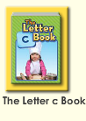  应用单词图书词汇活用D is for.....,The.....runs fast.A duck says: "Quack"!I am .....固定句型造句。  图4  图5  图6  图7
三、家庭活动布置：
T:Now I'll show you the activities.（将已放入功课的作业界面打开）
Look,today we have to do 3 activities.Who can show us how to do it.
S:Let me try.
T:Jason come here please.
Good job!Thank you Jason!
Class is over.Goodbye everyone.
S:Goodbye Yama.

