ABCmouse大班上Review:/ee/~/oh/& People-课时5
素材内容：
- People Part 2 Animation
- Practice page:I am a girl
- Practice page:Sara is a girl
- People
- Who is this?
- I'm a little teapot
素材截图：
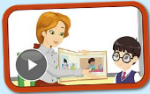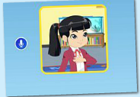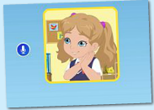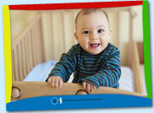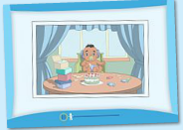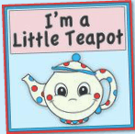
年龄段： 大班上
教学目标：
- 复习已学口语内容：I am a.../ She is a...?
2.能熟练掌握新的句型并理解句子的用法：This is...
3.能自如的与同伴进行口语交流及回答老师的问题。
4.掌握歌曲第5句内容并能演唱歌曲。
教具准备：1.视频中主要人物头像或图片 2.若干幼儿小时候的照片 3.水壶 4.茶杯
使用游戏：1.Conversation 2.Guessing game 3.TPR 4.Record game
教学步骤： | 备注
- 成果公布及展示：
T: Hello kids.
S: Hello, teacher.
T: Peter, can you show us your activities?
P: Yes.
T: Can you read these sentences?
T: Can you play this quiz game?
P: Yes,I can.
T: Can you sing the song? （演唱歌曲第一段内容）
P: Yes. I'm a little teapot...pour me out.
T: Wow. Excellent. Please show us your tickets, OK?
P: Look, I got 200 tickets, I want to buy a new hat for my avatar.
T: Can you show us your avatar?
P: Yes, He is a handsome boy. His name is Jason. He is 6. He has black hair, big eyes and small mouth. He likes robots. He likes swimming and running.
T: Wow, terrific! Thank you, Peter.
二、集体学习活动：  1）进入素材（图1、2），复习已学句子"I am a.../ She is a..."。  T: Listen and repeat!  T: Good, record these sentences.  T: Good job.  T: Who is this?  S: Sara/Lina.  T: Sara/Lina is a ... （TPR提示）  S: Sara/Lina is a girl.  T: Good. In our classroom. Who is a girl?  S: Lisa/Coco/Lucy/Kelly/Judy...is a girl.  T: Lisa, are you a girl?  L: Yes. I am a girl.  T: Peter, are you a girl?  P: No. I am a boy.  2）进入素材（图3），观看视频，掌握并理解句子"This is ..."。  T: Good, sit down, please. Let's watch the video, no voice!  T: OK, listen again.  T: What can you hear?  S: Boy/ Who is this/ This is ..../ Sara is a girl  T: Right? Let's check!  T: Yes, you're right!  T: Listen! Boy or girl? （见图4）  S: Boy.  T: Good. In our classroom. Who is a boy? Hands up!  T: Yes. You re all boys.  T: OK, read after the computer.  T: Guess,who is this? （见图5）  S: Sara.  T: Right? Listen again.  T: Yes. Repeat this sentence.  S: This is Sara.  T: Yes, Sara is a girl.  T: Guess,who is this? Listen!  S: This is Lina.  T: Right? Listen again.  T: Yes. Repeat again.  T: Guess,who is this? （教师拿出幼生小时候的照片，让幼生猜猜看是谁）  S: This is Lisa/Coco/Lucy/Kelly/Judy...  T: Excellent!  T: Now. Look at the computer, you're children. Please follow the  children. Are you ready?  S:Yes.  M: This is a boy.  S: Boy.  M: Who is this?  S: This is Sara.  M: Yes, Sara is a girl. Who is this?  S: This is Lina.  M: Yes.  T: Exchange. You're Miss Jones.  T: Good. One more time. ...（配合视频对话2-3遍）  T: Let's conversation. I'm Miss Jones, you're children. Are you ready?  S:Yes.  T: This is a boy.  S: Boy.  T: Who is this?  S: This is Sara.  T: Yes, Sara is a girl. Who is this?  S: This is Lina.  T: Yes.  T: Wonderful! One more time. ...（与幼生对话2-3遍）  T: Who wants to be Miss Jones/Nico/Ken/Carmen/Lina/Sara/Raj?  IS: Let me try!  T: OK, you're Miss Jones/Nico/Ken/Carmen/Lina/Sara/Raj. Let's  conversation.  3）进入素材（图7、8），复习检验已学口语内容，并完成发音练习。  T: Listen, what can you hear?  S: Who is this, this is Nico. Nico is a baby.  Who is this, this is Sara. Sara is a girl. （此内容在后部分可看到）  T: Good, read after it.  S: Who is this, this is Nico. Nico is a baby.  Who is this, this is Sara. Sara is a girl.  T: Listen again, no voice.（引导幼生听完剩下内容，为剩下内容做铺垫）  T: Now, Let's read another sentences.  T: Listen.  Computer: This is a baby...  T: Read after the computer.  T: Well, who can read these sentence. （教师关闭网站声音，幼生看图说句子）  S: This is a baby/ boy/girl.  T: Pretty good.  4）进入素材（图9），掌握第5句内容并能演唱歌曲。  T: Listen to a music!  T: Sleep, no voice!  T: Week up. Once again.  T: OK, follow the music. （跟唱第一段）  T: Let's sing and dance. （T带领孩子完成第一段演唱）  T: It's your turn, try it!  T: Sit down, please.  T: Listen and follow this sentence. "Polly put the kettle on, let's have tea."  T: Once gain.  T: Who out the kettle on?  S: Polly.  T: OK. You're Polly. Let's do the action. （T播放平台声音，S只听并做动作）  T: One more time.  T: OK, sing this sentence. "Polly put the ..."  S: "Polly put the ..."  T: Good, follow the radio.  S: "Polly put the kettle on, let's have tea."  T: Let's sing and dance.  T/S: "Polly put the kettle on, let's have tea."  T: Terrific! Sing and dance again.  T: Sit down, no voice.  T: Listen this music.（再次完整听完整首歌曲） | 图1  图2  图3  图4  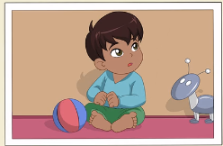  图5  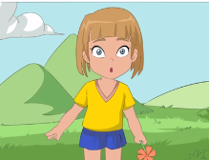  图6  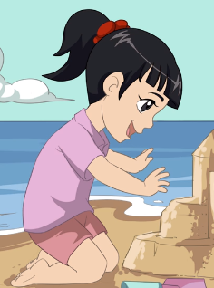  图7  图8  图9  注：这里Kettle 是烧水壶的意思。
三、家庭游戏活动布置：
T: Wow!So nice!Now I'll show you the homework.
T: You need finish one, two,three... activities. Do you know how to do it?
T: Who wants to try?
S: I can try!
T: OK, show it.
T: Good job! The next one...
T: Please remember use the buttons,Step by step. OK?
S: OK!
T: Class is over, Good bye everyone.
S: Goodbye.

