ABCmouse大班上更多发音/ch/-课时3
复习素材内容：  1. More English Sounds chant: chair  2. More English Sounds Sentence chant: chair  3.Sentence puzzle:/ch/ as in chair | 新授素材内容：  1. More English Sounds Sentence chant: chicken  2. Sentence puzzle:/ch/ as in chicken  3. More English Sounds book: /ch/ as in chair
素材截图：
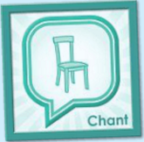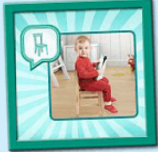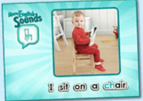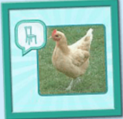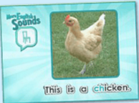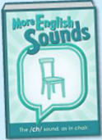
年龄段： 大班上
教学目标：
1.复习已学的诗歌，能熟练演唱。
2.学习并掌握新的诗歌，能模仿跟唱。
3.熟悉并了解/ch/的发音图书。
教具准备：1.图书中对应的单词卡 2.动物图卡
使用游戏：1.Make sentence 2.Ask and answer 3.High and low 4.Touching game
教学步骤： |  | 备注
- 成果公布及展示：
T: Hello kids.
S: Hello, teacher.
T: Gigi,can you show us your activities?
G:Yes.
T: Can you sing this chant?
G: "Hear the sound of..."
T: Very good.
T: Can you play this puzzle game?
G: Yes,I can.
T: Can you say this sentence?
G: I sit on a chair.
T: Wow. Excellent. Please show us your room,OK?
G: OK.
G: Look,this is my room. My room is clean and tidy. There is a bed/chair/
table in my room. My chair/bed/table/ is pink. I have a cute rabbit in my room. I like my room so much. Do you like my room?
T: Wow,terrific!Thank you Gigi.
- 集体学习活动：  - 先复习上节课已学过的诗歌及句型。见图1~图3.  T: Let's review these chants. Sing with the radio. OK?  T: Are you ready?  S:...  T: Pretty good. Now, stand up. Let's sing and dance.  T: Excellent. Sit down, please!  T: G1 and G2, Let's have a match!  T: Are you ready?  T: Which group is the best?  S: G1...  T: Look, What’s the sentence? （T询问S上节课所学的句子）  S: I sit on a chair.  T: Yes. You're right.  T: How about this?（T引导S用I sit on a...造句）  S: I sit on a table/desk/sandbeach/coach/bed....  T: Pretty good.  - 学习新的诗歌（见图4）。  T: Kids. Have a rest. Listen, no voice.  T: Once again.  T: What can you hear?  S: Hear the sound of /ch/, this is a chicken.  T: Good! Now, sing with the radio. Are you ready?  S: Hear the sound...  T: Wonderful, one more time.（听T指令，完成大/小声演唱）  T: Loudly!  S:...  T: Lowly!  ...  T: Nice job!  T: Can you find a new sentence in the chant?  S: This is a chicken.  T: Right? Let's check.  T: Yes. You're right.  3）教师打开此句对应的句型拼图（见图5），学习并掌握此句。  T: Look and listen carefully.  T: Listen again.  T: OK, read after these words one by one.  S:This is a chicken.  T: Read again.  T: Good, Who can play this puzzle?  S: Let me try.  T: Is that right?  S: Yes.  T: Play again.  T: Who wants to try?  S: Let me try!  T: Right?  T: You did a good job!  T: Look , what's in the picture?  S: A chicken.  T: So, this is a ...  S: This is a chicken.  T: Look, this is a ...（T拿出一些动物图片并引导S用this is a...造句）  S: This is a pig/dog/rabbit/duck/monkey...  T: Good job!  4）幼生掌握句子后，再次回到chant，把诗歌和句子再次巩固复习一次。  T: Kids, can you sing this "chicken" chant?  S: Yes.  T: OK. Sing it together.  T: Very good.  T: Now, let's do the action. Stand up, follow me.  T: Once again.  T: Now, it's your turn. Come on, kids.  T: Well done. Let's chant.（清唱加做动作）  T: Let's have a match. Bs Vs Gs.  T: Who wins?  ...  - 打开/ch/的发音图书，熟悉并掌握前7个发音的内容。（见图6）  T: Look and listen, no voice.  T: Listen again.  T: What can you hear in this book?  S: Chair,bench,chess,chain,chin,child,watch.  T: Very good.  T: OK. Read after it.  S: Chair,bench,chess,chain,chin,child,watch.  T: Yes, good. Once again.  S:...  T: Let's play a game. "Touching game".  T: Listen, If you hear the word, you should touch the card as quickly as you can.OK?  S: OK.  T: Are you ready?  S: Yes. I am ready.  T: Listen!  C: Chair/bench/chess/...  S:...  T: So nice! Exchange, I touch you say word. OK?  S: OK.  T: I need a "little teacher", who wants to try?  1S: Let me try!  ...  T: Good.Let's read these words one by one.（引导S再次回到网站跟读发音）  S: Chair,bench,chess,chain,chin,child,watch. |  | 图1:  图2：  图3：  图4：  图5：  图6：
三、家庭游戏活动布置：
T: Wow!So nice!Now I'll show you the homework.
T: You need finish one, two,three... activities. Do you know how to do it?
T: Who wants to try?
S: I can try!
T: OK, show it.
T: Good job! The next one...
T: Please remember use the buttons,Step by step. OK?
S: OK!
T: Class is over, Good bye everyone.
S: Goodbye.

