ABCmouse小班上Letters Review A-B-C课时2
素材内容：
- Letters a-b-c chant.
- A-b-c review cutout puzzle.
- Simple letter story:B
- Simple letter story:C
- a-b-c matching card game.
素材截图：
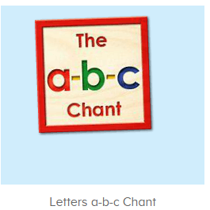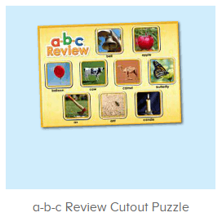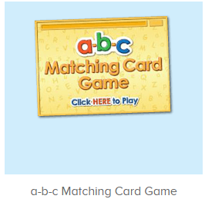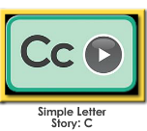
年龄段： 小班上
教学目标：
1.能熟练掌握字母A,B,C的发音并表演对应字母律动。
2.能熟练掌握对应的单词，看图能说。
3.能熟练将字母及对应单词进行配对。
4.能自如念唱诗歌并表演对应TPR。
5.能自如流利跟读字母故事B、C，能看图说故事。
教具准备：1.A,B,C开头的单词卡若干2.字母A,B,C的图卡
使用游戏：
1.Matching game 2.Team match
教学步骤： | 备注
- 成果公布及展示：  T: Hello kids,good morning.  S:Good morning Yama.  T:First,let's praise Lily,Andy,Peter,Jimmy....They have finished all their activities.  Everybody look,what is this?This is....(带领全体幼生回顾前三个字母已学过的关于我的名称)  S:This is my pet park/my avatar/my room.  T:Is it right?Let’s listen and repeat.  S:Change my avatar/Go to pet park/Go to my room.  Coco come here,please show us your pet park.  C:Yes.  C:This is my pet,my pet is a dog,the dog is white.  T:Wow,terrific!Thank you Coco.  Everybody together.  S:This is my pet,my pet is a dog,the dog is white.（带领幼生整体描述一遍）  T:Well done! | 公布家庭活动成果并展示关于我（我的宠物/我的化身/我的房间）
- 集体学习活动：  快乐唱片机  T:Now let's chant,follow the music.（教师点击播放图1诗歌，请幼生先听不跟唱并留意诗歌内容）  S:Letter a says “a”.......（跟唱2遍）  T:Very good.Now boys and girls will have a match,are you ready?(教师配合手势示意小组跟唱，可进行2-3次)  S:Yes.  Bs/Gs:Letter a says “a”.......  T:Let’s play a song chain game.(加入歌曲接龙游戏，全体跟唱诗歌，被老师拍到的幼生站起来跟唱诗歌，其余幼生不唱，可进行1-2轮)  S:Letter a says “a”.......  Peter/Molly/Ken:Apple alligator ant....  T:Nice job!Now let's add some actions.(请幼生跟着音乐一起边唱边做动作)  Wow!So nice,again.  T:Girls/boys come here,you will be the little teacher,boys/girls follow girls,ready?  S:We are ready.  Letter a says “a”.......  T:Great job!  单词拼拼乐  T:Puzzle time!Who can try?(教师打开图2拼图，选择级别2/3，请幼生完成拼图，其余幼生跟读发音，可操作2-3遍)  S:Let me try.  T:Sam/Tommy/Ken...please.  Everyone follow it.  S:Bell/apple/ant....  T:Nice job!Now look at these pictures and finish the puzzle.(教师准备与拼图对应的图卡，请幼生找出对应的图卡放在拼图的空位上并读出单词)  What is it?  S:It is apple/ant/bell....  T:Where can i put it?  Right?  Let’s check,listen and repeat.  S: apple/ant/bell....  T:Terrific!  字母小剧场  T:Story time!Listen and repeat.(打开图3/图4字母故事B/C，请幼生跟读)  S:Here is Bobby........../This is Connor...........(跟读2次)  T:Let's look and say.(教师出示整个字母故事图片，请幼生看图说故事)  S:Here is Bobby........../This is Connor...........  T:Very good!Let's perform the story,all together,are you ready?（教师播放字母故事，请幼生边说句子边做动作进行表演）  S:Yes,we are ready.  S:Here is Bobby........../This is Connor...........  T:Terrific!Now let's play a role game,Tom,Lucy,Lily,Paul,Coco,Sam,Jim,  Ken,come here please.(教师分发头饰，分配好角色，依照字母故事剧情，依次序表演故事)  T:Everybody say the sentences and they will perform the story,are you ready?  S:Yes,we are ready.  S:Here is Bobby........../This is Connor...........  单词对对碰  T:You all did a great job!Let’s play a game.（打开图5游戏素材，请幼生操作并跟读发音）  Who can try?  S:Let me try.  T:Lily/Susan/Jimmy....please.  Everybody listen and repeat.  S:Ax/barn/a/b/c.......  T:Nice job!Let’s chant again.  Please sing and dance with me.（再次跟唱歌曲加上律动表演）  S:Letter A says “a”.......  T:Very good!Now let's count our tickets.  Who can try?  S:Let me try.  T:Tommy please.  Where can we find our tickets?  S: "About me".  T:Tommy click it please.  Now let's count with ABCmouse.  S&ABCmouse:One,two,three......  T:So we have ten tickets today,great job!  Thank you Tommy. | 图1：  图2  图3  图4  图5
- 家庭活动布置：
T:Wow!So nice!Now look at me and I'll show you the homework.（将已放入功课的作业界面打开）
T: You have to do one,two,three activities.Each of them,you have to play 5 times,ok?
S:OK!
T:Very well.Now I will show you how to do it.Please listen and repeat.
Use the buttons,Step by step. (加上肢体动作演示）
OK?
S:OK!
T: Jason come here and show us how to do the activities.
Good job!Thank you Jason!Class is over, Good bye everyone.
S:Goodbye Yama.

