ABCmouse小班上Letters Review A-B-C课时1
素材内容：
- Letters a-b-c chant.
- A-b-c review cutout puzzle.
- Food ABC’s Jigsaw.
- Simple letter story:A
- a-b-c matching card game.
素材截图：
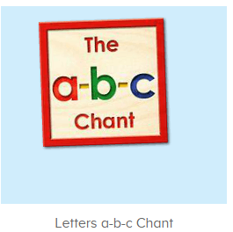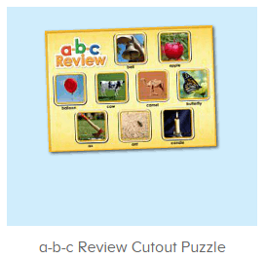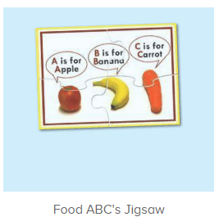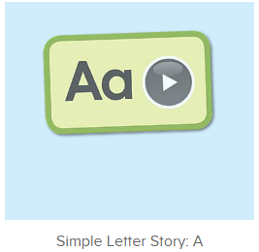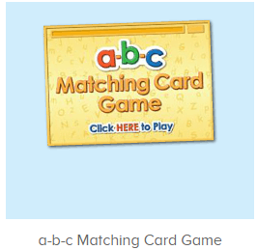
年龄段： 小班上
教学目标：
1.能熟练掌握字母A,B,C的发音并表演对应字母律动。
2.能熟练掌握对应的单词，看图能说。
3.能熟练将字母及对应单词进行配对。
4.能自如念唱诗歌并表演对应TPR。
5.能自如流利跟读字母故事A，能看图说故事。
教具准备：1.A,B,C开头的单词卡若干2.字母A,B,C的图卡 3.字母故事A人物头饰及道具
使用游戏：
1.Matching game 2.Team match
教学步骤： | 备注
- 成果公布及展示：  T: Hello kids,good morning.  S:Good morning Yama.  T:First,let's praise Lily,Andy,Peter,Jimmy....They have finished all their activities.  Everybody look,what is this?This is....(带领全体幼生回顾前三个字母已学过的关于我的名称)  S:This is my pet park/my avatar/my room.  T:Is it right?Let’s listen and repeat.  S:Change my avatar/Go to pet park/Go to my room.  Coco come here,please show us your pet park.  C:Yes.  C:This is my pet,my pet is a dog,the dog is white.  T:Wow,terrific!Thank you Coco.  Everybody together.  S:This is my pet,my pet is a dog,the dog is white.（带领幼生整体描述一遍）  T:Well done! | 公布家庭活动成果并展示关于我（我的宠物/我的化身/我的房间）
- 集体学习活动：  快乐唱片机  T:Now let's listen to the chant,no voice,ok?（教师点击播放图1诗歌，请幼生先听不跟唱并留意诗歌内容）  S:OK.  T:What can you hear?  S:Letter a/"b"/cat/apple....  T:Right?Let's check,listen carefully,if you hear apple,balloon,cat..please clap your hands,ok?  S:Ok.  T:Wow,very good,now follow it please.(教师配合手势和动作引导幼生，教师唱的那遍听，学生唱的那遍跟唱)  S:Letter a says “a”.......（跟唱2遍）  T:Very good.Now boys and girls will have a match,are you ready?(教师配合手势示意小组跟唱，可进行2-3次)  S:Yes.  Bs/Gs:Letter a says “a”.......  T:Now let's add some actions.Follow me please.(请幼生跟着音乐一起边唱边做动作)  Wow!So nice,again.  T:Girls/boys come here,you will be the little teacher,boys/girls follow girls,ready?  S:We are ready.  Letter a says “a”.......  T:Great job!  单词拼拼乐  T:Puzzle time!Please listen and repeat.(教师打开图2拼图，选择级别1，完成拼图并请幼生跟读发音，可操作2遍)  S:Bell,apple,balloon....  T:So good!Now look,what is it?(选择级别2，空出拼图，询问幼生拼图内容，请幼生上前操作核对，并引导幼生跟读发音)  S:It is bell/ant/apple....  T:Right?Who can try?  S:Let me try.  T:Sam/Tommy/Ken...please.  Everyone follow it.  S:Bell/apple/ant....  T:Well done!Now let’s play I do you say.Are you ready?(教师表演单词TPR，猜出的幼生，请其上前完成该拼图，其余幼生跟读发音)  S:Yes,we are ready.  T:What is it?  S:It is bell/apple/ant....  T:Jimmy/Molly/Candy....you are right,please finish the puzzle.Everybody repeat it.  S:Bell/apple/ant....  句子拼拼乐  T:So nice.The next puzzle.  Look,what can you see?  S:Apple/banana.....  T:Right?Listen carefully,no voice.(点击完成图3拼图，引导幼生只听不跟读并询问幼生听到的内容)  What can you hear?  S:A is for apple........  T:Right?Let’s check.Listen.(点击小喇叭请幼生听句子发音2遍)  Wow,so good!  Listen and repeat!（引导幼生跟读发音2-3遍）  S:A is for apple.....  T:Good,who wants to try?  S:Let me try.  T:Sam/Paul....please.Everybody listen and repeat.  S:A is for apple.....  T:Good!Now look at me,let’s play I do you say.Are you ready?  S:Yes,we are ready.  T:What is the sentence?  S:A is for apple....  T:Who can try?  S:Let me try.  T:Lily/Micky...please.  Ready?  S:Yes!  A is for apple....  T:Very nice.Now look at the pictures and make sentences.  What is it?  S:It is butterfly/bell/ant/cow.....  T:Look at my actions,what is the sentence?  A/B/C is for.....  S:A/B/C is for ant/bell/cow......  T:Nice,once again.  S:A/B/C is for ant/bell/cow......  字母小剧场  T:Story time!Listen and repeat.(打开图4字母故事A，请幼生跟读)  S:This is Al......  T:Boys and girls have a match,are you ready?  S:Yes,we are ready.  Bs/Gs:This is Al......  T:Let’s add some actions.Ready go!（加上的动作表演字母故事A）  S:This is Al........  T:Nice job!Now let's play a role game,Tom,Lucy,Lily,Paul,Coco,Sam,Jim,  Ken,come here please.(教师分发头饰，分配好角色，依照字母故事剧情，依次序表演故事)  T:Everybody say the sentences and they will perform the story,are you ready?  S:Yes,we are ready.  S:This is Al. Al is an ant.Al sees an apple. Look at the ants.The ants eat the apple. The apple is gone.This is Andy. Andy is an anteater.The ants are gone.  T:Wow,pretty good!Now let’s look and say.（请幼生看图说话）  S:This is Al......  单词对对碰  T:You all did a great job!Let’s play a game.（打开图5游戏素材，请幼生操作并跟读发音）  Who can try?  S:Let me try.  T:Lily/Susan/Jimmy....please.  Everybody listen and repeat.  S:Ax/barn/a/b/c.......  T:Nice job!Let’s chant again.  Please sing and dance with me.（再次跟唱歌曲加上律动表演）  S:Letter A says “a”.......  T:Very good!Now let's count our tickets.  Who can try?  S:Let me try.  T:Tommy please.  Where can we find our tickets?  S: "About me".  T:Tommy click it please.  Now let's count with ABCmouse.  S&ABCmouse:One,two,three......  T:So we have ten tickets today,great job!Thank you Tommy. | 图1：  图2  图3  图4  图5
- 家庭活动布置：
T:Wow!So nice!Now look at me and I'll show you the homework.（将已放入功课的作业界面打开）
T: You have to do one,two,three activities.Each of them,you have to play 5 times,ok?
S:OK!
T:Very well.Now I will show you how to do it.Please listen and repeat.
Use the buttons,Step by step. (加上肢体动作演示）
OK?
S:OK!
T: Jason come here and show us how to do the activities.
Good job!Thank you Jason!Class is over, Good bye everyone.
S:Goodbye Yama.

