ABCmouse小班上Letters Review A-C&Good Manners课时3
素材内容：
- What we say music video.
- Good manners part 1 animation.
- Good manners part 3 animation.
- Good Morning listen and learn.
- Practice page:Good morning.
- Practice page:Good night.
- Good morning,good night cutout puzzle.
素材截图：
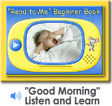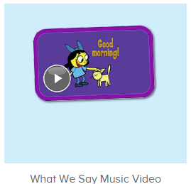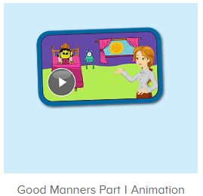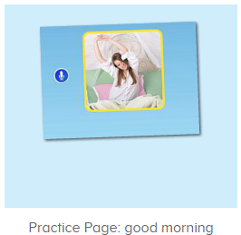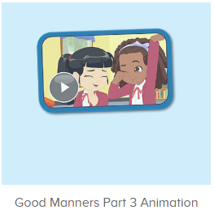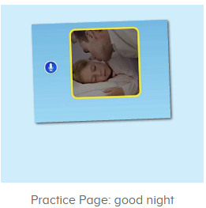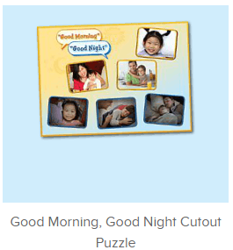
年龄段： 小班上
教学目标：
- 能从歌曲What we say中听出关键词、句good morning、good night.
- 掌握口语动画中的关键词、句good morning、good night.
- 能流利自如地说出good morning、good night.，发音清晰准确。
- 能应用good morning、good night.与同伴、老师及家人相互打招呼及道晚安。
教具准备：1.good morning、good night图卡
使用游戏：
1.Matching game 2.Team match
教学步骤： | 备注
- 成果公布及展示：  T: Hello kids,good morning.  S:Good morning Yama.  T:First,let's praise Lily,Andy,Peter,Jimmy....They have finished all their activities.  Everybody look,what is this?This is....(带领全体幼生回顾前三个字母已学过的关于我的名称)  S:This is my pet park/my avatar/my room.  T:Is it right?Let’s listen and repeat.  S:Change my avatar/Go to pet park/Go to my room.  Coco come here,please show us your room.  C:Yes.  C:This is room.My room is pink.This is my bed.My bed is a boat.  T:Wow,terrific!Thank you Coco.  Everybody together.  S:This is room.My room is pink.This is my bed.My bed is a boat.（带领幼生整体描述一遍）  T:Well done! | 公布家庭活动成果并展示关于我（我的宠物/我的化身/我的房间）
- 集体学习活动：  快乐唱片机  T:Now let’s enjoy the music video,listen and no voice.（打开图1歌曲素材，请幼生认真观看和听，不跟唱）  What can you hear?  S:Good morning/good night....  T:Right?Let’s check,listen.  Wow good job!  This time,when you hear good morning and good night,please clap your hands,ok?  S:OK.  口语动画小剧场  T:Nice job!Now watch the video and tell me when we see someone in the morning,what can we say,ok?（点击播放图2口语动画，在good morning处点击暂停并提问幼生）  S:OK.  T:What can we say when we see someone int he morning?  S:Good morning.  T:Right?Check again,listen and no voice.(拖动进度条重复播放该段视频)  趣味复读机  T:You did a great job!Now listen and no voice.（打开图3素材，请幼生跟读发音）  What can you hear?  S:Good morning.  T:Nice!Follow it please.  S:Good morning.（跟读3-4遍）  T:Well done.Good morning children.  S:Good morning teacher.  T:Good morning,Lily/Peter/Sam...  L/P/S:Good morning teacher.  T:Good job!Now let’s listen and learn.(打开图4素材，请幼生跟读发音)  S:Good morning/Good morning father/mother....(整体跟读一遍后，可进行分组跟读竞赛)  T:What can we say to your mother/father in the morning?（引导幼生学会与家人及同伴相互问早）  S:Good morning mother/father.  T:Very good,now let’s say good morning to your friends.  For example.good morning Lily/Peter/Jimmy...  Are you ready?  S:Yes,we are ready.  Good morning Lily/Sam......  T:Very good!Who can try?  S:Let me try.  T:Molly/Ken/Fiona...please.  Say good mother to your friends.  M/F/K:Good morning Molly/Ken/Fiona....  T:Nice job!Everybody together.  S:Good morning Molly/Ken/Fiona....  口语动画小剧场  T:Great job!Now let’s enjoy the video and tell me what can you hear,ok?(打开图5素材，提醒幼生关注关键词或句)  S:OK.  T:What can you hear?  S:Good morning/good night/goodbye....  T:Right?Let’s check.Watch carefully.  Nice job!  When we go to bed,what can we say?(提示关键词句)  S:.....  T:Watch and tell me.（重复播放与关键词句相关的视频片段）  What can we say?  S:Good night.  T:Terrific!Let’s listen and repeat.（打开图6素材，请幼生跟读发音）  S:Good night.(跟读4-5遍)  T:Good night,children.  S:Good night,teacher.  T:Good night,Lily/Peter/Sam...  L/P/S:Good night,teacher.  T:What can we say to your mother/father when you go to bed?（引导幼生学会与家人及同伴相互道晚安）  S:Good night,mother/father.  T:Very good,now let’s say good night to your friends.  For example.good night,Lily/Peter/Jimmy...  Are you ready?  S:Yes,we are ready.  Good night,Lily/Sam......  T:Very good!Who can try?  S:Let me try.  T:Molly/Ken/Fiona...please.  Say good night to your friends.  M/F/K:Good night,Molly/Ken/Fiona....  T:Nice job!Everybody together.  S:Good night,Molly/Ken/Fiona....  图片拼拼乐  T:Nice job!Puzzle time.(打开图7素材，请幼生跟读发音并操作)  Everybody listen and repeat.  S:Good morning......  T:Who can try?  S:Let me try.  T:Tom/kitty....please.Everybody listen and repeat.  S:Good morning......  T:Good job!Look,what is this?(出示图卡，请幼生说出图卡内容)  S:Good morning/Good night,mother....  T:Let’s play a guessing game.(教师把图卡反面朝上，请幼生猜图卡内容并进行核对，遇到不会的可点击拼图发音请幼生跟读)  What is this?  S:Good morning/Good night,mother....  T:Right?Let’s check.  Wow,you are right/wrong.What is this?  S:Good morning/Good night,mother....  T:Wonderful!  快乐唱片机  T:Now let’s sing a song.When you hear “good morning,good night”,please sing together,ok?（打开图1歌曲素材，请幼生认真跟唱关键词句good morning,good night，其余可不要求跟唱）  S:OK.  Good morning/good night....  T:Once again.  T:Very good!Now let's count our tickets.  Who can try?  S:Let me try.  T:Tommy please.  Where can we find our tickets?  S: "About me".  T:Tommy click it please.  Now let's count with ABCmouse.  S&ABCmouse:One,two,three......  T:So we have ten tickets today,great job!Thank you Tommy. | 图1：  图2  图3  图4  图5  图6  图7
- 家庭活动布置：
T:Wow!So nice!Now look at me and I'll show you the activities.（将已放入功课的作业界面打开）
T: You have to do one,two,three.... activities.
T:Now I will show you how to do it.Please listen and repeat.
Use the buttons,Step by step. (加上肢体动作演示）
OK?
S:OK!
T: Jason come here and show us how to do the activities.
Good job!Thank you Jason!
Please finish your activities and show me tomorrow,ok?
S:OK.
T:Class is over.Goodbye everyone.
S:Goodbye Yama.

