ABCmouse小班上Letters Review A-C&Good Manners课时4
素材内容：
- What we say:Please,thank you.
- Good manners part 2 animation.
- Practice page:Please.
- Practice page:Thank you
- Good manners practice..
- Good morning,good night cutout puzzle.
素材截图：
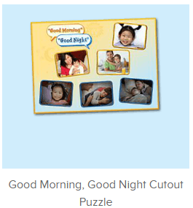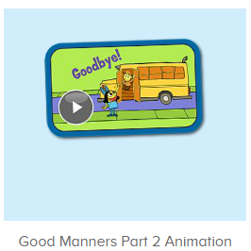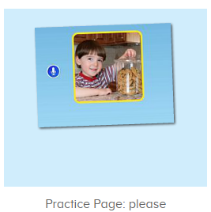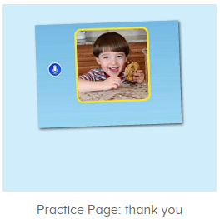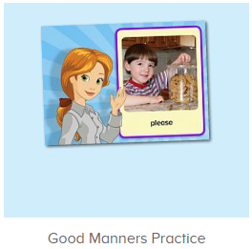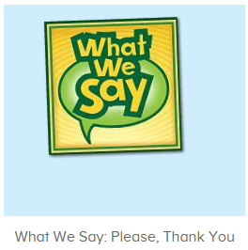
年龄段： 小班上
教学目标：
- 能从歌曲What we say中听出且跟唱关键词、句please,thank you.
- 掌握口语动画中的关键词、句please,thank you.
- 能流利自如地说出please,thank you.，发音清晰准确。
- 能应用please,thank you.与同伴、老师及家人进行简单的对话。
教具准备：1.please,thank you图卡
使用游戏：
1.Matching game 2.Team match
教学步骤： | 备注
- 成果公布及展示：  T: Hello kids,good morning.  S:Good morning Yama.  T:First,let's praise Lily,Andy,Peter,Jimmy....They have finished all their activities.  Everybody look,what is this?This is....(带领全体幼生回顾前三个字母已学过的关于我的名称)  S:This is my pet park/my avatar/my room.  T:Is it right?Let’s listen and repeat.  S:Change my avatar/Go to pet park/Go to my room.  Coco come here,please show us your room.  C:Yes.  C:This is room.My room is pink.This is my bed.My bed is a boat.  T:Wow,terrific!Thank you Coco.  Everybody together.  S:This is room.My room is pink.This is my bed.My bed is a boat.（带领幼生整体描述一遍）  T:Well done! | 公布家庭活动成果并展示关于我（我的宠物/我的化身/我的房间）
- 集体学习活动：  图片拼拼乐  T:Nice job!Puzzle time.(打开图1素材，请幼生跟读发音并操作)  Who can try?  S:Let me try.  T:Tom/kitty....please.Everybody listen and repeat.  S:Good morning......  T:Good job!Look,what is this?(出示图卡，请幼生说出图卡内容)  S:Good morning/Good night,mother....  T:Let’s play a guessing game.(教师把图卡反面朝上，请幼生猜图卡内容并进行核对，遇到不会的可点击拼图发音请幼生跟读)  What is this?  S:Good morning/Good night,mother....  T:Right?Let’s check.  Wow,you are right/wrong.What is this?  S:Good morning/Good night,mother....  T:Wonderful!  口语动画小剧场  T:Nice job!Now watch the video and tell me when we want something,what can we say,ok?（点击播放图2口语动画，在please处点击暂停并提问幼生）  S:OK.  T:What can we say when we want something?  S:Please.  T:Right?Check again,listen and no voice.(拖动进度条重复播放该段视频)  Wow,so good.And what can we say when we get something?  Watch carefully and tell me.（继续播放动画视频，在thank you处点击暂停并询问幼生）  What can we say when we get something?  S:Thank you.  T:Right?Check again,listen and no voice.(拖动进度条重复播放该段视频)  So nice.Let’s watch again.  趣味复读机  T:Now listen and no voice.（打开图3素材，请幼生只听不跟读2-3遍）  Listen and repeat.  S:Please....(跟读3-5遍，可加入小互动游戏)  T:So when we want something,what can we say?  S:Please.  T:Nice job!When we get something what can we say?  Please listen and tell me.(打开图4素材，请幼生只听不跟读再回答问题，可输入3-4遍)  S:Thank you.  T:Very good!Now follow it.  S:Thank you.(跟读3-5遍)  T:Very good!Now look,what is this?This is a....  S:This is a ball.(教师出示一个实物玩具，应用please和thank you进行情境应用，教师先做示范，再邀请幼生单独演练)  T:If you want the ball,what can you say?  S:Please?  T:Here you go.What can you say when you get the ball?  S:Thank you.  T:Good!Once again.  S:Please?  T:Here you go.  S:Thank you.  T:Nice job!Who can try?（邀请幼生上台演练）  S:Let me try.  T:Sam/Molly,please.  S/M:Please?  S/M:Thank you.  T:Nice job!Next team,who can try?  S:Let me try.  趣味录音机  T:Now let’s be the little recorder.Are you ready?(打开图5素材，进行录音比对，先请整体幼生集体录，再请单个或以小组为单位录音)  S:Yes,we are ready.  T:Please listen and record.  S:Please/good morning...  T:Hear your voice.  Ii it nice?  S:Yes.  T:Well done!Continue.  Your voice is do nice.  Now who can try?  S:Let me try.  T:Boys/girls/Peter/Molly/Lucas....please,are you ready?  S:Yes,we are ready.  快乐唱片机  T:Now listen to the music and tell me what can you hear,ok?(打开图6素材，请幼生听不跟唱并注意关键内容)  S:Ok  T:What can you hear?  S:Please/thank you....  T:Right?Let’s check.When you hear please/thank you,please clap your hands.(提示幼生听到关键词或句就拍手，可进行2-3轮)  So nice,once again.  Now this time,When you hear please/thank you,please clap your hands and sing it,ok?（提示幼生听到关键词或句就拍手加唱，可进行2-3轮)）  S:Ok.  T:Are you ready?  S:Yes, we are ready.  Please/thank you....  T:Good job!Again.  Wonderful!So when we want something,what can we say?  S:Please.  T:When we get something,what can we say?  S:Thank you.  T:Very good!Now let's count our tickets.  Who can try?  S:Let me try.  T:Tommy please.  Now let's count with ABCmouse.  S&ABCmouse:One,two,three......  T:So we have ten tickets today,great job!Thank you Tommy. | 图1：  图2  图3  图4  图5  图6
- 家庭活动布置：
T:Wow!So nice!Now look at me and I'll show you the activities.（将已放入功课的作业界面打开）
T: You have to do one,two,three.... activities.
T:Now I will show you how to do it.Please listen and repeat.
Use the buttons,Step by step. (加上肢体动作演示）
OK?
S:OK!
T: Jason come here and show us how to do the activities.
Good job!Thank you Jason!
Please finish your activities and show me tomorrow,ok?
S:OK.
T:Class is over.Goodbye everyone.
S:Goodbye Yama.

