大地ABCmouse小班上Letters Review A-C&Good Manners课时5
素材内容：
- What we say:Please,thank you.
- Good manners part 2 animation.
- Practice page:Please.
- Practice page:Thank you
- Good manners Quiz.
- Basic sight word:Please.
素材截图：
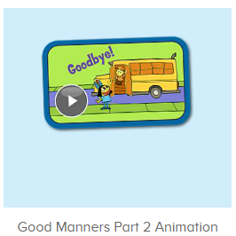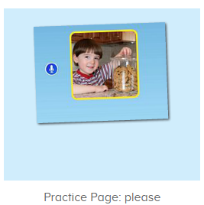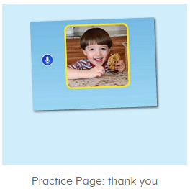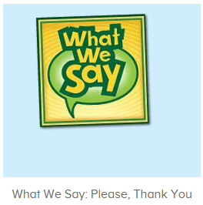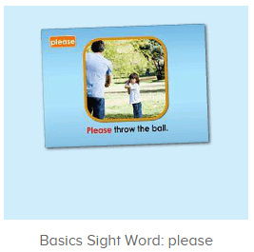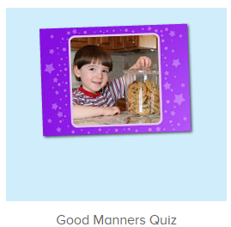
年龄段： 小班上
教学目标：
- 能从歌曲What we say中听出且跟唱关键词、句please,thank you，能流利跟唱“will you please,help me please.”
- 掌握口语动画中的关键词、句please,thank you.
- 能流利自如地说出please,thank you.，发音清晰准确。
- 能应用please,thank you.与同伴、老师及家人进行简单的对话。
- 掌握句子：Please throw the ball并能用句型please .......进行拓展造句。
教具准备：1.please,thank you图卡
使用游戏：
1.Matching game 2.Team match
教学步骤： | 备注
- 成果公布及展示：  T: Hello kids,good morning.  S:Good morning Yama.  T:First,let's praise Lily,Andy,Peter,Jimmy....They have finished all their activities.  Everybody look,what is this?This is....(带领全体幼生回顾前三个字母已学过的关于我的名称)  S:This is my pet park/my avatar/my room.  T:Is it right?Let’s listen and repeat.  S:Change my avatar/Go to pet park/Go to my room.  Coco come here,please show us your avatar.  C:Yes.  C:This is my avatar.My avatar is a girl.She has long hair.She is beautiful.  T:Wow,terrific!Thank you Coco.  Everybody together.  S:This is my avatar.My avatar is a girl.She has long hair.She is beautiful.（带领幼生整体描述一遍）  T:Well done! | 公布家庭活动成果并展示关于我（我的宠物/我的化身/我的房间）
- 集体学习活动：  快乐唱片机  T:Now Let’s sing.When you hear please/thank you,please clap your hands and sing it,ok?（提示幼生听到关键词或句就拍手加跟唱，可进行2-3轮)）  S:Ok.  T:Are you ready?  S:Yes, we are ready.  Please/thank you....  T:Good job!Now let’s listen and sing.(教师配合指令手势，引导幼生跟唱“will you please,help me please”，其余只听不跟唱,可跟唱关键词)  S:Will you.......  T:Once again.  S:Will you.......  T:Let’s have a match,Boys and girls,are you ready?  S:Yes,we are ready.  Bs/Gs:Will you please/help me please.  T:Follow me and do the actions.(教师带着幼生一起表演该句子动作)  T&S:Will you please,help me please.(可进行3-4遍)  口语动画小剧场  T:Nice job!Now watch the video.（点击播放图2口语动画，在please处点击暂停并提问幼生）  T:What can we say when we want something?  S:Please.  T:Right?Check again,listen and no voice.(拖动进度条重复播放该段视频)  Wow,so good.And what can we say when we get something?  Watch carefully and tell me.（继续播放动画视频，在thank you处点击暂停并询问幼生）  What can we say when we get something?  S:Thank you.  T:Right?Check again,listen and no voice.(拖动进度条重复播放该段视频)  So nice.Let’s watch again.  趣味复读机  T:Now listen and repeat..（打开图3素材，请幼生跟读）  S:Please....(跟读3-5遍，可加入小互动游戏)  T:So when we want something,what can we say?  S:Please.  T:Nice job!When we get something what can we say?  Please listen and tell me.(打开图4素材，请幼生跟读)  S:Thank you.(跟读3-5遍)  T:Very good!Now look,what is this?This is a....  S:This is a ball.(教师出示一个实物玩具，应用please和thank you进行情境应用，教师先做示范，再邀请幼生单独演练)  T:If you want the ball,what can you say?  S:Please?  T:Here you go.What can you say when you get the ball?  S:Thank you.  T:Good!Once again.  S:Please?  T:Here you go.  S:Thank you.  T:Nice job!Who can try?（邀请幼生上台演练）  S:Let me try.  T:Sam/Molly,please.  S/M:Please?  S/M:Thank you.  T:Nice job!Next team,who can try?  S:Let me try.  T:Very nice!Now listen and no voice.（打开图4素材，请幼生只听不跟读3-5遍）  What can you hear?  S:Please/ball....  T:Good!Follow it please.  S:Please throw the ball.(跟读3-5遍，可加入互动游戏，如大小声、how many times、分组等)  T:Follow me please.(教师带领幼生一起表演句子动作)  T&S:Please throw the ball.  T:It’s your turn.Repeat and do the actions.(教师点击素材发音，请幼生跟读且表演动作)  S:Please throw the ball.  T:Let’s play I do you say.Who can try?  S:Let me try.  T:Sam/Peter...please.(请幼生上前表演句子，其余幼生说句子)  Very good!Now let’s use please to make sentences.  For example,please stand up./Please sit down.  T:All together.(教师表演动作提示幼生说出句子)  T&S:Please turn left/right/jump.....  T:Who can try?  S:Let me try.  T:Kelly/Lucas...please.  K/L:Please jump/sit down/stand up....  T:Nice job!  音图对对碰  T:Now let’s listen and choose.（打开图5素材，请幼生听音选择正确图片）  Who can try?  S:Let me try.  T:Sam/Peter....please.  Right?  S:Yes.  T:What is this?  S:Please/thank you......  T:Well done!  快乐唱片机  T:Let’s sing again,stand up and do the actions.(打开图1歌曲素材，回顾复习。教师带着幼生一起表演该句子动作，其余只听不跟唱)  T&S:Will you please,help me please.(可进行3-4遍)  T:Very good!Now let's count our tickets.  Who can try?  S:Let me try.  T:Tommy please.  Now let's count with ABCmouse.  S&ABCmouse:One,two,three......  T:So we have ten tickets today,great job!Thank you Tommy. | 图1：  图2  图3  图4  图4  图5
- 家庭活动布置：  T:Wow!So nice!Now look at me and I'll show you the activities.（将已放入功课的作业界面打开）  T: You have to do one,two,three.... activities.  T:Now I will show you how to do it.Please listen and repeat.  Use the buttons,Step by step. (加上肢体动作演示）  OK?  S:OK!  T: Jason come here and show us how to do the activities.  Good job!Thank you Jason!  Please finish your activities and show me tomorrow,ok?  S:OK.  T:Class is over.Goodbye everyone.  S:Goodbye Yama. | 