大地ABCmouse小班上Letters Review A-C&Good Manners课时6
素材内容：
- What we say:Please,thank you.
- Good manners part 2 animation.
- Good manners Practice.
- Basic sight word:Please.
- Practice page:May I have the robot?
素材截图：
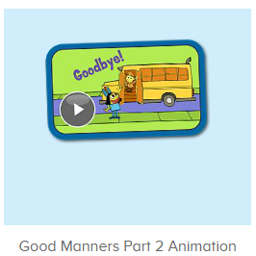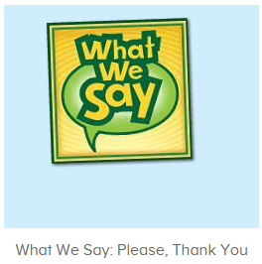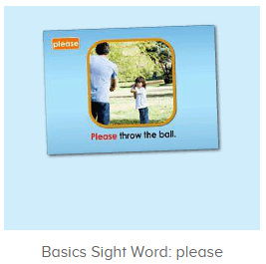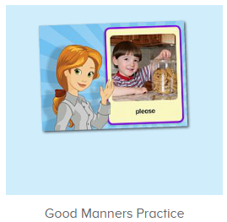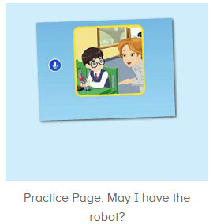
年龄段： 小班上
教学目标：
- 能从歌曲What we say中听出且跟唱关键词、句please,thank you，能流利跟唱“will you please,help me please.When we want something we say please”
- 掌握句子：Please throw the ball并能用句型please .......进行拓展造句。
- 掌握句子：May I have the robot?并能用句型may I have the .....进行拓展造句。
教具准备：1.图卡 2.其他已学过的物品或事物图卡/道具
使用游戏：
1.Matching game 2.Team match 3.TPR
教学步骤： | 备注
- 成果公布及展示：  T: Hello kids,good morning.  S:Good morning Yama.  T:First,let's praise Lily,Andy,Peter,Jimmy....They have finished all their activities.  Everybody look,what is this?This is....(带领全体幼生回顾前三个字母已学过的关于我的名称)  S:This is my pet park/my avatar/my room.  T:Is it right?Let’s listen and repeat.  S:Change my avatar/Go to pet park/Go to my room.  Coco come here,please show us your avatar.  C:Yes.  C:This is my avatar.My avatar is a girl.She has long hair.She is beautiful.  T:Wow,terrific!Thank you Coco.  Everybody together.  S:This is my avatar.My avatar is a girl.She has long hair.She is beautiful.（带领幼生整体描述一遍）  T:Well done! | 公布家庭活动成果并展示关于我（我的宠物/我的化身/我的房间）
- 集体学习活动：  快乐唱片机  T:Let’s sing,stand up and do the actions.(打开图1歌曲素材，回顾复习。教师带着幼生一起表演该句子动作，其余只听不跟唱)  T&S:Will you please,help me please.(可进行2-3遍)  T:Now listen and repeat.（教师配合出示指令手势，引导幼生听和跟唱第二段“When we want something we say please”）  S:Will you please,help me please./When we want something we say please..(进行3-4遍)  T:Now let’s have a match,boys and girls.are you ready?(轮流分组跟唱Will you please,help me please./When we want something we say please..)  S:Yes,we are ready.  Bs/Gs:Will you please,help me please./When we want something we say please..  T:Good job!Let’s do the actions.  T&S:Will you please,help me please./When we want something we say please..  趣味录音机  T:Now let’s be the little recorder.Are you ready?(打开图2素材，进行录音比对，先请整体幼生集体录，再请单个或以小组为单位录音)  S:Yes,we are ready.  T:Please listen and record.  S:Please/good morning...  T:Hear your voice.  Is it nice?  S:Yes.  T:Well done!Continue.  Your voice is so nice.  Now who can try?  S:Let me try.  T:Boys/girls/Peter/Molly/Lucas....please,are you ready?  S:Yes,we are ready.  趣味复读机  T:Very nice!The next one.Listen and repeat..（打开图3素材，请幼生跟读）  生一起表演句子动作)  S:Please throw the ball.  T:Now repeat and do the actions.(教师点击素材发音，请幼生跟读且表演动作)  S:Please throw the ball.  T:Let’s play I do you say.Who can try?  S:Let me try.  T:Sam/Peter...please.(请幼生上前表演句子，其余幼生说句子)  S:Please throw the ball.  T:Very good!Now let’s use please to make sentences.  For example,please stand up./Please sit down.  T:All together.(教师表演动作提示幼生说出句子)  T&S:Please turn left/right/jump.....  T:Who can try?  S:Let me try.  T:Kelly/Lucas...please.  K/L:Please jump/sit down/stand up....  T:Nice job!  口语动画小剧场  T:Now let’s enjoy the video and tell me when you want the robot,what can you say,ok?（打开图4口语动画视频，重点内容提示幼生留意，在关键信息出现后，教师可暂停，询问问题）  S:OK.  T:What can we say when you want the robot?（听完“May I have the robot”后，教师点击暂停，询问幼生问题）  S:.......  T:Listen again.  S:May I.......  趣味复读机  T:Right?Let’s listen and no voice.（打开图5素材，请幼生只听不跟读，输入遍数3-5遍）  T:Now follow it.(请幼生跟读，可加入互动游戏)  S:May I have the robot?(跟读3-5遍)  T:Very good.So when you want the robot,what can you say?  S:May I have the robot?  T:Nice job!Look,what is this?  S:Apple/ball/book......  T:Let’s make sentences.  For example,When I want the apple,I can say “may I have the apple”?  T:So when you want the ball/book......,what can you say?  S:May I have the ball/book.....?  T:Very good!Once again.  S:May I have the apple/ball/book.....?  T:Lily,come here.（教师把随意一张图卡或道具给该幼生，串联演示应用May I have....和thank you）  T:Lily,may I have the apple/ball/book.....?  Thank you,Lily.  Sit down please.  When you get something,what can you say?  S:Thank you.  T:Who can try?(请幼生上前演练，串联应用)  S:Let me try.  T:Lisa/Molly/Gina/Daniel....please.  L/M/G/D:May I have the apple/ball/book.....?  L/M/G/D:Thank you.  T:Well done!Next team.....  快乐唱片机  T:You all did a great job!Now let’s sing again,stand up and do the actions.(打开图1歌曲素材，回顾复习。教师带着幼生一起表演该句子动作，其余只听不跟唱)  S:Will you please,help me please./When we want something we say please..(进行3-4遍)  T:Very good!Now let's count our tickets.  Who can try?  S:Let me try.  T:Tommy please.  Now let's count with ABCmouse.  S&ABCmouse:One,two,three......  T:So we have ten tickets today,great job!Thank you Tommy. | 图1：  图2  图3  图4  图5
- 家庭活动布置：
T:Wow!So nice!Now look at me and I'll show you the activities.（将已放入功课的作业界面打开）
T: You have to do one,two,three.... activities.
T:Now I will show you how to do it.Please listen and repeat.
Use the buttons,Step by step. (加上肢体动作演示）
OK?
S:OK!
T: Jason come here and show us how to do the activities.
Good job!Thank you Jason!
Please finish your activities and show me tomorrow,ok?
S:OK.
T:Class is over.Goodbye everyone.
S:Goodbye Yama.

