大地ABCmouse小班上Letters Review A-C&Good Manners课时7
素材内容：
- What we say:Please,thank you.
- Good Manners Animation.
- Good morning,good night.
- Good morning,good night cutout puzzle.
- Practice page:May I have the robot?
素材截图：
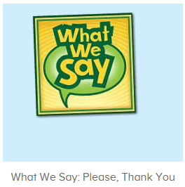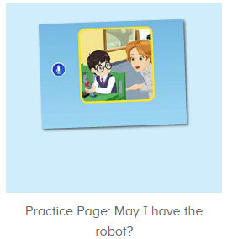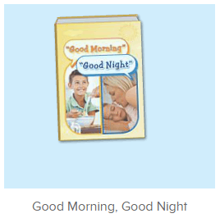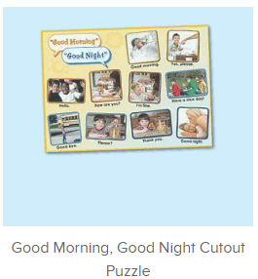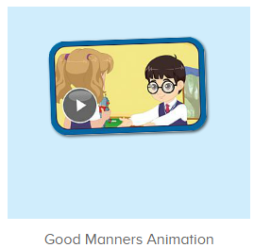
年龄段： 小班上
教学目标：
- 能从歌曲What we say中听出且跟唱关键词、句please,thank you，能流利跟唱第一、二句。
- 掌握口语动画中的关键词、句please,thank you，may I have the robot?
- 掌握句子：May I have the robot?并能用句型may I have the .....进行拓展造句。
- 能自如跟读图书句子，能给图书配音。
教具准备：1图书图卡 2.其他已学过的物品或事物图卡/道具
使用游戏：
1.Matching game 2.Team match 3.Little Recorder.
教学步骤： | 备注
- 成果公布及展示：  T: Hello kids,good morning.  S:Good morning Yama.  T:First,let's praise Lily,Andy,Peter,Jimmy....They have finished all their activities.  Everybody look,what is this?This is....(带领全体幼生回顾前三个字母已学过的关于我的名称)  S:This is my pet park/my avatar/my room.  T:Is it right?Let’s listen and repeat.  S:Change my avatar/Go to pet park/Go to my room.  Coco come here,please show us your avatar.  C:Yes.  C:This is my avatar.My avatar is a girl.She has long hair.She is beautiful.  T:Wow,terrific!Thank you Coco.  Everybody together.  S:This is my avatar.My avatar is a girl.She has long hair.She is beautiful.（带领幼生整体描述一遍）  T:Well done! | 公布家庭活动成果并展示关于我（我的宠物/我的化身/我的房间）
- 集体学习活动：  快乐唱片机  T:Now let’s sings song,stand up and do the actions.(打开图1歌曲素材，回顾复习。教师带着幼生一起表演该句子动作，其余只听不跟唱)  S:Will you please,help me please./When we want something we say please..(进行2-3遍)  T:Now let’s sing these two sentences.(请幼生重复跟唱第一、二句)  Listen and repeat.  S:When we want something we say please, “will you please,help me please”.When we want something we say please to all our friends and family.（跟唱3-5遍，可加入互动游戏，如分组、接龙等）  T:Very good!Now stand up and do the actions.  T&S:When we want something we say please, “will you please,help me please”.When we want something we say please to all our friends and family.(重复2-3遍，边唱边跳)  T:Good job!Boys come here,girls please follow boys.（播放音乐，分组上前带领展示）  Bs/Gs:When we want something we say please, “will you please,help me please”.When we want something we say please to all our friends and family.  趣味复读机  T:Wonderful!Now let’s practice,listen and repeat.(打开图2素材请幼生跟读，可加入互动游戏)  S:May I have the robot?(跟读3-5遍)  T:Very good.So when you want the robot,what can you say?  S:May I have the robot?  T:Nice job!Look,what is this?  S:Apple/ball/book......  T:Let’s use “May I have the....” to make sentences.  S:May I have the apple/ball/book.....?  T:Great job!When you get something,what can you say?  S:Thank you.  T:Who can try?(请幼生上前演练，串联应用)  S:Let me try.  T:Lisa/Molly/Gina/Daniel....please.  L/M/G/D:May I have the apple/ball/book.....?  L/M/G/D:Thank you.  T:Well done!Next team.....  You all did a great job!  Now let’s read a book.(打开图3图书素材，请幼生只听不跟读)  First,listen and no voice.  What is the name of this book?（播放完图书名字后点击暂停，询问幼生图书名称）  S:Good morning,good night.  T:Right?Let’s check.  Listen and repeat.(点击再读此页功能，请幼生跟读)  S:Good morning,good night.（跟读2遍）  T:So the book’s name is ....?  S:Good morning,good night.  T:Good job!Let’s continue,listen and no voice.(继续播放图书，请幼生只听不跟读)  What can you hear?  S:Good morning/good night/please/thank you/goodbye....  T:Right?Let’s check.(检验内容是否正确，如正确请给予及时的鼓励)  Wow,so good!  Now let’s read the book.  S:Good morning.........(跟读2遍)  T:Now Look at these pictures,let’s listen and match.(教师把图书图卡打乱顺序粘贴在白板上，可给图卡编号，请幼生根据发音找到对应图卡，并进行核对及跟读)  Are you ready?  S:Yes,we are ready.  T:Listen and no voice.  What can you hear?  S:Good morning/night/please......  T:Which picture is right?Number......?  S:1/2/3......  T:Terrific!Now follow it.  S:Good morning/night/please......  T:Good job!Now look at the pictures,what is this?  S:Good morning/night/please......  图片拼拼拼乐  T:You are so great!It’s puzzle time!（打开图4拼图素材，请幼生跟读发音）  Please listen and repeat.  S:Good morning/night/please......  T:Who can try?（请幼生轮流上前操作，其余幼生跟读发音）  S:Let me try.  T:Lily/Sam/Paul/Lucas.....please.  Everybody listen and repeat.  S:Good morning/night/please......  口语动画小剧场  T:Nice job!Now watch the video.（点击播放图5口语动画，可分段暂停，并询问幼生问题，询问关键词、句）  T:What can we say when we want something?  S:Please.  T:What can we say when we get something?  S:Thank you.  T:If you want the robot what can you say?  S:May I have the robot?  T:When you see someone in the morning,what can you say?  S:Good morning.  T:When you go home,what can you say?  S:Goodbye.  T:When you go to bed,what can you say?  S:Good night.  快乐唱片机  T:Let’s sing again,stand up and do the actions.(打开图1歌曲素材，回顾复习。教师带着幼生一起表演该句子动作，其余只听不跟唱)  T&S:When we want something we say please, “will you please,help me please”.When we want something we say please to all our friends and family.(重复2-3遍，边唱边跳)  T:Very good!Now let's count our tickets.  Who can try?  S:Let me try.  T:Tommy please.  Now let's count with ABCmouse.  S&ABCmouse:One,two,three......  T:So we have ten tickets today,great job!Thank you Tommy. | 图1：  图2  图3  图4  图5
- 家庭活动布置：
T:Wow!So nice!Now look at me and I'll show you the activities.（将已放入功课的作业界面打开）
T: You have to do one,two,three.... activities.
T:Now I will show you how to do it.Please listen and repeat.
Use the buttons,Step by step. (加上肢体动作演示）
OK?
S:OK!
T: Jason come here and show us how to do the activities.
Good job!Thank you Jason!
Please finish your activities and show me tomorrow,ok?
S:OK.
T:Class is over.Goodbye everyone.
S:Goodbye Yama.

