大地ABCmouse小班上Letters Review A-C&Good Manners课时8
素材内容：
- What we say:Please,thank you.
- Good Manners Animation.
- Good morning,good night.
- Good morning,good night cutout puzzle.
- Good morning,good night matching cards.
素材截图：
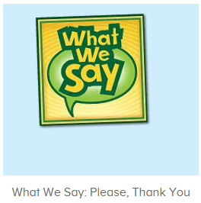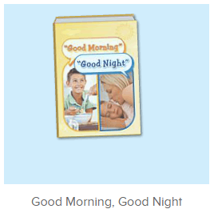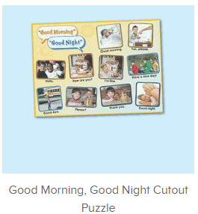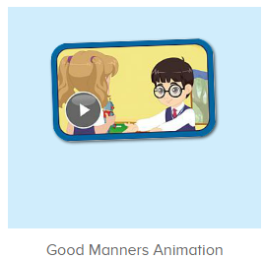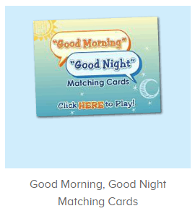
年龄段： 小班上
教学目标：
- 能从歌曲What we say中听出且跟唱关键词、句please,thank you，能流利跟唱第一、二、四句。
- 掌握口语动画中的关键词、句please,thank you，may I have the robot?
- 能自如跟读图书句子，能给图书配音，能用图书句子进行串联应用。
教具准备：1图书图卡 2.其他已学过的物品或事物图卡/道具
使用游戏：
1.Matching game 2.Team match 3.Little Recorder. 4.Role play
教学步骤： | 备注
- 成果公布及展示：  T: Hello kids,good morning.  S:Good morning Yama.  T:First,let's praise Lily,Andy,Peter,Jimmy....They have finished all their activities.  Everybody look,what is this?This is....(带领全体幼生回顾前三个字母已学过的关于我的名称)  S:This is my pet park/my avatar/my room.  T:Is it right?Let's listen and repeat.  S:Change my avatar/Go to pet park/Go to my room.  Coco come here,please show us your avatar.  C:Yes.  C:This is my avatar.My avatar is a girl.She has long hair.She is beautiful.  T:Wow,terrific!Thank you Coco.  Everybody together.  S:This is my avatar.My avatar is a girl.She has long hair.She is beautiful.（带领幼生整体描述一遍）  T:Well done! | 公布家庭活动成果并展示关于我（我的宠物/我的化身/我的房间）
- 集体学习活动：  快乐唱片机  T:Now let's sings song,stand up and do the actions.(打开图1歌曲素材，回顾复习。教师带着幼生一起表演该句子动作，其余只听不跟唱)  S:When we want something we say please, "will you please,help me please".When we want something we say please to all our friends and family.(重复2-3遍，边唱边跳)  T:Good job!Now let's follow the last sentence.(请幼生跟唱第1.2.4.句，第3句只听不跟唱)  S:When we want something we say please, "will you please,help me please".When we want something we say please to all our friends and family.....We should say thank you everyday to all our friends and family.(跟唱3-4遍，可加入互动游戏进行输入)  T:Good job!Let's add some actions,stand up please.(加上动作进行操练)  T&S:When we want something we say please, "will you please,help me please".When we want something we say please to all our friends and family.....We should say thank you everyday to all our friends and family.  T:Do you want to have a match with me?  S:Yes.  T:I sing first and you the next,ok?  S:OK.  T:Ready?  S:Yes,we are ready.  T/S:When we want something we say please. "Will you please,help me please".When we want something we say please to all our friends and family.....We should say thank you everyday to all our friends and family.  趣味复读机  T:Well done! Now let's read a book.(打开图2图书素材，请幼生跟读)  First,what is the name of this book?（播放图书前先询问幼生图书名字）  S:Good morning,good night.  T:Good job!Now let's read the book.  S:Good morning.........(跟读2遍)  T:Now I will turn off the sound,you will be the little recorders,are you ready?(把网站声音关掉，请幼生为图书配音，若遇到不熟练的可打开声音，让幼生跟读)  S:Yes,we are ready.  Good morning........  T:Good job!  Now let's make a conversation.（应用图书句子作对话，教师可加肢体语言作引导，也可请求班老师协助作对话演示）  Good morning,children.  S:Good morning,teacher.  T:Good!How are you?  S:I'm fine,thank you.  T:Have a nice day.  Very good!Once again.(可重复演练2-3遍)  Now who can try?(请幼生分组上前演练)  S:Let me try.  T:Sam/Lily/Paul/Lisa....please.  Very good!  图片拼拼拼乐  T:It's puzzle time!（打开图3拼图素材，先请幼生观察图片并说出内容，再进行核对跟读）  Look here,what is this?  S:Good morning/night/please......  T:Right?Let's check.  Lily/Paul/Kelly....come here and finish the puzzle.  Everybody listen and repeat.  S:Good morning/night/please......  T:Very nice!  Who can try?（请幼生轮流上前操作，其余幼生跟读发音）  S:Let me try  T:Lily/Sam/Paul/Lucas.....please.  Everybody listen and repeat.  S:Good morning/night/please......  记忆对对碰  T:Very good!Now let's play a game.（打开图4素材，请幼生根据发音选择正确的图片）  Please listen and choose.  Follow it.  S:How are you/Have a nice day......  T:Lily/Sam/Lucas....please.  Very good!Thank you.  口语动画小剧场  T:Nice job!Now watch the video.（点击播放图5口语动画，可分段暂停，并询问幼生问题，询问关键词、句）  T:What can we say when we want something?  S:Please.  T:What can we say when we get something?  S:Thank you.  T:If you want the robot what can you say?  S:May I have the robot?  T:When you see someone in the morning,what can you say?  S:Good morning.  T:When you go home,what can you say?  S:Goodbye.  T:When you go to bed,what can you say?  S:Good night.  快乐唱片机  T:Let's sing again,stand up and do the actions.(打开图1歌曲素材，回顾复习。教师带着幼生一起表演该句子动作，其余只听不跟唱)  T&S:When we want something we say please, "will you please,help me please".When we want something we say please to all our friends and family.....We should say thank you everyday to all our friends and family.  (重复2-3遍，边唱边跳)  T:Very good!Now let's count our tickets.  Who can try?  S:Let me try.  T:Tommy please.  Now let's count with ABCmouse.  S&ABCmouse:One,two,three......  T:So we have ten tickets today,great job!Thank you Tommy. | 图1：  图2  图3  图4  图5
- 家庭活动布置：
T:Wow!So nice!Now look at me and I'll show you the activities.（将已放入功课的作业界面打开）
T: You have to do one,two,three.... activities.
T:Now I will show you how to do it.Please listen and repeat.
Use the buttons,Step by step. (加上肢体动作演示）
OK?
S:OK!
T: Jason come here and show us how to do the activities.
Good job!Thank you Jason!
Please finish your activities and show me tomorrow,ok?
S:OK.
T:Class is over.Goodbye everyone.
S:Goodbye Yama.

