大地ABCmouse小班上Letters Review A-C&Good Manners课时9
素材内容：
- What we say:Please,thank you.
- Good Manners Animation.
- Practice page:Please.
- Practice page:Thank you.
- Practice page:Please throw the ball.
- Practice page:May I have the robot?
- Good morning,good night matching cards.
素材截图：
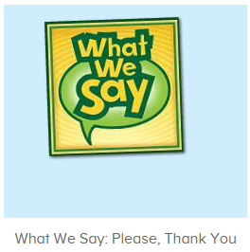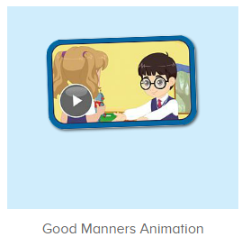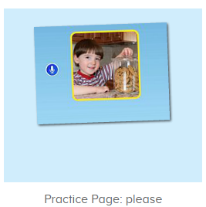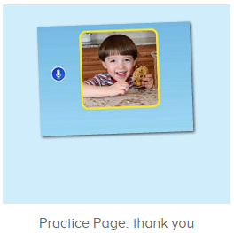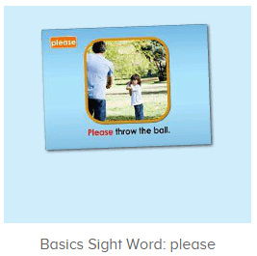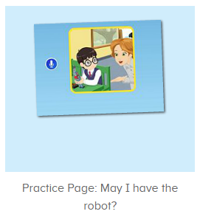
年龄段： 小班上
教学目标：
- 能从歌曲What we say中听出且跟唱关键词、句please,thank you，能流利跟整首歌曲。
- 掌握口语动画中的关键词、句please,thank you，may I have the robot?
- 能自如应用所学句子做串联应用。
教具准备：1图书图卡 2.其他已学过的物品或事物图卡/道具
使用游戏：
1.Matching game 2.Team match 3.Little Recorder. 4.Role play
教学步骤： | 备注
- 成果公布及展示：  T: Hello kids,good morning.  S:Good morning Yama.  T:First,let's praise Lily,Andy,Peter,Jimmy....They have finished all their activities.  Everybody look,what is this?This is....(带领全体幼生回顾前三个字母已学过的关于我的名称)  S:This is my pet park/my avatar/my room.  T:Is it right?Let's listen and repeat.  S:Change my avatar/Go to pet park/Go to my room.  Coco come here,please show us your avatar.  C:Yes.  C:This is my avatar.My avatar is a girl.She has long hair.She is beautiful.  T:Wow,terrific!Thank you Coco.  Everybody together.  S:This is my avatar.My avatar is a girl.She has long hair.She is beautiful.（带领幼生整体描述一遍）  T:Well done! | 公布家庭活动成果并展示关于我（我的宠物/我的化身/我的房间）
- 集体学习活动：  快乐唱片机  T:Let's sing,stand up and do the actions.(打开图1歌曲素材，回顾复习。教师带着幼生一起表演该句子动作，其余只听不跟唱)  T&S:When we want something we say please, "will you please,help me please".When we want something we say please to all our friends and family.....We should say thank you everyday to all our friends and family.  (重复2-3遍，边唱边跳)  T:Now let’s sing this sentence.（引导幼生只跟唱第三句，其余只听不跟唱）  S:We should say thank you for your help,for a gift,for everything.(跟唱3-4遍，可加入互动游戏，如接龙等。)  T:Let’s add some actions.  T&S:We should say thank you for your help,for a gift,for everything.  T:Wonderful!Let’s sing the whole song,all together.  T&S:When we want something we say please, "will you please,help me please".When we want something we say please to all our friends and family.We should say thank you for your help,for a gift,for everything.We should say thank you everyday to all our friends and family.  T:Once again.  口语动画小剧场  T:Nice job!Now watch the video.（点击播放图2口语动画，可分段暂停，并询问幼生问题，询问关键词、句）  T:What can we say when we want something?  S:Please.  T:What can we say when we get something?  S:Thank you.  T:If you want the robot what can you say?  S:May I have the robot?  T:When you see someone in the morning,what can you say?  S:Good morning.  T:When you go home,what can you say?  S:Goodbye.  T:When you go to bed,what can you say?  S:Good night.  趣味复读机  T:Well done! Now let's listen and repeat..(打开图3-图6素材，请幼生跟读)  S:Please/thank you/please throw the ball/may I have the robot?  T:Very good!Look at the pictures,what is this?  S:Balloon/apple/book/box....  T:Let’s make sentences.  Please throw....  S:Please throw the box/balloon....  T:Good!May I have....  S:May I have the apple/ball/balloon/box.....?  T:Great!Let’s make a conversation.（串联句子成对话进行演练）  For example,when I say “May I have the ball?”  You should say “Yes,please.”  Let’s have a try.  T:May I have the ball?  S:Yes,please.  T:Thank you.  Very good!  Once again.  May I have the apple/balloon/box...?  S:Yes,please.  T:Thank you.  Good job!  Who can try?  S:Let me try.  T:Lily/Lucas/Kelly...please.(请幼生上台演练对话)  记忆对对碰  T:Very good!Now let's play a game.（打开图7素材，请幼生根据发音选择正确的图片）  Please listen and choose.  Follow it.  S:How are you/Have a nice day......  T:Lily/Sam/Lucas....please.（请幼生上前操作，选择正确图片进行配对）  Very good!Thank you.  快乐唱片机  T:Let's sing again,stand up and do the actions.(打开图1歌曲素材，回顾复习。教师带着幼生一起表演该句子动作，其余只听不跟唱)  T&S:When we want something we say please, "will you please,help me please".When we want something we say please to all our friends and family.We should say thank you for your help,for a gift,for everything.We should say thank you everyday to all our friends and family.  (重复2-3遍，边唱边跳)  T:Very good!Now let's count our tickets.  Who can try?  S:Let me try.  T:Tommy please.  Now let's count with ABCmouse.  S&ABCmouse:One,two,three......  T:So we have ten tickets today,great job!Thank you Tommy. | 图1：  图2  图3  图4  图5  图6  图7
- 家庭活动布置：
T:Wow!So nice!Now look at me and I'll show you the activities.（将已放入功课的作业界面打开）
T: You have to do one,two,three.... activities.
T:Now I will show you how to do it.Please listen and repeat.
Use the buttons,Step by step. (加上肢体动作演示）
OK?
S:OK!
T: Jason come here and show us how to do the activities.
Good job!Thank you Jason!
Please finish your activities and show me tomorrow,ok?
S:OK.
T:Class is over.Goodbye everyone.
S:Goodbye Yama.

