ABCmouse小班上字母F课时10
复习内容：
- Simple letter story:F.
- The sound of letter F song.
- The letter F chant.
- Letter F cutout puzzle.
- The letter F book.
- About me复习
素材截图：
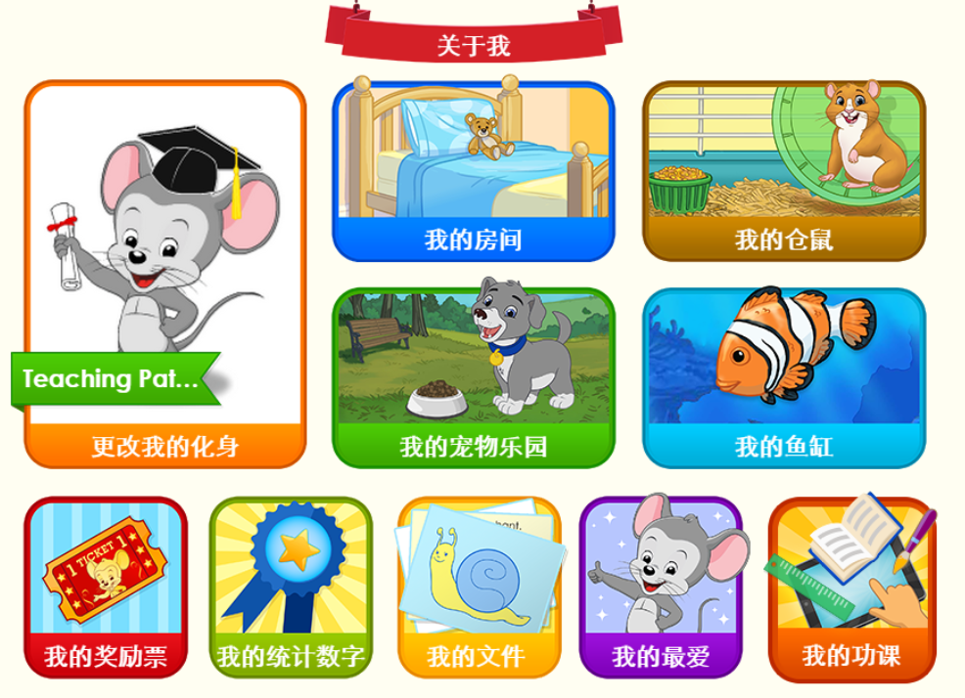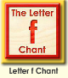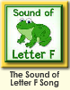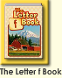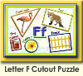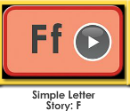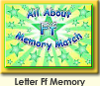
年龄段： 小班上
教学目标：
- 复习字母故事，能完整地看图说故事并表演整个字母故事。
- 复习字母歌曲和诗歌并能表演对应律动。
- 复习单词图书，并用F is for.....,I wash my...This is a ....,A... is......固定句型造句。
教具准备：1.字母故事卡片 2.字母故事相关头饰和图片 3.图书卡片
使用游戏：
1.Team match 2.Role play.3.TPR
教学步骤： | 备注
一、成果公布及展示  T: Hello kids,good morning.  S:Good morning Yama.  T:Before class,let's praise for Jimmy,Lily...They have finished all their activities.  T:Coco come here please,can you show us your tickets?  C:Yes.  T:Is this your tickets?  C:Yes.This is my tickets.  T:Everybody look,how many tickets does Coco have?Coco has....  S:Coco has 100 tickets.  T:So Coco,how many tickets do you have?I have....  C:I have 100 tickets.  T:Wonderful!What do you want to buy with your tickets?I want to buy...  C:I want to buy a pet.  T:Everybody,what does Coco want to buy?Coco wants to buy...  S:Coco wants to buy a pet.  T:Do you wan to be the tickets winner?  S:Yes.I want to be the tickets winner.  T:Very good.Coco,can you introduce your tickets again?This is my......  C:This is my tickets,I have 100 tickets,I want to buy a pet.I want to be the tickets winner..  T:So good!Thank you Coco,sit down please. | 公布家庭活动成果并展示我的奖励票
二、集体学习活动：  谁是大歌星  T:Good job!Now let's sing e song/letter e chant..(复习图1-图2字母f歌曲和单词诗歌，先跟唱再再轮流邀请几名幼生上前当小老师，带领幼生清唱并表演对应律动)  S:I know the sound of letter f/"f""f"letter f/letter f says "f".....  T:Very good!Now who can sing?  S:Let me try.  T:Lily/Paul/Jimmy/Lucy come here,you will be the little teacher.  Everybody stand up please.  Let's sing and dance.Ready?  S:Yes,go go go!  S:I know the sound of letter f/"f""f"letter f/letter f says "f".....  配音达人  T:Pretty good!Now let's read letter e book.（教师点击播放图3单词图书，请幼生跟读）  S:The letter f book.....  T:So good,now I will turn off the sound,let's be the little recorder.(请幼生一个接一个给图书配音，检验幼生掌握程度，遇到不会读的及时打开声音让其跟读)  Lily you will be the first then say it one by one.Are you ready?  S:Yes,we are ready.  L:The letter f book.  P:F,f,f,frog.....  换乐无穷  T:Now let's play I do you say.Look at my actions,what is the sentence?(教师出示图书卡片，利用单词图书词汇进行F is for.....,I wash my...This is a ....,A... is.....固定句型造句，不能用动作表示的，教师可用问题提示幼生）  S:F is for farm/This is a frog./A flower is red......  图块拼拼乐  T:Terrific!Puzzle time!Who can try?  S:Let me try.  T:Susan/Tom/Coco/Molly come here please.Everybody listen and repeat.(教师打开图4图块拼图，轮流请幼生上前操作一块，引导其他幼生跟读发音)  S:Fox/f.......  T:Terrific,thank you Susan/Tom/Coco/Molly.  看图说故事  T:Wonderful!Now let's repeat the story.(教师点击播放字母故事，请幼生跟读整个故事)  S:This is Fabio.Fabio is a chef.Fabio makes food.Freddy eats french fries.Fifi eats fish.Fletcher eats fried rice.Farah eats fruit.What do you like to eat?(跟读2-3次)  T:Let's look and say.(教师出示字母故事图片，请幼生看图说故事)  S:This is Fabio.Fabio is a chef.Fabio makes food.Freddy eats french fries.Fifi eats fish.Fletcher eats fried rice.Farah eats fruit.What do you like to eat?  T:Very good!Let's perform the story,are you ready?（加上动作，边说句子边做动作进行表演）  S:Yes,we are ready.  S:This is Fabio.Fabio is a chef.Fabio makes food.Freddy eats french fries.Fifi eats fish.Fletcher eats fried rice.Farah eats fruit.What do you like to eat?  小小表演家  T:Terrific!Let’s role play,who can try?(轮流邀请若干幼生上前充当故事角色，其他幼生说句子，表演整个字母故事)  S:Let me try.  记忆对对碰  T:Wonderful!Now let's play a memory match game.Who can try?(教师点击图6进入memory match游戏，一共可玩三轮，教师可邀请几位幼生上前操作，其他幼生跟读发音)  S:Let me try.  T:Tom/Lily/Monica/Louis/Jim please.Everybody listen and repeat.  S:Ferret/figs....  T:Good job!  ABCmouse游园会  T:You all did a good job today,let's go to "About me" to have some fun.  Everybody look,what is this?（引导整体幼生回顾已介绍过的关于我的板块）  S:This is my aquarium,my hamster,my tickets.  T:Good job!who can show us your tickets?（邀请单个幼生作独立展示）  S:Let me try.  T:Jimmy please.  T:Is this your tickets?  J:Yes.This is my tickets.  T:Everybody look,how many tickets does Jimmy have?Jimmy has....  S:Jimmy has 100 tickets.  T:So Jimmy,how many tickets do you have?I have....  J:I have 100 tickets.  T:Wonderful!What do you want to buy with your tickets?I want to buy...  J:I want to buy a pet.  T:Everybody,what does Jimmy want to buy?Jimmy wants to buy...  S:Jimmy wants to buy a pet.  T:Do you wan to be the tickets winner?  S:Yes.I want to be the tickets winner.  T:Very good.Jimmy,can you introduce your tickets again?This is my......  J:This is my tickets,I have 100 tickets,I want to buy a pet.I want to be the tickets winner.  T:Wow,terrific!Thank you Jimmy.  Everybody together.  S:This is my tickets,I have 100 tickets,I want to buy a pet.I want to be the tickets winner.（整体描述一遍）  T:Well done! | 图1  图2  图3  应用单词图书词汇活用F is for.....,I wash my...This is a ....,A... is.....固定句型造句。  图4  图5  图6  图7
三、家庭活动布置：
T:Now I'll show you the activities.（将已放入功课的作业界面打开）
T: Look,how many activities do you need to do?
S:.......
T:Very well.Now I will show you how to do it.Please listen carefully.
Jason come here and show us how to do the activities.
Good job!Thank you Jason!
Please finish the activities and show me tomorrow,ok?
S:OK!
T:Class is over, goodbye everyone.
S:Goodbye Yama.

