Letter I -课时2
复习素材内容：  - Basics letters: Ii is for itch.  - Basics letters: Ii is for igloo.  - Basics letters: Ii is for iguana.  - Basics letters: Ii is for impala. | 新授素材内容：  - The letter i Chant.  - Sentence Puzzle: Letter i, iguana.  - Alphabet Sentence Chant: i, iguana.
素材截图：
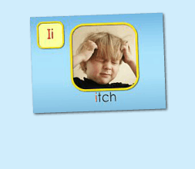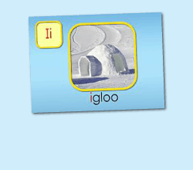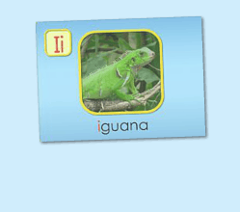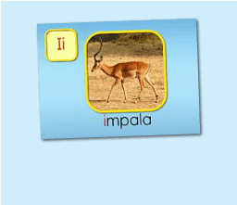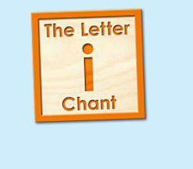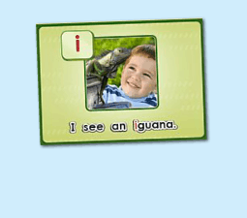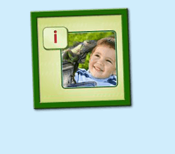
年龄段：小班下
教学目标：
- 能准确流利说出字母I的发音，能理解并认读词汇 itch, igloo, iguana, impala，会表演对应的TPR。
- 能自如演唱The Letter i chant和Alphabet sentence: i, iguana, 并表演相应诗歌律动。
- 能流利说出 I see an iguana.
教具准备：
1. 字母I开头的单词卡片 2. 字母I的图卡 3. 其他已学过的动物卡片
使用游戏：
1. I do you say game 2. Missing game
教学步骤： |  | 备注
- 成果公布及展示  T: Hello kids, Good morning./ good afternoon.  S: Hello ...  T: First, let's praise Lily, Andy..., they have finished their activities.  Lily, come here please, please show us your activities.  Lily: OK. (请完成家庭活动的幼生上前自从操作网站，向其余幼生展示家庭活动成果)  T: Lily, please show us your pet/ room/ avatar/ aquarium/ hamster/ tickets.  T: Wonderful!  T: Everybody comes on! Tomorrow please show us your pet/ room/ avatar/ aquarium/ hamster/ tickets, OK?  S: OK!  (关于我-我的化身)  T: Now, who can show us your avatar?（请一位幼生上前来展示化身，掌握基本介绍句型）  S: Let me try. （请幼生自主打开我的宠物）  T: Linda, please come here, tell me about your avatar.  Linda: I have a avatar... （如果幼生有卡壳，教师可进行提问引导）  T: Is it a boy or a girl?  Linda: girl.  T: So she is a ...  Linda: She is a girl.  T: Kids, is it a boy or a girl? （询问其余幼生）  She is ... (引导幼生说出完整句型)  S: She is a girl...  T: Good job! Is she beautiful? Linda?  Linda: Yes, she is beautiful.  T: Is she beautiful? Kids.  S: Yes, she is beautiful.  T: Good job! Linda, can you introduce your avatar again?  Linda: I have a avatar, she is a girl. She is beautiful.  T: Good job! Thank you Linda, go back to your seat please! |  | 公布家庭活动成果并展示我的化身
二、集体学习活动  温故知新---趣味复读机  T: Now, let's begin our class! First, please listen and repeat. （教师点击进入素材（图1-4），请幼生快速跟读网站平台发音，复习字母I的发音及4个基础词汇）  S: I, "i", itch, igloo, iguana, impala...  温故知新---谁是大模王  T: Very good! Now, look at me and guess what is it, OK?  S: OK!  T: What is it? It is ...（引导幼生用完整句型回答）  S: It is letter I/ "i"/ itch/ igloo/ iguana/ impala.  T: Who wants to try?  S: Let me try.  T: Tina/ Bobby come here, you do the actions and ask what is it, OK? （邀请2-3名幼生做TPR，询问其余幼生）  Tina/ Bobby: OK! What is it?  S: It is letter I/ "i"/ itch/ iguana/ impala/ igloo.  T: Good job! Thank you. Go back to your seat, please！  快乐唱片机  T: Good job! Now, let's listen a chant and tell me what can you hear, OK?  （教师点击（图5）诗歌素材，让幼生带任务仔细聆听，教师同时与幼生互动，或者做TPR提示）  S: OK!  T: What can you hear？  S: Letter i says "i"... / itch/ iguana...  T: Good job! Let's check it, listen snd no voice. （教师再播放一遍诗歌）  Is it right?  S: Yes.  T: OK, this time, we listen again and find something new, OK?  S: OK!  T: What can you hear (this time)?  S: ...  T: Let's check it again.（教师配合TPR动作，加快幼生理解诗歌）  T: Now, listen and repeat.（教师配合手势和动作引导幼生，教师唱的那遍听，学生唱的那边跟唱，跟唱2-3遍）  S: Letter i says "i"/ "i" "i" "i"/ iguana, itch, igloo/ "i" letter i.  T: Now, let's add some action to the chang. Follow me please. （教师带领幼生边听边做动作，第一遍先不听）  T: One more time. （第二第三遍边唱边做）  T: Good job!  快乐唱片机  T: Now, let's listen next chant and tell me what can you hear, OK? （教师点击（图6）诗歌素材，让幼生带着任务仔细聆听；教师可同时与幼生互动，或者做TPR提示）  S: OK!  T: What can you hear?  S: Letter i says "i"/ "i" "i" iguana/ I see an iguana/ "i" letter i..  T: Good job! Let's check it, listen and no voice.（教师再播放一遍诗歌）  Is it right?  S: Yes.  T: OK, this time, we listen again and find something new, OK?  S: OK!  T: What can hear (this time)?  S: ...  T: Can you hear "I see an iguana"?  S: Yes.  T: Let's check it again. （教师配合TPR动作，加快幼生理解诗歌）  T: Now, listen and repeat. （教师配合手势和动作引导幼生，教师唱的那遍听，学生唱的那遍歌词，跟唱2-3遍）  S: Letter i says "i"/ "i" "i" iguana/ I see an iguana/ "i" letter i  T: Now, let's add some action to the chant. Follow me please. （教师带领幼生边听边做动作，第一遍可先不听）  T: One more time.（第二遍第三遍边唱边做）  T: Good job!  Song Relay Game  T: Let's play a "Song Relay" game. （可以中午解释游戏规则：将幼生分为两组，每组8人，设定起点和终点，每组4人在起点，4人在终点。 老师播放一句歌词，并发号 "Ready, Go!", 每次一位幼儿从起点跑到终点处，与终点处的小伙伴击掌，并传送一句歌词。 一次类推，看哪一组传送的准确无误，且速度快。）  T: Ready, Go!  T: Good job. Team A/B win!  句子拼拼乐  T: Puzzle time!  T: Now, listen and no voice. And then tell me what can you hear, OK?（教师点击（图7）句子拼图素材，选择难度级别1，完成句子拼图，请幼生仔细聆听）  S: OK!  T: Tell me what can you hear.  S: iguana..  T: Good job! Let's check it.  Is it right?  S: Yes!  T: Good! Follow it. （教师点击小喇叭，请幼生跟读2-3遍）  S: I see an iguana.  T: Let's have a match, team A and team B, are you ready?  S: Yes!  TA: I/ see/ an / iguana.  TB: I/ see/ an/ iguana.  T: Good. TB get one point.  （What is missing game: 空出iguana；提问幼生不见的单词应该放哪里）  T: Now, look (at the puzzle), what is missing?  S: iguana...  T: Where can I put it? Here?  S: Yes!  T: Good! Who wants to try? Mandy, please. （选择难度级别2/3级，请幼生上台操作拼图，其余幼生跟读）  T: Good job! Thank you, Mandy.  T: Look (at the puzzle), what do you see?  I see ...  S: I see an iguana.  T: Good job!  (出示已学过的动物单词卡片，替换iguana造句)  T: Look, we have some old friends. Who are they?  S: ant/ elephant... （注意使用 "an", 把动物卡片放在iguana位置上）  T: What do you see?  I see an...  S: I see an ant/ elephant...  趣味大扫描---谁是大歌星  T: Now, let's sing the chant one by one. Are you ready?（复习环节，让幼生轮流，每人清唱一句，最后分小组轮流唱一句）  S: Letter i says "i"/ "i" "i" "i"/ iguana, itch, igloo/ "i" letter i.  T: Now, the next chant.  S: Letter i says "i"/ "i" "i" iguana/ i see an iguana/ "i" letter i.  T: Good job!  T: Very good! Now let's count our tickets.  Who can try?  S: Let me try.  T: Tommy please.  Where can we find our tickets?  S: "About me"  T: Mike click it please.  Now let's count with ABCmouse.  S&ABCmouse: One, Two, three...  T: So we have ten tickets today, great job! Thank you Mike. |  | 图1：  图2：  图3：  图4：  图5：  图6：  图7：
三、家庭游戏活动布置：  T: Now, I'll show you the activities. (将已放入功课的作业界面打开)  Here are your activities for today.  You have to do these activities.  How many activities? Let's count together.  S: One, two, three, four.  T: You have to do these activities, OK?  S: OK!  T: Each of them, you need to play 5 times. OK?  S: OK!  T: Look at me, I will show you.  Please listen and repeat. (加上肢体动作演示)  OK？  S: OK！  T: Clear?  S: Yes!  T: Who can show us how to do it?  S: Let me try!  T: Mary come here and show us how to do the activities. (每一位幼生上前演示如何操作)  T: Good job! Thank you Mary!  T: Who can retell how to do it?  S: Let me try!（教师可引导幼生）  T: Good! Please finish your activities and show me tomorrow, OK?  S: OK  T: Class is over, Goodbye, everyone.  S: Goodbye. |  | 家庭游戏活动：

