Letter I -课时3
复习素材内容：  - The letter i chant  - Alphabet Sentence Chant: i, iguana  - Sentence Puzzle: Letter i, iguana | 新授素材内容：  - Alphabet Sentence Chant: i, itch  - Alphabet Sentence Chant: i, igloo  - Sentence Puzzle: Letter i, itch  - Sentence Puzzle: Letter i, igloo  - Letter Ii Koi Maze
复素材截图：
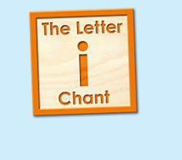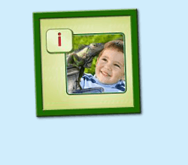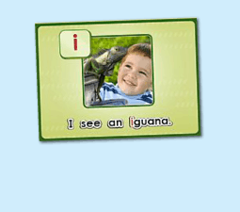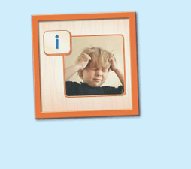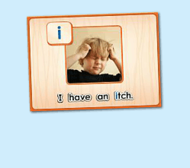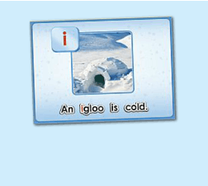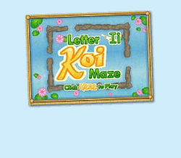
年龄段：小班下
教学目标：
- 能准确流利说出字母I的发音，能理解并认读词汇 itch, igloo, iguana, 会表演对应的TPR。
- 能自如演唱所学的chant，并表演相应诗歌律动。
- 能流利说出 I see an iguana./ I have an itch./ An igloo is cold. 这3个句型
教具准备：
1. 字母I开头的单词卡片 2. 字母I的图卡 3. 其他已学过的动物卡片
使用游戏：
1. Run the Dice 2. What is Missing Game 3. 歌词接龙
教学步骤： |  | 备注
- 成果公布及展示  T: Hello kids, Good morning./ good afternoon.  S: Hello ...  T: First, let's praise Lily, Andy..., they have finished their activities.  Lily, come here please, please show us your activities.  Lily: OK. (请完成家庭活动的幼生上前自从操作网站，向其余幼生展示家庭活动成果)  T: Lily, please show us your pet/ room/ avatar/ aquarium/ hamster/ tickets.  T: Wonderful!  T: Everybody comes on! Tomorrow please show us your pet/ room/ avatar/ aquarium/ hamster/ tickets, OK?  S: OK!  (关于我-我的化身)  T: Now, who can show us your avatar?（请一位幼生上前来展示化身，掌握基本介绍句型）  S: Let me try. （请幼生自主打开我的宠物）  T: Linda, please come here, tell me about your avatar.  Linda: I have a avatar... （如果幼生有卡壳，教师可进行提问引导）  T: Is it a boy or a girl?  Linda: girl.  T: So she is a ...  Linda: She is a girl.  T: Kids, is it a boy or a girl? （询问其余幼生）  She is ... (引导幼生说出完整句型)  S: She is a girl...  T: Good job! Is she beautiful? Linda?  Linda: Yes, she is beautiful.  T: Is she beautiful? Kids.  S: Yes, she is beautiful.  T: Good job! Linda, can you introduce your avatar again?  Linda: I have a avatar, she is a girl. She is beautiful.  T: Good job! Thank you Linda, go back to your seat please! |  | 公布家庭活动成果并展示我的化身
二、集体学习活动  温故知新---单词对对碰  T: Now, everybody looks at these pictures, what is it? （教师出示字母和词汇卡片图卡，快速复习一遍）  S: It is letter I/ iguana/ itch/ igloo/ impala.  T: What sound does letter I make?  S: Letter I says "I".  温故知新---谁是大歌星  T：Good! Now let's chant. Are you ready?（教师点击（图1）播放诗歌，可选择静音，或者把音乐关小，让幼生边唱边做TPR，检验幼生掌握诗歌的程度）  S: Yes, we are ready.  S: Letter i says "i"/ "i", "i", "i"/ iguana, itch, igloo/ "i" letter i.  T: Good job! Now boys and girls would have a match, OK?  S: OK!  T: Let's go!  Bs: Letter i says "i"/ iguana, itch, igloo  "i", "i", "i"/ "i" letter i.  T: What is the sentence? （教师出示句子卡片或打开拼图素材（图2），请幼生说出句子）  S: ...  T: What can you see in the puzzle/ picture?  I can see ...  S: I can see an iguana.  T: Good job! So what's the sentence?  S: I can see an iguana.  T: Good job!  T: Let's sing the next chant. Are you ready?  S: Yes, we are ready! （教师点击播放（图3）诗歌，可选择静音，或者把音乐关小，让幼生边唱边做TPR，检验幼生掌握诗歌的程度）  S: Letter i says "i"./ "i" "i" iguana./ I can see an iguana./ "i" letter i.  T: Good! Let's play a game! （可用Run the Dice游戏复习诗歌）  （把诗歌的句子黏在一个骰子上，或者制作制作成一个骰子，教师投掷骰子，快速唱出朝上的句子，可把幼生分为两组进行）  S: Letter i says "i"./ "i" "i" iguana./ I can see an iguana./ "i" letter i.  T: Good job!  快乐唱片机  T: Let's learn a new chant, OK?  （教师点击（图4）诗歌素材，让幼生带着任务仔细聆听；教师可同时与幼生互动，或者做TPR进行提示）  S: OK!  T: Listen and no voice, and then tell me what can you hear, OK?  S: OK!  T: What can you hear?  S: Letter i says "i"/ itch...  T: Good job！Let's check it. Listen and no voice.  Is it right?  S: Yes.  T: OK, this time, we listen again and find something new, OK?  S: OK!  T: What can you hear? (this time)  T: Can you hear "I have an itch"?  S: Yes.  T: Let's check it again. (教师配合TPR动作，加快幼生理解诗歌)  T: Now, listen and repeat. （教师配合手势和动作引导幼生，教师唱的那遍听，学生唱的那遍跟唱，跟唱2-3遍）  S: Letter i says "i". / "i", "i", itch. / I have an itch. / "i" letter i.  T: Good job! Now, let's add some action to the chant. Follow me please.  （教师带领幼生边听边做动作，第一遍先不唱）  T: One more time. （第二遍第三遍边唱边跳）  T: Good job!  Puzzle Time  T: Puzzle Time!  T: Now, listen and no voice. And tell me what can you hear, OK?（教师点击（图5）句子拼图素材，选择难度级别1，完成句子拼图，请幼生仔细聆听）  S: OK!  T: Tell me what can you hear.  S: I have an itch...  T: Good job! Let's check it, is it right?  S: Yes.  T: Good! Follow it. （教师点击小喇叭，请幼生跟读2-3遍）  S: I have an itch. （请幼生跟读2-3遍）  T: Good job! Let's have a match, team A and team B, are you ready?  S: Yes.  TA: I/ have/ an/ itch.  TB: I/ have/ an/ itch.  T: Good! TB get one point.  （What is missing game: 轮流空出an, itch; 提问幼生不见的单词应该放哪里）  T: Now, look (at the puzzle), what is missing?  S: an, itch.  T: Where can I put it? Here?  S: Yes.  T: Good! Who wants to try? Linda please. （选择难度级别2-3级，请幼生上台操作拼图，其余幼生跟读）  T: Good job! Thank you Linda.  T: What's the sentence?  S: ...  T: Follow it. (播放一遍句子，让幼生跟读)  T: What's the sentence?  S: I have an itch.  T: Good!  （替换造句）  T: Look! What is this? （教师拿出苹果道具，询问幼生）  This is an...  S: This is an apple.  T: Good!  So What do I have?  I have an...  S: I have an apple.  T: Good job!  歌词接龙  T: Now, let's sing the chant one by one, are you ready? （复习诗歌，让幼生轮流，每人清唱一句，最后分小组轮流唱一句）  S: Letter i says "i"./ "i", "i", itch./ i have an itch./ "i" letter i.  T: Good job!  快乐唱片机  T: Now, let's learn the next chant, OK?  (教师点击 （图6） 诗歌素材，让幼生带着任务仔细聆听；教师可同时与幼生互动，或者做TPR进行提示)  S: OK!  T: Listen and no voice, and then tell me what can you hear, OK?  S: OK!  T: What can you hear?  S: igloo, cold...  T: Good job! Let's check it. Listen and no voice.  Is it right?  S: Yes.  T: OK, this time, we listen again and find something new, OK?  S: OK!  T: What can you hear (this time)?  S: An igloo...  T: Can you hear "An igloo is cold"?  S: Yes.  T: Let's check it again. （教师配合TPR动作，加快幼生理解诗歌）  T: Now, listen and repeat. （教师配合手势和动作引导幼生，教师唱的那遍听，学生唱的那遍跟唱，跟唱2-3遍）  S: Letter i says "i"/ "i" "i" igloo/ An igloo is cold/ "i" letter i.  T: Good job! Now, let's add some action to the chant. Follow me please.  （教师带领幼生边听边做动作，第一遍先不唱）  T: One more time.（第二遍第三遍边唱边做）  T: Good job!  句子拼拼乐  T: Puzzle Time!  T: Now, listen and no voice. And then tell me what can you hear，OK？(教师点击（图7）句子拼图素材，选择难度级别1，完成句子拼图，请幼生仔细聆听)  S: OK!  T: Tell me what can you hear.  S: An igloo is cold.  T: Good job! Let's check it, is it right?  S: Yes.  T: Good! Follow it.（教师点击小喇叭，请幼生跟读2-3遍）  S: An igloo is cold.（请幼生跟读2-3遍）  T: Good! Let's have a match, team A and team B, are you ready?  S: Yes!  TA: An/ igloo/ is/ cold.  TB: An/ igloo/ is/ cold.  T: Good! TA gets one point.  （What is missing game: 轮流空出an, igloo; 提问幼生不见的单词应该放哪里）  T: Now, look at (the puzzle), what is missing?  S: an, igloo.  T: Where can i put it? Here?  S: Yes!  T: Good! Who wants to try? Luna please. （选择难度级别2-3级，请幼生上台操作拼图，其余幼生跟读）  T: Good job! Thank you, Luna.  T: What's the sentence?  S: An igloo is cold.  T: Follow it.（播放一遍句子，让幼生跟读）  T: What's the sentence?  S: An igloo is cold.  T: Good job!  换乐无穷  （出示单词ice, ice cream等图卡，替换igloo造句）  T: Look, what is this?  S: It is ice cream/ ice/ igloo.  T: Is it cold or hot? （教师用TPR进行提示）  S: cold..  T: So an igloo is ...  S: An igloo is cold.  T: Good! What about this? （拿出图卡）  An ice cream is ...  S: An ice cream is cold...  T: Good!  欢乐大迷宫  T: Let's play the letter T koi maze. Who wants to try? (教师打开（图8）字母迷宫，邀请幼生上前操作，其余幼生跟读发音)  S: Let me try.  T: Sam please. Everybody listen and repeat.  S: i ...  T: Wow, excellent! |  | 图1：  图2：  图3：  图4：  图5：  图6：  图7：  图8：
三、家庭游戏活动布置：  T: Now, I'll show you the activities. (将已放入功课的作业界面打开)  Here are your activities for today.  You have to do these activities.  How many activities? Let's count together.  S: One, two, three, four.  T: You have to do these activities, OK?  S: OK!  T: Each of them, you need to play 5 times. OK?  S: OK!  T: Look at me, I will show you.  Please listen and repeat. (加上肢体动作演示)  OK？  S: OK！  T: Clear?  S: Yes!  T: Who can show us how to do it?  S: Let me try!  T: Mary come here and show us how to do the activities. (每一位幼生上前演示如何操作)  T: Good job! Thank you Mary!  T: Who can retell how to do it?  S: Let me try!（教师可引导幼生）  T: Good! Please finish your activities and show me tomorrow, OK?  S: OK  T: Class is over, Goodbye, everyone.  S: Goodbye. |  | 家庭游戏活动：

