Letter I -课时4
复习内容：  - Alphabet Sentence Chant: i, iguana  - Alphabet Sentence Chant: i, itch  - Alphabet Sentence Chant: i, igloo  - The Letter i Chant | 新授素材截图：  - The Sound of Letter I Song  - The Letter i Book  - Alphabet Painting: I is for ice cream
素材截图：
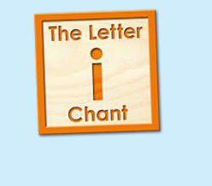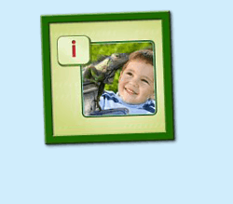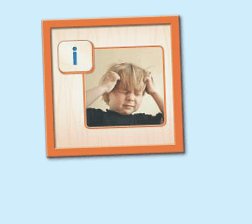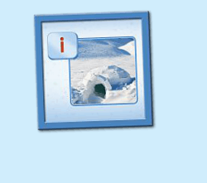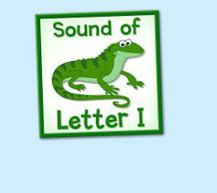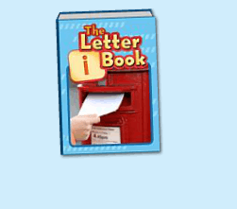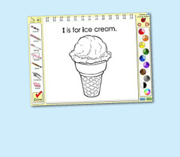
年龄段：小班下
教学目标：
1. 认识The Letter i Book, 能掌握和认读书中的词汇，并能用I is for... 句型造句。
2. 能自如演唱The Sound of Letter I Song, 并表演相应歌曲律动。
教具准备：
1. 图书对应的词汇图卡
使用游戏：
1. Run the Dice 2. Taboo Game
教学步骤： |  | 备注
- 成果公布及展示  T: Hello, Kids. Good morning./ Good afternoon.  S: Good morning./ Good afternoon.  T: Before class let's praise Coco, Tina...  They have finished their activities...  Coco come here please, can you show us your activities?  Coco: Yes.  T: OK, show us please. (请完成家庭活动的幼生上前自主操作，向其余幼生展示家庭活动成果)  T: Wonderful! Thank you, Coco.  T: Everyone come on! Tomorrow please show us your activities, OK?  S: OK!  (关于我-我的化身)  T: Now, who can show us your avatar?（请一位幼生上前来展示化身，掌握基本介绍句型）  S: Let me try. （请幼生自主打开我的宠物）  T: Linda, please come here, tell me about your avatar.  Linda: I have a avatar... （如果幼生有卡壳，教师可进行提问引导）  T: Is it a boy or a girl?  Linda: girl.  T: So she is a ...  Linda: She is a girl.  T: Kids, is it a boy or a girl? （询问其余幼生）  She is ... (引导幼生说出完整句型)  S: She is a girl...  T: Good job! Is she beautiful? Linda?  Linda: Yes, she is beautiful.  T: Is she beautiful? Kids.  S: Yes, she is beautiful.  T: Good job! Linda, can you introduce your avatar again?  Linda: I have a avatar, she is a girl. She is beautiful.  T: Good job! Thank you Linda, go back to your seat please! |  | 公布家庭活动成果并展示我的宠物
二、集体学习活动  温故知新---谁是大歌星  T: Now, let's chant. Are you ready?（教师依次点击（图1-图4）素材，可选择静音或者把音乐关小，让幼生边唱边做TPR，检验幼生掌握诗歌的程度）  S: Yes, we are ready.  S: Letter i says "i"/ "i", "i", "i"/ iguana, itch, igloo/ "i" letter i.  T: Good! Now boys and girls would have a match, OK?  S: OK!  T: Let's go!  Bs: Letter i says "i"/ I see an iguana.  Gs: "i", "i", "i"/ "i" letter i  T: Let's chant and do the action.（把音乐关小，让幼生边唱边做TPR）  T: Good job! Let's play a game!（可用Run the Dice游戏复习诗歌）  T: What's the sentence?（把歌词黏在一个骰子上面，或者直接制作一个骰子，教师投掷骰子，快速说出朝上的句子，可分组进行）  S: Letter i says "i"/ "i" "i" itch/ I have an itch/ "i" letter i  Letter i says "i"/ "i" "i" igloo/ An igloo is cold/ "i" letter i  T: Good job! Let's chant and do the action.（把音乐关小，让幼生边唱边做TPR）  T: Well done!  快乐唱片机  T: Now, let's listen a new song, no voice.  And then tell me what can you hear, OK? （教师点击（图5）歌曲，请幼生仔细聆听歌曲，不跟唱；同时教师可与幼生互动，或者做TPR进行提示）  S: OK!  T: What can you hear?  S: i letter "i"./ iguana...  T: Let's check it, listen again, no voice... （再播放一遍歌曲，在幼生提到的部分提出表扬，没有提到的部分可用TPR做提示）  Is it right?  S: Yes!  T: Good job! Listen and repeat.（利用暂停播放键，先跟唱前两句，后两句可示意幼生先听不跟唱）  S: i letter "i"./ "i" iguana letter i.  T: Good job! Continue.（利用暂停播放键，让幼生逐句跟唱全首）  S: i letter "i"./ "i" iguana letter i./ "i" is fun to say./ I sing "i" all day!  (加入Taboo game: 教师首先制定某个单词为不能说出的，在幼生跟唱时遇到制定的单词用拍手的方式代替发音)  T: Let's play a Taboo game. I is a taboo, don't say I, you should clap your hands, OK? （教师可以跟着幼生一起做活动，不能说的词汇教师提前给予提示动作，例如做拍手的手势，或者第一句由教师先来示范，后面的由幼生接龙）  S: OK!  T: Are you ready?  S: Yes, we are ready!  ( ) letter "i"./ "i" iguana letter ( )./ "i" is fun to say./ ( ) sing "i" all day!  T: Good job! This time "i" is a taboo, when you sing to "i", you should clap your hands, OK? Are you ready?  S: Yes, we are ready!  T: So good! Now, let's add some actions. Stand up, look at me and follow the music. (带领幼生边做TPR边跟唱)  T: Wow, Excellent! Once again.  Terrific! Now who wants to try? Lucy come here please, you will be the little teacher, everybody follows Lucy.  T: Good! Thank you Lucy, go back to your seat, please.  趣味复读机  T: Now, let's read a book. （教师点击（图6）图书素材）  T: Listen, no voice. And then tell me what's the name of this book. (教师加以手势动作示意幼生认真听书的名字，不跟读)  T: What is the name of this book?  S: The letter i book.  T: Let's check it, listen again.（再播放一遍书名）  Is it right?  S: Yes.  T: listen and repeat it.（再播放一次书名，让幼生跟读）  S: The letter I book.  T: Tell me again, What's the name of this book?  S: The letter I book.  T: Good job! Let's continue. Listen and no voice. (完整播放一遍图书，教师可与幼生互动，或者做TPR提示)  T: Tell me what can you hear/ find/ see.  S: igloo, impala, iguana...  T: Good! Let's check it and find something new! （完整播放一遍图书，在幼生说到的部分提出表扬，在幼生没有说到的部分可用TPR进行引导）  T: Good job! Can you find something new?  S: inside...  T: Let's check it again. （完整播放一遍图书，在幼生说到的部分提出表扬，在幼生没有说到的部分可用TPR进行引导）  T: Is it right?  S: Yes!  T: Now, let's listen and repeat the book. （让幼生跟读2-3遍）  （教师可利用暂停翻页键，对较难的词汇进行重复跟读）  T: Good job!  T: What sound does letter I make?  S: Letter I says "i".  T: Now, let's add some actions.（播放图书，教师带领幼生做TPR2-3遍）  （第一遍可不跟读，只做TPR；第二三遍边跟读边做TPR）  词卡对对碰  T: Good! Now, let's play a game.（教师拿出图书中词汇对应的图卡，点击自动播放，轮流让幼生上前根据听到的词汇挑出图卡）  T: Look! I have some pictures. Do you want to play the choose the cards game?  S: Yes!  T: I will put the cards on the floor, please choose the cards that you hear.  OK?  S: OK!  T: Good job! Now, let's listen and match the picture one by one.（让幼生轮流进行）  T: Good job！  T: This time, we listen and find the picture.（使用图卡，点击自动播放，轮流让幼生上前根据听到的词汇挑出图卡，并让幼生跟读）  T: Everyone, please come here and choose the cards one by one. (让幼生轮流进行listen and match，并让幼生跟读）  T: repeat it.  T: Good job! Who wants to try?  S: Let me try.  T: OK, Tom and John come here, listen and match the cards.（同时用手势引导其余幼生跟读词汇）  T: Now, let's listen and match the cards.（关闭平台画面，点击自动播放，打乱卡片顺序，轮流让幼生上前根据所听到的词汇挑出实物卡片，教师加以动作引导幼生跟读）  T: Everyone, please come here and choose the card one by one.（让幼生轮流进行listen and match, 让其余幼生跟读）  T: Good job!  T: Who can try?  S: Let me try.  T: Lucy and Rio come here please. Listen and match the cards.（邀请1-2位幼生上台听单词和配对图卡，教师用手势引导幼生跟读）  T: Great job!  (Guessing Game)  T: Now, let's play a guessing game.（回到平台，加入guessing game, 教师可利用暂停播放键让幼生猜图书下一页的词汇是什么）  T: Listen (carefully) and repeat.  S: igloo/ inside/ impala...  T: What is the next word?  S: inside.  T: inside? Let's check.  T: Good job! Follow it.  S: inside  T: Good, continue.  T: You all did a good job! Now look, what is this?（所以图卡排好顺序后，教师出示图卡询问幼生图卡内容，整体回顾词汇一遍）  S: igloo, inside, impala, inside, iguana...  T: Good!  美术涂涂乐  T: Let's do some painting. （教师打开（图7）涂色素材）  T: First, let's listen the sentence. （教师点击喇叭，让幼生听发音）  T: Listen again, And then tell me what can you hear, OK?  S: OK!  T: Quick response, what can you hear? One, two, three!  S: T is for treasure.  T: Let's check it.（再播放一次句子，检验答案）  Is it right?  S: Yes!  T: Good, Grace, you are the first, come here, please.  T: Please choose your favorite tools.  T: What is this?  Grace: pencil/ felt-tip/ brush/ marker/ crayon (让幼生选择一种工具，带领其余幼生跟读2-3遍)  T: What color do you like？  Grace: red/ pink... （让幼生跟读所选的颜色）  T: What color do you like?  S: red/ pink...（让其余幼生跟读）  T: Finished?  S: Yes.  T: Thank you Grace.  Is it beautiful?  S: Yes.  T: Now listen and repeat.（让幼生跟读2-3遍）  S: I is for ice cream.  T: Good job. What's this?（老师做TPR，复习前面所学过的词汇 igloo, itch, iguana...）  S: igloo, itch, iguana...  T: Good job! What about this?（无法做TPR的词汇，教师可出示单词卡片，教师做动作引导幼生造句）  S: I is for ice cream.  T: Excellent!  T:Very good! Now let's count our tickets.  Who can try?  S:Let me try.  T:Tommy please.  Where can we find our tickets?  S:"About me".  T:Tommy click it please.  Now let's count with ABCmouse.  S&ABCmouse:One, two, three...  T:So we have ten tickets today, great job! Thank you Tommy. |  | 图1：  图2：  图3:  图4：  图5：  图6：  图7：
三、家庭游戏活动布置：  T: Now, I'll show you the activities. (将已放入功课的作业界面打开)  Here are your activities for today.  You have to do these activities.  How many activities? Let's count together.  S: One, two, three, four.  T: You have to do these activities, OK?  S: OK!  T: Each of them, you need to play 5 times. OK?  S: OK!  T: Look at me, I will show you.  Please listen and repeat. (加上肢体动作演示)  OK？  S: OK！  T: Clear?  S: Yes!  T: Who can show us how to do it?  S: Let me try!  T: Mary come here and show us how to do the activities. (每一位幼生上前演示如何操作)  T: Good job! Thank you Mary!  T: Who can retell how to do it?  S: Let me try!（教师可引导幼生）  T: Good! Please finish your activities and show me tomorrow, OK?  S: OK  T: Class is over, Goodbye, everyone.  S: Goodbye. |  | 家庭游戏活动:

