Letter I -课时6
复习内容：  - The Sound of Letter I Song  - The Letter i Book  - Sentence Puzzle: Letter i, iguana  - Sentence Puzzle: Letter i, itch  - Sentence Puzzle: Letter i, igloo | 新授素材内容：  - Alphabet Jigsaw: Ii is for impala  - All About Ii Memory Match  - Simple Letter Story: I
素材截图：
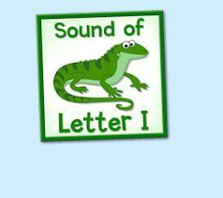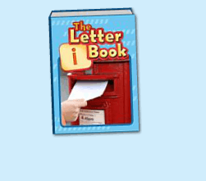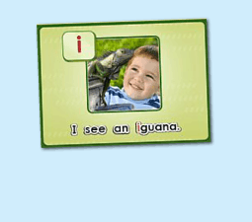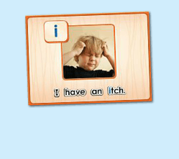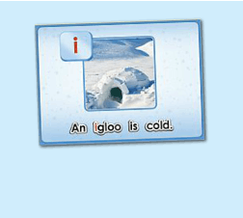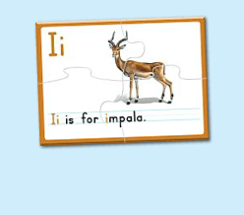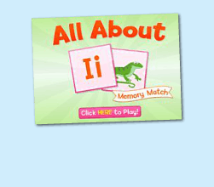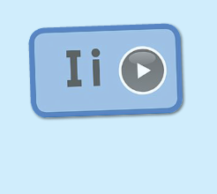
年龄：小班下
教学目标：
- 熟练运用Ii is for...的句型，能够自如替换句型。
- 字母故事初步熟悉
教具准备：
1. 学过的动物的词汇图卡
使用游戏：
1. 过小桥游戏 2. 闪电图卡 Game
教学步骤： |  | 备注
- 成果公布及展示  T: Hello, Kids. Good morning./ Good afternoon.  S: Good morning./ Good afternoon.  T: Before class let's praise Coco, Tina...  They have finished their activities...  Coco come here please, can you show us your activities?  Coco: Yes.  T: OK, show us please. (请完成家庭活动的幼生上前自主操作，向其余幼生展示家庭活动成果)  T: Wonderful! Thank you, Coco.  T: Everyone come on! Tomorrow please show us your activities, OK?  S: OK!  (关于我-我的化身)  T: Now, who can show us your avatar?（请一位幼生上前来展示化身，掌握基本介绍句型）  S: Let me try. （请幼生自主打开我的宠物）  T: Linda, please come here, tell me about your avatar.  Linda: I have a avatar... （如果幼生有卡壳，教师可进行提问引导）  T: Is it a boy or a girl?  Linda: girl.  T: So she is a ...  Linda: She is a girl.  T: Kids, is it a boy or a girl? （询问其余幼生）  She is ... (引导幼生说出完整句型)  S: She is a girl...  T: Good job! Is she beautiful? Linda?  Linda: Yes, she is beautiful.  T: Is she beautiful? Kids.  S: Yes, she is beautiful.  T: Good job! Linda, can you introduce your avatar again?  Linda: I have a avatar, she is a girl. She is beautiful.  T: Good job! Thank you Linda, go back to your seat please! |  | 公布家庭活动成果并展示我的化身
二、集体学习活动：  温故知新---谁是大歌星  T: Let's sing a song, OK? Stand up please. Are you ready? (教师点击（图1）复习歌曲素材，可选择静音或者把音乐关小，让幼生边唱边做TPR，检验幼生掌握歌曲的程度)  S: Yes, we are ready.  I letter "i"/ "i" iguana letter i/ "i" is fun to say/ I sing "i" all day（过小桥游戏：老师可以用中文解释游戏规则；老师把歌词做成卡片，老师讲歌词卡片摆在地上，每个小朋友需要跳过卡片然后唱出歌词，检验每一个小朋友的掌握程度）  T: Good job!  趣味复读机  T: Now let's read the letter i book, listen and repeat.（教师点击播放（图2）复习素材，可使用多种分组形式，请幼生跟读2-3遍）  S: igloo, inside, impala...  T: Very good. Now, let's have a match, boys and girls, are you ready? (请幼生分组进行，教师加以手势做引导)  S: Yes, we are ready.  Bs: igloo/ inside...  Gs: impala/ inside...  T: You all did a good job, you will get one point.  ( Listen and Match Game )  T: Now let's play the listen and match game.（教师关闭平台画面，点击自动播放，打乱卡片顺序，轮流让幼生上前根据所听到的词汇挑出对应的图卡，教师加以动作引导其余幼生跟读。遇到难的词汇，教师可用TPR做提示）  T: Everyone, please come here and choose the card one by one.（让幼生轮流进行listen and match, 让其余幼生跟读）  T: Good job!  T: Who can try?  S: Let me try.  T: Lucy and Amy come here please. Listen and match the cards.（邀请1-2位幼生上台听单词和配对图卡，教师用手势引导幼生跟读）  T: Good job! Lucy and Amy, please go back to your seat, thank you!  T: Now, look! What is this? (所有图卡排好顺序之后，教师出示图卡询问幼生图卡内容，整体回顾词汇一遍)  S: igloo, inside, impala, inside.  T: Good!  句子拼拼乐  T: Let's do some puzzle!  What's the name of the puzzle.（教师依次点击（图3-5）复习拼图素材，先请幼生说出拼图名字，可以配合动作给予提示，再进行核对）  S: A tiger has a tail.  T: Right? Let's check it, who can try? （请幼生上前操作拼图，幼生仔细听发音）  S: Let me try.  T: Jay, please. Everybody listen and repeat.  Right?  S: Yes.  T: Repeat again.  S: I see an iguana.  T: Great! Thank you Jay.  换乐无穷  T: Great! Can you make a sentence?（教师拿出学过的动物的卡片，让幼生造句）  S: I see an iguana.  S  T: What about this？  S: I see an ant/ elephant...  T: Good!  T: The next puzzle.  What is the name of this puzzle?（教师点击下一个拼图素材，先请幼生说出图片名字，可以配合动作给予提示，再进行核对）  S: I have an itch.  T: Let's check it, Ashley you are the first, come here please. Everybody listen and repeat.（请一位幼生上前操作拼图，其他幼生仔细听发音）  Is it right?  S: Yes.  T: Repeat again.  S: I have an itch.  换乐无穷  T: Can you use these words to make sentences? （教师出示图书单词卡片，用i is for...句型进行替换造句）  I is for... (教师可以先做示范，引导幼生活用句型）  S: I is for ...  T: Good! What is this? （教师拿出苹果道具）  S: This is an apple.  T: So what do i have?  I have an ...  S: I have an apple.  T: Good job!  句子拼拼乐  T: Good! Next puzzle!  What is the name of this puzzle? (教师点击打开第3个拼图素材，先请幼生说出拼图名字，可以配合动作给予提示，其他幼生仔细听发音)  S: Yes.  T: Repeat again.  S: An igloo is cold.  T: Good! Now, make the sentence.（教师拿出词汇图卡，让幼生造句）  S: An igloo is cold.  T: What about this? (拿出其他图卡，进行句型替换)  S: An ice is cold./ An ice cream is cold...  T: Good job!  T: Now, let's do a new puzzle, OK?  S: OK!  T: Look, what can you see（in the picture）？（教师点击（图6）进入拼图素材，先询问幼生图片的内容）  S: ...  T: OK! Let's do the puzzle first.  Lisa, come here please, please finish the puzzle, and everybody listen the sentence, and then tell me what can you hear, OK?（请一位幼生上前操作，让其余幼生听小喇叭发声）  S: OK!  T: Thank you, Lisa. Go back to your seat please.  Tell me what can you hear.  S: Ii is for impala.  T: Is it right? Let's check it.（教师点击小喇叭，让幼生听句子发音）  Is it right?  S: Yes.  T: Now, listen and repeat.（让幼生点击小喇叭2-3遍，让幼生跟读）  S: Ii is for impala.  T: Good! Look, what is this sentence. （教师把学过的T开头的词汇放在tractor的位置，让孩子替换单词说出句子）  S: Ii is for iguana/ itch/ impala...  T: Good!  闪电卡片Game  T: Now, let's play a game. (可以用中文和肢体动作解释游戏规则：老师快速在孩子面前闪过卡片，让孩子猜是哪个单词，然后说出 T is for ...的句子）Are you ready?  S: Yes, I am ready!  T: What is this? T is for...（刚开始可引导孩子）  T: Good！Continue! What is this?  S: Ii is for iguana/ turtle...  T: Good! Who wants to be little teacher?（邀请2-3名幼生上来操作游戏）  S: Let me try...  T: Lisa/ Lily/ Mandy come here and be the little teacher.  T: Ready, Go!  T: Good job!  T: Story time! （教师点击（图7）字母故事素材）  T: Let's enjoy "simple letter story: Ii". Are you ready?  （教师在播放字母故事的同时，教师可一边做TPR进行提示）  T: This time, please listen and no voice, and then tell me what can you hear, OK?（教师播放字母故事，让幼生带任务聆听）  S: OK.  T: Who can tell me what can you hear?  S: iguana, cold, happy...  T: Is it right? Let's check it, and find something new. （教师再播放一遍，在幼生提到的部分进行表扬，在幼生没有提到的部分暂停，进行提示）  Who is this? What is this? （通过提问的方式，让幼生对故事内容进行熟悉）  S: This is Izzy. This is iguana...  T: Good! Let's learn the simple letter story next time.  T: Great! Let's play a game.  First, listen carefully. （点击进入游戏素材（图8），聆听游戏的名称）  What's the name of this name?  S: All about Ii Memory Match.  C: Click here to play, who can try? （请一位幼生点击开始游戏）  S: Let me try.  T: Please say the name of this game.  S: All about Ii Memory Match.  T: Lisa. Have a try.  Everybody listen. （请他们聆听游戏规则1-2次，再点击翻开一张图片）  T: Look and listen (carefully).  T: What can you see? （指着翻过来的图片）  S: I can see...  T: Nice, another one. （继续翻开下一张）  What can you see?  S: I can see...  T: And this one. Wow, bingo! (继续翻开下一张，如果翻到同样的，就两张同时消失)  T: The next one. Who can try?（轮流请幼生上来进行游戏操作）  S: Let me try...  T: Follow it, please. (时间允许的情况下，请幼生跟读词汇)  S: ...  （线下延伸配对活动：1）  T: What's this letter?  S: It's letter i.  T: And what's this?（出示单词卡，里面包含已学过的字母i的单词及其他字母的部分词汇）  T: Let's do memory match. Find the word begins with letter i（把单词卡反面朝上摆放好，请幼生上台来翻）  T: Who wants to try?  S: Let me try.  T: Amy, come on.  T: What's this.（等幼生翻完一张卡片后，询问全体）  S: It's ...  T: Incredible. The next.（挑选下一位的同时，举起卡片，示意幼生跟读）  （线下延伸配对活动：2）  T: Let's review. Ready! Go! （出示已学过的单词卡）  Memory match time. Are you ready?（把单词卡反面朝上摆放）  S: Yes, I'm ready.  T: Look and guess. What's this?（做TPR提示）  S: This is ...  T: Bingo. Which one is... （请幼生选择卡片，翻转配对，配对正确，表扬，配对错误，再多给一次机会。）  T: Good! How about this one?  （线下延伸配对活动：3）  T: Let's review. Ready! Go! （出示已学词汇的单词卡，每个词汇有2个一样的，3-5组）  T: Memory match time. Who can try? （打乱顺序，依次反面朝上排列）  S: I can try. （请一位幼生上来翻第一张）  T: Well done. What's this?  S: ... （请回答得最快的幼生来找出另一张相同的）  T: Gorge, find another one. Wonderful.  T:The same. Bingo. Who can be the next?（翻出另一张相同的后，给予击掌鼓励）  S: ...  T: Read it together.  S: ...  T: Who can be the next? （请刚才参与的幼生选择一位幼生接力翻卡片）  1S: ...  备注：以此类推，完成所有配对。  T:Very good! Now let's count our tickets.  Who can try?  S:Let me try.  T:Tommy please.  Where can we find our tickets?  S:"About me".  T:Tommy click it please.  Now let's count with ABCmouse.  S&ABCmouse:One,two,three...  T:So we have ten tickets today,great job! Thank you Tommy. |  | 图1：  图2：  图3：  图4：  图5：  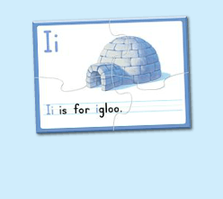  图6：  图7：  图8：
三、家庭游戏活动布置：  T: Now, I'll show you the activities. (将已放入功课的作业界面打开)  Here are your activities for today.  You have to do these activities.  How many activities? Let's count together.  S: One, two, three, four.  T: You have to do these activities, OK?  S: OK!  T: Each of them, you need to play 5 times. OK?  S: OK!  T: Look at me, I will show you.  Please listen and repeat. (加上肢体动作演示)  OK？  S: OK！  T: Clear?  S: Yes!  T: Who can show us how to do it?  S: Let me try!  T: Mary come here and show us how to do the activities. (每一位幼生上前演示如何操作)  T: Good job! Thank you Mary!  T: Who can retell how to do it?  S: Let me try!（教师可引导幼生）  T: Good! Please finish your activities and show me tomorrow, OK?  S: OK  T: Class is over, Goodbye, everyone.  S: Goodbye. |  | 家庭游戏活动：

