Letter I -课时8
复习内容：  - Alphabet Sentence Chant: i, iguana  - Alphabet Sentence Chant: i, itch  - Alphabet Sentence Chant: i, igloo  - Sentence Puzzle: Letter i, iguana  - Sentence Puzzle: Letter i, itch  - Sentence Puzzle: Letter i, igloo | 新授素材内容：  - Simple Letter Story: I  - Izzy and his iguana go to see ilia.  - Ilia lives in an igloo.
素材截图：
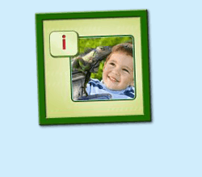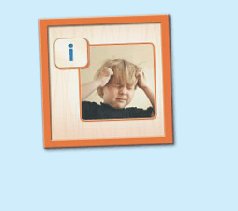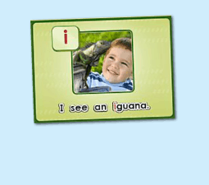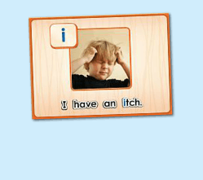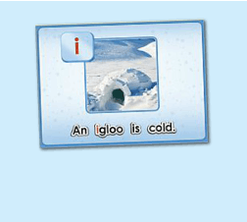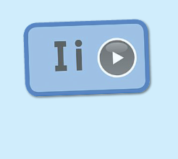
年龄段：小班下
教学目标：
- 复习3首句子诗歌和3个句子
- 学校字母故事4-6句，能表演所学的句子
教具准备：
1. 字母故事卡片、头饰、道具等 2. 字母故事图卡
使用游戏：
1. I do you say game
教学步骤： |  | 备注
- 成果公布及展示  T: Hello, Kids. Good morning./ Good afternoon.  S: Good morning./ Good afternoon.  T: Before class let's praise Coco, Tina...  They have finished their activities...  Coco come here please, can you show us your activities?  Coco: Yes.  T: OK, show us please. (请完成家庭活动的幼生上前自主操作，向其余幼生展示家庭活动成果)  T: Wonderful! Thank you, Coco.  T: Everyone come on! Tomorrow please show us your activities, OK?  S: OK!  ( 关于我-我的化身 )  T: Now, who can show us your avatar?（请一位幼生上前来展示化身，掌握基本介绍句型）  S: Let me try. （请幼生自主打开我的宠物）  T: Linda, please come here, tell me about your avatar.  Linda: I have a avatar... （如果幼生有卡壳，教师可进行提问引导）  T: Is it a boy or a girl?  Linda: girl.  T: So she is a ...  Linda: She is a girl.  T: Kids, is it a boy or a girl? （询问其余幼生）  She is ... (引导幼生说出完整句型)  S: She is a girl....  T: Good job! Is she beautiful? Linda?  Linda: Yes, she is beautiful.  T: Is she beautiful? Kids.  S: Yes, she is beautiful.  T: Good job! Linda, can you introduce your avatar again?  Linda: I have a avatar, she is a girl. She is beautiful.  T: Good job! Thank you Linda, go back to your seat please! |  | 公布家庭活动成果并展示我的化身
二、集体学习活动：  温故知新---小小表演家  T: Let's do some puzzle!  What's the name of this puzzle. （教师依次点击（图1-3）复习句子拼图素材，先请幼生说出拼图名字，可以配合动作给予提示，再进行核对）  S: I see an iguana.  T: Right? Let's check it, who can try? （请一位幼生上前操作拼图，其他幼生仔细听发音）  S: Let me try.  T: Jack, please. Everybody listen and repeat.  Is it right?  S: Yes.  T: Repeat again.  S: I see an iguana.  T: Great! Thank you, Jack.  换乐无穷  T: Great! Can you make a sentence?（教师拿出学过的动物的卡片，让幼生造句）  S: I see an ant/ elephant...（注意 "an"）  T: Good!  T: The next puzzle.  What is the name of this puzzle? （教师点击下一个拼图素材，先请幼生说出图片名字，可以配合动作给予提示，再进行核对）  S: I have an itch.  T: Let's check it, Andy, you are the first, come here please. Everybody listen and repeat. （请一位幼生上前操作拼图，其他幼生仔细听发音）  Is it right?  S: Yes.  T: Repeat again.  S: I have an itch.  T: Can you make a sentence? （拿出ice, ice cream等卡片，让幼生造句）  S: An ice cream is cold. （注意 "an"）  T: Good job!  T: Next puzzle!  What is the name of this puzzle?（教师点击打开第三个拼图素材，先请幼生说出拼图名字，可以配合动作给予提示，再进行核对）  S: An igloo is cold.  T: Let's check it, Mandy, you are the first, come here please. Everybody listen and repeat. （请一位幼生上前来操作拼图，其余幼生仔细听发音）  Is it right?  S: Yes.  T: Repeat again.  S: An igloo is cold.  T: Can you make a sentence? （拿出ice, ice cream等卡片，让幼生造句）  S: An ice cream is cold. （注意 "an"）  T: Good job!  温故知新-谁是大歌星  T: Now let's sing the chant. Are you ready?（教师依次点击（图4-图6）诗歌素材，可选择静音或者把音乐关小，让幼生边唱边做TPR，检验幼生掌握诗歌的程度）  S: Yes, we are ready.  T: Let's go!  S: Letter i says "t"/ "i" "i" "i"/ I see an iguana.......  （复习3首诗歌）  T: Let's chant and do the action.（把音乐关小，让幼生边唱边做TPR）  T: Good job! Let's play a game! (可用Run the Dice游戏复习诗歌)  T: What's the sentence? (把歌词黏在一个骰子上，或者直接制作成一个骰子，教师投掷骰子，快速说出朝上的句子，可分组进行)  S: ......  T: Good job! Who can try? (邀请2-3名幼生，检验个别幼生掌握情况)  T: Abby/ Bob/ Tiffany please sing the chant!（带领其余幼生一起做TPR）  T: Well done!  （字母故事：第二段）  T: Look! Who is this? What is this? Is this ...（教师拿出人物头饰或者故事截图与幼生进行内容回顾）  S: This Izzy. No, this not Izzy. This is an iguana.  T: Let's perform the story. Everybody stand up. Let's perform the "Simple Letter story: Ii" Ready! Go! (教师点击（图7）播放字母故事，带领幼生把学过的内容表演一遍)  S: Simple letter story: Ii, this is Izzy...  T: Good! Sit down please! Let's repeat. Are you ready? （每次播放1句就暂停，让幼生跟读，以此类推到第5句）  S: This is Izzy. No, this is not izzy. This is an iguana. This is Izzy. Izzy and his iguana go to see Ilia.  T: Good！Listen again. （点击播放，第5句播放完后继续暂停）  S: ...  T: Repeat it.  S: Izzy and his iguana go to see Ilia.  T: Good! Listen again. （点击播放，第4句播放完后继续暂停）  S: ...  T: Repeat.  S: Izzy and his iguana go to see Ilia.  T: One more time.  S: Izzy and his iguana go to see Ilia.  T: Look! Who are they? （教师拿出Izzy和iguana的头饰，询问幼生）  They are....  S: They are Izzy and iguana.  T: Good! Who would they go to see?  S: ...  T: Let's listen again. （再播放字母故事的同时，教师做TPR提示）  T: So... Izzy and his iguana go to .....  S: Izzy and his iguana go to see Ilia.  T: Good! Continue. （播放字母故事，教师手势提示幼生跟读，以此类推到第6句）  S: This is Izzy. No, this is not Izzy. This is an iguana. This is Izzy. Izzy and his iguana go to see Ilia. Ilia lives in an igloo.  T: Good! Repeat again. （提示幼生再跟读第6句）  S: Ilia lives in a igloo.  T: Look! What is this? （教师指着igloo，询问幼生）  This is an ... （注意 "an"）  S: This is an igloo.  T: Good! Where does Ilia live?  S: ...  T: Let's listen again.  Ilia lives in an ... （注意 "an"）  S: Ilia lives in an igloo.  T: So where does ilia lives?  S: Ilia lives in an igloo.  T: Good job! Who can to be Ilia?  S: Let me try.  T: Amy, come here please. （让幼生带上头饰，教师带领幼生一起做TPR）  T: Everybody looks Amy, and say the sentence, OK?  S: OK! Ilia Ilia lives in an igloo.  T: Good! One more time.  S: Ilia lives in an igloo.  T: Good job! Who can try to say the sentence? （抽查2-3名幼生）  （教师做TPR，让幼生说句子）  S: Let me try.  3S: Ilia lives in igloo.  T: Good! Thank you.  T: Now, everybody stand up, follow me.（教师带领幼生做新学的句子的TPR，第1次可要求幼生不跟到，边听边做。第2-次边跟读边做TPR）  T: Now, who can be the little teacher? (教师邀请2-3名幼生上台带领其余幼生做TPR，其余幼生边跟读边做TPR)  S: This is Izzy......  T: Good! Let's review. Look at the picture. （教师拿出字母故事前6句的图片，以此展示给幼生看，回顾句子）  S: This is Izzy......  T: Good! Everybody stand up. "Simple Letter Story: Ii" Ready! Go!  （教师带领幼生把学了的句子再复习一遍，同步播放字母故事） |  | 图1：  图2：  图3：  图4：  图5：  图6：  图7：
三、家庭游戏活动布置：  T: Now, I'll show you the activities. (将已放入功课的作业界面打开)  Here are your activities for today.  You have to do these activities.  How many activities? Let's count together.  S: One, two, three, four.  T: You have to do these activities, OK?  S: OK!  T: Each of them, you need to play 5 times. OK?  S: OK!  T: Look at me, I will show you.  Please listen and repeat. (加上肢体动作演示)  OK？  S: OK！  T: Clear?  S: Yes!  T: Who can show us how to do it?  S: Let me try!  T: Mary come here and show us how to do the activities. (每一位幼生上前演示如何操作)  T: Good job! Thank you Mary!  T: Who can retell how to do it?  S: Let me try!（教师可引导幼生）  T: Good! Please finish your activities and show me tomorrow, OK?  S: OK  T: Class is over, Goodbye, everyone.  S: Goodbye. |  | 家庭游戏活动：

