Letter I -课时10
复习内容：  - Simple Letter Story: Ii  - The Sound of Letter I Song  - All About Ii Memory Match  - The Letter I Book  - The Letter I Book | 新授素材内容：  - Letter I Cutout Puzzle
素材截图：
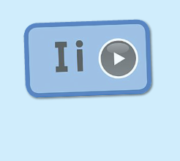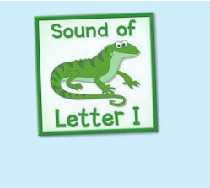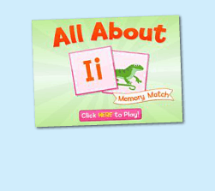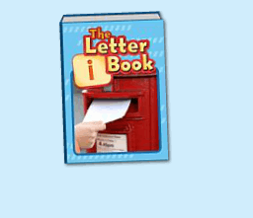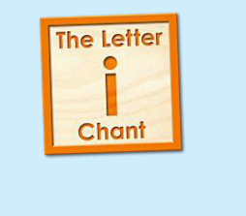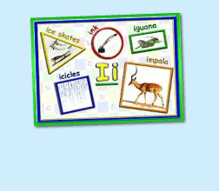
年龄段：小班下
教学目标：
- 复习字母故事，能表演整个字母故事
- 复习字母歌曲和诗歌
- 复习单词图示，能进行简单的句型词汇的替换
教具准备：
1. 字母故事卡片、头饰、道具等 2. 歌词卡片
使用游戏：
1. 配音游戏 2. 过小桥游戏
教学步骤： |  | 备注
- 成果公布及展示  T: Hello, Kids. Good morning./ Good afternoon.  S: Good morning./ Good afternoon.  T: Before class let's praise Coco, Tina...  They have finished their activities...  Coco come here please, can you show us your activities?  Coco: Yes.  T: OK, show us please. (请完成家庭活动的幼生上前自主操作，向其余幼生展示家庭活动成果)  T: Wonderful! Thank you, Coco.  T: Everyone come on! Tomorrow please show us your activities, OK?  S: OK!  ( 关于我-我的化身 )  T: Now, who can show us your avatar?（请一位幼生上前来展示化身，掌握基本介绍句型）  S: Let me try. （请幼生自主打开我的宠物）  T: Linda, please come here, tell me about your avatar.  Linda: I have a avatar...... （如果幼生有卡壳，教师可进行提问引导）  T: Is it a boy or a girl?  Linda: girl.  T: So she is a ...  Linda: She is a girl.  T: Kids, is it a boy or a girl? （询问其余幼生）  She is ... (引导幼生说出完整句型)  S: She is a girl....  T: Good job! Is she beautiful? Linda?  Linda: Yes, she is beautiful.  T: Is she beautiful? Kids.  S: Yes, she is beautiful.  T: Good job! Linda, can you introduce your avatar again?  Linda: I have a avatar, she is a girl. She is beautiful.  T: Good job! Thank you Linda, go back to your seat please! |  | 公布家庭活动成果并展示我的化身
二、集体学习活动：  看图说故事  T: Now please look at the picture and tell me the story. （教师出示字母故事卡片，请幼生复述故事）  S: This is Izzy…  T: Good! Let's perform the story. （教师打开（图1）字母故事，请幼生边跟读边做TPR）  S: This is Izzy…  T: Good! Who wants to be Izzy? Who wants to be Iguana/ Ilia?  S: Let me try.  T: Tom and Mike, Peter please.  （台上孩子表演故事，台下孩子复述故事）  S: OK!  This is Izzy….  T: Good! You all did a good job! Next Amy, Luna, Jessica, you will be the Izzy, Iguana and ilia. （教师请说的好的幼生上台替换，表演故事）  谁是大歌星  T: Good job! Now let's sing a song. First, listen and repeat. （教师点击播放（图2）歌曲，可把音乐关小，请幼生跟唱）  S: …  T: Let's have a match. Boys and Girls, are you ready? （多种形式分组清唱）  Boys: i letter "i"./ i iguana letter i.  Girls: "i" is fun to say./ I sing "i" all day.  T: Good job!  T: Now, let's chant. Please listen and repeat. (教师点击（图3）单词诗歌，可把音乐静音或者关小，请幼生跟唱）  T: Let's play a game.（过小桥游戏，把诗歌和歌曲的歌词卡片放在地上，幼生轮流跨过卡片，唱出歌词）  Are you ready?  S: Yes!  T: Ready! Go!  S: ...  配音达人  T: Now let's read letter t book. (教师点击播放（图4）单词图书，请幼生跟读)  S: igloo…  T: Good! Now, I will turn off the sound, let's be the little recorder game, are you ready!?  S: Yes, we are ready.  igloo...  换乐无穷  T: Look at my action, What is the sentence? （教师出示图书的卡片，利用单词图书进行I is for ..., The ... is ...等多种句型替换造句）  S: I is for igloo/ I is for...  T: Good! Now, look at the igloo, what color is it?  S: The igloo is white...  （教师可进行其他简单句型替换）  图块拼拼乐  T: Now, let's play a puzzle game. Who can try? （教师打开（图5）图块拼图素材，轮流请幼生上前操作一块，引导其余幼生跟读发音）  S: Let me try.  T: Lily, Mary, Molly, Sherlock ... Come here please. Everybody listen and repeat.  S: …  T: Good job! Thank you, go back to your seat please.  记忆对对碰  T: Good! Now let's play a memory match game. Who can try?（教师点击（图6）进入memory match game，一共可玩三轮，教师可邀请几位幼生上前操作，其他幼生跟读发音）  S: Let me try.  T: Tom/ Jimmy/ Candy please. Everybody listen and repeat.  S: …  T: Good job!  线下延伸配对活动：  T: Memory match time. Who can try?  （出示单词卡，已学词汇，每个词汇有一对，3-5个词汇）  （打乱顺序，依次反面朝上排列）  S: I can try. （请一位幼生上来翻第一张）  T: Well done. What's this?  S: ... （请回答得最快的幼生来找出另一张相同的）  T: Gorge, find another one. Wonderful.  T: The same. Bingo. Who can be the next?（翻出另一张相同的后，给予击掌鼓励）  S: ...  T: Read it together.  S: ....  T: Who can be the next? （请刚才参与的幼生选择一位幼生接力翻卡片）  1S: ...  备注：以此类推，完成所有配对。  T:Very good! Now let's count our tickets.  Who can try?  S:Let me try.  T:Tommy please.  Where can we find our tickets?  S:"About me".  T:Tommy click it please.  Now let's count with ABCmouse.  S&ABCmouse:One,two,three...  T:So we have ten tickets today,great job! Thank you Tommy. |  | 图1：  图2：  图3：  图4：  图5：  图6：
三、家庭游戏活动布置：  T: Now, I'll show you the activities. (将已放入功课的作业界面打开)  Here are your activities for today.  You have to do these activities.  How many activities? Let's count together.  S: One, two, three, four.  T: You have to do these activities, OK?  S: OK!  T: Each of them, you need to play 5 times. OK?  S: OK!  T: Look at me, I will show you.  Please listen and repeat. (加上肢体动作演示)  OK？  S: OK！  T: Clear?  S: Yes!  T: Who can show us how to do it?  S: Let me try!  T: Mary come here and show us how to do the activities. (每一位幼生上前演示如何操作)  T: Good job! Thank you Mary!  T: Who can retell how to do it?  S: Let me try!（教师可引导幼生）  T: Good! Please finish your activities and show me tomorrow, OK?  S: OK  T: Class is over, Goodbye, everyone.  S: Goodbye. |  | 家庭游戏活动：

