ABCmouse小班上My face课时4
素材内容：
- My Face part 1 Animation.
- My Face Practice.
- My Face Cutout Puzzle.
- Head,shoulders,knees and toes music video.
- This is my face.
- My Face Quiz.
素材截图：
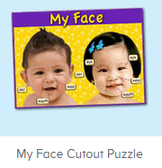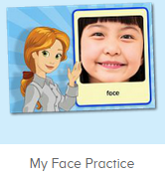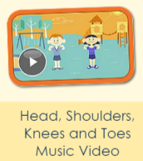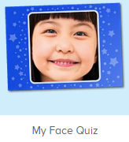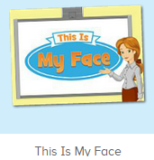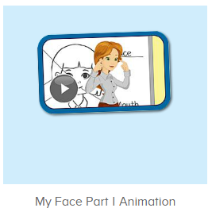
年龄段： 小班上
教学目标：
- 认识五官的英文名称并能流利说出face,eye,ear,nose,mouth。
- 能根据老师的指令快速指出自己的五官各部位。
- 能跟唱歌曲Eyes, and ears,and mouth,and nose这一句。
- 能听出口语动画视频的关键句子This is my.....。
教具准备：1、五官face、eye、ear、mouth、nose图卡 2.脸部图片
使用游戏：
1.Matching game 2.Team match 3.TPR
教学步骤： | 备注
- 成果公布及展示：  T: Hello kids,good morning.  S:Good morning Yama.  T:First,let's praise Lily,Andy,Peter,Jimmy....They have finished all their activities.  Everybody look,what is this?（引导整体幼生回顾已介绍过的关于我的板块）  S:This is my aquarium,my hamster,my tickets.  T:Good job!Jimmy,come here and show us your aquarium .（邀请单个幼生作独立展示）  J:OK.  This is my aquarium,I have two fish,this one is blue,this one is yellow.  T:Wow,terrific!Thank you Jimmy.  Everybody together.  S:This is my aquarium,I have two fish,this one is blue,this one is yellow.（整体描述一遍）  T:Well done! | 公布家庭活动成果并轮流展示关于我（我的奖励票/我的鱼缸/我的仓鼠）
- 集体学习活动：  欢乐唱吧  T:Now please enjoy the music video.  Listen carefully.If you hear head//eye/nose/mouth/ear...please show me,ok?（教师播放图1歌曲，请幼生仔细听不跟唱，请幼生听到相关内容时就指出相应的部位，增加互动性）  S:OK.  T:Nice job!This time follow it,ok?（教师引导幼生跟唱Eyes, and ears,and mouth,and nose并加上动作，其余只听不跟唱）  S:OK.  Eyes, and ears,and mouth,and nose.....  T:Nice job!Once again.(可重复进行3-4遍，或加入互动游戏让幼生重复跟唱)  This time let’s have a match,boys and girls,are you ready?  S:Yes,we are ready!  Bs/Gs:Eyes, and ears,and mouth,and nose.....  T:Wonderful!Girls,you win the match!  趣味录音机  T:Now let’s practice.  Listen and answer.（教师点击播放图2素材，请幼生仔细听并回答Miss Jones的问题）  S:This is face/eye/nose/mouth/ear.  T:Nice job!Please show me your face/eye/nose/mouth/ear.  Good!what is this?（老师可以转向指班级别的幼生的脸，询问幼生问题并引导回答）  S:This is face/eye/nose/mouth/ear.  T:Very nice.Now let’s record.  Are you ready?  S:Yes,we are ready!  T:Listen and answer.  S:This is face/eye/nose/mouth/ear.  T:Let’s hear your voice.  Wonderful!  Now let’s play a game “Simon says”.（加入互动游戏，老师可用中文向幼生讲解游戏玩法）  Ready?  S:Yes,we are ready.  T:Simon says:Touch your face/eye/nose/mouth/ear.  Lily,you are right./Peter,you are wrong.  Once again.  Simon says:Touch your face/eye/nose/mouth/ear.  Wonderful!Boys,you are the winner.  Now who wants to be the little teacher?  S:Let me try.  T:Lily/Peter...please.  Now is Lily/Peter says..ok?  S:OK.  Lily/Peter: Face/eye/nose/mouth/ear...  My Face拼拼乐  T:Good job!It’s puzzle time.  Look,what is this?(操作图3拼图素材前先询问幼生各部位的名称，进行核对与跟读)  S:This is face/eye/nose/mouth/ear.  T:Right?Let’s check.  Wow,good job!  Now listen and repeat.  S:Face/eye/nose/mouth/ear.  T:Who wants to try?（选择级别2/3，请幼生上前操作，其余幼生跟读）  S:Let me try.  T:Sam/Paul/Lily...please.  Everybody listen and repeat.  S:Face/eye/nose/mouth/ear.  听音配对  T:Terrific!Now let’s play a game,please listen and find.（点击进入图4素材，请幼生听问题并找出正确的图片）  Which one is right?This one?  S:No.  T:What is this?（询问幼生画面上图片的内容是什么，检验幼生掌握程度）  S:This is face/ear...  T:What about this?  S:This is eye/ear...  T:So which one is right?  Who can try?  S:Let me try.  T:Lily/Lucas/Henry...please.  Wow,good job!Thank you!  Let’s continue.  Listen and point  T:Now let’s listen and point.（点击进入图5素材，请幼生听问题并指出正确部位）  First,listen carefully.  Where is Miss Jones’s eye/ear/nose..?  S:Here...  T:Who can try?  S:Let me try.  T:Fiona/Daniel/Cherry...please.  Good job!  So what is this?  S:This is nose/eye/ear....  口语动画剧场  T:Well done!Now please enjoy the video and tell me what can you hear,ok?(播放图6素材，请幼生仔细听不跟读并告诉老师听到了什么内容)  S:OK.  T:What can you hear?  S:Face/eye...  T:Right?Let’s check,listen again then tell me what did Miss Jones say,ok?  S:OK.  T:Face/eye..good job!（核对时发现幼生有说出的内容，教师给予及时的肯定和鼓励）  Now tell me,what did Miss Jones say?This is my....  S:This is my face/eye...  T:Good job!We will learn the sentence next time.  欢乐唱吧  T:Now let’s sing and dance.  Stand up and follow me.（打开图7素材，教师引导幼生跟唱Eyes, and ears,and mouth,and nose并加上动作，其余只听不跟唱但可以表演动作）  S:OK.  Eyes, and ears,and mouth,and nose.....  T:Nice job!Once again.(可重复进行3-4遍，或加入互动游戏让幼生重复跟唱)  This time let’s have a match,boys and girls,are you ready?  S:Yes,we are ready!  Bs/Gs:Eyes, and ears,and mouth,and nose...  T:Wonderful!Girls,you win the match!  You all did a good job!  Now let's count our tickets.  Who can try?  S:Let me try.  T:Tommy please.  Where can we find our tickets?  S: "About me".  T:Tommy click it please.  Now let's count with ABCmouse.  S&ABCmouse:One,two,three......  T:So we have ten tickets today,great job!  Thank you Tommy. | 图1  图2  （Simon says:老师通过说Simon says发布指令，如Simon says:Touch your face，幼生则找指令触摸face，如教师只是说touch your face，幼生则不做任何动作,教师示范2轮后可以请幼生上前当小老师发布指令，可以简化程序，幼生直接说单词即可）  图3  图4  图5  图6  图7
- 家庭活动布置：
T:Wow!So nice!Now I'll show you the activities.（将已放入功课的作业界面打开）
T: Look,how many activities do you need to do?
S:.......
T:Very well.Now I will show you how to do it.Please listen carefully.
Jason come here and show us how to do the activities.
Good job!Thank you Jason!
Please finish the activities and show me tomorrow,ok?
S:OK!
T:Class is over, Goodbye everyone.
S:Goodbye Yama.

