ABCmouse小班上My face课时5
素材内容：
- My Face part 1 Animation.
- My Face Practice.
- My Face Cutout Puzzle.
- Head,shoulders,knees and toes music video.
- This is my face.
- My Face Quiz.
素材截图：
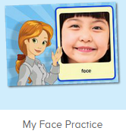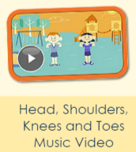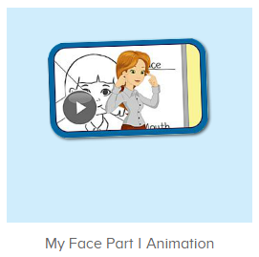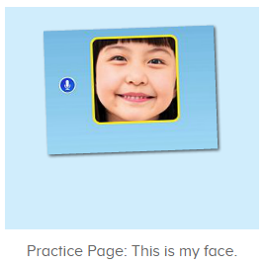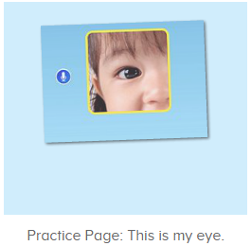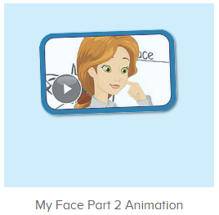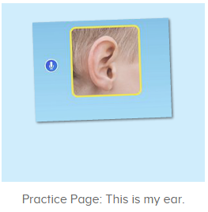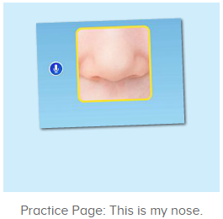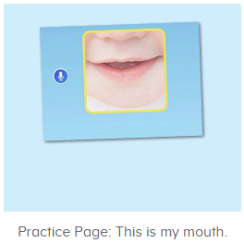
年龄段： 小班上
教学目标：
- 能流利说出face,eye,ear,nose,mouth。
- 能根据老师的指令快速指出自己的五官各部位。
- 能跟唱歌曲Eyes, and ears,and mouth,and nose这一句。
- 能听出口语动画视频的关键句子This is my.....，并能用this is my...句型介绍自己的五官。
教具准备：1、五官face、eye、ear、mouth、nose图卡 2.脸部图片
使用游戏：
1.Matching game 2.Team match 3.TPR
教学步骤： | 备注
- 成果公布及展示：  T: Hello kids,good morning.  S:Good morning Yama.  T:First,let's praise Lily,Andy,Peter,Jimmy....They have finished all their activities.  Everybody look,what is this?（引导整体幼生回顾已介绍过的关于我的板块）  S:This is my aquarium,my hamster,my tickets.  T:Good job!Jimmy,come here and show us your aquarium .（邀请单个幼生作独立展示）  J:OK.  This is my aquarium,I have two fish,this one is blue,this one is yellow.  T:Wow,terrific!Thank you Jimmy.  Everybody,now you are all Jimmy,let’s say it together.  S:This is my aquarium,I have two fish,this one is blue,this one is yellow.（整体描述一遍）  T:Well done! | 公布家庭活动成果并轮流展示关于我（我的奖励票/我的鱼缸/我的仓鼠）
- 集体学习活动：  欢乐唱吧  T:Now let’s sing and dance.  Stand up and follow me.（打开图1素材，教师引导幼生跟唱Eyes, and ears,and mouth,and nose并加上动作，其余只听不跟唱但可以表演动作）  S:OK.  Eyes, and ears,and mouth,and nose.....  T:Nice job!Once again.(可重复进行3-4遍，或加入互动游戏让幼生重复跟唱)  This time let’s have a match,boys and girls,are you ready?  S:Yes,we are ready!  Bs/Gs:Eyes, and ears,and mouth,and nose...  T:Wonderful!Girls,you win the match!  趣味录音机  T:Now let’s practice.  Listen and answer.（教师点击播放图2素材，请幼生仔细听并回答Miss Jones的问题）  S:This is face/eye/nose/mouth/ear.  T:Nice job!Please show me your face/eye/nose/mouth/ear.  Good!what is this?（老师可以转向指班级别的幼生的脸，询问幼生问题并引导回答）  S:This is face/eye/nose/mouth/ear.  T:Very nice.Now let’s record.  Are you ready?  S:Yes,we are ready!  T:Listen and answer.  S:This is face/eye/nose/mouth/ear.  T:Let’s hear your voice.  Wonderful!  Now let’s play a game “Simon says”.（加入互动游戏，老师可用中文向幼生讲解游戏玩法）  Ready?  S:Yes,we are ready.  T:Simon says:Touch your face/eye/nose/mouth/ear.  Lily,you are right./Peter,you are wrong.  Once again.  Simon says:Touch your face/eye/nose/mouth/ear.  Wonderful!Boys,you are the winner.  Now who wants to be the little teacher?  S:Let me try.  T:Lily/Peter...please.  Now is Lily/Peter says..ok?  S:OK.  Lily/Peter: Face/eye/nose/mouth/ear...  口语动画剧场  T:Well done!Now please enjoy the video and tell me what can you hear,ok?(播放图3/图6素材，请幼生仔细听不跟读并告诉老师听到了什么内容)  S:OK.  T:What can you hear?  S:Face/eye...  T:Right?Let’s check,listen again then tell me what did Miss Jones say,ok?  S:OK.  T:Face/eye..good job!（核对时发现幼生有说出的内容，教师给予及时的肯定和鼓励）  Now tell me,what did Miss Jones say?This is my....  S:This is my face/eye...  T:Good job!Listen again.  趣味复读机  T:Now listen carefully,no voice.（打开图4-图8素材，请幼生先听不跟读，输入3-4遍）  Now listen and repeat.  S:This is my face/eye/nose/ear/mouth.（跟读3-4次）  T:Very good!Please show me your face/eye.（教师请幼生指出自己的脸部和眼睛，然后教师询问幼生问题，引导幼生用This is my...来回答）  So what is this?This is my...  S:This is This is my face/eye/nose/ear/mouth.  T:Boys/girls,please show me your face/eye.  So what is this?  Bs/Gs:This is my face/eye/nose/ear/mouth.  T:Lily/Peter/John...,what is this?（教师走到幼生身边指出她的face/eye/nose/ear/mouth，询问问题）  L/P/J:This is my face/eye/nose/ear/mouth.  T:Good job.Now look,this is my face/eye/nose/ear/mouth.  Who can show us your face/eye/nose/ear/mouth?  S:Let me try.  T:Kenny/Gina/Rio...please.  K/G/R:This is my face/eye/nose/ear/mouth.  T:Very good!Let’s praise.  欢乐唱吧  T:Now let’s sing and dance.  Stand up and follow me.（打开图1素材，教师引导幼生跟唱Eyes, and ears,and mouth,and nose并加上动作，其余只听不跟唱但可以表演动作）  S:OK.  Eyes, and ears,and mouth,and nose.....  T:Nice job!Once again.(可重复进行3-4遍，或加入互动游戏让幼生重复跟唱)  This time let’s have a match,boys and girls,are you ready?  S:Yes,we are ready!  Bs/Gs:Eyes, and ears,and mouth,and nose...  T:Wonderful!Girls,you win the match!  Now let's count our tickets.  Who can try?  S:Let me try.  T:Tommy please.  Where can we find our tickets?  S: "About me".  T:Tommy click it please.  Now let's count with ABCmouse.  S&ABCmouse:One,two,three......  T:So we have ten tickets today,great job!  Thank you Tommy. | 图1  图2  （Simon says:老师通过说Simon says发布指令，如Simon says:Touch your face，幼生则找指令触摸face，如教师只是说touch your face，幼生则不做任何动作,教师示范2轮后可以请幼生上前当小老师发布指令，可以简化程序，幼生直接说单词即可）  图3  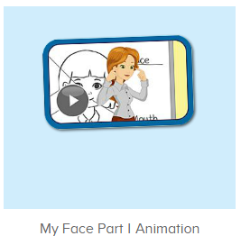  图4  图5  图6  图7  图8
- 家庭活动布置：
T:Wow!So nice!Now I'll show you the activities.（将已放入功课的作业界面打开）
T: Look,how many activities do you need to do?
S:.......
T:Very well.Now I will show you how to do it.Please listen carefully.
Jason come here and show us how to do the activities.
Good job!Thank you Jason!
Please finish the activities and show me tomorrow,ok?
S:OK!
T:Class is over, Goodbye everyone.
S:Goodbye Yama.

