ABCmouse小班上My face课时6
素材内容：
- My Face Cutout Puzzle.
- Head,shoulders,knees and toes music video.
- Practice page:This is my face/eye/ear/nose/mouth
- My Happy Face Beginner.
素材截图：
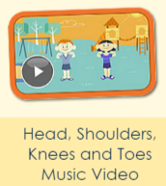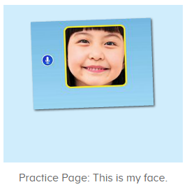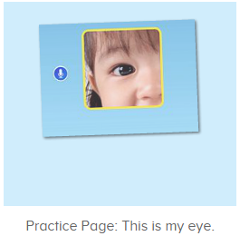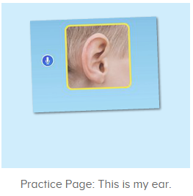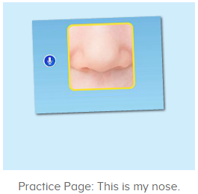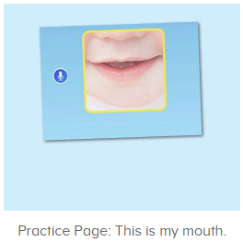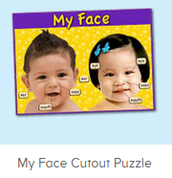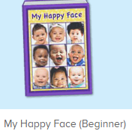
年龄段： 小班上
教学目标：
- 能流利说出face,eye,ear,nose,mouth,并能用this is my...句型介绍自己的五官。
- 能跟唱歌曲第一、二句。
- 能流利跟读图书My happy face。
教具准备：1、五官face、eye、ear、mouth、nose图卡 2.脸部图片
使用游戏：
1.Matching game 2.Team match 3.TPR
教学步骤： | 备注
- 成果公布及展示：  T: Hello kids,good morning.  S:Good morning Yama.  T:First,let's praise Lily,Andy,Peter,Jimmy....They have finished all their activities.  Everybody look,what is this?（引导整体幼生回顾已介绍过的关于我的板块）  S:This is my aquarium,my hamster,my tickets.  T:Good job!Jimmy,come here and show us your aquarium .（邀请单个幼生作独立展示）  J:OK.  This is my aquarium,I have two fish,this one is blue,this one is yellow.  T:Wow,terrific!Thank you Jimmy.  Everybody,now you are all Jimmy,let's say it together.  S:This is my aquarium,I have two fish,this one is blue,this one is yellow.（整体描述一遍）  T:Well done! | 公布家庭活动成果并轮流展示关于我（我的奖励票/我的鱼缸/我的仓鼠）
- 集体学习活动：  欢乐唱吧  T:Now let's sing and dance.  Stand up and follow me.（打开图1素材，教师引导幼生跟唱Eyes, and ears,and mouth,and nose并加上动作，其余只听不跟唱但可以表演动作）  S:OK.  Eyes, and ears,and mouth,and nose.....  T:Nice job!Once again.  This time let's follow this sentence,are you ready?（跟唱第二句歌词，第一句听）  S:Yes,we are ready!  S:Head,shoulders,knees and toes,Knees and toes...  T:Wonderful!Once again.(重复跟唱3-4遍，可加入互动游戏)  Now boys and girls have a match,ok?  S:Ok.  Gs/Bs:Head,shoulders,knees and toes/Knees and toes...  T:All together.  S:Head,shoulders,knees and toes,Knees and toes...  趣味复读机  T:Now listen and repeat.（打开图2-图6素材，请幼生跟读）  S:This is my face/eye/nose/ear/mouth.（跟读3-4次）  T:Very good!Please show me your face/eye.（教师请幼生指出自己的脸部和眼睛，然后教师询问幼生问题，引导幼生用This is my...来回答）  So what is this?This is my...  S:This is This is my face/eye/nose/ear/mouth.  T:Boys/girls,please show me your face/eye.  So what is this?  Bs/Gs:This is my face/eye/nose/ear/mouth.  T:Lily/Peter/John...,what is this?（教师走到幼生身边指出她的face/eye/nose/ear/mouth，询问问题）  L/P/J:This is my face/eye/nose/ear/mouth.  T:Good job.Now look,this is my face/eye/nose/ear/mouth.  Who can show us your face/eye/nose/ear/mouth?  S:Let me try.  T:Kenny/Gina/Rio...please.  K/G/R:This is my face/eye/nose/ear/mouth.  T:Very good!Let's praise.  趣读图书  T:I have an interesting book,let's read it.  First listen and tell me what is the name of this book,ok?（点击播放图7图书，先请幼生听图书名字）  S:OK.  T:What is the name of this book?  S:My happy face.  T;Nice job!Follow it.  S:My happy face.(跟读2-3遍)  T:Well done!Let's continue,listen no voice.  What can you hear?  S:Face/this is my face....  T:Right?Let's check,no voice.  Good!  This time,follow the book.  S:My happy face/face/this is my face....  T:Good job!This time follow the book and show me your face/ear..,ok?（请幼生边跟读图书边指出相应的部位）  S:OK.  My happy face/face/this is my face....  T:Nice job!Now let's play a game,girls/boys follow the book,and the girls/boys show me your face/ear...,ok?（加入互动游戏，由男女生或分小组跟读图书，另一组的幼生则指出相应的部位）  S:OK.  Bs/Gs:My happy face/face/this is my face....  T:Fantastic!  拼图拼拼乐  T:T:Good job!It's puzzle time.  Look,what is this?(操作图8拼图素材前先询问幼生各部位的名称，进行核对与跟读)  S:This is face/eye/nose/mouth/ear.  T:Right?Let's check.  Wow,good job!  Now listen and repeat.  S:Face/eye/nose/mouth/ear.  T:Who wants to try?（选择级别2/3，请幼生上前操作，其余幼生跟读）  S:Let me try.  T:Sam/Paul/Lily...please.  Everybody listen and repeat.  S:Face/eye/nose/mouth/ear.  T:Good job!Now let's use "this is my..." to make sentences.  What is this?  S:This is my face/nose/mouth...  T:Who can try?  S:Let me try.  T:Tim/Kelly/Lucy...please.  What is this?  T/K/L:This is my face/eye/nose...  T:Great job!  欢乐唱吧  T:Now let's sing and dance.  Stand up and follow me.（打开图1素材，教师引导幼生连续跟唱前两段段并加上动作）  S:OK.  Head,shoulders,knees and toes,Knees and toes...  T:Nice job!Once again  This time let's add some actions,are you ready?  S:Yes,we are ready!  Bs/Gs:Head,shoulders,knees and toes,Knees and toes...  T:Wonderful!  Now let's count our tickets.  Who can try?  S:Let me try.  T:Tommy please.  Where can we find our tickets?  S: "About me".  T:Tommy click it please.  Now let's count with ABCmouse.  S&ABCmouse:One,two,three......  T:So we have ten tickets today,great job!  Thank you Tommy. | 图1  图2  图3  图4  图5  图6  图7  图8
- 家庭活动布置：
T:Wow!So nice!Now I'll show you the activities.（将已放入功课的作业界面打开）
T: Look,how many activities do you need to do?
S:.......
T:Very well.Now I will show you how to do it.Please listen carefully.
Jason come here and show us how to do the activities.
Good job!Thank you Jason!
Please finish the activities and show me tomorrow,ok?
S:OK!
T:Class is over, Goodbye everyone.
S:Goodbye Yama.

