ABCmouse小班上My face课时7
素材内容：
- Head,shoulders,knees and toes music video.
- My Happy Face.
- My face part 3 Animation.
- Parts of the face cutout puzzle.
- My Face picture picker.
素材截图：
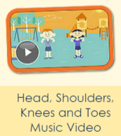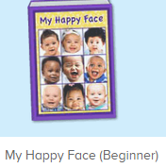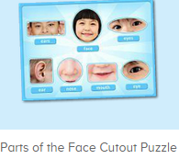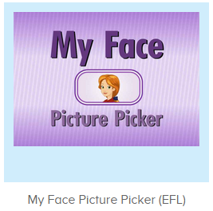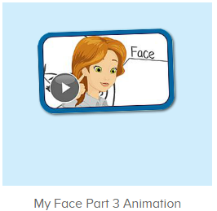
年龄段： 小班上
教学目标：
- 能流利说出face,eye,ear,nose,mouth,并能用this is my...,these are my...句型介绍自己的五官。
- 能跟唱歌曲第1-3句。
- 能流利跟读图书My happy face。
教具准备：1、五官face、eye、ear、mouth、nose图卡 2.脸部图片
使用游戏：
1.Matching game 2.Team match 3.TPR
教学步骤： | 备注
- 成果公布及展示：  T: Hello kids,good morning.  S:Good morning Yama.  T:First,let's praise Lily,Andy,Peter,Jimmy....They have finished all their activities.  Everybody look,what is this?（引导整体幼生回顾已介绍过的关于我的板块）  S:This is my aquarium,my hamster,my tickets.  T:Good job!Jimmy,come here and show us your hamster .（邀请单个幼生作独立展示）  J:OK.  This is my hamster,I have two hamsters,this one is orange,this one is brown.  T:Wow,terrific!Thank you Jimmy.  Everybody,now you are all Jimmy,let's say it together.  S:This is my hamster,I have two hamsters,this one is orange,this one is brown.（整体描述一遍）  T:Well done! | 公布家庭活动成果并轮流展示关于我（我的奖励票/我的鱼缸/我的仓鼠）
- 集体学习活动：  欢乐唱吧  T:Now let's sing and dance.  Stand up and follow me.（打开图1素材，教师引导幼生连续跟唱前两句并加上动作）  S:OK.  Head,shoulders,knees and toes,Knees and toes...  T:Nice job!Once again  This time let's add some actions,are you ready?  S:Yes,we are ready!  Bs/Gs:Head,shoulders,knees and toes,Knees and toes...  T:Now let's sing the song again.（引导幼生连续跟唱第一段，可先不加动作）  S:Head,shoulders,knees and toes,Knees and toes,Head,shoulders,knees and toes,Knees and toes,Eyes, and ears,and mouth,and nose, Head,shoulders,  knees and toes,Knees and toes!（可重复2-3遍）  T:Very nice!Now I will have a match with you,ok?  S:Ok.  T/S:Head,shoulders,knees and toes,Knees and toes/Head,shoulders,knees and toes,Knees and toes/Eyes, and ears,and mouth,and nose/Head,shoulders,  knees and toes/Knees and toes!（加入互动游戏与老师分组竞赛接龙）  T:Now let's add some actions,stand up please.  S:Head,shoulders,knees and toes,Knees and toes,Head,shoulders,knees and toes,Knees and toes,Eyes, and ears,and mouth,and nose, Head,shoulders,  knees and toes,Knees and toes!（可重复2-3遍）  T:You did a great job!  口语动画小剧场  T:Now let's enjoy the video,listen carefully and tell we what can you hear,ok?（点击图2口语动画视频，提醒幼生关注重点句子）  S:OK.  T:What can you hear?  S:Ear/nose....  T:Very good!Listen again and tell me how many ears does Miss Jones have,ok?  S:OK.  T:So how many ears does Miss Jones have?  S:Two.  T:How many ears/eyes do you have?I have....  S:I have tow ears/eyes.  T:Very good!Look,I have two ears,so these are my ears.  趣读图书  T:Now let's read a book.  Firs,tell me what is the name of this book?（读图书前可先询问有关图书的名字或内容）  S:My happy face.  T:Nice job!Follow the book.（点击播放图3图书，请幼生跟读）  S:My happy face/face/this is my face....  T:Good job!This time follow the book and show me your face/ear..,ok?（请幼生边跟读图书边指出相应的部位）  S:OK.  My happy face/face/this is my face....  T:Nice job!Now let's play a game,girls/boys follow the book,and the girls/boys show me your face/ear...,ok?（加入互动游戏，由男女生或分小组跟读图书，另一组的幼生则指出相应的部位）  S:OK.  Bs/Gs:My happy face/face/this is my face....  T:Fantastic!Now listen and answer.（教师点击手动翻页，询问幼生问题并引导幼生说出图书句子）  What is this/are these?  S:This is my.../these are my....  T:Wonderful!Now let's be the little recorder,ready?  S:Yes,we are ready!  My happy face/face/this is my face....  拼图拼拼乐  T:Good job!It's puzzle time.  Look,what can you see?I can see...(操作图4拼图素材前先询问幼生各部位的名称，进行核对与跟读)  S:I can see face/eye/nose/mouth/ear...  T:Right?Let's check.  Who can try?  S:Let me try.  T:Tim/Kelly/Gina...please.  Everybody listen and repeat.  S:Face/eyes/nose/mouth/ears...  T:Good job!Now let's use "this is my...and these are my..." to make sentences.  Look,what is this?  S:This is my face/nose/mouth...  T:What are these?  S:These are my eye/ears.  T:Good job!  Who can try?  S:Let me try.  T:Tim/Kelly/Lucy...please.  What is this?/What are these?  T/K/L:This is my face/eye/nose.../These are my ears...  T:Well done!  听音配对  T:Now please listen and choose,listen carefully and choose the right picture.（打卡图5素材，请幼生请音选图卡）  What can you hear?  S:Nose/eye/mouth....  T:Who can try?  S:Let me try.  T:Gina/Dora/Lily...please.  Good job!  欢乐唱吧  T:Now let's sing and dance.  Stand up and follow me.（打开图1素材，教师引导幼生连续跟唱第一段并加上动作）  S:OK.  Head,shoulders,knees and toes,Knees and toes,Head,shoulders,knees and toes,Knees and toes,Eyes, and ears,and mouth,and nose, Head,shoulders,  knees and toes,Knees and toes!  T:Wonderful!Once again.  Now let's count our tickets.  Who can try?  S:Let me try.  T:Tommy please.  Where can we find our tickets?  S: "About me".  T:Tommy click it please.  Now let's count with ABCmouse.  S&ABCmouse:One,two,three......  T:So we have ten tickets today,great job!  Thank you Tommy. | 图1  图2  图3  图4  图5
- 家庭活动布置：
T:Wow!So nice!Now I'll show you the activities.（将已放入功课的作业界面打开）
T: Look,how many activities do you need to do?
S:.......
T:Very well.Now I will show you how to do it.Please listen carefully.
Jason come here and show us how to do the activities.
Good job!Thank you Jason!
Please finish the activities and show me tomorrow,ok?
S:OK!
T:Class is over, Goodbye everyone.
S:Goodbye Yama.

