ABCmouse 中班（下）字母J - 课时2
复习素材内容：  - Basics letters:Jj is for jacket.  - Basics letters:Jj is for jar.  - Basics letters:Jj is for jam. | 新授素材内容：  - The letter j Chant.  - Sentence Puzzle:Letter j, juice.  - Alphabet Sentence Chant:j, juice.
素材截图：
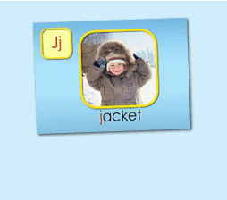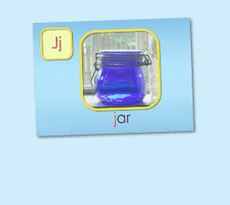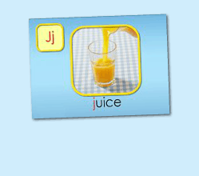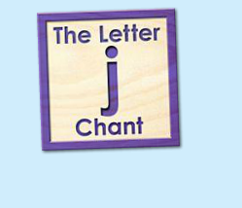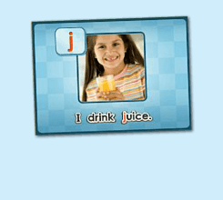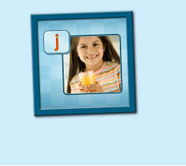
年龄段：小班下
教学目标：
- 能准确流利说出字母J的发音，能理解并认读词汇 jacket, jar, juice，会表演对应的TPR。
- 能自如演唱The Letter j chant和Alphabet sentence:j, juice, 并表演相应诗歌律动。
- 能流利说出 I drink juice.
教具准备：
1. 字母J开头的单词卡片 2. 字母J的图卡 3. 其他已学过的饮料卡片
使用游戏：
1. I do you say game 2. Missing game
教学步骤：
- 成果公布及展示  T:Hello kids, Good morning./ good afternoon.  S:Hello ...  T:First, let's praise Lily, Andy..., they have finished their activities.  Lily, come here please, please show us your activities.  Lily:OK. (请完成家庭活动的幼生上前自从操作网站，向其余幼生展示家庭活动成果)  T:Lily, please show us your pet/ room/ avatar/ aquarium/ hamster/ tickets.  T:Wonderful!  T:Everybody comes on! Tomorrow please show us your pet/ room/ avatar/ aquarium/ hamster/ tickets, OK?  S:OK!  (关于我-我的房间)  T:Linda, come here please, can you show us your room? （请一位幼生上前展示我的房间，掌握介绍句型）  Linda:OK!（请幼生自主打开我的房间）  T:Linda, Is this your room?  Yes, this is ...  Linda:Yes, this is my room.  T:Good! What is this? This is my ...  Linda:This is my bed.  T:Good job!  T:Kids, What is this?  This is ...（引导幼生说出完整句型）  S:This is a bed.  T:Good job!  S:Linda, What color is your bed?  Linda:It is yellow.  T:Kids, what color is Linda's bed?  S:yellow.  T:So, Linda's bed is ....  S:Linda's bed is yellow.  T:Good job! Linda, can you introduce your room again?  Linda:Yes. This is my room. This is my bed. It is yellow. （若幼生有卡壳，教师可做提示）  T:Good job! |  | 公布家庭活动成果并展示我的房间
二、集体学习活动  趣味复读机  T:Now, let's begin our class! First, please listen and repeat. （教师点击进入素材（图1-3），请幼生快速跟读网站平台发音，复习字母J的发音及3个基础词汇）  S:J, "j", jacket, jar, juice..  I do you say  T:Very good! Now, look at me and guess what is it, OK?  S:OK!  T:What is it? It is ...（引导幼生用完整句型回答）  S:It is letter I/ "i"/ itch/ igloo/ iguana/ impala.  T:Who wants to try?  S:Let me try.  T:Tina/ Bobby come here, you do the actions and ask what is it, OK? （邀请2-3名幼生做TPR，询问其余幼生）  Tina/ Bobby:OK! What is it?  S:It is letter I/ "i"/ itch/ iguana/ impala/ igloo.  T:Good job! Thank you. Go back to your seat, please！  T:Good job! Now, let's listen a chant and tell me what can you hear, OK?  （教师点击（图4）诗歌素材，让幼生带任务仔细聆听，教师同时与幼生互动，或者做TPR提示）  S:OK!  T:What can you hear？  S:Letter j says "j"... / juice/ jacket/ jar.....  T:Good job! Let's check it, listen and no voice. （教师再播放一遍诗歌）  Is it right?  S:Yes.  T:OK, this time, we listen again and find something new, OK?  S:OK!  T:What can you hear (this time)?  S:...  T:Let's check it again.（教师配合TPR动作，加快幼生理解诗歌）  T:Now, listen and repeat.（教师配合手势和动作引导幼生，教师唱的那遍听，学生唱的那边跟唱，跟唱2-3遍）  S:Letter j says "j"/ "j" "j" "j"/ juice, jacket, jar/ "j" letter j.  T:Now, let's add some action to the chant. Follow me please. （教师带领幼生边听边做动作，第一遍先不听）  T:One more time. （第二第三遍边唱边做）  T:Good job!  T:Now, let's listen next chant and tell me what can you hear, OK? （教师点击（图5）诗歌素材，让幼生带着任务仔细聆听；教师可同时与幼生互动，或者做TPR提示）  S:OK!  T:What can you hear?  S:Letter j says "j"/ "j" "j" juice/ I drink juice/ "j" letter j.  T:Good job! Let's check it, listen and no voice.（教师再播放一遍诗歌）  Is it right?  S:Yes.  T:OK, this time, we listen again and find something new, OK?  S:OK!  T:What can hear (this time)?  S:...  T:Can you hear "I drink juice"?  S:Yes.  T:Let's check it again. （教师配合TPR动作，加快幼生理解诗歌）  T:Now, listen and repeat. （教师配合手势和动作引导幼生，教师唱的那遍听，学生唱的那遍歌词，跟唱2-3遍）  S:Letter j says "j"/ "j" "j" juice/ I drink juice/ "j" letter j.  T:Now, let's add some action to the chant. Follow me please. （教师带领幼生边听边做动作，第一遍可先不听）  T:One more time.（第二遍第三遍边唱边做）  T:Good job!  Song Relay Game  T:Let's play a "Song Relay" game. （可以中午解释游戏规则：将幼生分为两组，每组8人，设定起点和终点，每组4人在起点，4人在终点。 老师播放一句歌词，并发号 "Ready, Go!", 每次一位幼儿从起点跑到终点处，与终点处的小伙伴击掌，并传送一句歌词。 一次类推，看哪一组传送的准确无误，且速度快。）  T:Ready, Go!  T:Good job. Team A/B win! |  | 图1：  图2：  图3：  图4：  图5：
Puzzle Time  T:Puzzle time!  T:Now, listen and no voice. And then tell me what can you hear, OK?（教师点击（图6）句子拼图素材，选择难度级别1，完成句子拼图，请幼生仔细聆听）  S:OK!  T:Tell me what can you hear.  S:I drink juice.  T:Good job! Let's check it.  Is it right?  S:Yes!  T:Good! Follow it. （教师点击小喇叭，请幼生跟读2-3遍）  S:I drink juice.  T:Let's have a match, team A and team B, are you ready?  S:Yes!  TA:I/ drink/ juice.  TB:I/ drink/ juice.  T:Good. TB get one point.  （What is missing game:依次空出drink和juice, 询问幼生不见的词应该放哪里）  T:Now, look (at the puzzle), what is missing?  S:drink/ juice...  T:Where can I put it? Here?  S:Yes!  T:Good! Who wants to try? Mandy, please. （选择难度级别2/3级，请幼生上台操作拼图，其余幼生跟读）  T:Good job! Thank you, Mandy.  T:Look (at the puzzle), what do you drink?  I drink ...  S:I drink juice.  T:Good job! |  | 图6:
（出示已学过的饮料单词卡片，替换juice造句)
T:Look, What are these?
S:water, milk...
T:What do you drink?
I drink....
S:I drink water/ milk/ juice...

（复习-歌词接龙）
T:Now, let's sing the chant one by one. Are you ready?（复习环节，让幼生轮流，每人清唱一句，最后分小组轮流唱一句）
S:Letter j says "j"/ "j" "j" "j"/ jacket, jar, juice/ "j" letter j.
T:Now, the next chant.
S:Letter j says "j"/ "j" "j" juice/ I drink juice/ "j" letter j.
T:Good job!
三、家庭游戏活动布置：  T:Now, I'll show you the activities. (将已放入功课的作业界面打开)  Here are your activities for today.  You have to do these activities.  How many activities? Let's count together.  S:One, two, three, four.  T:You have to do these activities, OK?  S:OK!  T:Each of them, you need to play 5 times. OK?  S:OK!  T:Look at me, I will show you.  Please listen and repeat. (加上肢体动作演示)  OK？  S:OK！  T:Clear?  S:Yes!  T:Who can show us how to do it?  S:Let me try!  T:Mary come here and show us how to do the activities. (每一位幼生上前演示如何操作)  T:Good job! Thank you Mary!  T:Who can retell how to do it?  S:Let me try!（教师可引导幼生）  T:Good! Please finish your activities and show me tomorrow, OK?  S:OK  T:Class is over, Goodbye, everyone.  S:Goodbye. |  | 家庭游戏活动：

