ABCmouse 中班（下）字母J - 课时3

复习素材内容：  - The letter j chant  - Alphabet Sentence Chant:j, juice  - Sentence Puzzle:Letter j, juice | 新授素材内容：  - Alphabet Sentence Chant:j, jar  - Alphabet Sentence Chant:j, jacket  - Sentence Puzzle:Letter j, jar  - Sentence Puzzle:Letter j, jacket  - Letter Ji Koi Maze
素材截图：
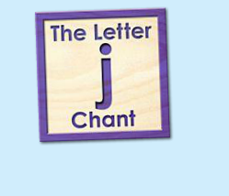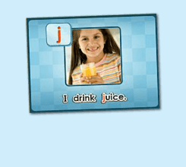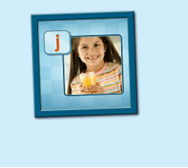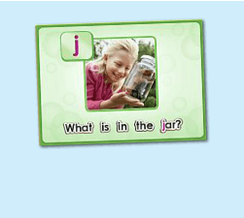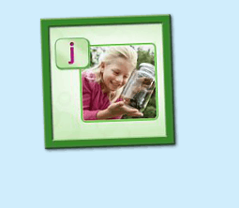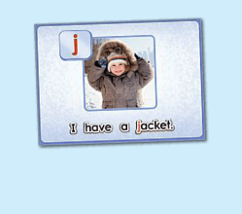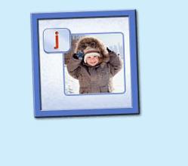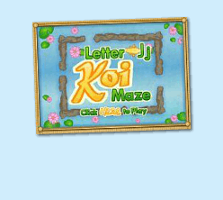
年龄段：小班下
教学目标：
- 能准确流利说出字母J的发音，能理解并认读词汇 jacket, jar, juice, 会表演对应的TPR。
- 能自如演唱所学的chant，并表演相应诗歌律动。
- 能流利说出 I drink juice./ what is in the jar?/ I have a jacket. 这3个句型
教具准备：
1. 字母I开头的单词卡片 2. 字母I的图卡 3. 其他已学过的
使用游戏：
1. Run the Dice 2. What is Missing Game 3. 歌词接龙
教学步骤：
- 成果公布及展示  T:Hello kids, Good morning./ good afternoon.  S:Hello ...  T:First, let's praise Lily, Andy..., they have finished their activities.  Lily, come here please, please show us your activities.  Lily:OK. (请完成家庭活动的幼生上前自从操作网站，向其余幼生展示家庭活动成果)  T:Lily, please show us your pet/ room/ avatar/ aquarium/ hamster/ tickets.  T:Wonderful!  T:Everybody comes on! Tomorrow please show us your pet/ room/ avatar/ aquarium/ hamster/ tickets, OK?  S:OK!  (关于我-我的房间)  T:Linda, come here please, can you show us your room? （请一位幼生上前展示我的房间，掌握介绍句型）  Linda:OK!（请幼生自主打开我的房间）  T:Linda, Is this your room?  Yes, this is ...  Linda:Yes, this is my room.  T:Good! What is this? This is my ...  Linda:This is my bed.  T:Good job!  T:Kids, What is this?  This is .... （引导幼生说出完整句型）  S:This is a bed...  T:Good job!  S:Linda, What color is your bed?  Linda:It is yellow.  T:Kids, what color is Linda's bed?  S:yellow.  T:So, Linda's bed is ....  S:Linda's bed is yellow.  T:Good job! Linda, can you introduce your room again?  Linda:Yes. This is my room. This is my bed. It is yellow. （若幼生有卡壳，教师可做提示）  T:Good job! |  | 公布家庭活动成果并展示我的房间
二、集体学习活动  温故知新---单词对对碰  T:Now, everybody looks at these pictures, what is it? （教师出示字母和词汇卡片图卡，快速复习一遍）  S:It is letter J/ jacket/ jar/ juice.  T:What sound does letter J make?  S:Letter J says "j".  温故知新---谁是大歌星  T：Good! Now let's chant. Are you ready?（教师点击（图1）播放诗歌，可选择静音，或者把音乐关小，让幼生边唱边做TPR，检验幼生掌握诗歌的程度）  S:Yes, we are ready.  S:Letter j says "j"/ "j", "j", "j"/ jacket, jar, juice/ "j" letter j.  T:Good job! Now boys and girls would have a match, OK?  S:OK!  T:Let's go!  Bs:Letter j says "j"/ juice, jacket, jar  "j", "j", "j"/ "j" letter j.  T:What is the sentence? （教师出示句子卡片或打开拼图素材（图2），请幼生说出句子）  S:...  T:I drink ...  S:I drink juice.  T:Good job! So what's the sentence?  S:I drink juice.  T:Good job!  T:Let's sing the next chant. Are you ready?  S:Yes, we are ready! （教师点击播放（图3）诗歌，可选择静音，或者把音乐关小，让幼生边唱边做TPR，检验幼生掌握诗歌的程度）  S:Letter j says "j"./ "j" "j" juice./ I drink juice./ "j" letter j.  T:Good! Let's play a game! （可用Run the Dice游戏复习诗歌）  （把诗歌的句子黏在一个骰子上，或者制作制作成一个骰子，教师投掷骰子，快速唱出朝上的句子，可把幼生分为两组进行）  S:Letter j says "j"./ "j" "j" juice./ I drink juice./ "j" letter j.  T:Good job!  快乐唱片机  T:Let's learn a new chant, OK?  （教师点击（图4）诗歌素材，让幼生带着任务仔细聆听；教师可同时与幼生互动，或者做TPR进行提示）  S:OK!  T:Listen and no voice, and then tell me what can you hear, OK?  S:OK!  T:What can you hear?  S:Letter j says "j"/ jar...  T:Good job！Let's check it. Listen and no voice.  Is it right?  S:Yes.  T:OK, this time, we listen again and find something new, OK?  S:OK!  T:What can you hear? (this time)  T:Can you hear "what is in the jar?"?  S:Yes.  T:Let's check it again. (教师配合TPR动作，加快幼生理解诗歌)  T:Now, listen and repeat. （教师配合手势和动作引导幼生，教师唱的那遍听，学生唱的那遍跟唱，跟唱2-3遍）  S:Letter j says "j". / "j", "j", jar. / What is in the jar? / "j" letter j.  T:Good job! Now, let's add some action to the chant. Follow me please.  （教师带领幼生边听边做动作，第一遍先不唱）  T:One more time. （第二遍第三遍边唱边跳）  T:Good job!  Puzzle Time  T:Puzzle Time!  T:Now, listen and no voice. And tell me what can you hear, OK?（教师点击（图5）句子拼图素材，选择难度级别1，完成句子拼图，请幼生仔细聆听）  S:OK!  T:Tell me what can you hear.  S:What is in the jar?  T:Good job! Let's check it, is it right?  S:Yes.  T:Good! Follow it. （教师点击小喇叭，请幼生跟读2-3遍）  S:What is in the jar? （请幼生跟读2-3遍）  T:Good job! Let's have a match, team A and team B, are you ready?  S:Yes.  TA:What/ is/ in/ the/ jar?  TB:What/ is/ in/ the/ jar?  T:Good! TB get one point.  （What is missing game:轮流空出in, jar; 提问幼生不见的单词应该放哪里）  T:Now, look (at the puzzle), what is missing?  S:in, jar.  T:Where can I put it? Here?  S:Yes.  T:Good! Who wants to try? Linda please. （选择难度级别2-3级，请幼生上台操作拼图，其余幼生跟读）  T:Good job! Thank you Linda.  T:What's the sentence?  S:...  T:Follow it. (播放一遍句子，让幼生跟读)  T:What's the sentence?  S:What is in the jar?  T:Good!  （替换造句：可拿出杯子或盒子等道具或词汇卡片）  T:Look, What is this?  S:cup, box....  T:So, what's the sentence? （将道具或卡片放在"jar"的单词前面）  S:Where is in the cup/ box?  T:Good job!  歌词接龙  T:Now, let's sing the chant one by one, are you ready? （复习诗歌，让幼生轮流，每人清唱一句，最后分小组轮流唱一句）  S:Letter j says "j"./ "j", "j", jar./ What is in the jar/ "j" letter j.  T:Good job!  快乐唱片机  T:Now, let's learn the next chant, OK?  (教师点击 （图6） 诗歌素材，让幼生带着任务仔细聆听；教师可同时与幼生互动，或者做TPR进行提示)  S:OK!  T:Listen and no voice, and then tell me what can you hear, OK?  S:OK!  T:What can you hear?  S:I/ have/ jacket.  T:Good job! Let's check it. Listen and no voice.  Is it right?  S:Yes.  T:OK, this time, we listen again and find something new, OK?  S:OK!  T:What can you hear (this time)?  S:I have a jacket.  T:Is it right?  T:Let's check it again. （教师配合TPR动作，加快幼生理解诗歌）  T:Now, listen and repeat. （教师配合手势和动作引导幼生，教师唱的那遍听，学生唱的那遍跟唱，跟唱2-3遍）  S:Letter j says "j"/ "j" "j" jacket/ I have a jacket/ "j" letter j.  T:Good job! Now, let's add some action to the chant. Follow me please.  （教师带领幼生边听边做动作，第一遍先不唱）  T:One more time.（第二遍第三遍边唱边做）  T:Good job!  Puzzle Time  T:Puzzle Time!  T:Now, listen and no voice. And then tell me what can you hear，OK？(教师点击（图7）句子拼图素材，选择难度级别1，完成句子拼图，请幼生仔细聆听)  S:OK!  T:Tell me what can you hear.  S:I have a jacket.  T:Good job! Let's check it, is it right?  S:Yes.  T:Good! Follow it.（教师点击小喇叭，请幼生跟读2-3遍）  S:I have a jacket.（请幼生跟读2-3遍）  T:Good! Let's have a match, team A and team B, are you ready?  S:Yes!  TA:I/ have/ a/ jacket.  TB:I/ have/ a/ jacket.  T:Good! TA gets one point.  （What is missing game:轮流空出have, jacket; 提问幼生不见的单词应该放哪里）  T:Now, look at (the puzzle), what is missing?  S:have, jacket.  T:Where can i put it? Here?  S:Yes!  T:Good! Who wants to try? Luna please. （选择难度级别2-3级，请幼生上台操作拼图，其余幼生跟读）  T:Good job! Thank you, Luna.  T:What's the sentence?  S:I have a jacket.  T:Follow it.（播放一遍句子，让幼生跟读）  T:What's the sentence?  S:I have a jacket.  T:Good job!  （替换造句：拿出一些衣物的词汇图卡）  T:Look, What is this?  S:T-shirt, dress.....  T:So, what do i have?  I have a ......  S:I have a dress/ T - shirt.  T:Good job!  欢乐大迷宫  T:Let's play the letter T koi maze. Who wants to try? (教师打开（图8）字母迷宫，邀请幼生上前操作，其余幼生跟读发音)  S:Let me try.  T:Sam please. Everybody listen and repeat.  S:j ...  T:Wow, Excellent!! |  | 图1：  图2：  图3：  图4：  图5：  图6：  图7：  图8：
三、家庭游戏活动布置：  T:Now, I'll show you the activities. (将已放入功课的作业界面打开)  Here are your activities for today.  You have to do these activities.  How many activities? Let's count together.  S:One, two, three, four.  T:You have to do these activities, OK?  S:OK!  T:Each of them, you need to play 5 times. OK?  S:OK!  T:Look at me, I will show you.  Please listen and repeat. (加上肢体动作演示)  OK？  S:OK！  T:Clear?  S:Yes!  T:Who can show us how to do it?  S:Let me try!  T:Mary come here and show us how to do the activities. (每一位幼生上前演示如何操作)  T:Good job! Thank you Mary!  T:Who can retell how to do it?  S:Let me try!（教师可引导幼生）  T:Good! Please finish your activities and show me tomorrow, OK?  S:OK  T:Class is over, Goodbye, everyone.  S:Goodbye. |  | 家庭游戏活动：

