Letter J -课时8
复习内容：  - Alphabet Sentence Chant:j, juice  - Alphabet Sentence Chant:j, jar  - Alphabet Sentence Chant:j, jacket  - Sentence Puzzle:Letter j, juice  - Sentence Puzzle:Letter j, jar  - Sentence Puzzle:Letter j, jacket | 新授素材内容：  - Simple Letter Story:J  - Jaden and Janet like to jump  - Here are Jeff and Joan  - Jeff and Joan like to laugh at jokes
素材截图：
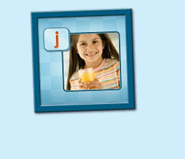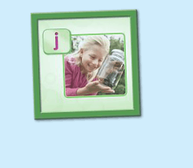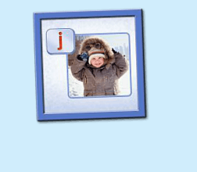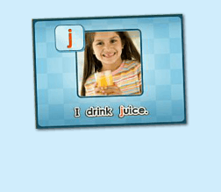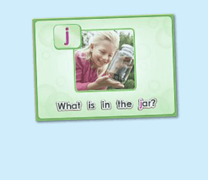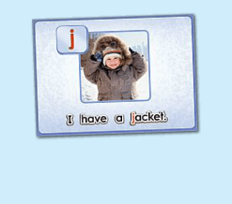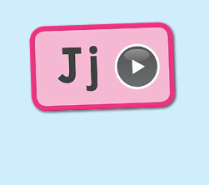
年龄段：小班下
教学目标：
- 复习3首句子诗歌和3个句子
- 学校字母故事4-6句，能表演所学的句子
教具准备：
1. 字母故事卡片、头饰、道具等 2. 字母故事图卡
使用游戏：
1. I do you say game
教学步骤： |  | 备注
- 成果公布及展示  T:Hello, Kids. Good morning./ Good afternoon.  S:Good morning./ Good afternoon.  T:Before class let's praise Coco, Tina...  They have finished their activities...  Coco come here please, can you show us your activities?  Coco:Yes.  T:OK, show us please. (请完成家庭活动的幼生上前自主操作，向其余幼生展示家庭活动成果)  T:Wonderful! Thank you, Coco.  T:Everyone come on! Tomorrow please show us your activities, OK?  S:OK!  (关于我-我的房间)  T:Linda, come here please, can you show us your room? （请一位幼生上前展示我的房间，掌握介绍句型）  Linda:OK!（请幼生自主打开我的房间）  T:Linda, Is this your room?  Yes, this is .......  Linda:Yes, this is my room.  T:Good! What is this? This is my ......  Linda:This is my bed.  T:Good job!  T:Kids, What is this?  This is .... （引导幼生说出完整句型）  S:This is a bed...  T:Good job!  S:Linda, What color is your bed?  Linda:It is yellow.  T:Kids, what color is Linda's bed?  S:yellow.  T:So, Linda's bed is ....  S:Linda's bed is yellow.  T:Good job! Linda, can you introduce your room again?  Linda:Yes. This is my room. This is my bed. It is yellow. （若幼生有卡壳，教师可做提示）  T:Good job! |  | 公布家庭活动成果并展示我的房间
二、集体学习活动：  温故知新---小小表演家  T:Let's do some puzzle!  What's the name of this puzzle. （教师依次点击（图1-3）复习句子拼图素材，先请幼生说出拼图名字，可以配合动作给予提示，再进行核对）  S:I drink juice.  T:Right? Let's check it, who can try? （请一位幼生上前操作拼图，其他幼生仔细听发音）  S:Let me try.  T:Jack, please. Everybody listen and repeat.  Is it right?  S:Yes.  T:Repeat again.  S:I drink juice.  T:Great! Thank you, Jack.  换乐无穷  T:Great! Can you make a sentence?（教师拿出学过的饮料的卡片，让幼生造句）  S:I drink water/ milk....  T:Good!  T:The next puzzle.  What is the name of this puzzle? （教师点击下一个拼图素材，先请幼生说出图片名字，可以配合动作给予提示，再进行核对）  S:What is in the jar?  T:Let's check it, Andy, you are the first, come here please. Everybody listen and repeat. （请一位幼生上前操作拼图，其他幼生仔细听发音）  Is it right?  S:Yes.  T:Repeat again.  S:What is in the jar?  T:Can you make a sentence? （拿出box, cup等卡片，让幼生造句）  S:What is in the box/ cup?  T:Good job!  T:Next puzzle!  What is the name of this puzzle?（教师点击打开第三个拼图素材，先请幼生说出拼图名字，可以配合动作给予提示，再进行核对）  S:I have a jacket.  T:Let's check it, Mandy, you are the first, come here please. Everybody listen and repeat. （请一位幼生上前来操作拼图，其余幼生仔细听发音）  Is it right?  S:Yes.  T:Repeat again.  S:I have a jacket..  T:Can you make a sentence? （拿出词汇卡片，让幼生造句）  S:I have a pen. / i have a pencil ...  T:Good job!  温故知新-谁是大歌星  T:Now let's sing the chant. Are you ready?（教师依次点击（图4-图6）诗歌素材，可选择静音或者把音乐关小，让幼生边唱边做TPR，检验幼生掌握诗歌的程度）  S:Yes, we are ready.  T:Let's go!  S:Letter j says "j"/ "j" "j" "j"/ I drink juice......  （复习3首诗歌）  T:Let's chant and do the action.（把音乐关小，让幼生边唱边做TPR）  T:Good job! Let's play a game! (可用Run the Dice游戏复习诗歌)  T:What's the sentence? (把歌词黏在一个骰子上，或者直接制作成一个骰子，教师投掷骰子，快速说出朝上的句子，可分组进行)  S:......  T:Good job! Who can try? (邀请2-3名幼生，检验个别幼生掌握情况)  T:Abby/ Bob/ Tiffany please sing the chant!（带领其余幼生一起做TPR）  T:Well done!  （字母故事：第二段）  T:Look! Who is this?教师拿出人物头饰或者故事截图与幼生进行内容回顾）  T:Here is ...  S:Here is jimmy. Jimmy likes to juggle jars of jam. Here are Jaden and Janet.  T:Let's perform the story. Everybody stand up. Let's perform the "Simple Letter story:Jj" Ready! Go! (教师点击（图7）播放字母故事，带领幼生把学过的内容表演一遍)  S:Simple letter story:Jj, Here is Jimmy..........  T:Good! Sit down please! Let's repeat. Are you ready? （每次播放1句就暂停，让幼生跟读，以此类推到第4句）  S:Here is Jimmy. Jimmy likes to juggle jars of jam. Here are Jaden and Janet. Jaden and Janet likes to jump.  T:Good！Listen again. （点击播放，第4句播放完后继续暂停）  S:...  T:Repeat it.  S:Jaden and Janet likes to jump.  T:Good! Listen again. （点击播放，第4句播放完后继续暂停）  S:...  T:Repeat it.（在幼生跟读的同时，教师做TPR作引导）  S:Jaden and Janet likes to jump.  T:One more time.  S:Jaden and Janet likes to jump.  T:Look! Who are they? （教师拿出Jaden 和Janet的头饰，询问幼生）  Here are ...  S:Here are Jaden and Janet.  T:Good! What do they like to do?  S:Jaden and Janet likes to jump.  T:Is it right? Let's check it. (播放字母故事，至第4句暂停)  Is it right?  S:Yes! Good.  T:Who like to jump? （询问幼生）  S:me, me ...  T:Lily and Candy come here. Follow me do the action. （做Jump的TPR）  T:Kids, do Lily and Candy like to jump?  S:Yes.  T:Lily and Candy like to .....  S:Lily and Candy likes to jump.  T:Good job! （替换几个幼生进行造句）  Thank you Lily and Candy, go back to your seat please.  T:Continue! （播放字母故事，至第5句暂停）  Listen and repeat. （在幼生跟读的同时，教师做动作串联）  S:Here is Jimmy. Jimmy likes to juggle jars of jam. Here are Jaden and Janet. Jaden and Janet likes to jump. Here are Jeff and Joan.  T:Good! Who are they?  S:Jeff and Joan.  T:So what's the sentence?  Here are.....  S:Here are Jeff and Joan.  T:Good! Continue! （播放字母故事，至第6句暂停）  Listen and repeat. （在幼生跟读的同时，教师做动作串联）  S:Here is Jimmy. Jimmy likes to juggle jars of jam. Here are Jaden and Janet. Jaden and Janet likes to jump. Here are Jeff and Joan. Jeff and Joan like to laugh at jokes.  T:What do Jeff and Joan like to do?  Jeff and Joan like to...  S:...  T:Listen again! （让幼生仔细听）  S:Jeff and Joan like to laugh at jokes.  T:Good! Repeat it.  S:Jeff and Joan like to laugh at jokes. （幼生在跟读的同时，做TPR提示幼生）  T:Good! Tom and Lynn come here, follow my action. （教师带领幼生做第6句的TPR，其余幼生说出句子）  T:Look! What do Tom and Lynn like to do？  Tom and Lynn like to ....  S:Tom and Lynn like to laugh at jokes. （替换多组幼生进行替换造句）  T:Good! Thank you.  T:Look! What Jeff and Joan like to do?（回到字母故事中，教师做TPR提示）  S:Jeff and Joan like to laugh at jokes.  T:Good job! Everybody stand up, follow me.（教师带领幼生做新学的句子的TPR，第1次可要求幼生不跟到，边听边做。第2-3次边跟读边做TPR）  T:Now, who can be the little teacher? (教师邀请2-3名幼生上台带领其余幼生做TPR，其余幼生边跟读边做TPR)  S:Here is Jimmy....  T:Good! Let's review. Look at the picture. （教师拿出字母故事前6句的图片，以此展示给幼生看，回顾句子）  S:Here is Jimmy...  T:Good! Everybody stand up. "Simple Letter Story:Jj" Ready! Go!  （教师带领幼生把学了的句子再复习一遍，同步播放字母故事） |  | 图1：  图2：  图3：  图4：  图5：  图6：  图7：  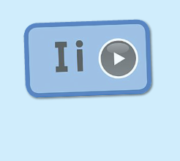
三、家庭游戏活动布置：  T:Now, I'll show you the activities. (将已放入功课的作业界面打开)  Here are your activities for today.  You have to do these activities.  How many activities? Let's count together.  S:One, two, three, four.  T:You have to do these activities, OK?  S:OK!  T:Each of them, you need to play 5 times. OK?  S:OK!  T:Look at me, I will show you.  Please listen and repeat. (加上肢体动作演示)  OK？  S:OK！  T:Clear?  S:Yes!  T:Who can show us how to do it?  S:Let me try!  T:Mary come here and show us how to do the activities. (每一位幼生上前演示如何操作)  T:Good job! Thank you Mary!  T:Who can retell how to do it?  S:Let me try!（教师可引导幼生）  T:Good! Please finish your activities and show me tomorrow, OK?  S:OK  T:Class is over, Goodbye, everyone.  S:Goodbye. |  | 家庭游戏活动：

