Letter J -课时10
复习内容：  - Simple Letter Story:Jj  - The Sound of Letter J Song  - All About Jj Memory Match  - The Letter j Book  - The Letter j Chant | 新授素材内容：  - Letter J Cutout Puzzle
素材截图：
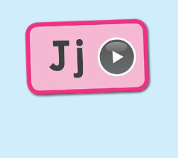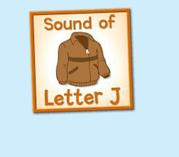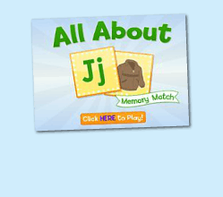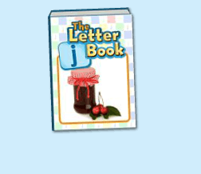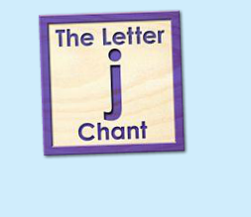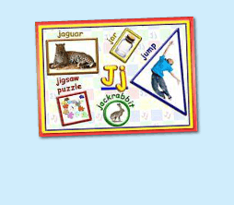
年龄段：小班下
教学目标：
- 复习字母故事，能表演整个字母故事
- 复习字母歌曲和诗歌
- 复习单词图示，能进行简单的句型词汇的替换
教具准备：
1. 字母故事卡片、头饰、道具等 2. 歌词卡片
使用游戏：
1. 配音游戏 2. 过小桥游戏
教学步骤： |  | 备注
- 成果公布及展示  T:Hello, Kids. Good morning./ Good afternoon.  S:Good morning./ Good afternoon.  T:Before class let's praise Coco, Tina...  They have finished their activities...  Coco come here please, can you show us your activities?  Coco:Yes.  T:OK, show us please. (请完成家庭活动的幼生上前自主操作，向其余幼生展示家庭活动成果)  T:Wonderful! Thank you, Coco.  T:Everyone come on! Tomorrow please show us your activities, OK?  S:OK!  (关于我-我的房间)  T:Linda, come here please, can you show us your room? （请一位幼生上前展示我的房间，掌握介绍句型）  Linda:OK!（请幼生自主打开我的房间）  T:Linda, Is this your room?  Yes, this is ....  Linda:Yes, this is my room.  T:Good! What is this? This is my ...  Linda:This is my bed.  T:Good job!  T:Kids, What is this?  This is ...（引导幼生说出完整句型）  S:This is a bed...  T:Good job!  S:Linda, What color is your bed?  Linda:It is yellow.  T:Kids, what color is Linda's bed?  S:yellow.  T:So,Linda's bed is ....  S:Linda's bed is yellow.  T:Good job! Linda, can you introduce your room again?  Linda:Yes. This is my room. This is my bed. It is yellow. （若幼生有卡壳，教师可做提示）  T:Good job! |  | 公布家庭活动成果并展示我的房间
二、集体学习活动：  看图说故事  T:Now please look at the picture and tell me the story. （教师出示字母故事卡片，请幼生复述故事）  S:Here is Jimmy  T:Good! Let's perform the story. （教师打开（图1）字母故事，请幼生边跟读边做TPR）  S:Here is Jimmy.  T:Good! Here is Jimmy ...  S:Let me try.  T:Tom and Mike, Peter please.  （台上孩子表演故事，台下孩子复述故事）  S:OK!  Here is Jimmy.  T:Good! You all did a good job! Next Amy, Luna, Jessica, you will be the Izzy, Iguana and ilia. （教师请说的好的幼生上台替换，表演故事）  谁是大歌星  T:Good job! Now let's sing a song. First, listen and repeat. （教师点击播放（图2）歌曲，可把音乐关小，请幼生跟唱）  S:"j" "j" letter j./ "j" "j" jacket letter j./ "j" "j" "j" I hear the sound/ "j" "j" jacket all around. / "j" "j" letter j./ I sing "j" "j" "j" all day!  T:Let's have a match. Boys and Girls, are you ready? （多种形式分组清唱）  Boys:"j" "j" letter j./ "j" "j" jacket letter j./ "j" "j" "j" I hear the sound  Girls:"j" "j" jacket all around. / "j" "j" letter j./ I sing "j" "j" "j" all day!  T:Good job!  T:Now, let's chant. Please listen and repeat. (教师点击（图3）单词诗歌，可把音乐静音或者关小，请幼生跟唱）  T:Let's play a game.（过小桥游戏，把诗歌和歌曲的歌词卡片放在地上，幼生轮流跨过卡片，唱出歌词）  Are you ready?  S:Yes!  T:Ready! Go!  S:..  配音达人  T:Now let's read letter t book. (教师点击播放（图4）单词图书，请幼生跟读)  S:jar....  T:Good! Now, I will turn off the sound, let's be the little recorder game, are you ready!?  S:Yes, we are ready.  jar....  换乐无穷  T:Look at my action, What is the sentence? （教师出示图书的卡片，利用单词图书进行J is for ..., The ... is ...等多种句型替换造句）  S:J is for Jj. The jean is blue....  T:Good! Now, look at the jam, what color is it?  S:The jam is yellow.  （教师可进行其他简单句型替换）  图块拼拼乐  T:Now, let's play a puzzle game. Who can try? （教师打开（图5）图块拼图素材，轮流请幼生上前操作一块，引导其余幼生跟读发音）  S:Let me try.  T:Lily, Mary, Molly, Sherlock ... Come here please. Everybody listen and repeat.  S:….  T:Good job! Thank you, go back to your seat please.  记忆对对碰  T:Good! Now let's play a memory match game. Who can try?（教师点击（图6）进入memory match game，一共可玩三轮，教师可邀请几位幼生上前操作，其他幼生跟读发音）  S:Let me try.  T:Tom/ Jimmy/ Candy please. Everybody listen and repeat.  S:...  T:Good job!  线下延伸配对活动：  T:Memory match time. Who can try?  （出示单词卡，已学词汇，每个词汇有一对，3-5个词汇）  （打乱顺序，依次反面朝上排列）  S:I can try. （请一位幼生上来翻第一张）  T:Well done. What's this?  S:...（请回答得最快的幼生来找出另一张相同的）  T:Gorge, find another one. Wonderful.  T:The same. Bingo. Who can be the next?（翻出另一张相同的后，给予击掌鼓励）  S:...  T:Read it together.  S:...  T:Who can be the next? （请刚才参与的幼生选择一位幼生接力翻卡片）  1S:...  备注：以此类推，完成所有配对。  T:Very good! Now let's count our tickets.  Who can try?  S:Let me try.  T:Tommy please.  Where can we find our tickets?  S:"About me".  T:Tommy click it please.  Now let's count with ABCmouse.  S&ABCmouse:One,two,three...  T:So we have ten tickets today,great job! Thank you Tommy. |  | 图1：  图2：  图3：  图4：  图5：  图6：
三、家庭游戏活动布置：  T:Now, I'll show you the activities. (将已放入功课的作业界面打开)  Here are your activities for today.  You have to do these activities.  How many activities? Let's count together.  S:One, two, three, four.  T:You have to do these activities, OK?  S:OK!  T:Each of them, you need to play 5 times. OK?  S:OK!  T:Look at me, I will show you.  Please listen and repeat. (加上肢体动作演示)  OK？  S:OK！  T:Clear?  S:Yes!  T:Who can show us how to do it?  S:Let me try!  T:Mary come here and show us how to do the activities. (每一位幼生上前演示如何操作)  T:Good job! Thank you Mary!  T:Who can retell how to do it?  S:Let me try!（教师可引导幼生）  T:Good! Please finish your activities and show me tomorrow, OK?  S:OK  T:Class is over, Goodbye, everyone.  S:Goodbye. |  | 家庭游戏活动：

