Letter K-课时3
复习素材内容：  - The letter k chant  - Alphabet Sentence Chant:k, kangaroo  - Sentence Puzzle:Letter k, kangaroo | 新授素材内容：  - Alphabet Sentence Chant:k, kite  - Alphabet Sentence Chant:k, key  - Sentence Puzzle:Letter k, kite  - Sentence Puzzle:Letter k, key  - Letter Kk Koi Maze
素材截图：
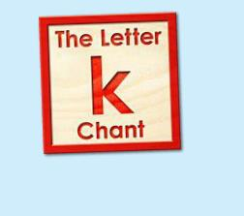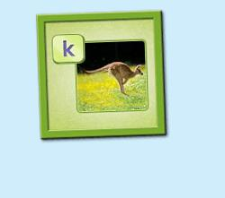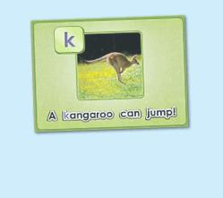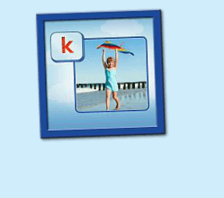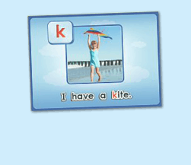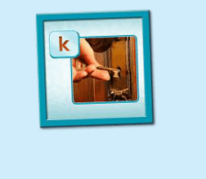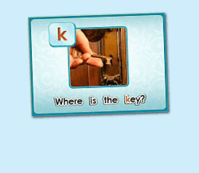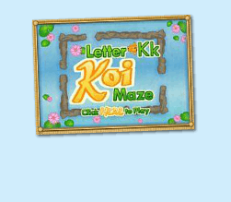
年龄段：小班下
教学目标：
- 能准确流利说出字母K的发音，能理解并认读词汇 kangaroo, kite, key, kitten会表演对应的TPR。
- 能自如演唱所学的chant, 并表演相应诗歌律动。
- 能流利说出 A kangaroo can jump./ I have a kite./ Where is the key? 这3个句型。
教具准备：
1. 字母K开头的单词卡片 2. 字母K的图卡
使用游戏：
1. Run the Dice 2. What is Missing Game 3. 歌词接龙
教学步骤：
- 成果公布及展示  T:Hello kids, Good morning./ good afternoon.  S:Hello ...  T:First, let's praise Lily, Andy..., they have finished their activities.  Lily, come here please, please show us your activities.  Lily:OK. (请完成家庭活动的幼生上前自从操作网站，向其余幼生展示家庭活动成果)  T:Lily, please show us your pet/ room/ avatar/ aquarium/ hamster/ tickets.  T:Wonderful!  T:Everybody comes on! Tomorrow please show us your pet/ room/ avatar/ aquarium/ hamster/ tickets, OK?  S:OK!  （关于我-我的鱼缸）  T: Linda, come here please, can you show us your aquarium?（请一位幼生上前展示我的房间，掌握介绍句型）  Linda: OK!（请幼生自主打开我的房间）  T: Linda, Is this your aquarium?  Yes, this is ...  Linda: Yes, this is my aquarium.  T: Good! How many fishes do you have?  I have ...  Linda: I have Three fishes.  T: Good job!  T: Kids, How many fishes does Linda have?  Linda has ....（引导幼生说出完整句型）  S: Linda has three fishes.  T: Good job!  T: Linda, What color is this one?  This one is...  Linda: This one is yellow.  T: Kids, what color is this one?  S: This one is blue.  T: Good job! Linda, can you introduce your room again?  Linda: Yes. This is my aquarium, I have three fishes. This one is Yellow, this one is...（若幼生有卡壳，教师可做提示）  T: Good job! |  | 公布家庭活动成果并展示我的鱼缸
二、集体学习活动  温故知新---单词对对碰  T:Now, everybody looks at these pictures, what is it? （教师出示字母和词汇卡片图卡，快速复习一遍）  S:It is letter K/ kangaroo/ kite/ key/ kitten.  T:What sound does letter K make?  S:Letter K says "k".  温故知新---谁是大歌星  T：Good! Now let's chant. Are you ready?（教师点击（图1）播放诗歌，可选择静音，或者把音乐关小，让幼生边唱边做TPR，检验幼生掌握诗歌的程度）  S:Yes, we are ready.  S:Letter k says "k"/ "k", "k", "k"/ kite, kangaroo, key/ "k" letter k.  T:Good job! Now boys and girls would have a match, OK?  S:OK!  T:Let's go!  Bs:Letter k says "k"/ "k", "k", "k"  Gs:kite, kangaroo, key/ "k" letter k.  T:What is the sentence? （教师出示句子卡片或打开拼图素材（图2），请幼生说出句子）  S:...  T:A kangaroo ...  S:A kangaroo can jump ...  T:Good job! So what's the sentence?  S:A kangaroo can jump.  T:Good job!  T:Let's sing the next chant. Are you ready?  S:Yes, we are ready! （教师点击播放（图3）诗歌，可选择静音，或者把音乐关小，让幼生边唱边做TPR，检验幼生掌握诗歌的程度）  S:Letter k says "k"./ "k" "k" kangaroo./ A kangaroo can jump./ "k" letter k.  T:Good! Let's play a game! （可用Run the Dice游戏复习诗歌）  （把诗歌的句子黏在一个骰子上，或者制作制作成一个骰子，教师投掷骰子，快速唱出朝上的句子，可把幼生分为两组进行）  S:Letter k says "k"./ "k" "k" kangaroo./ A kangaroo can jump./ "k" letter k.  T:Good job!  快乐唱片机  T:Let's learn a new chant, OK?  （教师点击（图4）诗歌素材，让幼生带着任务仔细聆听；教师可同时与幼生互动，或者做TPR进行提示）  S:OK!  T:Listen and no voice, and then tell me what can you hear, OK?  S:OK!  T:What can you hear?  S:Letter k says "k"/ kite...  T:Good job！Let's check it. Listen and no voice.  Is it right?  S:Yes.  T:OK, this time, we listen again and find something new, OK?  S:OK!  T:What can you hear? (this time)  T:Can you hear " I have a ...? " ?  S:Yes.  T:Let's check it again. (教师配合TPR动作，加快幼生理解诗歌)  T:Now, listen and repeat. （教师配合手势和动作引导幼生，教师唱的那遍听，学生唱的那遍跟唱，跟唱2-3遍）  S:Letter k says "k". / "k", "k", kite. / I have a kite/ "k" letter k.  T:Good job! Now, let's add some action to the chant. Follow me please.  （教师带领幼生边听边做动作，第一遍先不唱）  T:One more time. （第二遍第三遍边唱边跳）  T:Good job!  Puzzle Time  T:Puzzle Time!  T:Now, listen and no voice. And tell me what can you hear, OK?（教师点击（图5）句子拼图素材，选择难度级别1，完成句子拼图，请幼生仔细聆听）  S:OK!  T:Tell me what can you hear.  S:I have a kite.  T:Good job! Let's check it, is it right?  S:Yes.  T:Good! Follow it. （教师点击小喇叭，请幼生跟读2-3遍）  S:I have a kite. （请幼生跟读2-3遍）  T:Good job! Let's have a match, team A and team B, are you ready?  S:Yes.  TA:I/ have/ a/ kite.  TB:I/ have/ a/ kite.  T:Good! TB get one point.  （What is missing game:轮流空出kite; 提问幼生不见的单词应该放哪里）  T:Now, look (at the puzzle), what is missing?  S:kite.  T:Where can I put it? Here?  S:Yes.  T:Good! Who wants to try? Linda please. （选择难度级别2-3级，请幼生上台操作拼图，其余幼生跟读）  T:Good job! Thank you Linda.  T:What's the sentence?  S:...  T:Follow it. (播放一遍句子，让幼生跟读)  T:What's the sentence?  S:I have a kite.  T:Good!  （替换造句:可使用任意道具或者幼生熟悉的词汇卡片）  T:Look, What is this?  S:pen, pencil  T:So, I have a ...  S:I have a pen, pencil...  T:Good job!  T:Good job!  歌词接龙  T:Now, let's sing the chant one by one, are you ready? （复习诗歌，让幼生轮流，每人清唱一句，最后分小组轮流唱一句）  S:Letter k says "k"./ "k", "k", kite./ I have a kite / "k" letter k.  T:Good job!  快乐唱片机  T:Now, let's learn the next chant, OK?  (教师点击 （图6） 诗歌素材，让幼生带着任务仔细聆听；教师可同时与幼生互动，或者做TPR进行提示)  S:OK!  T:Listen and no voice, and then tell me what can you hear, OK?  S:OK!  T:What can you hear?  S:K, "k", key  T:Good job! Let's check it. Listen and no voice.  Is it right?  S:Yes.  T:OK, this time, we listen again and find something new, OK?  S:OK!  T:What can you hear (this time)?  S:K, "k", where is ...?  T:Is it right?  T:Let's check it again. （教师配合TPR动作，加快幼生理解诗歌）  T:Now, listen and repeat. （教师配合手势和动作引导幼生，教师唱的那遍听，学生唱的那遍跟唱，跟唱2-3遍）  S:Letter k says "k"/ "k" "k" key/ Where is the key? / "k" letter k.  T:Good job! Now, let's add some action to the chant. Follow me please.  （教师带领幼生边听边做动作，第一遍先不唱）  T:One more time.（第二遍第三遍边唱边做）  T:Good job!  Puzzle Time  T:Puzzle Time!  T:Now, listen and no voice. And then tell me what can you hear，OK？(教师点击（图7）句子拼图素材，选择难度级别1，完成句子拼图，请幼生仔细聆听)  S:OK!  T:Tell me what can you hear.  S:Where is the key.  T:Good job! Let's check it, is it right?  S:Yes.  T:Good! Follow it.（教师点击小喇叭，请幼生跟读2-3遍）  S:Where is the key?（请幼生跟读2-3遍）  T:Good! Let's have a match, team A and team B, are you ready?  S:Yes!  TA:Where/ is/ the/ key.  TB:Where/ is/ the/ key.  T:Good! TA gets one point.  （What is missing game:轮流空出where, key; 提问幼生不见的单词应该放哪里）  T:Now, look at (the puzzle), what is missing?  S:where, key.  T:Where can i put it? Here?  S:Yes!  T:Good! Who wants to try? Luna please. （选择难度级别2-3级，请幼生上台操作拼图，其余幼生跟读）  T:Good job! Thank you, Luna.  T:What's the sentence?  S:Where is the key.  T:Follow it.（播放一遍句子，让幼生跟读）  T:What's the sentence?  S:Where is the key.  T:Good job!  （替换造句：可使用任意道具）  T:Look, What is this?  S:bag, pen, book..... （教师把任意道具藏起来）  T:Where is the bag?  Follow me.  S:Where is the bag?  T:Where ... （教师把任意道具藏起来，可用嘴型引导孩子）  S:Where is the pen/ book...?  T:Good job!  欢乐大迷宫  T:Let's play the letter T koi maze. Who wants to try? (教师打开（图8）字母迷宫，邀请幼生上前操作，其余幼生跟读发音)  S:Let me try.  T:Sam please. Everybody listen and repeat.  S:k …  T:Wow, Excellent!! |  | 图1：  图2：  图3：  图4：  图5：  图6：  图7：  图8：
三、家庭游戏活动布置：  T:Now, I'll show you the activities. (将已放入功课的作业界面打开)  Here are your activities for today.  You have to do these activities.  How many activities? Let's count together.  S:One, two, three, four.  T:You have to do these activities, OK?  S:OK!  T:Each of them, you need to play 5 times. OK?  S:OK!  T:Look at me, I will show you.  Please listen and repeat. (加上肢体动作演示)  OK？  S:OK！  T:Clear?  S:Yes!  T:Who can show us how to do it?  S:Let me try!  T:Mary come here and show us how to do the activities. (每一位幼生上前演示如何操作)  T:Good job! Thank you Mary!  T:Who can retell how to do it?  S:Let me try!（教师可引导幼生）  T:Good! Please finish your activities and show me tomorrow, OK?  S:OK  T:Class is over, Goodbye, everyone.  S:Goodbye. |  | 家庭游戏活动：  