Letter K-课时4
复习内容：  - Alphabet Sentence Chant:k, kangaroo  - Alphabet Sentence Chant:k, kite  - Alphabet Sentence Chant:k, key  - The Letter k Chant | 新授素材截图：  - The Sound of Letter K Song  - The Letter k Book  - Alphabet Painting:k is for kiwis
素材截图：
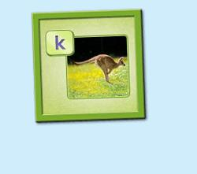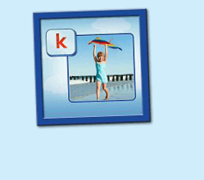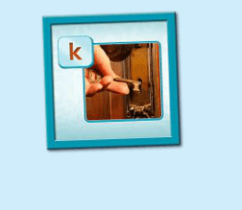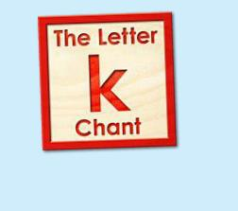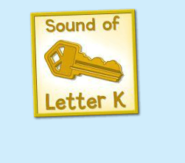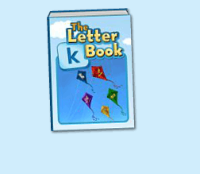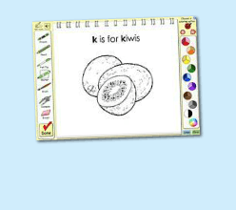
教学目标：
1. 认识The Letter k Book, 能掌握和认读书中的词汇，并能用K is for... 句型造句。
2. 能自如演唱The Sound of Letter K Song, 并表演相应歌曲律动。
教具准备：
1. 图书对应的词汇图卡 2. 诗歌歌词卡片
使用游戏：
1. Run the Dice 2. Taboo Game
教学步骤：
- 成果公布及展示  T:Hello, Kids. Good morning./ Good afternoon.  S:Good morning./ Good afternoon.  T:Before class let's praise Coco, Tina...  They have finished their activities...  Coco come here please, can you show us your activities?  Coco:Yes.  T:OK, show us please.（请完成家庭活动的幼生上前自主操作，向其余幼生展示家庭活动成果）  T:Wonderful! Thank you, Coco.  T:Everyone come on! Tomorrow please show us your activities, OK?  S:OK!  （关于我-我的鱼缸）  T: Linda, come here please, can you show us your aquarium?（请一位幼生上前展示我的房间，掌握介绍句型）  Linda: OK!（请幼生自主打开我的房间）  T: Linda, Is this your aquarium?  Yes, this is ...  Linda: Yes, this is my aquarium.  T: Good! How many fishes do you have?  I have ...  Linda: I have Three fishes.  T: Good job!  T: Kids, How many fishes does Linda have?  Linda has ....（引导幼生说出完整句型）  S: Linda has three fishes.  T: Good job!  T: Linda, What color is this one?  This one is...  Linda: This one is yellow.  T: Kids, what color is this one?  S: This one is blue.  T: Good job! Linda, can you introduce your room again?  Linda: Yes. This is my aquarium, I have three fishes. This one is Yellow, this one is... （若幼生有卡壳，教师可做提示）  T: Good job!  - 集体学习活动  快乐唱片机  T:Now, let's chant. Are you ready?（教师依次点击（图1-图4）素材，可选择静音或者把音乐关小，让幼生边唱边做TPR，检验幼生掌握诗歌的程度）  S:Yes, we are ready.  S:Letter k says "k"/ "k", "k", "k"/ kite, kangaroo, kite/ "k" letter k.  T:Good! Now boys and girls would have a match, OK?  S:OK!  T:Let's go!  Bs:Letter k says "k"/ kite, kangaroo, kite  Gs:"k", "k", "k"/ "k" letter k  T:Let's chant and do the action.（把音乐关小，让幼生边唱边做TPR）  T:Good job! Let's play a game!（可用Run the Dice游戏复习诗歌）  T:What's the sentence?（把歌词黏在一个骰子上面，或者直接制作一个骰子，教师投掷骰子，快速说出朝上的句子，可分组进行）  S:Letter k says "k"/ "k" "k" kite/ I have a kite/ "k" letter k  Letter k says "k"/ "k" "k" key/ Where is the key/ "k" letter k  T:Good job! Let's chant and do the action.（把音乐关小，让幼生边唱边做TPR）  T:Well done!  T:Now, let's listen a new song, no voice.  And then tell me what can you hear, OK? （教师点击（图5）歌曲，请幼生仔细聆听歌曲，不跟唱；同时教师可与幼生互动，或者做TPR进行提示）  S:OK!  T:What can you hear?  S:k letter "k"./ key....  T:Let's check it, listen again, no voice... （再播放一遍歌曲，在幼生提到的部分提出表扬，没有提到的部分可用TPR做提示）  Is it right?  S:Yes!  T:Good job! Listen and repeat.（利用暂停播放键，先跟唱前两句，后两句可示意幼生先听不跟唱）  S:Hear the sound of letter k/ "k" "k" k  T:Good job! Continue.（利用暂停播放键，让幼生逐句跟唱3-4句）  S:Hear the sound of letter k/ "Key!" Sing it with me.  T:Good!  (加入Taboo game:教师首先制定某个单词为不能说出的，在幼生跟唱时遇到制定的单词用拍手的方式代替发音)  T:Let's play a Taboo game. k is a taboo, don't say k, you should clap your hands, OK? （教师可以跟着幼生一起做活动，不能说的词汇教师提前给予提示动作，例如做拍手的手势，或者第一句由教师先来示范，后面的由幼生接龙）  S:OK!  T:Are you ready?  S:Yes, we are ready!  Hear the sound of letter ( )/ "k" "k" "k"/ Hear the sound of letter ( )/ "Key!" Sing it with me.  T:Good job! This time "k" is a taboo, when you sing to "k", you should clap your hands, OK? Are you ready?  S:Yes, we are ready! ...  T:So good! Now, let's add some actions. Stand up, look at me and follow the music. (带领幼生边做TPR边跟唱)  T:Wow, Excellent! Once again.  Terrific! Now who wants to try? Lucy come here please, you will be the little teacher, everybody follows Lucy.  T:Good! Thank you Lucy, go back to your seat, please.  T:Now, let's read a book. （教师点击（图6）图书素材）  T:Listen, no voice. And then tell me what's the name of this book. (教师加以手势动作示意幼生认真听书的名字，不跟读)  T:What is the name of this book?  S:The letter k book.  T:Let's check it, listen again.（再播放一遍书名）  Is it right?  S:Yes.  T:listen and repeat it.（再播放一次书名，让幼生跟读）  S:The letter k book.  T:Tell me again, What's the name of this book?  S:The letter k book.  T:Good job! Let's continue. Listen and no voice. (完整播放一遍图书，教师可与幼生互动，或者做TPR提示)  T:Tell me what can you hear/ find/ see.  S:key, king, kitten...  T:Good! Let's check it and find something new! （完整播放一遍图书，在幼生说到的部分提出表扬，在幼生没有说到的部分可用TPR进行引导）  T:Good job! Can you find something new?  S:kangaroo...  T:Let's check it again. （完整播放一遍图书，在幼生说到的部分提出表扬，在幼生没有说到的部分可用TPR进行引导）  T:Is it right?  S:Yes!  T:Now, let's listen and repeat the book. （让幼生跟读2-3遍）  （教师可利用暂停翻页键，对较难的词汇进行重复跟读）  T:Good job!  T:What sound does letter K make?  S:Letter K says "k".  T:Now, let's add some actions.（播放图书，教师带领幼生做TPR2-3遍）  （第一遍可不跟读，只做TPR；第二三遍边跟读边做TPR）  Listen and Match  T:Good! Now, let's play a game.（教师拿出图书中词汇对应的图卡，点击自动播放，轮流让幼生上前根据听到的词汇挑出图卡）  T:Look! I have some pictures. Do you want to play the choose the cards game?  S:Yes!  T:I will put the cards on the floor, please choose the cards that you hear.  OK?  S:OK!  T:Good job! Now, let's listen and match the picture one by one.（让幼生轮流进行）  T:Good job！  T:This time, we listen and find the picture.（使用图卡，点击自动播放，轮流让幼生上前根据听到的词汇挑出图卡，并让幼生跟读）  T:Everyone, please come here and choose the cards one by one. (让幼生轮流进行listen and match，并让幼生跟读）  T:repeat it.  T:Good job! Who wants to try?  S:Let me try.  T:OK, Tom and John come here, listen and match the cards.（同时用手势引导其余幼生跟读词汇）  T:Now, let's listen and match the cards.（关闭平台画面，点击自动播放，打乱卡片顺序，轮流让幼生上前根据所听到的词汇挑出实物卡片，教师加以动作引导幼生跟读）  T:Everyone, please come here and choose the card one by one.（让幼生轮流进行listen and match, 让其余幼生跟读）  T:Good job!  T:Who can try?  S:Let me try.  T:Lucy and Rio come here please. Listen and match the cards.（邀请1-2位幼生上台听单词和配对图卡，教师用手势引导幼生跟读）  T:Great job!  Guessing Game  T:Now, let's play a guessing game.（回到平台，加入guessing game, 教师可利用暂停播放键让幼生猜图书下一页的词汇是什么）  T:Listen (carefully) and repeat.  S:key/ king/ kitten...  T:What is the next word?  S:kangaroo.  T:kangaroo? Let's check.  T:Good job! Follow it.  S:kangaroo  T:Good, continue.  T:You all did a good job! Now look, what is this?（所以图卡排好顺序后，教师出示图卡询问幼生图卡内容，整体回顾词汇一遍）  S:k...  T:Good!  T:Let's do some painting. （教师打开（图7）涂色素材）  T:First, let's listen the sentence. （教师点击喇叭，让幼生听发音）  T:Listen again, And then tell me what can you hear, OK?  S:OK!  T:Quick response, what can you hear? One, two, three!  S:k is for kiwis.  T:Let's check it.（再播放一次句子，检验答案）  Is it right?  S:Yes!  T:Good, Grace, you are the first, come here, please.  T:Please choose your favorite tools.  T:What is this?  Grace:pencil/ felt-tip/ brush/ marker/ crayon (让幼生选择一种工具，带领其余幼生跟读2-3遍)  T:What color do you like？  Grace:red/ pink... （让幼生跟读所选的颜色）  T:What color do you like?  S:red/ pink....（让其余幼生跟读）  T:Finished?  S:Yes.  T:Thank you Grace.  Is it beautiful?  S:Yes.  T:Now listen and repeat.（让幼生跟读2-3遍）  S:k is for kiwis.  T:Good job. What's this?（老师做TPR，复习前面所学过的词汇 kangaroo, key, kite, kiwis.....）  S:kangaroo, key, kite, kiwis..  T:Good job! What about this?（无法做TPR的词汇，教师可出示单词卡片，教师做动作引导幼生造句）  S:K is for kiwis.  T:Excellent! |  | 公布家庭活动成果并展示我的鱼缸  图1：  图2：  图3:  图4：  图5：  图6：  图7：
三、家庭游戏活动布置：  T:Now, I'll show you the activities. (将已放入功课的作业界面打开)  Here are your activities for today.  You have to do these activities.  How many activities? Let's count together.  S:One, two, three, four.  T:You have to do these activities, OK?  S:OK!  T:Each of them, you need to play 5 times. OK?  S:OK!  T:Look at me, I will show you.  Please listen and repeat. (加上肢体动作演示)  OK？  S:OK！  T:Clear?  S:Yes!  T:Who can show us how to do it?  S:Let me try!  T:Mary come here and show us how to do the activities. (每一位幼生上前演示如何操作)  T:Good job! Thank you Mary!  T:Who can retell how to do it?  S:Let me try!（教师可引导幼生）  T:Good! Please finish your activities and show me tomorrow, OK?  S:OK  T:Class is over, Goodbye, everyone.  S:Goodbye. |  | 家庭游戏活动:

