Letter K -课时6
复习内容：  - The Sound of Letter K Song  - The Letter k Book  - Sentence Puzzle:Letter k, kangaroo  - Sentence Puzzle:Letter k, kite  - Sentence Puzzle:Letter k, key | 新授素材内容：  - Alphabet Jigsaw:Kk is for  - All About Kk Memory Match  - Simple Letter Story:K
素材截图：
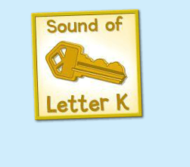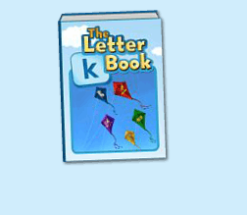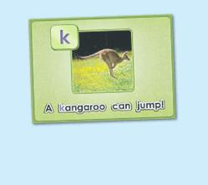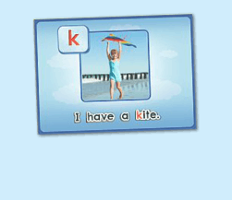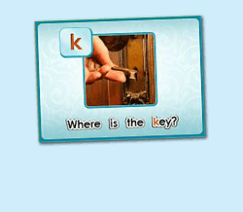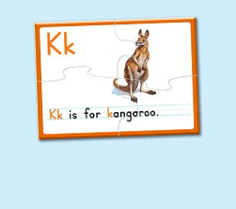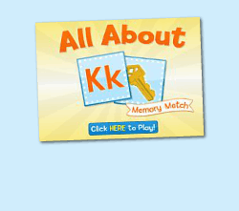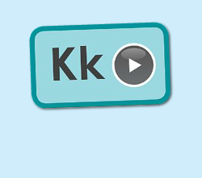
年龄：小班下
教学目标：
- 熟练运用K is for...的句型，能够自如替换句型。
- 字母故事初步熟悉。
教具准备：
1. 单词图书的词汇卡片
使用游戏：
1. 过小桥游戏 2. 闪电图卡 Game
教学步骤： |  | 备注
- 成果公布及展示  T:Hello, Kids. Good morning./ Good afternoon.  S:Good morning./ Good afternoon.  T:Before class let's praise Coco, Tina...  They have finished their activities...  Coco come here please, can you show us your activities?  Coco:Yes.  T:OK, show us please. (请完成家庭活动的幼生上前自主操作，向其余幼生展示家庭活动成果)  T:Wonderful! Thank you, Coco.  T:Everyone come on! Tomorrow please show us your activities, OK?  S:OK!  （关于我-我的鱼缸）  T:Linda, come here please, can you show us your aquarium?（请一位幼生上前展示我的房间，掌握介绍句型）  Linda:OK!（请幼生自主打开我的房间）  T:Linda, Is this your aquarium?  Yes, this is ...  Linda:Yes, this is my aquarium.  T:Good! How many fishes do you have?  I have ...  Linda:I have Three fishes.  T:Good job!  T:Kids, How many fishes does Linda have?  Linda has ...（引导幼生说出完整句型）  S:Linda has three fishes.  T:Good job!  T:Linda, What color is this one?  This one is...  Linda:This one is yellow.  T:Kids, what color is this one?  S:This one is blue.  T:Good job! Linda, can you introduce your room again?  Linda:Yes. This is my aquarium, I have three fishes. This one is Yellow, this one is...（若幼生有卡壳，教师可做提示）  T:Good job! |  | 公布家庭活动成果并展示我的鱼缸
二、集体学习活动：  温故知新---谁是大歌星  T:Let's sing a song, OK? Stand up please. Are you ready? (教师点击（图1）复习歌曲素材，可选择静音或者把音乐关小，让幼生边唱边做TPR，检验幼生掌握歌曲的程度)  S:Yes, we are ready.  Hear the sound of letter k. "k" "k" k. "k" "k" k. Hear the sound of letter k. "Key!" Sing it with me.  （过小桥游戏：老师可以用中文解释游戏规则；老师把歌词做成卡片，老师讲歌词卡片摆在地上，每个小朋友需要跳过卡片然后唱出歌词，检验每一个小朋友的掌握程度）  T:Good job!  趣味复读机  T:Now let's read the letter k book, listen and repeat.（教师点击播放（图2）复习素材，可使用多种分组形式，请幼生跟读2-3遍）  S:key, king, kitten....  T:Very good. Now, let's have a match, boys and girls, are you ready? (请幼生分组进行，教师加以手势做引导)  S:Yes, we are ready.  Bs:key, kitten...  Gs:king, kangaroo...  T:You all did a good job, you will get one point.  ( Listen and Match Game )  T:Now let's play the listen and match game.（教师关闭平台画面，点击自动播放，打乱卡片顺序，轮流让幼生上前根据所听到的词汇挑出对应的图卡，教师加以动作引导其余幼生跟读。遇到难的词汇，教师可用TPR做提示）  T:Everyone, please come here and choose the card one by one.（让幼生轮流进行listen and match, 让其余幼生跟读）  T:Good job!  T:Who can try?  S:Let me try.  T:Lucy and Amy come here please. Listen and match the cards.（邀请1-2位幼生上台听单词和配对图卡，教师用手势引导幼生跟读）  T:Good job! Lucy and Amy, please go back to your seat, thank you!  T:Now, look! What is this? (所有图卡排好顺序之后，教师出示图卡询问幼生图卡内容，整体回顾词汇一遍)  S:key, king, kitten, kangaroo  T:Good!  句子拼拼乐  T:Let's do some puzzle!  What's the name of the puzzle.（教师依次点击（图3-5）复习拼图素材，先请幼生说出拼图名字，可以配合动作给予提示，再进行核对）  S:A kangaroo can jump.  T:Right? Let's check it, who can try? （请幼生上前操作拼图，幼生仔细听发音）  S:Let me try.  T:Jay, please. Everybody listen and repeat.  Right?  S:Yes.  T:Repeat again.  S:A kangaroo can jump.  T:Great! Thank you Jay.  换乐无穷  T:Great! Can you make a sentence?（教师拿出学过的动物的图卡，让幼生造句）  S:A dog can jump.  T:What about this？  S:A cat can jump  T:Good! Can a dog run? （教师可用TPR提示，替换"jump"造句）  S:Yes.  T:So... A kangaroo can ...  S:A kangaroo can jump.  T:Good job!  T:The next puzzle.  What is the name of this puzzle?（教师点击下一个拼图素材，先请幼生说出图片名字，可以配合动作给予提示，再进行核对）  S:I have a kite.  T:Let's check it, Ashley you are the first, come here please. Everybody listen and repeat.（请一位幼生上前操作拼图，其他幼生仔细听发音）  Is it right?  S:Yes.  T:Repeat again.  S:I have a kite.  换乐无穷  T:Can you use these words to make sentences? （教师出示图书单词卡片，用k is for...句型进行替换造句）  k is for... (教师可以先做示范，引导幼生活用句型）  S:k is for ...  T:Good! What is this? （教师拿出任意道具）  S:a pen/ a ball...  T:So... What do i have?  I have ...  S:I have a pen/ a ball.  T:Good job!  句子拼拼乐  T:Good! Next puzzle!  What is the name of this puzzle? (教师点击打开第3个拼图素材，先请幼生说出拼图名字，可以配合动作给予提示，其他幼生仔细听发音)  S:Where is the key?  T:Is it right? Let's check.  Is it right?  S:Yes!  T:Repeat again.  S:Where is the key?  T:Good! Now, make the sentence.（教师拿出道具，做出藏起来的动作）  T:Where is the ...?  S:Where is the pen?  T:What about this?  S:Where is the pencil?  T:Good job!  T:Now, let's do a new puzzle, OK?  S:OK!  T:Look, what can you see（in the picture）？（教师点击（图6）进入拼图素材，先询问幼生图片的内容）  S:kangaroo.  T:Good job! Let's do the puzzle first.  Lisa, come here please, please finish the puzzle, and everybody listen the sentence, and then tell me what can you hear, OK?（请一位幼生上前操作，让其余幼生听小喇叭发声）  S:OK!  T:Thank you, Lisa. Go back to your seat please.  Tell me what can you hear.  S:Kk is for kangaroo.  T:Is it right? Let's check it.（教师点击小喇叭，让幼生听句子发音）  Is it right?  S:Yes.  T:Now, listen and repeat.（让幼生点击小喇叭2-3遍，让幼生跟读）  S:Kk is for kangaroo.  T:Good! Look, what is this sentence. （教师把学过的K开头的词汇放在kangaroo的位置，让孩子替换单词说出句子）  S:Kk is for kite./ key./ king...  T:Good!  闪电卡片Game  T:Now, let's play a game. (可以用中文和肢体动作解释游戏规则：老师快速在孩子面前闪过卡片，让孩子猜是哪个单词，然后说出 K is for ...的句子）Are you ready?  S:Yes, I am ready!  T:What is this? K is for...（刚开始可引导孩子）  T:Good！Continue! What is this?  S:Kk is for kangaroo/ king/ kite...  T:Good! Who wants to be little teacher?（邀请2-3名幼生上来操作游戏）  S:Let me try...  T:Lisa/ Lily/ Mandy come here and be the little teacher.  T:Ready, Go!  T:Good job!  T:Story time! （教师点击（图7）字母故事素材）  T:Let's enjoy "simple letter story:Kk". Are you ready?  （教师在播放字母故事的同时，教师可一边做TPR进行提示）  T:This time, please listen and no voice, and then tell me what can you hear, OK?（教师播放字母故事，让幼生带任务聆听）  S:OK.  T:Who can tell me what can you hear?  S:kite....  T:Is it right? Let's check it, and find something new. （教师再播放一遍，在幼生提到的部分进行表扬，在幼生没有提到的部分暂停，进行提示）  Who is this? What is this?（通过提问的方式，让幼生对故事内容进行熟悉）  S:This is Kimmy, this is kite...  T:Good! Let's learn the simple letter story next time.  T:Great! Let's play a game.  First, listen carefully. （点击进入游戏素材（图8），聆听游戏的名称）  What's the name of this name?  S:All about Jj Memory Match.  C:Click here to play, who can try? （请一位幼生点击开始游戏）  S:Let me try.  T:Please say the name of this game.  S:All about Kk Memory Match.  T:Lisa. Have a try.  Everybody listen. （请他们聆听游戏规则1-2次，再点击翻开一张图片）  T:Look and listen (carefully).  T:What can you see? （指着翻过来的图片）  S:I can see...  T:Nice, another one. （继续翻开下一张）  What can you see?  S:I can see....  T:And this one. Wow, bingo! (继续翻开下一张，如果翻到同样的，就两张同时消失)  T:The next one. Who can try?（轮流请幼生上来进行游戏操作）  S:Let me try...  T:Follow it, please. (时间允许的情况下，请幼生跟读词汇)  S:...  （线下延伸配对活动：1）  T:What's this letter?  S:It's letter k.  T:And what's this?（出示单词卡，里面包含已学过的字母k的单词及其他字母的部分词汇）  T:Let's do memory match. Find the word begins with letter k（把单词卡反面朝上摆放好，请幼生上台来翻）  T:Who wants to try?  S:Let me try.  T:Amy, come on.  T:What's this.（等幼生翻完一张卡片后，询问全体）  S:It's ...  T:Incredible. The next.（挑选下一位的同时，举起卡片，示意幼生跟读）  （线下延伸配对活动：2）  T:Let's review. Ready! Go! （出示已学过的单词卡）  Memory match time. Are you ready?（把单词卡反面朝上摆放）  S:Yes, I'm ready.  T:Look and guess. What's this?（做TPR提示）  S:This is ...  T:Bingo. Which one is... （请幼生选择卡片，翻转配对，配对正确，表扬，配对错误，再多给一次机会。）  T:Good! How about this one?  （线下延伸配对活动：3）  T:Let's review. Ready! Go! （出示已学词汇的单词卡，每个词汇有2个一样的，3-5组）  T:Memory match time. Who can try? （打乱顺序，依次反面朝上排列）  S:I can try. （请一位幼生上来翻第一张）  T:Well done. What's this?  S:..（请回答得最快的幼生来找出另一张相同的）  T:Gorge, find another one. Wonderful.  T:The same. Bingo. Who can be the next?（翻出另一张相同的后，给予击掌鼓励）  S:...  T:Read it together.  S:...  T:Who can be the next? （请刚才参与的幼生选择一位幼生接力翻卡片）  1S:...  备注：以此类推，完成所有配对。  T:Very good! Now let's count our tickets.  Who can try?  S:Let me try.  T:Tommy please.  Where can we find our tickets?  S:"About me".  T:Tommy click it please.  Now let's count with ABCmouse.  S&ABCmouse:One,two,three....  T:So we have ten tickets today,great job! Thank you Tommy. |  | 图1：  图2：  图3：  图4：  图5：  图6：  图7：  图8：
三、家庭游戏活动布置：  T:Now, I'll show you the activities. (将已放入功课的作业界面打开)  Here are your activities for today.  You have to do these activities.  How many activities? Let's count together.  S:One, two, three, four.  T:You have to do these activities, OK?  S:OK!  T:Each of them, you need to play 5 times. OK?  S:OK!  T:Look at me, I will show you.  Please listen and repeat. (加上肢体动作演示)  OK？  S:OK！  T:Clear?  S:Yes!  T:Who can show us how to do it?  S:Let me try!  T:Mary come here and show us how to do the activities. (每一位幼生上前演示如何操作)  T:Good job! Thank you Mary!  T:Who can retell how to do it?  S:Let me try!（教师可引导幼生）  T:Good! Please finish your activities and show me tomorrow, OK?  S:OK  T:Class is over, Goodbye, everyone.  S:Goodbye. |  | 家庭游戏活动：

