Letter J -课时8
复习内容：  - Alphabet Sentence Chant:k, kangaroo  - Alphabet Sentence Chant:k, kite  - Alphabet Sentence Chant:k, key  - Sentence Puzzle:Letter k, kangaroo  - Sentence Puzzle:Letter k, kite  - Sentence Puzzle:Letter k, key | 新授素材内容：  - Simple Letter Story:K  - Kenny helps kimmy with the kite  - Kimmy's kite flies high in the sky
素材截图：
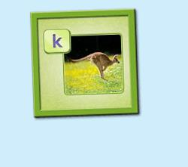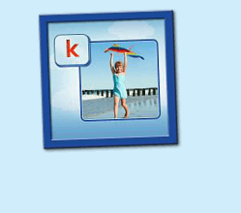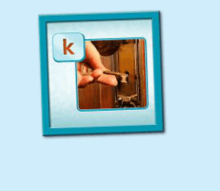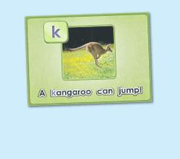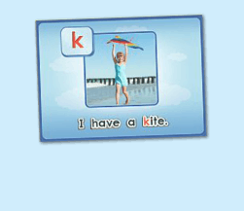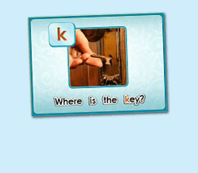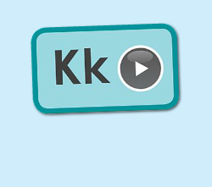
年龄段：小班下
教学目标：
- 复习3首句子诗歌和3个句子
- 学校字母故事3-4句，能表演所学的句子
教具准备：
1. 字母故事卡片、头饰、道具等 2. 字母故事图卡
使用游戏：
1. I do you say game
教学步骤： |  | 备注
- 成果公布及展示  T:Hello, Kids. Good morning./ Good afternoon.  S:Good morning./ Good afternoon.  T:Before class let's praise Coco, Tina...  They have finished their activities...  Coco come here please, can you show us your activities?  Coco:Yes.  T:OK, show us please. (请完成家庭活动的幼生上前自主操作，向其余幼生展示家庭活动成果)  T:Wonderful! Thank you, Coco.  T:Everyone come on! Tomorrow please show us your activities, OK?  S:OK!  （关于我-我的鱼缸）  T:Linda, come here please, can you show us your aquarium?（请一位幼生上前展示我的房间，掌握介绍句型）  Linda:OK!（请幼生自主打开我的房间）  T:Linda, Is this your aquarium?  Yes, this is ...  Linda:Yes, this is my aquarium.  T:Good! How many fishes do you have?  I have ...  Linda:I have Three fishes.  T:Good job!  T:Kids, How many fishes does Linda have?  Linda has ...（引导幼生说出完整句型）  S:Linda has three fishes.  T:Good job!  T:Linda, What color is this one?  This one is...  Linda:This one is yellow.  T:Kids, what color is this one?  S:This one is blue.  T:Good job! Linda, can you introduce your room again?  Linda:Yes. This is my aquarium, I have three fishes. This one is Yellow, this one is....（若幼生有卡壳，教师可做提示）  T:Good job! |  | 公布家庭活动成果并展示我的鱼缸
集体学习活动：  温故知新---小小表演家  T:Let's do some puzzle!  What's the name of this puzzle. （教师依次点击（图1-3）复习句子拼图素材，先请幼生说出拼图名字，可以配合动作给予提示，再进行核对）  S:A kangaroo can jump.  T:Right? Let's check it, who can try? （请一位幼生上前操作拼图，其他幼生仔细听发音）  S:Let me try.  T:Jack, please. Everybody listen and repeat.  Is it right?  S:Yes.  T:Repeat again.  S:A kangaroo can jump.  T:Great! Thank you, Jack.  换乐无穷  T:Great! Can you make a sentence?（教师拿出学过的动物的卡片，让幼生造句）  S:A dog can jump.  T:What about this?  S:A cat can jump.  T:What about this. （教师做TPR）  S:A dog can eat./ A cat can run. （进行动作的替换）  T:Good!  T:The next puzzle.  What is the name of this puzzle? （教师点击下一个拼图素材，先请幼生说出图片名字，可以配合动作给予提示，再进行核对）  S:I have a kite.  T:Let's check it, Andy, you are the first, come here please. Everybody listen and repeat. （请一位幼生上前操作拼图，其他幼生仔细听发音）  Is it right?  S:Yes.  T:Repeat again.  S:I have a kite.  T:Good! Lily, what do you have?  Lily:I have a pen./ book...  T:Good! Linda, what do you have?  Linda:I have a ... （询问多位幼生）  T:Good job!  T:Next puzzle!  What is the name of this puzzle?（教师点击打开第三个拼图素材，先请幼生说出拼图名字，可以配合动作给予提示，再进行核对）  S:Where is the key?  T:Let's check it, Mandy, you are the first, come here please. Everybody listen and repeat. （请一位幼生上前来操作拼图，其余幼生仔细听发音）  Is it right?  S:Yes.  T:Repeat again.  S:Where is the key?  T:Can you make a sentence? （教师把随手拿到的道具藏起来，让幼生造句）Where ...  S:Where is the book?/ Where is the pen?  T:Good job!  温故知新-谁是大歌星  T:Now let's sing the chant. Are you ready?（教师依次点击（图4-图6）诗歌素材，可选择静音或者把音乐关小，让幼生边唱边做TPR，检验幼生掌握诗歌的程度）  S:Yes, we are ready.  T:Let's go!  S:Letter k says "k"/ "k" kangaroo/ A kangaroo can jump/ "k" letter k  （复习3首诗歌）  T:Let's chant and do the action.（把音乐关小，让幼生边唱边做TPR）  T:Good job! Let's play a game! (可用Run the Dice游戏复习诗歌)  T:What's the sentence? (把歌词黏在一个骰子上，或者直接制作成一个骰子，教师投掷骰子，快速说出朝上的句子，可分组进行)  S:...  T:Good job! Who can try? (邀请2-3名幼生，检验个别幼生掌握情况)  T:Abby/ Bob/ Tiffany please sing the chant!（带领其余幼生一起做TPR）  T:Well done!  （字母故事：第二段）  T:Look! Who is this? 教师拿出人物头饰或者故事截图与幼生进行内容回顾）  T:This is ...  S:This is Kimmy.  T:What is this?  S:This is kite.  T:What does Kimmy have?  S:Kimmy has a kite.  T:Let's perform the story. Everybody stand up. Let's perform the "Simple Letter story:Kk" Ready! Go! (教师点击（图7）播放字母故事，带领幼生把学过的内容表演一遍)  S:Simple letter story:Kk, This is kimmy. Kimmy has a kite.  T:Good! Sit down please! Let's repeat. Are you ready? （每次播放1句就暂停，让幼生跟读，以此类推到第3句）  S:This is Kimmy. Kimmy has a kite. Kenny helps Kimmy with the kite.  T:Good！Listen again. （点击播放，第3句播放完后继续暂停）  S:...  T:Repeat it.  S:Kenny helps Kimmy with the kite.  T:Good! Listen again. （点击播放，第3句播放完后暂停）  S:Kenny helps Kimmy with the kite.  T:Repeat it.（在幼生跟读的同时，教师做TPR作引导）  S:Kenny helps Kimmy with the kite.  T:One more time.  S:Kenny helps Kimmy with the kite.  T:Look! Who are they? （教师拿出Kimmy和Kenny的头饰，询问幼生）  This is ...  S:This is Kimmy. This is Kenny.  T:Good! What does Kimmy have?  S:Kimmy has a kite.  T:What did Kenny do? Kenny helps ...  S:Kenny hepls Kimmy with the kite.  T:Is it right? Let's check it. (播放字母故事，至第3句暂停)  Is it right?  S:Yes!  T:Lily and Amy, come here please. （把kite道具或者图卡给Lily）  T:Look! Who has a kite?  S:Lily has a kite.  T:Good! Who helps Lily with the kite? （让幼生做TPR）  S:Amy helps Lily with the kite.  T:Good job! Thank you, Lily and Amy. Go back to your seat please.  T:Continue. （播放字母故事，至第4句暂停）  Listen and repeat. （在幼生跟读的同时，教师做动作串联）  S:This is Kimmy. Kimmy has a kite. Kenny helps Kimmy with the kite. Kimmy's kite flies high in the sky.  T:Repeat it.  S:Kimmy's kite flies high in the sky.  T:One more time.  S:Kimmy's kite flies high in the sky.  T:Do you know what can flies high in the sky?  S:...（可展示一些小鸟或者飞机在天上的图片，加强幼生的理解）  T:Look, what is this?  S:bird/ plane/ helicopter  T:So ... What flies high in the sky?  S:Bird/ plane/ helicopter  T:A bird/ plane/ helicopter flies ... （引导幼生说出完整句子）  S:A bird/ plane/ helicopter flies high in the sky.  T:Good job! Who can try?  S:Let me try.  T:Lisa, look, what flies high in the sky?  L:A helicopter flies high in the sky.  T:Good! Olaf, look, what flies high in the sky?  O:A bird flies high in the sky.  T:Good job! Look, what flies high in the sky? （回到原字母故事画面上）  Kimmy's kite ...  S:Kimmy's kite flies high in the sky.  T:Good job! Who can do the action?  S:Let me try!  T:Bobby, come here please, you do the action, and other people say the sentence, OK? （让幼生发挥想象力，做第3-4句的TPR）  S:OK!  S:Kenny helps Kimmy with the kite. Kimmy's kite flies high in the sky.  T:Good job! Thank you Bobby. Go back to your seat please.  T:Who wants to be Kimmy and Kenny? （请幼生做Role play）  S:Let me try!  T:Tom and Tina come here, other people say the sentence.  S:This is Kimmy. Kimmy has a kite. Kenny helps Kimmy with the kite. Kimmy's kite flies high in the sky.  T:Good job! Thank you, Tom and Tina. Go back to your seat, please.  Everybody stand up, follow me.（教师带领幼生做学过的句子的TPR，第1次可要求幼生不跟到，边听边做。第2-3次边跟读边做TPR）  T:Good! Let's review. Look at the picture. （教师拿出字母故事前4句的图片，以此展示给幼生看，回顾句子）  S:This is Kimmy ...  T:Good! Everybody stand up. "Simple Letter Story:Kk" Ready! Go!  （教师带领幼生把学了的句子再复习一遍，同步播放字母故事） |  | 图1：  图2：  图3：  图4：  图5：  图6：  图7：
三、家庭游戏活动布置：  T:Now, I'll show you the activities. (将已放入功课的作业界面打开)  Here are your activities for today.  You have to do these activities.  How many activities? Let's count together.  S:One, two, three, four.  T:You have to do these activities, OK?  S:OK!  T:Each of them, you need to play 5 times. OK?  S:OK!  T:Look at me, I will show you.  Please listen and repeat. (加上肢体动作演示)  OK？  S:OK！  T:Clear?  S:Yes!  T:Who can show us how to do it?  S:Let me try!  T:Mary come here and show us how to do the activities. (每一位幼生上前演示如何操作)  T:Good job! Thank you Mary!  T:Who can retell how to do it?  S:Let me try!（教师可引导幼生）  T:Good! Please finish your activities and show me tomorrow, OK?  S:OK  T:Class is over, Goodbye, everyone.  S:Goodbye. |  | 家庭游戏活动：

