Letter K-课时2
复习素材内容：  - Basics letters:Kk is for kangaroo  - Basics letters:Kk is for key  - Basics letters:Kk is for kite  - Basics letters:Kk is for kitten | 新授素材内容：  - The letter k Chant.  - Sentence Puzzle:Letter k, kangaroo.  - Alphabet Sentence Chant:k, kangaroo.
素材截图：
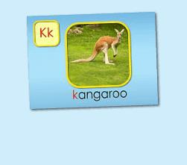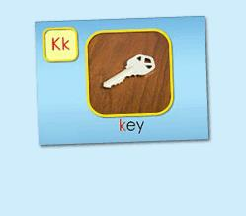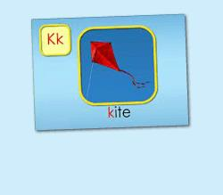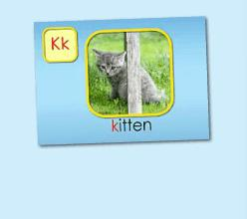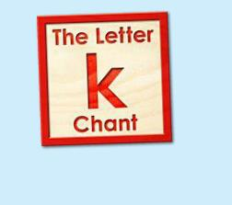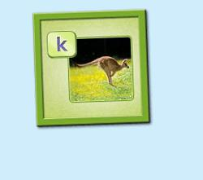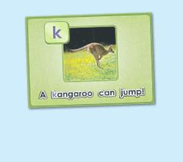
年龄段：小班下
教学目标：
- 能准确流利说出字母K的发音，能理解并认读词汇 kangaroo, key, kite, kitten会表演对应的TPR。
- 能自如演唱The Letter k chant和Alphabet sentence:k, kangaroo, 并表演相应诗歌律动。
- 能流利说出 A kangaroo can jump.
教具准备：
1. 字母K开头的单词卡片 2. 字母K的图卡 3. 其他已学过动物
使用游戏：
1. I do you say game 2. Missing game
教学步骤：
- 成果公布及展示  T:Hello kids, Good morning./ good afternoon.  S:Hello ...  T:First, let's praise Lily, Andy..., they have finished their activities.  Lily, come here please, please show us your activities.  Lily:OK. (请完成家庭活动的幼生上前自从操作网站，向其余幼生展示家庭活动成果)  T:Lily, please show us your pet/ room/ avatar/ aqurium/ hamster/ tickets.  T:Wonderful!  T:Everybody comes on! Tomorrow please show us your pet/ room/ avatar/ aquarium/ hamster/ tickets, OK?  S:OK!  (关于我-我的鱼缸)  T: Linda, come here please, can you show us your aquarium?（请一位幼生上前展示我的房间，掌握介绍句型）  Linda: OK!（请幼生自主打开我的房间）  T: Linda, Is this your aquarium?  Yes, this is ...  Linda: Yes, this is my aquarium.  T: Good! How many fishes do you have?  I have ...  Linda: I have Three fishes.  T: Good job!  T: Kids, How many fishes does Linda have?  Linda has .... （引导幼生说出完整句型）  S: Linda has three fishes.  T: Good job!  T: Linda, What color is this one?  This one is...  Linda: This one is yellow.  T: Kids, what color is this one?  S: This one is blue.  T: Good job! Linda, can you introduce your room again?  Linda: Yes. This is my aquarium, I have three fishes. This one is Yellow, this one is... （若幼生有卡壳，教师可做提示）  T: Good job! |  | 公布家庭活动成果并展示我的鱼缸
二、集体学习活动  趣味复读机  T:Now, let's begin our class! First, please listen and repeat. （教师点击进入素材（图1-4），请幼生快速跟读网站平台发音，复习字母K的发音及3个基础词汇）  S:K, "k", kangaroo, key, kite, kitten..  I do you say  T:Very good! Now, look at me and guess what is it, OK?  S:OK!  T:What is it? It is ...（引导幼生用完整句型回答）  S:It is letter K./ kangaroo/ key/ kite/ kitten  T:Who wants to try?  S:Let me try.  T:Tina/ Bobby come here, you do the actions and ask what is it, OK? （邀请2-3名幼生做TPR，询问其余幼生）  Tina/ Bobby:OK! What is it?  S:It is letter K./ kangaroo/ key/ kite/ kitten  T:Good job! Thank you. Go back to your seat, please！  T:Good job! Now, let's listen a chant and tell me what can you hear, OK?  （教师点击（图5）诗歌素材，让幼生带任务仔细聆听，教师同时与幼生互动，或者做TPR提示）  S:OK!  T:What can you hear？  S:Letter k says "k"... / kite, kangaroo, key  T:Good job! Let's check it, listen and no voice. （教师再播放一遍诗歌）  Is it right?  S:Yes.  T:OK, this time, we listen again and find something new, OK?  S:OK!  T:What can you hear (this time)?  S:...  T:Let's check it again.（教师配合TPR动作，加快幼生理解诗歌）  T:Now, listen and repeat.（教师配合手势和动作引导幼生，教师唱的那遍听，学生唱的那边跟唱，跟唱2-3遍）  S:Letter k says "k". "k" "k" "k". Kite, kangaroo, key. "k" letter k.  T:Now, let's add some action to the chant. Follow me please. （教师带领幼生边听边做动作，第一遍先不听）  T:One more time. （第二第三遍边唱边做）  T:Good job!  T:Now, let's listen next chant and tell me what can you hear, OK? （教师点击（图6）诗歌素材，让幼生带着任务仔细聆听；教师可同时与幼生互动，或者做TPR提示）  S:OK!  T:What can you hear?  S:Letter k says "k"/ "k" "k" kangaroo/ A Kangaroo can jump / "k" letter k.  T:Good job! Let's check it, listen and no voice.（教师再播放一遍诗歌）  Is it right?  S:Yes.  T:OK, this time, we listen again and find something new, OK?  S:OK!  T:What can hear (this time)?  S:....  T:Can you hear "jump"?  S:Yes.  T:Let's check it again. （教师配合TPR动作，加快幼生理解诗歌）  T:Now, listen and repeat. （教师配合手势和动作引导幼生，教师唱的那遍听，学生唱的那遍歌词，跟唱2-3遍）  S:Letter k says "k"/ "k" "k" kangaroo/ A gangaroo can jump/ "k" letter k.  T:Now, let's add some action to the chant. Follow me please. （教师带领幼生边听边做动作，第一遍可先不听）  T:One more time.（第二遍第三遍边唱边做）  T:Good job!  Song Relay Game  T:Let's play a "Song Relay" game. （可以中午解释游戏规则：将幼生分为两组，每组8人，设定起点和终点，每组4人在起点，4人在终点。 老师播放一句歌词，并发号 "Ready, Go!", 每次一位幼儿从起点跑到终点处，与终点处的小伙伴击掌，并传送一句歌词。 一次类推，看哪一组传送的准确无误，且速度快。）  T:Ready, Go!  T:Good job. Team A/B win!  Puzzle Time  T:Puzzle time!  T:Now, listen and no voice. And then tell me what can you hear, OK?（教师点击（图7）句子拼图素材，选择难度级别1，完成句子拼图，请幼生仔细聆听）  S:OK!  T:Tell me what can you hear.  S:A kangaroo can jump.  T:Good job! Let's check it.  Is it right?  S:Yes!  T:Good! Follow it. （教师点击小喇叭，请幼生跟读2-3遍）  S:A kangaroo can jump.  T:Let's have a match, team A and team B, are you ready?  S:Yes!  TA:A/ can.  TB:kangaroo/ jump.  T:Good. TB get one point.  （What is missing game:依次空出kangaroo和jump, 询问幼生不见的词应该放哪里）  T:Now, look (at the puzzle), what is missing?  S:kangaroo, jump  T:Where can I put it? Here?  S:Yes!  T:Good! Who wants to try? Mandy, please. （选择难度级别2/3级，请幼生上台操作拼图，其余幼生跟读）  T:Good job! Thank you, Mandy.  T:Look (at the puzzle), what can a kangaroo do?  A kangaroo can ...  S:A kangaroo can jump.  T:Good job!  (出示已学过的动物图卡，替换kangaroo造句；用TPR可替换jump造句)  T:Look, What are these?  S:cat, dog...  T:What can a cat/ dog?  A cat/ dog can ...  T:Can cat/ dog jump?  S:Yes.  T:A cat/ dog ...  S:A cat/ dog can jump.  T:Good! Can cat/ dog eat/ run?  S:A cat/dog can eat/run  T:Good job!  （复习-歌词接龙）  T:Now, let's sing the chant one by one. Are you ready?（复习环节，让幼生轮流，每人清唱一句，最后分小组轮流唱一句）  S:Letter k says "k"/ "k" "k" "k"/ kite, kangaroo, key/ "k" letter k.  T:Now, the next chant.  S:Letter k says "k"/ "k" "k" kangaroo/ A kangaroo can jump/ "k" letter k.  T:Good job! |  | 图1：  图2：  图3：  图4：  图5：  图6：  图7:
三、家庭游戏活动布置：  T:Now, I'll show you the activities. (将已放入功课的作业界面打开)  Here are your activities for today.  You have to do these activities.  How many activities? Let's count together.  S:One, two, three, four.  T:You have to do these activities, OK?  S:OK!  T:Each of them, you need to play 5 times. OK?  S:OK!  T:Look at me, I will show you.  Please listen and repeat. (加上肢体动作演示)  OK？  S:OK！  T:Clear?  S:Yes!  T:Who can show us how to do it?  S:Let me try!  T:Mary come here and show us how to do the activities. (每一位幼生上前演示如何操作)  T:Good job! Thank you Mary!  T:Who can retell how to do it?  S:Let me try!（教师可引导幼生）  T:Good! Please finish your activities and show me tomorrow, OK?  S:OK  T:Class is over, Goodbye, everyone.  S:Goodbye. |  | 家庭游戏活动：

