Letter L -课时6
复习内容：  - The Sound of Letter L Song  - The Letter l Book  - Sentence Puzzle:Letter l, lion  - Sentence Puzzle:Letter l, lemon  - Sentence Puzzle:Letter l, ladybug | 新授素材内容：  - Alphabet Jigsaw:Ll is for leaf  - All About Ll Memory Match  - Simple Letter Story:L
素材截图：
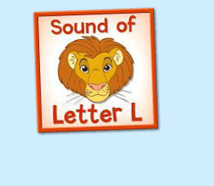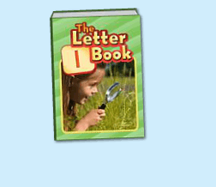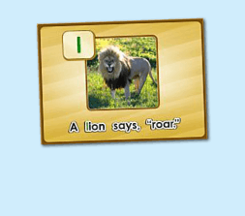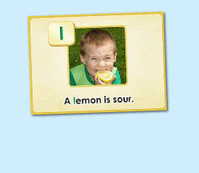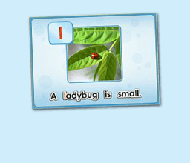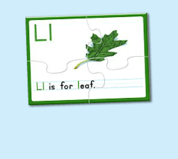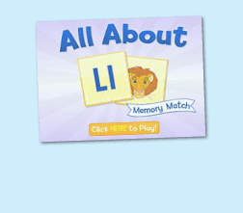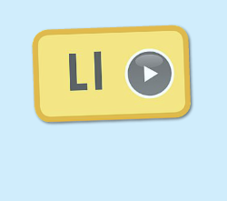
年龄：小班下
教学目标：
- 熟练运用L is for...的句型，能够自如替换句型，并理解其意思。
- 字母故事初步熟悉。
教具准备：
1. 单词图书的词汇卡片 2. 幼生学习过的动物图卡
使用游戏：
1. 过小桥游戏 2. 闪电图卡
教学步骤： |  | 备注
- 成果公布及展示  T:Hello, Kids. Good morning./ Good afternoon.  S:Good morning./ Good afternoon.  T:Before class let's praise Coco, Tina...  They have finished their activities...  Coco come here please, can you show us your activities?  Coco:Yes.  T:OK, show us please. (请完成家庭活动的幼生上前自主操作，向其余幼生展示家庭活动成果)  T:Wonderful! Thank you, Coco.  T:Everyone come on! Tomorrow please show us your activities, OK?  S:OK!  ( 关于我-我的仓鼠 )  T:Peter, come here please. Can you show us your hamster?  Peter:Yes!  T:Show us please. (让幼生自主打开仓鼠)  T:Is this your hamster maze?  Peter:Yes.  T:This is ... (引导幼生说完整句子)  Peter:This is my hamster maze.  T:How many hamsters do you have?  Peter:Two.  T:I have ... (引导幼生说完整句子)  Peter:I have 2 hamsters  T:Kids, Let's count it together.  S:One, two.  T:So, kids, how many hamsters does Peter have?  Peter has ... (引导幼生说完整句子)  S:Peter has two hamsters.  T:Good! What's the color of your hamster?  This one is ...  Peter:This one is brown.  T:Kids, What about this one?  S:This one is gray.  T:Good! Peter, can you introduce your hamster again?  Peter:Yes.  T:This is my hamster maze. I have two hamsters. This one is brown. This one is gray. （若幼生有卡壳，教师可做提示） |  | 公布家庭活动成果并展示我的仓鼠
二、集体学习活动：  温故知新---谁是大歌星  T:Let's sing a song, OK? Stand up please. Are you ready? (教师点击（图1）复习歌曲素材，可选择静音或者把音乐关小，让幼生边唱边做TPR，检验幼生掌握歌曲的程度)  S:Yes, we are ready.  "l" hear the sound?/ "l" letter L is all around/ "l" lion is fun to say/ I sing "l" all day/ "l" hear the sound?/ "l" letter L is all around  （过小桥游戏：老师可以用中文解释游戏规则；老师把歌词做成卡片，老师讲歌词卡片摆在地上，每个小朋友需要跳过卡片然后唱出歌词，检验每一个小朋友的掌握程度）  T:Good job!  趣味复读机  T:Now let's read the letter l book, listen and repeat.（教师点击播放（图2）复习素材，可使用多种分组形式，请幼生跟读2-3遍）  S:key, king, kitten....  T:Very good. Now, let's have a match, boys and girls, are you ready? (请幼生分组进行，教师加以手势做引导)  S:Yes, we are ready.  Bs:ladybug, look ...  Gs:leaf, lemon ...  T:You all did a good job, you will get one point.  ( Listen and Match Game )  T:Now let's play the listen and match game.（教师关闭平台画面，点击自动播放，打乱卡片顺序，轮流让幼生上前根据所听到的词汇挑出对应的图卡，教师加以动作引导其余幼生跟读。遇到难的词汇，教师可用TPR做提示）  T:Everyone, please come here and choose the card one by one.（让幼生轮流进行listen and match, 让其余幼生跟读）  T:Good job!  T:Who can try?  S:Let me try.  T:Lucy and Amy come here please. Listen and match the cards.（邀请1-2位幼生上台听单词和配对图卡，教师用手势引导幼生跟读）  T:Good job! Lucy and Amy, please go back to your seat, thank you!  T:Now, look! What is this? (所有图卡排好顺序之后，教师出示图卡询问幼生图卡内容，整体回顾词汇一遍)  S:ladybug, leaf, look, lemon  T:Good!  句子拼拼乐  T:Let's do some puzzle!  What's the name of the puzzle.（教师依次点击（图3-5）复习拼图素材，先请幼生说出拼图名字，可以配合动作给予提示，再进行核对）  S:A lion says, "roar."  T:Right? Let's check it, who can try? （请幼生上前操作拼图，幼生仔细听发音）  S:Let me try.  T:Jay, please. Everybody listen and repeat.  Right?  S:Yes.  T:Repeat again.  S:A lion says, "roar."  T:Great! Thank you Jay.  换乐无穷  T:Great! Can you make a sentence?（教师拿出学过的动物的图卡，让幼生造句）  S:A dog says, "woof."  T:What about this？  S:A cat says, "meow"  T:Good job!  T:The next puzzle.  What is the name of this puzzle?（教师点击下一个拼图素材，先请幼生说出图片名字，可以配合动作给予提示，再进行核对）  S:A lemon is sour.  T:Let's check it, Ashley you are the first, come here please. Everybody listen and repeat.（请一位幼生上前操作拼图，其他幼生仔细听发音）  Is it right?  S:Yes.  T:Repeat again.  S:A lemon is sour.  换乐无穷  T:Look! What is this? （教师拿出奇异果的词汇卡片）  S:A kiwi.  T:So can you make a sentence?  A kiwi ... （教师可用TPR做提示）  S:A kiwi is sour.  T:Good job!  句子拼拼乐  T:Good! Next puzzle!  What is the name of this puzzle? (教师点击打开第3个拼图素材，先请幼生说出拼图名字，可以配合动作给予提示，其他幼生仔细听发音)  S:A ladybug is small.  T:Is it right? Let's check.  Is it right?  S:Yes!  T:Repeat again.  S:A ladybug is small.  T:Good!  （替换造句：使用幼生学习过的动物图卡）  T:Look, What is this?  S:butterfly, frog （可用较大的动物做对比）  T:Is a butterfly/ frog big or small?  S:small  T:So, A butterfly/ frog is ...  S:A butterfly/ frog is small.  T:Good job!  T:Now, let's do a new puzzle, OK?  S:OK!  T:Look, what can you see（in the picture）？（教师点击（图6）进入拼图素材，先询问幼生图片的内容）  S:Leaf  T:Good job! Let's do the puzzle first.  Lisa, come here please, please finish the puzzle, and everybody listen the sentence, and then tell me what can you hear, OK?（请一位幼生上前操作，让其余幼生听小喇叭发声）  S:OK!  T:Thank you, Lisa. Go back to your seat please.  Tell me what can you hear.  S:Ll is for leaf.  T:Is it right? Let's check it.（教师点击小喇叭，让幼生听句子发音）  Is it right?  S:Yes.  T:Now, listen and repeat.（让幼生点击小喇叭2-3遍，让幼生跟读）  S:Ll is for leaf,  T:Good! Look, what is this sentence. （教师把学过的L开头的词汇放在leaf的位置，让孩子替换单词说出句子）  S:Ll is for ladybug/ lemon/ lamb ...  T:Good!  闪电卡片Game  T:Now, let's play a game. (可以用中文和肢体动作解释游戏规则：老师快速在孩子面前闪过卡片，让孩子猜是哪个单词，然后说出 L is for ...的句子）Are you ready?  S:Yes, I am ready!  T:What is this? L is for...（刚开始可引导孩子）  T:Good！Continue! What is this?  S:Ll is for ladybug/ leaf/ look/ lemon/ lion ...  T:Good! Who wants to be little teacher?（邀请2-3名幼生上来操作游戏）  S:Let me try...  T:Lisa/ Lily/ Mandy come here and be the little teacher.  T:Ready, Go!  T:Good job!  T:Story time! （教师点击（图7）字母故事素材）  T:Let's enjoy "simple letter story:Ll". Are you ready?  （教师在播放字母故事的同时，教师可一边做TPR进行提示）  T:This time, please listen and no voice, and then tell me what can you hear, OK?（教师播放字母故事，让幼生带任务聆听）  S:OK.  T:Who can tell me what can you hear?  S:lion, lizard ...  T:Is it right? Let's check it, and find something new. （教师再播放一遍，在幼生提到的部分进行表扬，在幼生没有提到的部分暂停，进行提示）  Who is this? What is this?（通过提问的方式，让幼生对故事内容进行熟悉）  S:This is Leo. Leo is lion ...  T:Good! Let's learn the simple letter story next time.  T:Great! Let's play a game.  First, listen carefully. （点击进入游戏素材（图8），聆听游戏的名称）  What's the name of this game?  S:All about Ll Memory Match.  C:Click here to play, who can try? （请一位幼生点击开始游戏）  S:Let me try.  T:Please say the name of this game.  S:All about Ll Memory Match.  T:Lisa. Have a try.  Everybody listen. （请他们聆听游戏规则1-2次，再点击翻开一张图片）  T:Look and listen (carefully).  T:What can you see? （指着翻过来的图片）  S:I can see...  T:Nice, another one. （继续翻开下一张）  What can you see?  S:I can see....  T:And this one. Wow, bingo! (继续翻开下一张，如果翻到同样的，就两张同时消失)  T:The next one. Who can try?（轮流请幼生上来进行游戏操作）  S:Let me try...  T:Follow it, please. (时间允许的情况下，请幼生跟读词汇)  S:...  （线下延伸配对活动：1）  T:What's this letter?  S:It's letter l.  T:And what's this?（出示单词卡，里面包含已学过的字母l的单词及其他字母的部分词汇）  T:Let's do memory match. Find the word begins with letter l（把单词卡反面朝上摆放好，请幼生上台来翻）  T:Who wants to try?  S:Let me try.  T:Amy, come on.  T:What's this.（等幼生翻完一张卡片后，询问全体）  S:It's ...  T:Incredible. The next.（挑选下一位的同时，举起卡片，示意幼生跟读）  （线下延伸配对活动：2）  T:Let's review. Ready! Go! （出示已学过的单词卡）  Memory match time. Are you ready?（把单词卡反面朝上摆放）  S:Yes, I'm ready.  T:Look and guess. What's this?（做TPR提示）  S:This is ...  T:Bingo. Which one is... （请幼生选择卡片，翻转配对，配对正确，表扬，配对错误，再多给一次机会。）  T:Good! How about this one?  （线下延伸配对活动：3）  T:Let's review. Ready! Go! （出示已学词汇的单词卡，每个词汇有2个一样的，3-5组）  T:Memory match time. Who can try? （打乱顺序，依次反面朝上排列）  S:I can try. （请一位幼生上来翻第一张）  T:Well done. What's this?  S:...... （请回答得最快的幼生来找出另一张相同的）  T:Gorge, find another one. Wonderful.  T:The same. Bingo. Who can be the next?（翻出另一张相同的后，给予击掌鼓励）  S:...  T:Read it together.  S:....  T:Who can be the next? （请刚才参与的幼生选择一位幼生接力翻卡片）  1S:....  备注：以此类推，完成所有配对。  T:Very good! Now let's count our tickets.  Who can try?  S:Let me try.  T:Tommy please.  Where can we find our tickets?  S:"About me".  T:Tommy click it please.  Now let's count with ABCmouse.  S&ABCmouse:One,two,three....  T:So we have ten tickets today,great job! Thank you Tommy. |  | 图1：  图2：  图3：  图4：  图5：  图6：  图7：  图8：
三、家庭游戏活动布置：  T:Now, I'll show you the activities. (将已放入功课的作业界面打开)  Here are your activities for today.  You have to do these activities.  How many activities? Let's count together.  S:One, two, three, four.  T:You have to do these activities, OK?  S:OK!  T:Each of them, you need to play 5 times. OK?  S:OK!  T:Look at me, I will show you.  Please listen and repeat. (加上肢体动作演示)  OK?  S:OK!  T:Clear?  S:Yes!  T:Who can show us how to do it?  S:Let me try!  T:Mary come here and show us how to do the activities. (每一位幼生上前演示如何操作)  T:Good job! Thank you Mary!  T:Who can retell how to do it?  S:Let me try!（教师可引导幼生）  T:Good! Please finish your activities and show me tomorrow, OK?  S:OK  T:Class is over, Goodbye, everyone.  S:Goodbye. |  | 家庭游戏活动：

