ABCmouse大班上Review:/ear/~/ch/& Clothes,part1-课时3
素材内容：
1. More English Sounds Clothing Cut out Puzzle
2. More English Sounds Clothing Cut out Puzzle
3. More English Sounds Pop and Peek, Part 2
4. Clothes,part1-A Animation
5. Clothes,Part1 Practice
6. Practice page:This is a hat
7. Ten in the bed
素材截图：
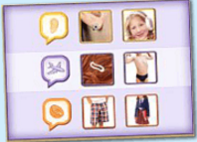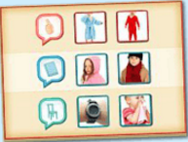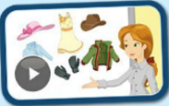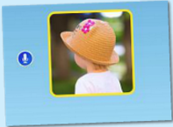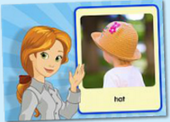

年龄段： 大班上
教学目标：
- 复习更多发音/ear/~/ch/，能看图完成拼图并跟读造句。
2.掌握词汇：Clothes,hat,shirt,dress,jacket,gloves.
3.能熟练掌握并理解句子的用法：This is a..../These are...
4.能自如的与同伴进行口语交流及回答老师的问题。
5.掌握歌曲第3、4句内容并能熟练演唱已学内容。
教具准备：1.拼图中出现的单词卡 2.口语视频中出现的衣物图片或实物 3.1-10的数字卡片4. 床和10个小人道具
使用游戏：1.Make sentences 2.Ask and answer 3.Conversation 4.Record game 5. Role play
教学步骤： | 备注
- 成果公布及展示：
T: Hello kids.
S: Hello, teacher.
T: Lisa, can you show us your activities?
L: Yes.
T: Can you read these words?
T: Can you play this puzzle game?
L: Yes,I can.
T: Can you sing the song? （唱前2句即可）
L: Yes. "There were ten in the bed and the little one said"
T: Wow. Excellent. Please show us your room, OK?
L: Look,this is my room. My room is so pretty. There is a bed/chair/table/
window in my room. My chair/bed/table/ is blue. My room cost me 500 tickets.
T: Wow, terrific! Thank you, Lisa.
二、集体学习活动：  1）进入素材（图1，2），复习巩固/ear/~/or/发音，能看图完成拼图并跟读造句。  T: Puzzle time, who wants to play?  S: Let me try!  T: Good. Play again, read after it!  S: Earring, hear the "ear"sound in earring...  Underwear, hear the "air"sound in underwear...  ...  T: Good job. Let's make sentence one by one. Hear the ... sound in ...  T: Who can try!  1S: Let m try! Hear the "ear"sound in earmuffs.  T: Good. Any more?  S: Hear the "ear"sound in ear/hear/earth...  （"air"~"ch"发音造句同上）  2）进入素材（图3），复习巩固/ear/~/ch/的发音。  T: Who wants to play?  1S: Let me try!  T: OK.Listen carefully.  T: Which sound?  S: /air/.  T: Good, click the /air/ balloons.  T: The next is...?  S: /ear/  T: Good, click the /thh/balloons.  （点击完所有发音气球后，完成图片拼图）  T: Play this puzzle.  T: What is in the picture?  S: It's a thumb.  T: So, the /thh/ sound in thumb.  T: Play again. Who can try?  T: OK. Listen and repeat.  S: Let me try!  （邀请1-2位幼生上台操作此游戏）  3）进入素材（图4），观看视频，掌握并理解句子"This is a..../These are..."。  T: Look! Who is this? （打开视频并暂停在人物集中的画面上，如右图5）  S: Miss Jones,Nico,Ken,Carmen,Lina,Sara,Raj.  T: Yes, you're right.  T:Let's watch the video! （T组织S一起观看口语视频）  T: What can you see?  S: I can see some clothes/hat/dress/shirt/jacket...  T: Really? Watch again!  T: Can you see a /hat/dress/shirt/jacket...?  S:Yes. We can.  T: Look, what's this? （T拿出已准备好的衣物或图片询问S）  S: Hat/dress/shirt/jacket...  T: What are these? （T拿出一副手套或图片询问S）  S: Gloves.  T: Good,kids.  T: Let's follow the video. Read the sentences one by one. Are you ready?  S: Yes, we are ready.  C: This is a hat/shirt/dress/jacket.  S: This is a hat/shirt/dress/jacket.  C: And these are gloves.  S: And these are gloves.  T: Wonderful! One more time!  T: Kids, Do you have a hat/shirt/dress/jacket?  S: Yes, I have.  T: OK, show me. Use "This is a.../These are..."  （T引导S用This is a.../These are...介绍自己带来的衣物）  1S: This is a hat.  2S: This is a dress.  3S: These are gloves.  ...  T: Good boy/girl.  T: Lily, what's this?  L: Dress, this is a dress.  T: Peter. what's this?  L: Jacket, this is a jacket.  （T点名让幼生用已学的句子回答问题）  T: Good job! Follow the video. Are you ready?  S:Yes.  S: This is a...  T: Good. One more time. ...（跟读2-3遍）.  - 进入素材（图6、7），复习检验已学口语内容，并完成发音练习。  T: Listen, what can you hear?  S: Clothes,hat,shirt,dress,jacket,gloves.  T: Good, read after it.  S: Clothes,hat,shirt,dress,jacket,gloves.  T: Very good.  T: Let's practice. First, listen Miss Jones' s voice. Then, record your voice.  OK?  Computer: Clothes, what are these?  S: Clothes.  T: Listen your voice.  T: Pretty good. The next one.  Computer: Hat, what's this?  S: Hat.  T: Listen your voice.  T: Pretty good. The next one.  (shirt,dress,jacket,gloves)  T: Look at this picture, what can you see?  S: I can see a hat.  T: Good, listen and repeat.  Computer: This is a hat.  S: This is a hat.  T: Pretty good.  - 进入素材（图9），复习1、2句，掌握歌曲第3、4句内容。  T: Listen to a music!  T: Sleep, no voice!  T: Week up. Once again.  T: OK, follow the music. （跟唱第1、2句）  T: Let's sing and dance. （T带领S完成第一段演唱）  T: OK.Sit down. And follow it.  T: Sing after the computer.  S: "There were ten in the bed and the little one said,"  T: Good, one more time.  T: Listen, new sentences.  C: "roll over! roll over!" So they all rolled over and one fell out.  T: Listen again!  T: Tell me, what happend?  T/S: One kid fell out.  T: OK. I need ten kids. Who wants to try?  S: Let me try!  T: Let's count.  S: One, two, three...ten.  T: Good. Sleep. Lisa, when you hear the "roll over", you should"roll over" and fall down. OK? （T请10位S上台现场演绎此段歌曲内容）  L: OK.  T: Listen!  ...  T: Wow! Fantastic!  T: Once again! Who wants to try? （再邀请S演绎一遍）  S: Let me try!  ...  T: Terrific! Sing with the radio.  T: Stand up! Sing and dance with me.  S: "roll over! roll over!" So they all rolled over and one fell out.  T: Good, again.  T: Kids, one fell out. So, how many kids are left?（引导S看图或道具回答）  T: Let's count.  S: One, two, three...nine.  T: Good, so clever.  T: Listen this music.（再次完整听完整首歌曲） | 图1  图2  图3  图4  图5  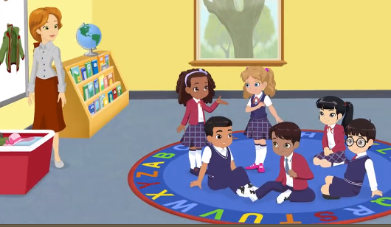  图6  图7  图8
三、家庭游戏活动布置：
T: Wow!So nice!Now I'll show you the homework.
T: You need finish one, two,three... activities. Do you know how to do it?
T: Who wants to try?
S: I can try!
T: OK, show it.
T: Good job! The next one...
T: Please remember use the buttons,Step by step. OK?
S: OK!
T: Class is over, Good bye everyone.
S: Goodbye.

