My Body - 课时2
复习素材：  - My Body, Part 1-A Animation  - Practice Page: This is my body  - Practice Page: This is my head | 新授素材：  - My Body, Part 1 Practice  - My Body  - My Body Memory Match
素材截图：
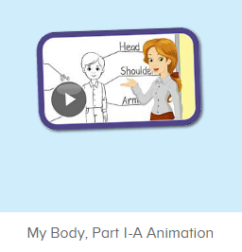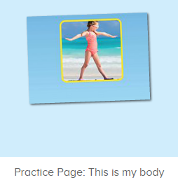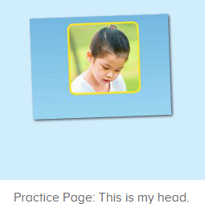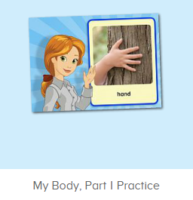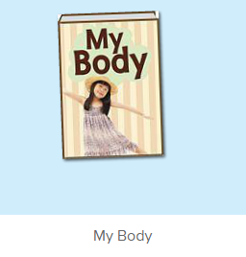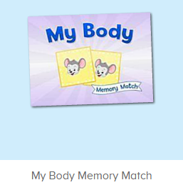
年龄段：小班下
教学目标：
- 熟练掌握词汇head, body, 发音与平台一致。
- 熟练掌握句型，This is my ...
- 提前熟悉图书My Body，能说出图书的名称。
使用游戏：
1. I do you say
教学步骤：
- 成果公布及展示：  T: Hello Kids, good morning.  S: Good morning.  T: First, let’s praise Lily, Andy, Peter, Jimmy... They have finished all their activities.  Everybody look, what is this? This is ...  S: This is about me.  T: Is it right? Let’s listen and repeat.  S: About me.  T: Good! So what is this?  This is ...  S: This is about me.  T: Good! What is this?  S: This is my pet park/ my room/ avatar ...  T: Is it right? Let’s listen and repeat.  S: Go to pet park./ Go to my room./ Go to my hamster./ Change my avatar.  T: Good! Which one do you like?  I like ... （教师做提示）  S: I like my room./ my pet part...  T: Good job! Lily, which one do you like?  I like ...  Lily: I like my room. （可再提问多个幼生）  T: Good job! Can you introduce about me?  Lily: Yes.  T: This is ... （教师做提示）  Lily: This is about me. This is my room. I like my room.  T: Good job! Now, you are all Lily, let’s say it again.  S: This is about me. This is my room. I like my room.  T: Good job! Thank you Lily.  - 集体学习活动：  口语动画小剧场  T: Now, let’s watch the video, when you hear head and body, please follow the action, OK? （打开图1口语动画素材进行复习，请幼生在听到body和head时，跟着做TPR，教师也做TPR进行提示）  S: Body... Head...  T: Good job! What is this?（教师做TPR）  S: This is my body. （提示幼生做TPR）  T: Good! What is this? （教师做TPR）  S: This is my head. （提示幼生做TPR）  T: Good job! Now, let’s play I do you say. Lena and Tom come here please. Lena do the action, and Tom say the sentence, OK?  S: OK  Tom: This is my head. /This is my body.  T: Good job! Who can try?  S: Let me try.  T: Lisa and Teddy come here please. Lisa you do the action, and Teddy say the sentence, OK?  Teddy: ... （可邀请多组幼生进行）  T: Good job! Now, who can be the little teacher?  S: Let me try.  T: Sarah, come here, you do the action, and other people say the sentence.  S: This is my head./ This is my body. （可邀请多位幼生进行）  T: Good job!  T: Look! What’s the sentence of this picture? （教师打开图2图3素材，教师可把音量调制静音）  S: This is my body./ This is my head.  T: Really? Let’s check it. （教师点击图片）  Is it right?  S: Yes.  T: Good job! Follow it. （教师点击图片，让幼生跟读）  S: This is my body./ This is my head.  T: Good job!  T: One more time.  S: This is my body./ This is my head.  T: Good job!  小小配音员  T: Now, let’s record our voice.（点击图4录音素材）  let’s listen teacher’s voice. （点击画面上的教师）  What can you hear?  S: Body. What is this?  T: Let’s check. Is it right?（再次点击画面上的教师）  S: Yes.  T: Follow it.  S: Body. What is this?  T: So ... What is this?  S: Body.  T: Now, let’s record our voice. What is this? Ready! Go! （点击录音）  S: Body.  T: Let’s listen.（播放录制的声音）What is this?  S: Body.  T: Good job! Who wants to try?  S: Let me try.  T: Lily, come here please. （让幼生自己操作录音）  T: Ready! Go!（先点击画面上的教师，再示意幼生录音）  Lily: Body.  T: Let’s listen Lily’s voice. （播放刚刚录制的声音）  T: Is it the same?  S: Yes.  T: Excellent!  T: Now, the next one. let’s listen teacher’s voice. （点击画面上的教师）  What can you hear?  S: Head. What is this?  T: Let’s check. Is it right?（再次点击画面上的教师）  S: Yes.  T: Follow it.  S: Head. What is this?  T: So ... What is this?  S: Head.  T: Now, let’s record our voice. What is this? Ready! Go! （点击录音）  S: Head.  T: Let’s listen.（播放录制的声音）What is this?  S: Head.  T: Good job! Who wants to try?  S: Let me try.  T: Leon, come here please.  T: Ready! Go!（先点击画面上的教师，再示意幼生录音）  Leon: Head.  T: Let’s listen Lily’s voice. （播放刚刚录制的声音）  T: Is it the same?  S: Yes.  T: Well done!  趣味图书  T: Book time! （教师点击图5图书素材）  T: Listen and no voice. And then tell me what’s the name of this book. （教师加以手势示意幼生认真听书的名字，不跟读）  T: What is the name of this book?  S: My body.  T: Let’s check it, listen again. （再播放一遍书名）  Is it right?  S: Yes.  T: Listen and repeat it. 播放一次书名，让幼生跟读）  S: My body.  T: Tell me again, what’s the name of this book?  S: My body.  T: Good job! Let’s enjoy the book “ My body ”.  （教师在播放图书的同时，教师可一边做TPR进行提示）  T: This time, please listen and no voice, and then tell me what can you hear, OK? （教师播放图书，让幼生带任务聆听）  S: OK!  T: What can you hear?  S: Hello./ My name.../ body./ head...  T: Is it right? Let’s check it, and find something new. （教师再播放一遍，在幼生提到的部分进行表扬，在幼生没有提到的部分暂停，进行提示）  Who is this? What is this?（通过提问的方式，让幼生对故事内容进行熟悉）  S: This is Bella. This is my head...  T: Good job!  Memory Match  T: Let’s play a game.  First, listen carefully. （点击进入图6游戏素材，聆听游戏的名称）  What’s the name of this game?  S: My Body Memory Match.  T: Click here to play, who can try? （请一位幼生点击开始游戏）  S: Let me try.  T: Lisa, come here. Have a try.  Everybody listen.（请他们聆听游戏规则1-2次)  T: Let’s play it. When you hear body and head, please follow it. OK?  S: OK.  T: Lisa, ready! Go!  S: Body./ Head.  T: Good!  T:Now let's count our tickets.  Who can try?  S:Let me try.  T:Tommy please.  Where can we find our tickets?  S:"About me".  T:Tommy click it please.  Now let's count with ABCmouse.  S&ABCmouse:One,two,three....  T:So we have ten tickets today,great job! Thank you Tommy. |  | 公布家庭游戏活动成果并展示关于我版块  图1：  图2：  图3：  图4：  图5:  图6：
三、家庭游戏活动布置：  T: Now, I’ll show you the activities. (将已放入功课的作业界面打开)  Here are your activities for today.  You have to do these activities.  How many activities? Let’s count together.  S: One, two, three, four.  T: You have to do these activities, OK?  S: OK!  T: Each of them, you need to play 5 times. OK?  S: OK!  T: Look at me, I will show you.  Please listen and repeat. (加上肢体动作演示)  OK？  S: OK！  T: Clear?  S: Yes!  T: Who can show us how to do it?  S: Let me try!  T: Mary come here and show us how to do the activities. (每一位幼生上前演示如何操作)  T: Good job! Thank you Mary!  T: Who can retell how to do it?  S: Let me try!（教师可引导幼生）  T: Good! Please finish your activities and show me tomorrow, OK?  S: OK  T: Class is over, Goodbye, everyone.  S: Goodbye. |  | 家庭游戏活动：

