My Body - 课时4
复习素材：  - My Body, Part 1-B Animation  - Practice Page: This is my shoulder  - Practice Page: This is my arm  - Practice Page: These are my arms  - My Body, Part 1 Practice | 新授素材：  - My Body  - This is my shoulder  - This is my arm
素材截图：
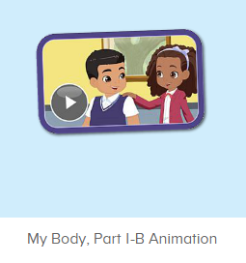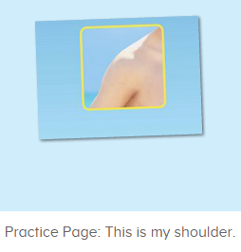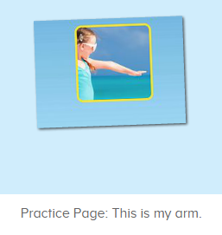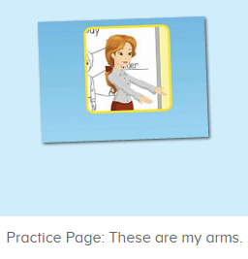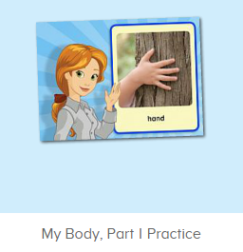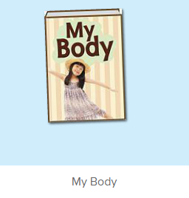
年龄段：小班下
教学目标：
- 熟练掌握词汇shoulder, arm, 发音与平台一致。
- 熟练掌握句型，This is .../ These are ...，能理解其区别。
- 学习图书故事第7-8句。
使用游戏：
1. I do you say
教学步骤：
- 成果公布及展示：  T: Hello Kids, good morning.  S: Good morning.  T: First, let’s praise Lily, Andy, Peter, Jimmy... They have finished all their activities.  Everybody look, what is this? This is ...  S: This is about me.  T: Is it right? Let’s listen and repeat.  S: About me.  T: Good! So what is this?  This is ...  S: This is about me.  T: Good! What is this?  S: This is my pet park/ my room/ avatar ...  T: Is it right? Let’s listen and repeat.  S: Go to pet park./ Go to my room./ Go to my hamster./ Change my avatar.  T: Good! Which one do you like?  I like ... （教师做提示）  S: I like my room./ my pet part...  T: Good job! Lily, which one do you like?  I like ...  Lily: I like my room. （可再提问多个幼生）  T: Good job! Can you introduce about me?  Lily: Yes.  T: This is ... （教师做提示）  Lily: This is about me. This is my room. I like my room.  T: Good job! Now, you are all Lily, let’s say it again.  S: This is about me. This is my room. I like my room.  T: Good job! Thank you Lily.  - 集体学习活动：  口语动画小剧场  T: Now, let’s watch the video, when you hear shoulder and arm, please follow the action, OK? （打开图1口语动画素材进行复习，请幼生在听到shoulder和arm时，跟着做TPR，教师也做TPR进行提示）  S: Shoulder ... Arm ...  T: Good job! What is this? （教师做TPR）  S: This is my shoulder. （提示幼生做TPR）  T: Good! What is this? （教师做TPR）  S: This is my arm. （提示幼生做TPR）  T: What are these? （教师做TPR，示意两边手臂）  S: These are my arms. （提示幼生做TPR）  T: What are these? （教师做TPR，示意两边肩膀）  S: These are my shoulders. （提示幼生做TPR）  T: Good job! Now, let’s play I do you say. Lena and Tom come here please. Lena do the action, and Tom say the sentence, OK?  S: OK  Tom: This is my shoulder./ This is my arm./ These are my shoulders./ These are my arms.  T: Good job! Who can try?  S: Let me try.  T: Lisa and Teddy come here please. Lisa you do the action, and Teddy say the sentence, OK?  Teddy: OK ... （可邀请多组幼生进行）  T: Good job! Now, who can be the little teacher?  S: Let me try.  T: Sarah, come here, you do the action, and other people say the sentence.  S: This is my shoulder./ This is my arm./ These are my shoulders./ These are my arms. （可邀请多组幼生进行）  T: Good job!  T: Look! What’s the sentence of this picture? （教师打开图2-图4素材，教师可把音量调制静音）  S: This is my shoulder./ This is my arm./ These are my arms.  T: Really? Let’s check it. （教师点击图片）  Is it right?  S: Yes.  T: Good job! Follow it. （教师点击图片，让幼生跟读）  S: This is my shoulder./ This is my arm./ These are my arms.  T: Good job!  T: One more time.  S: This is my shoulder./ This is my arm./ These are my arms.  T: Good job!  小小配音员  T: Now, let’s record our voice. （点击图5录音素材）  What is this? Ready! Go!（点击录音）  S: Body.  T: Let’s listen. Is it the same?  S: Yes.  T: Good job! Next one. What is this? Ready! Go! （点击录音）  S: Head.  T: Let’s listen. Is it the same?  S: Yes.  T: Good job! The next one.  First, let’s listen teacher’s voice.（点击画面上的教师）  What can you hear?  S: Shoulder.  T: Good! Who wants to try?  S: Let me try.  T: Lily, come here please.（让幼生自己操作录音）  T: Ready! Go! （先点击画面上的教师，再示意幼生录音）  Lily: Shoulder.  T: Let’s listen Lily’s voice. （播放刚刚录制过声音）  T: Is it the same?  S: Yes.  T: Excellent!  T: Now, the next one. Let’s listen teacher’s voice. （点击画面上的教师）  What can you hear?  S: Arm.  T: Good! Who wants to try?  S: Let me try.  T: Peter, come here please.（让幼生自己操作录音）  T: Ready! Go! （先点击画面上的教师，再示意幼生录音）  Peter: Arm.  T: Let’s listen Peter’s voice. （播放刚刚录制过声音）  T: Is it the same?  S: Yes.  T: Excellent!  趣味图书  T: Book time! （教师点击图6图书素材）  T: Look! Who is this? （教师拿出人物头饰与幼生进行内容回顾）  This is ...  S: This is Bella.  T: Good job!  T: Let’s do the action. Everybody stand up. Ready! Go! (教师点击图6播放图书，带领幼生把学过的内容表演一遍)  S: My Body. Hello! My name is Bella. How are you? I’m fine. This is my body. This is my head.  T: Good! Sit down please!Let’s repeat. Are you ready? （每次播放1句就暂停，让幼生跟读，以此类推到第8句）  S: Hello! My name is Bella. How are you? I’m fine. This is my body. This is my head. This is my shoulder. This is my arm.  T: Good! Listen again. （重复播放第7-8句）  S: ...  T: Repeat it.  S: This is my shoulder. This is my arm.  T: Good! One more time.  S: This is my shoulder. This is my arm. （让幼生跟读2-3遍）  T: Good! Kids, what is this? （教师示意肩膀，询问幼生）  This is ...  S: This is my shoulder.  T: Good! Follow my action. （教师做TPR）  S: This is my shoulder. （引导幼生做TPR）  T: Well done! What is this? （教师示意肩膀，询问幼生）  This is ...  S: This is my arm. （引导幼生做TPR）  T: Good! Now, let’s play I do you say. Who can try?  S: Let me try.  T: Tom, come here, you do the action and other people say the sentence.  S: This is my shoulder. This is my arm.  T: Good job! （可再邀请多位幼生做TPR，其余幼生说出句子）  T: Everybody stand up. Let’s perform the book “My Body” Ready! Go! （教师带领幼生把学过的句子复习一遍，同步播放故事图书）  T: Hello! My name is Bella. |  | 公布家庭游戏活动成果并展示关于我版块  图1：  图2：  图3:  图4：  图5：  图6：
三、家庭游戏活动布置：  T: Now, I’ll show you the activities. (将已放入功课的作业界面打开)  Here are your activities for today.  You have to do these activities.  How many activities? Let’s count together.  S: One, two, three, four.  T: You have to do these activities, OK?  S: OK!  T: Each of them, you need to play 5 times. OK?  S: OK!  T: Look at me, I will show you.  Please listen and repeat. (加上肢体动作演示)  OK?  S: OK!  T: Clear?  S: Yes!  T: Who can show us how to do it?  S: Let me try!  T: Mary come here and show us how to do the activities. (每一位幼生上前演示如何操作)  T: Good job! Thank you Mary!  T: Who can retell how to do it?  S: Let me try!（教师可引导幼生）  T: Good! Please finish your activities and show me tomorrow, OK?  S: OK  T: Class is over, Goodbye, everyone.  S: Goodbye. |  | 家庭游戏活动：

