My Body - 课时5
复习素材：  - My Body, Part 1 Animation | 新授素材：  - My Body, Part 1-C Animation  - Practice Page: This is my hand  - Practice Page: This is my finger  - Practice Page: These are my hands.  - Practice Page: These are six fingers.  - My Body  - This is my hand.  - This is my finger.
素材截图：
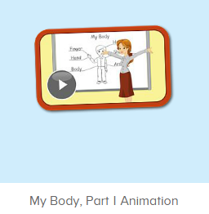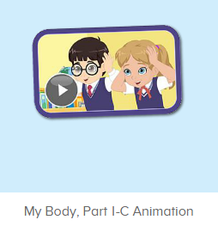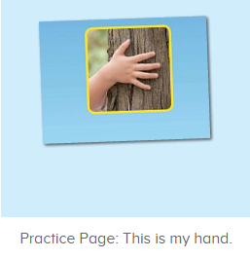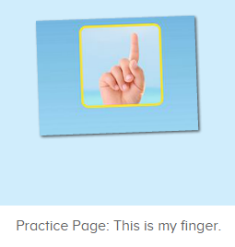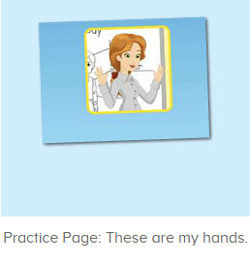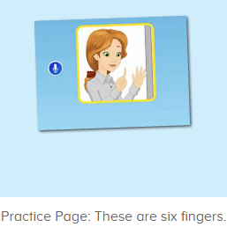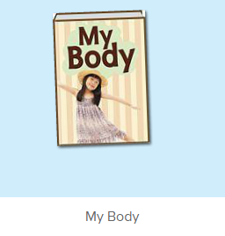
教学目标：
- 熟练掌握词汇hand, finger, 发音与平台一致。
- 熟练掌握句型，This is my ...和 These are my ...，并理解其区别。
- 学习故事图书9-10，掌握简单句型。
教学用具：
1. shoulder, arm图卡
使用游戏：
1. 过小桥游戏 2. I say you do
教学步骤：
- 成果公布及展示：  T: Hello Kids, good morning.  S: Good morning.  T: First, let’s praise Lily, Andy, Peter, Jimmy... They have finished all their activities.  Everybody look, what is this? This is ...  S: This is about me.  T: Is it right? Let’s listen and repeat.  S: About me.  T: Good! So what is this?  This is ...  S: This is about me.  T: Good! What is this?  S: This is my pet park/ my room/ avatar ...  T: Is it right? Let’s listen and repeat.  S: Go to pet park./ Go to my room./ Go to my hamster./ Change my avatar.  T: Good! Which one do you like?  I like ... （教师做提示）  S: I like my room./ my pet part...  T: Good job! Lily, which one do you like?  I like ...  Lily: I like my room. （可再提问多个幼生）  T: Good job! Can you introduce about me?  Lily: Yes.  T: This is ... （教师做提示）  Lily: This is about me. This is my room. I like my room.  T: Good job! Now, you are all Lily, let’s say it again.  S: This is about me. This is my room. I like my room.  T: Good job! Thank you Lily.  - 集体学习活动：  过小桥游戏  T: Let’s play a game.  When you jump across the card, please say the sentences, OK?  （过小桥游戏：老师可以用中文解释游戏规则；老师把图片摆在地上，每个小朋友需要跳过图卡然后说出句子，检验每一个小朋友的掌握程度）  T: Let’s do it one by one. Ready! Go!  S: This is my body./ This is my head./ ...  口语动画小剧场  T: Now, let’s watch the video, listen and no voice. （打开图1口语动画素材，请幼生认真观看和听，不跟读）  What can you hear?  S: This is ...  T: Right? Let’s check it, listen again. （教师再次播放口语动画，在幼生说出来的地方进行鼓励，在幼生没有说出来的地方进行提示）  T: This time, when you hear hand, please clap your hands, OK?  S: OK. （教师用TPR做提示）  T: Good! This time, when you hear finger, please stamp your feat, OK?  S: OK.  T: Good! Now, let’s watch again. When you hear hand and finger, please follow it, OK? （教师再次播放口语动画，在播放到This is my hand, This is my finger的句子后暂停，示意让幼生跟读）  T: Follow it.  S: This is my hand./ This is my finger. （在幼生跟读的同时，教师也做TPR进行提示）  T: One more time.  S: This is my hand./ This is my finger.  T: Good job! What is this? （教师示意手，询问幼生）  This is my …  S: This is my hand.  T: Good! What is this? （老师示意手指，询问幼生）  This is…  S: This is my finger.  T: Good job! Now, we watch it one more time. When you hear “These are ... ”, please follow it, OK? （教师再次播放口语动画，在播放到These are ... 的句子后暂停，示意让幼生跟读）  S: These are my hands./ These are my fingers.（在幼生跟读的同时，教师也做TPR进行提示）  T: One more time.  S: These are my hands./ These are my fingers.  T: Excellent! What are these? （教师示意双手，询问幼生）  These are my …  S: These are my hands.  T: Good! What are these? （教师示意手指，询问幼生）  These are my …  S: These are my fingers.  T: Good job! Now, let’s do the action together. （带领幼生边说边做TPR）  S: This is my hand. This is my finger. These are my hands. These are my fingers. （带领幼生做2-3次）  T: Good job! Now, let’s play I say you do. （教师说出句子，幼生做TPR）  T: This is my hand./ This is my finger./ These are my hands./ These are my fingers.  T: Good job! Let’s play I do you say. Who can be the little teacher?  S: Let me try.  T: Jennifer, come here, you do the action, and other people say the sentences, OK? （邀请幼生上台做动作，其余幼生说出句子）  S: OK!  S: This is my hand./ This is my finger./ These are my hands./ These are my fingers.  T: Good job! Thank you, Jennifer. （可再邀请多位幼生上台做动作，其余幼生说出句子）  T: Now, let’s watch the video again. （教师播放图2口语动画素材-My Body Part 1 Animation, 在学过的部分，示意幼生一起做TPR， 其余部分让幼生继续观看）  趣味复读机  T: Now, listen and repeat.（打开图3素材，请幼生跟读发音）  What can you hear?  S: This is my hand.  T: Good! Follow it please.  S: This is my hand.  T: Nice! Let’s add the action.  T: This is my hand. （幼生边做边说，示意幼生一起）  S: This is my hand.  T: Good job! What is this?  This is ...（教师做TPR提示）  S: This is my hand. （提示幼生做TPR）  T: Good job! Lisa, what is this? （教师做TPR提示，可再询问多位幼生）  Lisa: This is my hand. （提示幼生做TPR）  T: Good job!  T: What about this, listen and repeat. （打开图4素材，请幼生跟读发音）  S: This is my finger.  T: Good! Follow it please.  S: This is my finger. （让幼生跟读3-5遍）  T: Nice! Let’s add the action.  T: This is my finger. （教师边做边说，示意幼生一起）  S: This is my finger.  T: Good job! What is this? （教师做TPR提示）  S: This is my finger.  T: Good job! Linda, What is this? （教师做TPR提示，可再询问多位幼生）  Linda: This is my finger.  T: Good job! Next one. Listen and repeat. （打开图5素材，请幼生跟读发音）  S: These are my hands.  T: One more time.  S: These are my hands.  T: Good job! What are these? （教师做TPR提示）  These are ...  S: These are my hands. （提示幼生做TPR）  T: Good job! Lily, what are these?（教师做TPR提示，可再询问多位幼生）  Lily: These are my hands.  T: Good job!  T: What are these? （教师指着两边肩膀）  These are ...  S: These are my hands.  T: Good job! Teddy, what are these? （教师做TPR提示，可再询问多位幼生）  Teddy: These are my hands.  T: Good job! What about this, listen and repeat. （打开图6素材，请幼生跟读发音）  S: These are six fingers.  T: One more time.  S: These are six fingers.  T: Good job! What are these? （教师伸出6跟手指）  These are ...  S: These are six fingers. （提示幼生做TPR）  T: Good job! Linda, what are these?（教师伸出2跟手指，可再询问多位幼生）  Linda: These are two fingers.  T: Good job!  T: What are these? （教师伸出10跟手指）  These are ...  S: These are ten fingers.  T: Good job! Ted, what are these? （教师回到平台上）  Ted: These are six fingers.  T: Good job!  趣味图书  T: Book time! （教师点击图7图书素材）  T: Look! Who is this? （教师拿出人物头饰与幼生进行内容回顾）  This is …  S: This is Bella.  T: Good job!  T: Let’s do the action. Everybody stand up. Ready! Go! (教师点击播放图书，带领幼生把学过的内容表演一遍)  S: My Body. Hello! My name is Bella. How are you? I’m fine. This is my body. This is my head. This is my shoulder. This is my arm.  T: Good! Sit down please! Let’s repeat. Are you ready? （每次播放1句就暂停，让幼生跟读，依次类推到第10句）  S: My Body. Hello! My name is Bella. How are you? I’m fine. This is my body. This is my head. This is my shoulder. This is my arm. This is my hand. This is my finger.  T: Good! Listen again. （重复播放第7-8句）  S: …  T: Repeat it.  S: This is my hand. This is my finger.  T: Good! One more time.  S: This is my hand. This is my finger. （让幼生跟读2-3遍）  T: Good! Kids. What is this? （教师示意手，询问幼生）  This is …  S: This is my hand.  T: Good! Follow my action. （教师做TPR）  S: This is my hand. （引导幼生做TPR）  T: Well done! What is this? （教师示意手指，询问幼生）  This is …  S: This is my finger. （引导幼生做TPR）  T: Good! Tina, come here, you do the action and other people say the sentence.  S: This is my hand. This is my finger.  T: Good job! （可再邀请多位幼生做TPR，其余幼生说出句子）  T: Everybody stand up. Let’s perform the book “My Body” Ready! Go! （教师带领幼生把学过的句子复习一遍，同步播放故事图书）  T: Hello! My name is Bella…  T:Very good! Now let's count our tickets.  Who can try?  S:Let me try.  T:Tommy please.  Where can we find our tickets?  S: "About me".  T:Tommy click it please.  Now let's count with ABCmouse.  S&ABCmouse: One, two, three......  T: So we have ten tickets today, great job! Thank you Tommy. |  | 公布家庭游戏活动成果并展示关于我版块  图1：  图2：  图3：  图4：  图5：  图6：  图7：
三、家庭游戏活动布置：  T: Now, I’ll show you the activities. (将已放入功课的作业界面打开)  Here are your activities for today.  You have to do these activities.  How many activities? Let’s count together.  S: One, two, three, four.  T: You have to do these activities, OK?  S: OK!  T: Each of them, you need to play 5 times. OK?  S: OK!  T: Look at me, I will show you.  Please listen and repeat. (加上肢体动作演示)  OK?  S: OK!  T: Clear?  S: Yes!  T: Who can show us how to do it?  S: Let me try!  T: Mary come here and show us how to do the activities. (每一位幼生上前演示如何操作)  T: Good job! Thank you Mary!  T: Who can retell how to do it?  S: Let me try!（教师可引导幼生）  T: Good! Please finish your activities and show me tomorrow, OK?  S: OK  T: Class is over, Goodbye, everyone.  S: Goodbye. |  | 家庭游戏活动：

