My Body - 课时10
复习素材：
- My Body Music Video
- My Body Memory Match
- My Body
- My Body, Part 1
素材截图：
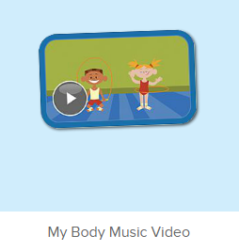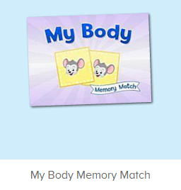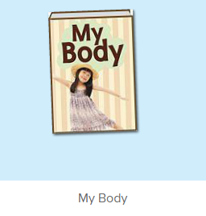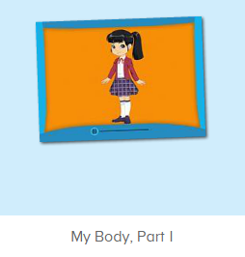
教学目标：
- 复习歌曲My Body第一段，能跟着旋律唱出来，并能做对应的TPR。
- 复习图书My Body，复习关键句型This is ..., These are ...。
教学用具：
1. This is my body/ head/ arm, These are my arms/ hands...等句型的图卡 2. Body/ head 等词汇图卡
使用游戏：
1. 舞蹈接龙 2. I do you say 3. Whisper Game 4. Fast reaction
教学步骤：
- 成果公布及展示：  T: Hello Kids, good morning.  S: Good morning.  T: First, let’s praise Lily, Andy, Peter, Jimmy... They have finished all their activities.  Everybody look, what is this? This is ...  S: This is about me.  T: Is it right? Let’s listen and repeat.  S: About me.  T: Good! So what is this?  This is ...  S: This is about me.  T: Good! What is this?  S: This is my pet park/ my room/ avatar ...  T: Is it right? Let’s listen and repeat.  S: Go to pet park./ Go to my room./ Go to my hamster./ Change my avatar.  T: Good! Which one do you like?  I like ... （教师做提示）  S: I like my room./ my pet part...  T: Good job! Lily, which one do you like?  I like ...  Lily: I like my room. （可再提问多个幼生）  T: Good job! Can you introduce about me?  Lily: Yes.  T: This is ... （教师做提示）  Lily: This is about me. This is my room. I like my room.  T: Good job! Now, you are all Lily, let’s say it again.  S: This is about me. This is my room. I like my room.  T: Good job! Thank you Lily. | 家庭游戏活动成果并展示关于我版块
- 集体学习活动：  快乐唱片机  T: Now Let’s sing the song - My Body. （教师打开图1歌曲素材，请幼生一起唱）  S: My head is on top of my body...  T: Good! Now, everybody stand up, let’s sing and dance. （教师再次播放歌曲，请幼生边唱边做TPR）  S: My head is on top of my body...  T: Good! Now, let’s play a game. We sing and dance one by one.（舞蹈接龙游戏：请一组幼生上台排成一行，播放音乐，每位幼生跟随音乐按顺序表演一句歌词）  T: Team1 come here. （可分几组进行比赛）  Are you ready?  Team1: Yes.  T: Ready! Go!  Team1: ...  T: Wow, good job! Now, Team2 come here please.  Team2: ...  T: Well done! Team 1 win!  记忆对对碰  T: Now, let’s play a memory match game. Who can try? （教师点击图2进入memory match game，一共可玩三轮，教师可邀请几位幼生上前操作，让其余幼生跟读发音）  S: Let me try.  T: Tom/ Jimmy/ Candy please. Everybody listen and repeat.  S: …..  T: Good job!  线下延伸配对活动：  T: Memory match time. Who can try?  （出示词汇卡片，每个词汇有一对，3-5个词汇）  （打乱顺序，依次反面朝上排列）  S: I can try. （请一位幼生上来翻第一张）  T: Well done. What's this?  S: ...... （请回答得最快的幼生来找出另一张相同的）  T: Gorge, find another one. Wonderful.  T: The same. Bingo. Who can be the next?（翻出另一张相同的后，给予击掌鼓励）  S: ...  T: Read it together.  S: ....  T: Who can be the next? （请刚才参与的幼生选择一位幼生接力翻卡片）  1S: ....  备注：以此类推，完成所有配对。  小小配音员  T: Now, let’s read the book - My Body. （教师点击播放图3故事图书，请幼生跟读）  S: Hello! My name is ...  T: Good! Now, I will turn off the sound, let’s be the little recorder.  Are you ready?  S: Yes, we are ready.  S: Hello! My name is ...  T: Let’s play I do you say. Who can be the little teacher?  S: Let me try.  T: Sarah/ Mandy/ ...come here, you do the action, and other people say the sentence.  S: This is my body./ These are my fingers. ...  T: Good job!  Whisper Game  T: Let’s play the Whisper Game! （将幼生均分为若干组，每组幼生排成一列，教师给第一位幼生轻声说一个句子，幼生用接力方式轻声传给后面的幼生，每组最后一名幼生听到句子后，最快最准说出句子的组胜利。）  T: We have 2/3/4 teams. The first sentence is ... （教师轻声对每组第一位幼生说）  T: Are you ready?  S: Yes!  T: Ready! Go! （每组幼生用接力的方式轻声传给后面的幼生）  S1: These are my arms. （注意让幼生掌握These are）  T: Good job! Team 1 win! What’s the sentence?  S: These are my arms.  T: Good job! Continue. The next sentence is ... （教师轻声对每组第一位幼生说）  T: Are you ready?  S: Yes!  T: Ready! Go!  S: ...  趣味复读机  T: Now, Let’s watch the video, Listen and repeat. （教师打开图4素材）  S: This is my body. ... （每句暂停，让幼生跟读1-2遍）  T: Good! Let’s watch it again. When I stop, you say the next sentence, OK?（教师在每个“ This is”的句式后暂停，让幼生猜下一个“These are”的句式）  T: What’s the next sentence? （教师可用TPR做提示）  These are ...  S: These are my arms.  T: Really? Let’s check it. （播放句子，进行检验）  Is it right?  S: Yes!  T: Good job! Continue. （播放下一个“This is”的句式后暂停）  What’s the next sentence?  These are ...  S: These are my shoulders.  T: Really? Let’s check it. （播放句子，进行检验）  Is it right?  S: Yes!  T: Good job! Continue. （以此类推）  S: ...  T: Now, let’s play a game - Fast reaction.  If I say “This is my hand.”, you say “These are my hands.”; If I say “These are my fingers.”, you say “This is my finger.” （教师做TPR提示）  T: This is my hand. Ready! Go! （教师做TPR提示）  S: These are my hands.  T: Good job! （对最快说出的幼生进行表扬）  T:Very good! Now let's count our tickets.  Who can try?  S:Let me try.  T:Tommy please.  Where can we find our tickets?  S:"About me".  T:Tommy click it please.  Now let's count with ABCmouse.  S&ABCmouse:One,two,three...  T:So we have ten tickets today,great job! Thank you Tommy. | 图1：  图2：  图3：  图4：
三、家庭游戏活动布置：  T: Now, I’ll show you the activities. (将已放入功课的作业界面打开)  Here are your activities for today.  You have to do these activities.  How many activities? Let’s count together.  S: One, two, three, four.  T: You have to do these activities, OK?  S: OK!  T: Each of them, you need to play 5 times. OK?  S: OK!  T: Look at me, I will show you.  Please listen and repeat. (加上肢体动作演示)  OK?  S: OK!  T: Clear?  S: Yes!  T: Who can show us how to do it?  S: Let me try!  T: Mary come here and show us how to do the activities. (每一位幼生上前演示如何操作)  T: Good job! Thank you Mary!  T: Who can retell how to do it?  S: Let me try!（教师可引导幼生）  T: Good! Please finish your activities and show me tomorrow, OK?  S: OK  T: Class is over, Goodbye, everyone.  S: Goodbye. | 家庭游戏活动：

