Letters Review G-H-I&My Body Part 2课时3
素材内容：
- My Body, Part 2A-Animation
- My Body, Part 2 Animation
- Practice Page: This is my body
- Practice Page: This is my leg
- Practice Page: This is my knee
- My Body Music Video
素材截图：
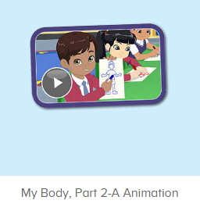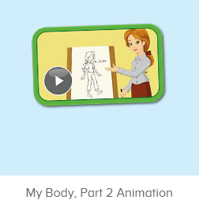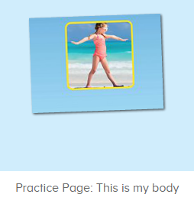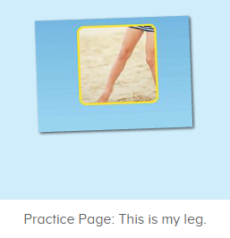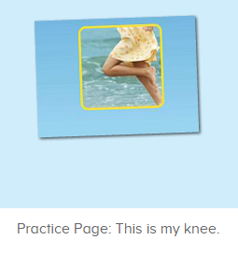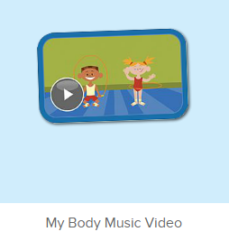
年龄段：小班下
教学目标：
- 能从口语动画小剧场中听出关键词汇body, leg, knee.
- 能理解并认读词汇body, leg, knee.
- 复习歌曲My Body第一段，初步熟悉第二段。
教具准备：
1. This is my leg/ knee图卡
使用游戏：
1. I do you say 2. Choosing card
教学步骤：
一、成果公布及展示：  T: Hello kids, good morning.  S: Good morning.  T: First, let's praise Lily, Andy, Peter, Jimmy... They have finished all their activities.  Everybody look,what is this? This is... (带领全体幼生回顾前三个字母已学过的关于我的名称)  S: This is my pet park/ my ticket/ my avatar.  T: Is it right? Let’s listen and repeat.  S: Go to pet park/ my ticket/ change my avatar.  Coco come here, please show us your pet park.  C: Yes.  C: This is my pet, my pet is a dog, the dog is white.  T: Wow, terrific! Thank you Coco.  Everybody together.  S: This is my pet, my pet is a dog, the dog is white.（带领幼生整体描述一遍）  T: Well done! | 公布家庭活动成果并展示关于我（我的宠物/我的奖励票/我的化身）
- 集体学习活动：  口语动画小剧场  T: Now, let’s watch the video, listen and no voice. （打开图1口语动画素材，请幼生认真观看和听，不跟读）  What can you hear?  S: This is my body...  T: Right? Let’s check it, listen again. （教师再次播放口语动画，在幼生说出来的地方进行鼓励，在幼生没有说出来的地方进行提示）  T: This time, when you hear, body, please clap your hands, OK?  S: OK.  T: Good! This time, when you hear leg, please stamp your feet, OK?  S: OK.  T: Good! This time, when you hear knee, please stand up, OK?  S: OK.  T: Good! Now, let’s watch again. When you hear This is my leg and This is my knee, please follow it, OK?（教师再次播放口语动画，在播放到This is my body和This is my head的句子后暂停，示意让幼生跟读）  T: Follow it.  S: This is my leg./ This is my knee.（在幼生跟读的同时，教师也做TPR提示）  T: One more time.  S: This is my leg./ This is my knee.  T: Good job! What is this? （教师示意腿，询问幼生）  This is my ...  S: This is my leg.  T: Good job! What is this? （教师示意膝盖，询问幼生）  This is my ...  S: Good job! Now stand up, let’s do the action together. （带领幼生边说句子边做TPR）  S: This is my leg./ This is my knee. （带领幼生做2-3次TPR）  T: Good job! Sit down please. Now, let’s play I say you do. （教师说出句子，幼生做TPR）  T: This is my leg./ This is my knee.  T: Good job! Let’s play I do you say. Who can be the little teacher?  S: Let me try.  T: Jennifer, come here, yo do the action, and other people say the sentences, OK? （邀请幼生上台做动作，其余幼生说出句子）  S: OK!  S: This is my leg./ This is my knee.  T: Good job! Thank you, Jennifer. （可再邀请多位幼生上台做动作，其余幼生说出句子）  T: Now, let’s watch the video again. （教师播放图2口语动画素材My Body Part 2 Animation, 在body, leg, knee的部分，示意幼生一起做TPR，其余部分让幼生继续观看）  趣味复读机  T: Now, listen and repeat.（打开图3素材，请幼生跟读发音）  What can you hear?  S: This is my body.  T: Good! Follow it please.  S: This is my body.（让幼生跟读3-5遍）  T: Nice! Let’s add the action.  T: This is my body.（让幼生边做边说，示意幼生一起）  S: This is my body.  T: Good job! What is this?  This is ... （教师做TPR提示）  S: This is my body. （提示幼生做TPR）  T: Good job! Tina, What is this? （教师做TPR提示，可再询问多位幼生）  Tina: This is my body. （提示幼生做TPR）  T: Good job!  T: What about this? Listen and repeat. （打开图4素材，请幼生跟读发音）  S: This is my leg.  T: Good! Follow it please.  S: This is my leg. （让幼生跟读3-5遍）  T: Nice! Let’s add the action. （教师边做边说，示意幼生一起）  T: This is my leg. （教师边做边说，示意幼生一起）  S: This is my leg.  T: Good job! What is this?（教师做TPR提示）  S: This is my leg. （提示幼生做TPR）  T: Good job! Linda, what is this? （教师做TPR提示，可再询问多位幼生）  Linda: This is my leg. （提示幼生做TPR）  T: Good job!  T: What about this, listen and repeat. （打开图5素材，请幼生跟读发音）  S: This is my knee.  T: Good! Follow it please.  S: This is my knee. （让幼生跟读3-5遍）  T: Nice! Let’s add the action.  T: This is my knee. （教师边做边说，示意幼生一起）  S: This is my knee.  T: Good! What is this? （提示幼生做TPR）  S: This is my knee. （提示幼生做TPR）  T: Good job! Elsa, What is this? （教师做TPR提示，可再询问多位幼生）  Elsa: This is my knee.  T: Good job!  Choosing Card  T: Good job! Let’s play choosing card game. You choose the card one by one, and say the sentence, OK? （教师拿出body, leg, knee的图卡）  S: OK  S: This is my body./ This is my leg./ This is my knee.  T: Good job!  快乐唱片机  T: Now let’s sing the song - My Body. （教师打开图6歌曲素材，请幼生一起唱）  S: My head is on top of my body...  T: Good! Now, everybody stand up, let’s sing and dance.（教师再次播放歌曲第一段，请幼生边唱边做TPR）  S: My head is on top of my body...  T: Good! Now, let’s play a game. We sing and dance one by one. （舞蹈接龙游戏：请一组幼生上台排成一行，播放音乐第一段，每位幼生跟随音乐按顺序表演一句歌词）  T: Team1 come here. （可分几组进行比赛）  Are you ready?  Team1: Yes.  T: Ready! Go!  Team1: ...  T: Wow, good job! Now, Team2 come here please.  Team2: ...  T: Well done! Team 1 win!  T: Now, let’s listen carefully. And then tell me what can you hear, OK? （播放歌曲第二段，请幼生带着任务聆听）  T: Tell me what can you hear.  S: body, finger....  T: Good job! We will learn it next time!  T:Very good! Now let's count our tickets.  Who can try?  S:Let me try.  T:Tommy please.  Where can we find our tickets?  S: "About me".  T:Tommy click it please.  Now let's count with ABCmouse.  S&ABCmouse: One,two,three......  T: So we have ten tickets today, great job! Thank you Tommy. | 图1：  图2：  图3：  图4：  图5：  图6：
三、家庭游戏活动布置：  T: Now, I’ll show you the activities. (将已放入功课的作业界面打开)  Here are your activities for today.  You have to do these activities.  How many activities? Let’s count together.  S: One, two, three, four.  T: You have to do these activities, OK?  S: OK!  T: Each of them, you need to play 5 times. OK?  S: OK!  T: Look at me, I will show you.  Please listen and repeat. (加上肢体动作演示)  OK?  S: OK!  T: Clear?  S: Yes!  T: Who can show us how to do it?  S: Let me try!  T: Mary come here and show us how to do the activities. (每一位幼生上前演示如何操作)  T: Good job! Thank you Mary!  T: Who can retell how to do it?  S: Let me try!（教师可引导幼生）  T: Good! Please finish your activities and show me tomorrow, OK?  S: OK  T: Class is over, Goodbye, everyone.  S: Goodbye. | 家庭游戏活动：

