Letters Review G-H-I&My Body Part 2课时5
复习素材：  1. My Body Memory Match  2. My Body Part 2 Animation  3. My Body Music Video | 新授素材：  - My Body, Part 2-B Animation  - My Body, Part 2 Practice  - My Body Music Video  - My body has two arms and legs.  - My body is special to me.
素材截图：
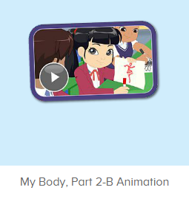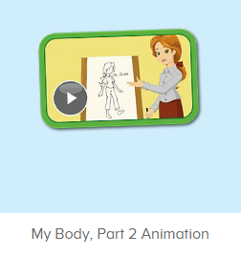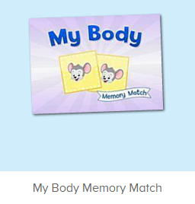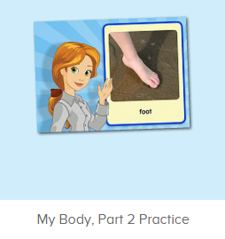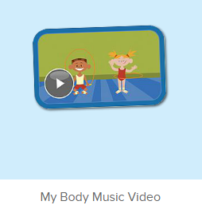
年龄段：小班下
教学目标：
- 能从口语动画小剧场中听出关键词汇leg, legs, knee, knees.
- 能理解并掌握句子This is my leg/ knee. 和These are my legs./ knees.
- 学习歌曲My Body第二段的第3-4句.
教具准备：
1. This is my leg./ knee.和These are my legs./ knees的图卡。2. 身体部位的词汇卡片
使用游戏：
1. I say you do 2. 过小桥游戏
教学步骤：
一、成果公布及展示：  T: Hello kids, good morning.  S: Good morning.  T: First, let's praise Lily, Andy, Peter, Jimmy... They have finished all their activities.  Everybody look,what is this? This is... (带领全体幼生回顾前三个字母已学过的关于我的名称)  S: This is my pet park/ my ticket/ my avatar.  T: Is it right? Let’s listen and repeat.  S: Go to pet park/ my ticket/ change my avatar.  Coco come here, please show us your pet park.  C: Yes.  C: This is my pet, my pet is a dog, the dog is white.  T: Wow, terrific! Thank you Coco.  Everybody together.  S: This is my pet, my pet is a dog, the dog is white.（带领幼生整体描述一遍）  T: Well done! |  | 公布家庭活动成果并展示关于我（我的宠物/我的奖励票/我的化身）
- 集体学习活动：  口语动画小剧场  T: Now, let’s watch the video, listen and no voice. （打开图1口语动画素材，请幼生认真观看和听，不跟读）  What can you hear?  S: leg, legs, knee, knees.  T: Is it right? Let’s check it, listen again. （教师再次播放口语动画，在幼生说出来的地方进行鼓励）  T: Good job! Now, let’s watch again. When you hear leg, legs, knee and knees, please follow it, OK? （教师再次播放口语动画，在播放到重点词汇和句子后暂停，示意让幼生跟读）  T: Follow it.  S: This is my leg./ This is my knee./ These are my legs./ These are my knees. （在幼生跟读的同时，教师也做TPR提示）  T: One more time.  S: This is my leg./ This is my knee./ These are my legs./ These are my knees.  T: What is this? What are these? （教师示意腿）  S: This is my leg. These are my legs.  T: What is this? What are these? （教师示意膝盖）  S: This is my knee. These are my knees.  T: Good job! Now stand up, let’s do the action together.（带领幼生边说边做TPR）  S: This is my leg./ This is my knee./ These are my legs./ These are my knees. （带领幼生做2-3次TPR）  T: Good job! Sit down please. Now, let’s play I say you do.（教师说出句子，幼生做TPR）  T: This is my leg./ This is my knee./ These are my legs./ These are my knees.  T: Good job! Let’s play I do you say. Who can be the little teacher?  S: let me try.  T: Jennifer, come here, you do the action, and other people say the sentences, OK?  S: OK!  S: This is my leg./ This is my knee./ These are my legs./ These are my knees.  T: Good job! Thank you, Jennifer. （可再邀请多位幼生上台做动作，其余幼生说出句子）  T: Now, let’s watch the video again. （教师播放图2口语动画素材My Body Part 2 Animation, 在body, leg, legs, knee, knees的部分，示意幼生一起做TPR，其余部分让幼生继续观看）  过小桥游戏  T: Let’s play a game.  When you jump across the card, please say ten sentences, OK?  （过小桥游戏：老师可以用中文解释游戏规则；老师把图片摆在地上，每个小朋友需要跳过图卡然后说出句子，检验每一个小朋友的掌握程度）  T: Let’s do it one by one. Ready! Go!  S: This my body./ This is my leg./ This is my knee. These are my legs. These are my knees.  记忆对对碰  T: Now, let’s play a memory match game. Who can try? （教师点击图3进入memory match game，一共可玩三轮，教师可邀请几位幼生上前操作，让其余幼生跟读发音）  S: Let me try.  T: Tom/ Jimmy/ Candy please. Everybody listen and repeat.  S: …..  T: Good job!  线下延伸配对活动：  T: Memory match time. Who can try?  （出示词汇卡片，每个词汇有一对，3-5个词汇）  （打乱顺序，依次反面朝上排列）  S: I can try. （请一位幼生上来翻第一张）  T: Well done. What's this?  S: ...... （请回答得最快的幼生来找出另一张相同的）  T: Gorge, find another one. Wonderful.  T: The same. Bingo. Who can be the next?（翻出另一张相同的后，给予击掌鼓励）  S: ...  T: Read it together.  S: ....  T: Who can be the next? （请刚才参与的幼生选择一位幼生接力翻卡片）  1S: ....  备注：以此类推，完成所有配对。  小小配音员  T: Now, let’s record our voice. （点击图4录音素材）  What is this? Ready! Go!（点击录音）  S: Leg.  T: Let’s listen. Is it the same?  S: Yes.  T: Good job! Next one. What is this? Ready! Go! （点击录音）  S: Head.  T: Let’s listen. Is it the same?  S: Yes.  T: Good job! The next one.  First, let’s listen teacher’s voice.（点击画面上的教师）  What can you hear?  S: knee.  T: Good! Who wants to try?  S: Let me try.  T: Lily, come here please. （让幼生自己操作录音）  T: Ready! Go! （先点击画面上的教师，再示意幼生录音）  Lily: Shoulder.  T: Let’s listen Lily’s voice. （播放刚刚录制过的声音）  T: Is it the same?  S: Yes.  T: Excellent!  快乐唱片机  T: Now, everybody stand up. Let’s perform the song - My Body. （教师打开图5素材，教师带领幼生跟随歌曲到第二段第2句，边唱边做TPR）  S: My head is on top of my body. My head has nose, mouth and teeth. My head has two eyes and ears. My body is special to me. Eyes, ears, mouth and teeth, My body is special to me, to me! My body can do many things. My body is special to me. My body has ten toes and fingers. My body has two hands and feet. （幼生边唱边做TPR）  T: Good! Sit down please! Let’s follow it. Are you ready? （从头开始播放，每播放一句就暂停，让幼生跟唱，播放到第二段第3句暂停）  S: ... My body has two arms and legs.  T: Good! My body has two arms and legs. （教师慢速带领幼生唱，并带领幼生做TPR）  S: My body has two arms and legs.  T: One more time.（引领幼生跟唱）  S: My body has two arms and legs. （让幼生跟唱1-2遍）  T: Good! What does my body have?  My body has ... （教师用TPR提示）  S: My body has two arms and legs.  T: Really? Let’s check it. （再次播放歌曲）  Is it right?  S: Yes.  T: Follow it. （让幼生跟唱2-3遍）  S: My body has two arms and legs.  T: Good! Who can do the action?  S: Let me try.  T: Elena, come here, you do the action. And other people sing it, OK?  S: My body has two arms and legs. （教师可领唱做提示）  T: Well done! Thank you Elena. Go back to your seat please.  T: Continue. （播放歌曲，每播放一句就暂停，让幼生跟唱，到第二段第4句暂停）  S: ...  T: My body is special to me. （教师慢速带领幼生跟唱，并带领幼生做TPR）  S: My body is special to me.  T: One more time. （引导幼生跟唱）  S: My body is special to me.  T: Good! What is special to me? （教师用TPR提示）  S: My body is special to me.  T: Really? Let’s check it. （再次播放歌曲）  Is it right?  S: Yes.  T: Follow it. （让幼生跟唱2-3遍）  S: My body is special to me.  T: Good job! Who can do the action?  S: let me try.  T: Ellen, come here, you do the action. And other people sing it, OK?  S: My body is special to me. （教师可领唱做提示）  T: Well done! Thank you, Ellen. Go back to your seat please.  T: Now, let’s sing it together. （播放歌曲到第二段第2句暂停）  S: My body is special to me.  T: Excellent! Now everybody stand up, follow my action. （带领幼生跟随歌曲TPR，第一遍可只做TPR，不跟唱）  S: My head is on top of my body...  （第2、3遍边做TPR，边跟唱）  T: Good job! Who can try?  S: Let me try.  T: Peter, come here, you do the action, and other people sing it, OK?  S: OK!  S: My head is on top of my body...（台上幼生跟随歌曲做TPR，其余幼生跟唱，可再邀请多位幼生上台）  T: Good job! Thank you, Peter, go back to your seat please.  T: Now, everybody stand up, let’s perform the song together. （教师带领幼生一起跟随歌曲边唱边做TPR）  S: My head is on top of my body....  T:Very good! Now let's count our tickets.  Who can try?  S:Let me try.  T:Tommy please.  Where can we find our tickets?  S: "About me".  T:Tommy click it please.  Now let's count with ABCmouse.  S&ABCmouse: One,two,three......  T: So we have ten tickets today, great job! Thank you Tommy. |  | 图1：  图2：  图3：  图4：  图5:
三、家庭游戏活动布置：  T: Now, I’ll show you the activities. (将已放入功课的作业界面打开)  Here are your activities for today.  You have to do these activities.  How many activities? Let’s count together.  S: One, two, three, four.  T: You have to do these activities, OK?  S: OK!  T: Each of them, you need to play 5 times. OK?  S: OK!  T: Look at me, I will show you.  Please listen and repeat. (加上肢体动作演示)  OK?  S: OK!  T: Clear?  S: Yes!  T: Who can show us how to do it?  S: Let me try!  T: Mary come here and show us how to do the activities. (每一位幼生上前演示如何操作)  T: Good job! Thank you Mary!  T: Who can retell how to do it?  S: Let me try!（教师可引导幼生）  T: Good! Please finish your activities and show me tomorrow, OK?  S: OK  T: Class is over, Goodbye, everyone.  S: Goodbye. |  | 家庭游戏活动：

