Letters Review G-H-I&My Body Part 2课时6
复习素材：  - My Body Music Video  - My Body Part 2 Animation | 新授素材：  - My Body, Part 2-C Animation  - Practice Page: This is my foot  - Practice Page: These are my feet  - Practice Page: This is my toe  - Practice Page: These are my toes  - My Body Music Video  - Finders, toes, hands, feet  - My body is special to me, to me!
素材截图：
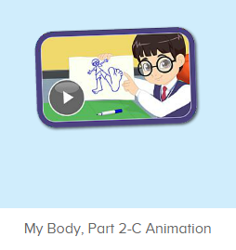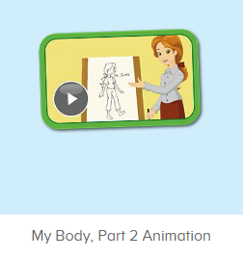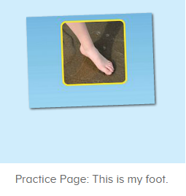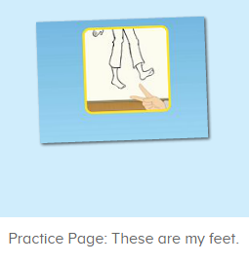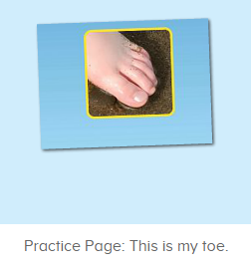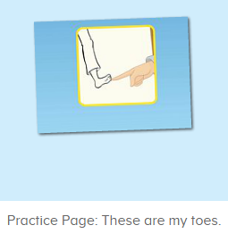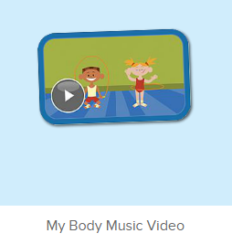
年龄段：小班下
教学目标：
- 能从口语动画小剧场中听出关键词汇foot, feet, toe, toes
- 能理解并掌握句子 This is my foot/ feet. 和 These are my toe/ toes
3. 学习歌曲My Body第二段的第5-6句
教具准备：
1. leg, legs, knee, knees的词汇图卡和句子图卡
使用游戏：
1. Choosing Card 2. I say you do
教学步骤：
一、成果公布及展示：  T: Hello kids, good morning.  S: Good morning.  T: First, let's praise Lily, Andy, Peter, Jimmy... They have finished all their activities.  Everybody look,what is this? This is... (带领全体幼生回顾前三个字母已学过的关于我的名称)  S: This is my pet park/ my ticket/ my avatar.  T: Is it right? Let’s listen and repeat.  S: Go to pet park/ my ticket/ change my avatar.  Coco come here, please show us your pet park.  C: Yes.  C: This is my pet, my pet is a dog, the dog is white.  T: Wow, terrific! Thank you Coco.  Everybody together.  S: This is my pet, my pet is a dog, the dog is white.（带领幼生整体描述一遍）  T: Well done! |  | 公布家庭活动成果并展示关于我（我的宠物/我的奖励票/我的化身）
- 集体学习活动：  Choosing Card  T: Let’s play choosing card game. You choose the card one by one, and say the words and the sentence, OK? （教师拿出leg, legs, knee, knees的词汇图卡和句子图卡）  S: OK  S: leg./ knee./ This is my leg./ These are my knees...  T: Good job!  口语动画小剧场  T: Now, let’s watch the video, listen and no voice. （打开图1口语动画素材，请幼生认真观看和听，不跟读）  What can you hear?  S: This is ...  T: Right? Let’s check it, listen again. （教师再次播放口语动画，在幼生说出来的地方进行鼓励，在幼生没有说出来的地方进行提示）  T: This time, when you hear foot, please clap your hands, OK?  S: OK.  T: Good! This time, when you hear feet, please stamp your feet, OK?  S: OK.  T: Well done! This time, when you hear toe and toes, please stand up, OK?  S: OK.  T: Excellent, Now, let’s watch again. When you hear This is my foot, These are my feet, this is my toe and these are my toes, please follow it, OK? （教师再次播放口语动画，在播放到关键句型时暂停，示意让幼生跟读）  T: Follow it.  S: This is my foot./ These are my feet./ This is my toe./ These are my toes. （在幼生跟读的同时，教师也做TPR进行提示）  T: One more time.  S: This is my foot./ These are my feet./ This is my toe./ These are my toes.  T: Good! What is this? （教师示意一只脚，询问幼生）  This is my ...  S: This is my foot.  T: What are these? （教师示意双脚，询问幼生）  These are my ...  S: These are my my feet. （重点关注feet）  T: One more time.  S: These are my feet.  T: What is this? （教师示意一根脚趾，询问幼生）  S: This is my toe.  T: What are these? （教师示意全部脚趾，询问幼生）  S: These are my toes.  T: How many toes do you have?  I have..  S: I have ten toes.  T: Let’s count together.  S: 1, 2, 3, ....  T: So my body has ...  S: My body has ten toes.  T: Good job! Now, stand up, let’s do the action together. （带领幼生边说边做TPR）  S: This is my foot./ These are my feet./ This is my toe./ These are my toes. （带领幼生做2-3次）  T: Good job! Sit down please. Now, let’s play I say you do. （教师说出句子，幼生做TPR）  T: This is my foot./ These are my feet./ This is my toe./ These are my toes.  T: Good job! Let’s play I do you say. Who can be the little teacher?  S: Let me try.  T: Jennifer, come here, you do the action, and other people say the sentence, OK? （邀请幼生上台做动作，其余幼生说出句子）  S: OK!  S: This is my foot./ These are my feet./ This is my toe./ These are my toes.  T: Good job! Thank you, Jennifer. （可再邀请多位幼生上台做动作，其余幼生说出句子）  T: Now, let’s watch the video again. （教师播放图2口语动画素材- My Body Part 2 Animation，示意幼生在听到关键词汇和句型的时候做TPR）  趣味复读机  T: Now, listen and repeat. （打开图3素材，请幼生跟读发音）  What can you hear?  S: This is my foot.  T: Good! Follow it please.  S: This is my foot. （让幼生跟读3-5遍）  T: Nice! Let’s add the action.  T: This is my foot. （幼生边做边说，示意幼生一起）  S: This is my foot.  T: Good job! What is this?  This is ... （幼生做TPR提示）  S: This is my foot. （提示幼生做TPR）  T: Good job! Lisa, What is this? （教师做TPR提示，可再询问多位幼生）  Lisa: This is my foot. （提示幼生做TPR）  T: Good job!  T: What about this, listen and repeat. （打开图4素材，请幼生跟读发音）  S: These are my feet.  T: Good! Follow it please.  S: These are my feet. （让幼生跟读3-5遍）  T: Nice! Let’s add the action.  T: These are my feet. （教师边做边说，示意幼生一起）  S: These are my feet.  T: Good job! What are these? （教师做TPR提示）  S: These are my feet. （提示幼生做TPR）  T: Good job! Linda, What is this?（教师做TPR提示，可再询问多位幼生）  Linda: These are my feet.  T: Good job!  T: Next one! Listen and repeat.（打开图5素材，请幼生跟读发音）  S: This is my toe.  T: Good! Follow it please.  S: This is my toe. （让幼生跟读3-5遍）  T: Nice! Let’s add the action.  T: This is my toe. （教师边做边说，示意幼生一起）  S: This is my toe.  T: Good job! What is this? （教师做TPR提示）  S: This is my toe. （提示幼生做TPR）  T: Good job! Lily, what is this? （教师做TPR提示，可再询问多位幼生）  Lily: This is my toe.  T: Good job! The last one. Listen and repeat.（打开图6素材，请幼生跟读发音）  S: These are my toes.  T: Good! Follow it please.  S: These are my toes. （让幼生跟读3-5遍）  T: Nice! Let’s add the action.  T: These are my toes. （教师边做边说，示意幼生一起）  S: These are my toes.  T: Good job! What are these? （教师做TPR提示）  S: These are my toes. （提示幼生做TPR）  T: Good job! Ivy, what are these? （教师可指着幼生的相应部位，进行询问）  Ivy: These are my toes.（教师做TPR提示，可再询问多位幼生）  Ivy: These are my toes.  T: Good job!  快乐唱片机  T: Now, everybody stand up. Let’s perform the song - My Body.（教师打开图7素材，教师带领幼生跟随歌曲到第二段第4句，边唱边做TPR）  S: My head is on top of my body. My head has nose, mouth and teeth. My Head has two eyes and ears. My body is special to me. Eyes, ears, mouth and teeth, My body is special to me, to me! My body can do many things. My body is special to me. My body has two ten toes and fingers. My body has two hands and feet. My body has two arms and lets. My body is special to me. （幼生边唱边做TPR）  T: Good! Sit down please! Let’s follow it. Are you ready? （从头开始播放，每播放一句就暂停，让幼生跟唱，播放到第二段第5句暂停）  S: ... Fingers, toes, hands, feet.  T: Good! Fingers, toes, hands, feet. （教师慢速带领幼生唱，并带领幼生做TPR）  S: Fingers, toes, hands, feet.  T: One more time. （引领幼生跟唱）  S: Fingers, toes, hands, feet. （让幼生跟唱1-2遍）  T: Good! Fingers, toes ... And what? （只唱开头，然后询问幼生）  S: Fingers, toes, hands, feet. （教师用TPR提示）  T: Really? Let’s check it. （再次播放歌曲）  Is it right?  S: Yes.  T: Follow it. （让幼生跟唱2-3遍）  S: Fingers, toes, hands, feet.  T: Good! Who can do the action?  S: Let me try.  T: Elena, come here, you do the action. And other people sing it, OK?  S: Fingers, toes, hands, feet. （教师可领唱做提示）  T: Well done! Thank you Elena. Go back to your seat please.  T: Continue. （播放歌曲，每播放一句就暂停，让幼生跟唱，到第二段第6句暂停）  S: ...  T: My body is special to me, to me. （教师慢速带领幼生跟唱，并带领幼生做TPR）  S: My body is special to me, to me.  T: One more time. （引导幼生跟唱2-3遍）  S: My body is special to me, to me.  T: Good job! Who can do the action?  S: let me try.  T: Ellen, come here, you do the action. And other people sing it, OK?  S: My body is special to me, to me. （教师可领唱做提示）  T: Well done! Thank you, Ellen. Go back to your seat please.  T: Now everybody stand up, follow my action. （带领幼生跟随歌曲TPR，第一遍可只做TPR，不跟唱）  S: My head is on top of my body...  （第2、3遍边做TPR，边跟唱）  T: Good job! Who can try?  S: Let me try.  T: Peter, come here, you do the action, and other people sing it, OK?  S: OK!  S: My head is on top of my body...（台上幼生跟随歌曲做TPR，其余幼生跟唱，可再邀请多位幼生上台）  T: Good job! Thank you, Peter, go back to your seat please.  T: Now, everybody stand up, let’s perform the song together. （教师带领幼生一起跟随歌曲边唱边做TPR）  S: My head is on top of my body....  T:Very good! Now let's count our tickets.  Who can try?  S:Let me try.  T:Tommy please.  Where can we find our tickets?  S: "About me".  T:Tommy click it please.  Now let's count with ABCmouse.  S&ABCmouse: One,two,three......  T: So we have ten tickets today, great job! Thank you Tommy. |  | 图1：  图2：  图3:  图4：  图5：  图6：  图7：
三、家庭游戏活动布置：  T: Now, I’ll show you the activities. (将已放入功课的作业界面打开)  Here are your activities for today.  You have to do these activities.  How many activities? Let’s count together.  S: One, two, three, four.  T: You have to do these activities, OK?  S: OK!  T: Each of them, you need to play 5 times. OK?  S: OK!  T: Look at me, I will show you.  Please listen and repeat. (加上肢体动作演示)  OK?  S: OK!  T: Clear?  S: Yes!  T: Who can show us how to do it?  S: Let me try!  T: Mary come here and show us how to do the activities. (每一位幼生上前演示如何操作)  T: Good job! Thank you Mary!  T: Who can retell how to do it?  S: Let me try!（教师可引导幼生）  T: Good! Please finish your activities and show me tomorrow, OK?  S: OK  T: Class is over, Goodbye, everyone.  S: Goodbye. |  | 家庭游戏活动：

