Letters Review G-H-I&My Body Part 2课时7
复习素材：  - Practice Page: This is my foot  - Practice Page: These are my feet  - Practice Page: This is my toe  - Practice Page: These are my toes  - My Body Music Video  - My Body | 新授素材：  - My Body Music Video  - My Body can do many things.  - My Body is special to me.  - My Body  - This is my foot.  - This is my toe.  3. Parts of the Lower Body Cutout Puzzle
素材截图：
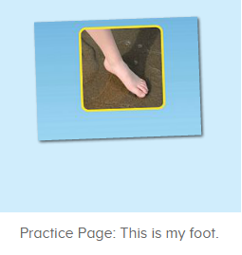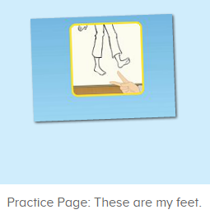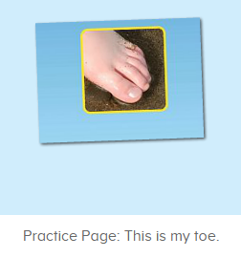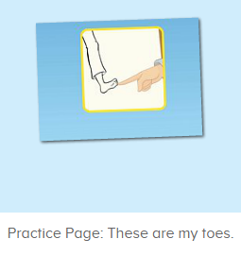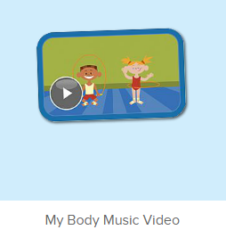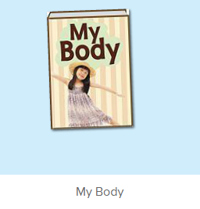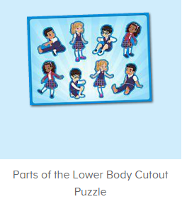
年龄段：小班下
教学目标：
- 熟练掌握词汇foot, feet, toe, toes, 能准确理解其意思。
- 能活用句型This is.../ These are ...
- 学习歌曲My Body第二段的第7-8句。
- 学习故事图书My Body第11-12句。
教具准备：
1. 身体部位的词汇的图卡和句子图卡
使用游戏：
1. Whisper Game 2. Bomb game
教学步骤：
一、成果公布及展示：  T: Hello kids, good morning.  S: Good morning.  T: First, let's praise Lily, Andy, Peter, Jimmy... They have finished all their activities.  Everybody look,what is this? This is... (带领全体幼生回顾前三个字母已学过的关于我的名称)  S: This is my pet park/ my ticket/ my avatar.  T: Is it right? Let’s listen and repeat.  S: Go to pet park/ my ticket/ change my avatar.  Coco come here, please show us your pet park.  C: Yes.  C: This is my pet, my pet is a dog, the dog is white.  T: Wow, terrific! Thank you Coco.  Everybody together.  S: This is my pet, my pet is a dog, the dog is white.（带领幼生整体描述一遍）  T: Well done! |  | 公布家庭活动成果并展示关于我（我的宠物/我的奖励票/我的化身）
- 集体学习活动：  趣味复读机  T: Now, let’s begin our class! First listen and repeat. （教师点击进入素材图1-图4，请幼生快速跟读网站平台发音，关键词汇和句子）  S: This is my my foot./ These are my feet./ This is my toe./ These are my toes.  Whisper Game  T: Let’s play a new game - Whisper Game! （将幼生均分为若干组，每组幼生排成一列，教师给第一位幼生轻声说一个句子，幼生用接力方式轻声传给后面的幼生，每组最后一名幼生听到句子后，最快最准说出句子的组胜利。）  T: We have 2/3/4 teams. The first sentence is ... （教师轻声对每组第一位幼生说）  T: Are you ready?  S: Yes!  T: Ready! Go! （每组幼生用接力的方式轻声传给后面的幼生）  S1: This is my foot.  T: Good job! Team 1 win! What’s the sentence?  S: This is my foot.  T: Good job! Continue. The next sentence is ... （教师轻声对每组第一位幼生说）  T: Are you ready?  S: Yes!  T: Ready! Go!  S: ...  T: Now, everybody stand up. Let’s perform the song - My Body. （教师打开图5素材，教师带领幼生跟随歌曲到第6句，边唱边做TPR）  S: My head is on top of my body....  T: Good! Sit down please! Let’s follow it. Are you ready? （从头开始播放，每播放一句就暂停，让幼生跟唱，播放到第二段第7句暂停）  S: ... My body can do many things.  T: Good! My body can do many things. （教师慢速带领幼生唱，并带领幼生做TPR）  S: My body can do many things.  T: One more time.  S: My body can to many things.  T: Good! My Body ... （教师领唱）  S: My body can do many things.  T: Who can do the action?  S: Let me try!  T: Lynn, please do the action. And other people sing it, OK?  Lynn: ... （ Lynn做TPR）  S: My body can do many things.  T: Good! Continue! （播放歌曲，每播放一句就暂停，让幼生跟唱，到第二段第8句暂停）  S: ...  T: One more time. （让幼生跟唱2-3遍）  S: My body is special to me.  T: Good job! Who can do the action?  S: Let me try.  T: Elsa, come here, you do the action. And other people sing it, OK?  Elsa... （Elsa做TPR）  S: My body is special to me.  T: Well done! Thank you, Elsa. Go back to your seat please.  T: Now, everybody stand up, let’s sing and dance together. （带领幼生跟随歌曲做TPR）  S: My head is on top of my body...  T: Good job! Who can try?  S: Let me try.  T: Anna, come here, you do the action, and other people sing it, OK?  S: OK! My head is on top of my body...（台上幼生跟随歌曲做TPR，其余幼生跟唱，可再要求多位幼生上台）  T: Excellent!  Bomb game  T: Let’s play a game - Bomb Game. （拿出词汇图卡或者句子图卡，指定一个单词或者句子为炸弹，当看到炸弹时要马上起立，不能读出单词或者句子）  This one is bomb. When you see it, please stand up, and don’t read it, OK?  S: OK!  T: Please read word by word./ sentence by sentence.  S: ....  T: Good job! Now let’s do it one by one. （让幼生轮流抽取卡片，建议个别幼生掌握情况）Remember! Don’t read the bomb!  趣味图书  T: Now let’s perform the book. （教师打开图6故事图书，播放至学过的部分，请幼生边跟读边做TPR）  S: Hello! My name is Bella...  T: Good! Now, let’s listen and repeat. Are you ready? （每次播放1句就暂停，让幼生跟读，以此类推到第11句）  S: My Body. Hello! My name is ...  T: Good! Listen again. （重复播放第11-12句）  S: ...  T: Repeat it.  S: This is my foot. This is my toe.  T: Good! One more time.  S: This is my foot. This is my toe.  T: Good! Kids. What is this? （教师示意脚，询问幼生）  This is my ...  S: This is my foot.  T: Good! Follow my action. （教师做TPR）  S: This is my foot. （引导幼生做TPR）  T: Well done! What is this? （教师示意脚趾，询问幼生）  This is my toe.  T: Good! Follow my action. （教师做TPR）  S: This is my toe. （引导幼生做TPR）  S: Well done! Andy, come here, you do the action and other people say the sentence.  S: This is my foot./ This is my toe.  T: Good job! （可再邀请多位幼生做TPR，其余幼生说出句子）  T: Everybody stand up. Let’s perform the book “My Body” Ready! Go! （教师带领幼生把学过的句子复习一遍，同步播放故事图书）  T: Hello! My name is Bella...  贴图拼拼乐  T: Puzzle time! Who can try? （教师打开图7拼图素材）  S: Let me try.  T: Ella, come here please, do the puzzle.  Other people tell me what can you hear, OK? （示意幼生拼第一个拼图）  S: Leg.（幼生把听到的说出来）  T: Good job! Ella, Continue. （让幼生继续拼下一个贴图）  Repeat it!  S: Knee.  T: Good! Continue. （以此类推，直到拼完）  S: ...  T: Thank you, Ella, go back to your seat please.  T: Now, let’s play a game. I say a word, and you choose the puzzle.  （教师说出一个单词，幼生要选择对应的贴图）  For example, I say “legs”, which one is “legs”? Who can try?  S: Let me try. Selena, come here, choose “knee”. （幼生点击答案）  T: Is it right?  S: Yes!  T: Good job!  T: Let’s do it one by one. （让幼生轮流进行）  T: Which one is “toe”?  S1: ... （幼生点击答案）  T: Is it right?  S: Yes!  T: Well done! Continue. （以此类推进行）  T:Very good! Now let's count our tickets.  Who can try?  S:Let me try.  T:Tommy please.  Where can we find our tickets?  S:"About me".  T:Tommy click it please.  Now let's count with ABCmouse.  S&ABCmouse:One,two,three ....  T:So we have ten tickets today,great job! Thank you Tommy. |  | 图1：  图2：  图3：  图4：  图5：  图6：  图7：
三、家庭游戏活动布置：  T: Now, I’ll show you the activities. (将已放入功课的作业界面打开)  Here are your activities for today.  You have to do these activities.  How many activities? Let’s count together.  S: One, two, three, four.  T: You have to do these activities, OK?  S: OK!  T: Each of them, you need to play 5 times. OK?  S: OK!  T: Look at me, I will show you.  Please listen and repeat. (加上肢体动作演示)  OK?  S: OK!  T: Clear?  S: Yes!  T: Who can show us how to do it?  S: Let me try!  T: Mary come here and show us how to do the activities. (每一位幼生上前演示如何操作)  T: Good job! Thank you Mary!  T: Who can retell how to do it?  S: Let me try!（教师可引导幼生）  T: Good! Please finish your activities and show me tomorrow, OK?  S: OK  T: Class is over, Goodbye, everyone.  S: Goodbye. |  | 家庭游戏活动：

