Letters Review G-H-I&My Body Part 2课时8
复习素材：  - My Body Music Video  - My Body | 新授素材：  - My Body, Part 2 Practice  - This Is My Body Part 2  - My Body Painting Page Girl, part 2
素材截图：
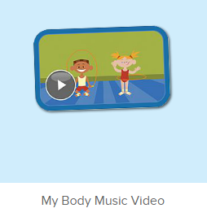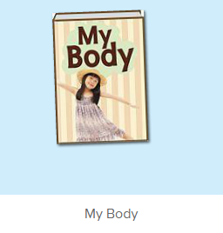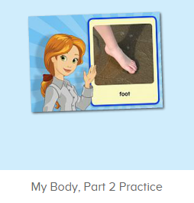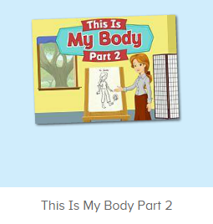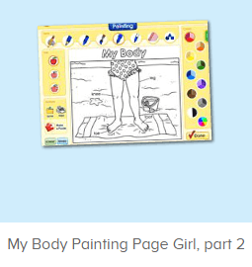
年龄段：小班下
教学目标：
- 复习歌曲My Body，能跟随歌曲旋律完整唱出歌词，并能做出对应的TPR。
- 复习故事图书My Body，熟练掌握关键句型。
教具准备：
1. 教师自画像
使用游戏：
1. 动作接龙游戏 2. I do you say
教学步骤：
一、成果公布及展示：  T: Hello kids, good morning.  S: Good morning.  T: First, let's praise Lily, Andy, Peter, Jimmy... They have finished all their activities.  Everybody look,what is this? This is... (带领全体幼生回顾前三个字母已学过的关于我的名称)  S: This is my pet park/ my ticket/ my avatar.  T: Is it right? Let’s listen and repeat.  S: Go to pet park/ my ticket/ change my avatar.  Coco come here, please show us your pet park.  C: Yes.  C: This is my pet, my pet is a dog, the dog is white.  T: Wow, terrific! Thank you Coco.  Everybody together.  S: This is my pet, my pet is a dog, the dog is white.（带领幼生整体描述一遍）  T: Well done! |  | 公布家庭活动成果并展示关于我（我的宠物/我的奖励票/我的化身）
- 集体学习活动：  快乐唱片机  T: Now, let’s sing the song - My Body. （教师打开图1歌曲素材，请幼生一起唱）  S: My head is on top of my body...  T: Good! Now, everybody stand up, let’s sing and dance. （教师再次播放歌曲，请幼生边唱边做TPR）  S: My head is on top of my body...  T: Good! Now, let’s play a game. We sing and dance one by one. （动作接龙游戏：请一组幼生上台排成一行，播放音乐，每位幼生跟随音乐按顺序表演一句歌词）  T: Team 2 come here. （可分几组进行比赛）  Are you ready?  Team 2: Yes.  T: Ready! Go!  Team 2: ...  T: Wow, good job! Now, Team 1 come here please.  Team 1: ...  T: Well done! Team 2 win!  小小配音员  T: Now, let’s read the book - My Body. （教师点击播放图2故事图书，请幼生跟读）  S: Hello! My name is ...  T: Good! Now, I will turn off the sound, let’s be the little recorder.  Are you ready?  S: Yes, we are ready.  S: Hello! My name is ...  T: Let’s play I do you say. Who can be the little teacher?  S: Let me try.  T: Sarah/ Mandy/ ...come here, you do the action, and other people say the sentence.  S: This is my body./ These are my fingers. ...  T: Good job!  T: Now let’s record our voice. （点击图3录音素材）  Let’s listen teacher’s voice. （点击画面上的教师）  What can you hear?  S: leg. What is this?  T: Let’s check it. Is it right? （再次点击画面上的教师）  S: Yes.  T: Follow it.  S: leg. What is this?  T: So... What is this?  S: Leg.  T: Now, let’s record our voice. What is this? Ready! Go! （点击录音）  S: Leg.  T: Let’s listen.（播放录制的声音）What is this?  S: Leg.  T: Good job! Who wants to try?  S: Let me try.  T: Lily, come here please. （让幼生自己操作录音）  T: Ready! Go!（先点击画面上的教师，再示意幼生录音）  Lily: knee.  T: Let’s listen Lily’s voice. （播放刚刚录制的声音）  T: Is it the same?  S: Yes.  T: Excellent!  T: Now, the next one. let’s listen teacher’s voice. （点击画面上的教师）  What can you hear?  S: foot. What is this?  T: Let’s check. Is it right?（再次点击画面上的教师）  S: Yes.  T: Follow it.  S: foot. What is this?  T: So ... What is this?  S: foot.  T: Now, let’s record our voice. What is this? Ready! Go! （点击录音）  S: foot.  T: Let’s listen.（播放录制的声音）What is this?  S: foot.  T: Good job! Who wants to try?  S: Let me try.  T: Leon, come here please.  T: Ready! Go!（先点击画面上的教师，再示意幼生录音）  Leon: foot.  T: Let’s listen Leon’s voice. （播放刚刚录制的声音）  T: Is it the same?  S: Yes.  T: Well done! Continue.  S: ...  小小绘画家  T: Look! This is me. （教师拿出事先准备好的自画像）  This is my leg. This is my knee... （着重介绍身体下半部分）  T: Now, can you draw yourself?  S: Yes! （让小朋友画一个简单的自画像）  T: First, please draw your body. （给幼生限定时间）  And then please draw your ...  T: Have you finished?  S: Yes.  T: Now, show us one by one. （让幼生上台展示自己的自画像，然后介绍一个部位）  T: Sunny, is this you?  S: Yes.  T: What is this?  S: This is my leg.  T: Good job! Next one. （以此类推，建议个别幼生掌握情况）  T: Now, let’s play a game. Listen carefully. （教师打开图4游戏素材，让幼生仔细听游戏规则）  T: Kate, come here, and play the game.  T: Where is my ... （教师可复述游戏的问句）  S: ... （要求多位幼生进行游戏）  T: Wow, you all did a good job!  T: Now, let’s do some painting. （点击进入图3涂色素材）  T: Look, what’s the name of this picture?  S: ...  T: Let’s listen.（点击喇叭2-3次，请幼生聆听）  T: Tell me the name of the picture. One, two, three!  S: My Body.  T: Very good! Jack, you are the first, come here, please.  T: Please choose your favorite tools.  T: What is this? （询问全体幼生，选择任意一种工具）  S: Crayon/ brush/ pencil/ felt-tip/ marker (跟读1-2次)  T: Look, what is this? （询问其余幼生）  S: Knee./ toe./ leg...  T: Good! Jack, please choose the color. （幼生自主决定颜色）  T: What color is it?  S: It’s brown... （跟读所选的颜色）  T: Color it please. （幼生涂色）  T: Thank you, Jack. Finished?  Is it beautiful? （询问其余幼生）  S: Yes.  T: Good! Thank you Jack, go back to your seat please.  T:Very good! Now let's count our tickets.  Who can try?  S:Let me try.  T:Tommy please.  Where can we find our tickets?  S:"About me".  T:Tommy click it please.  Now let's count with ABCmouse.  S&ABCmouse:One,two,three ....  T:So we have ten tickets today,great job! Thank you Tommy. |  | 图1:  图2：  图3：  图4：  图5：
三、家庭游戏活动布置：  T: Now, I’ll show you the activities. (将已放入功课的作业界面打开)  Here are your activities for today.  You have to do these activities.  How many activities? Let’s count together.  S: One, two, three, four.  T: You have to do these activities, OK?  S: OK!  T: Each of them, you need to play 5 times. OK?  S: OK!  T: Look at me, I will show you.  Please listen and repeat. (加上肢体动作演示)  OK?  S: OK!  T: Clear?  S: Yes!  T: Who can show us how to do it?  S: Let me try!  T: Mary come here and show us how to do the activities. (每一位幼生上前演示如何操作)  T: Good job! Thank you Mary!  T: Who can retell how to do it?  S: Let me try!（教师可引导幼生）  T: Good! Please finish your activities and show me tomorrow, OK?  S: OK  T: Class is over, Goodbye, everyone.  S: Goodbye. |  | 家庭游戏活动：

