Letters Review G-H-I&My Body Part 2课时9
新授素材：
- Head, Shoulders, Knees and Toes Music Video
- Head, shoulders, knees and toes, knees and toes.
- Eyes, and ears, and mouth and nose.
- My Body Cutout Puzzle
- My Body, Part 2 Quiz
- My Body Painting Page Boy, part 2
素材截图：
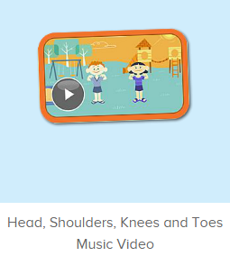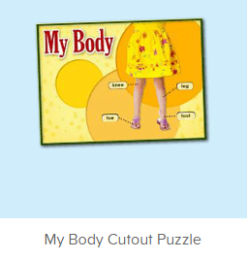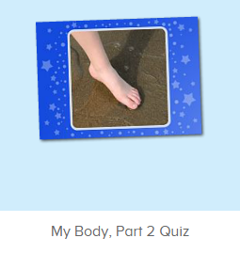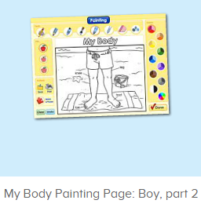
年龄段：小班下
教学目标：
- 学习歌曲Head, Shoulders, Knees and Toes，熟悉旋律和歌词，并能做出对应的TPR。
- 熟练掌握词汇leg, knee, foot, toe与其复数形式。
教具准备：
1. 教师、幼生自画像
使用游戏：
1. I do you say
教学步骤：
一、成果公布及展示：  T: Hello kids, good morning.  S: Good morning.  T: First, let's praise Lily, Andy, Peter, Jimmy... They have finished all their activities.  Everybody look,what is this? This is... (带领全体幼生回顾前三个字母已学过的关于我的名称)  S: This is my pet park/ my ticket/ my avatar.  T: Is it right? Let’s listen and repeat.  S: Go to pet park/ my ticket/ change my avatar.  Coco come here, please show us your pet park.  C: Yes.  C: This is my pet, my pet is a dog, the dog is white.  T: Wow, terrific! Thank you Coco.  Everybody together.  S: This is my pet, my pet is a dog, the dog is white.（带领幼生整体描述一遍）  T: Well done! | 公布家庭活动成果并展示关于我（我的宠物/我的奖励票/我的化身）
- 集体学习活动：  快乐唱片机  （备注：在正式进行歌曲学习之前，可现在碎片化时间渗入歌曲2-3遍）  T: Let’s listen to a song! （教师点击图1歌曲动画素材）  T: Let’s enjoy the song “Head, Shoulders, Knees and Toes”. Are you ready?  （打开歌曲动画之前，先给幼生明确的提示）  S: Yes, I’m ready. （播放第一遍歌曲动画，教师也做TPR提示）  T: Now, this time look and listen carefully. And then tell me what can you hear. OK? （教师播放歌曲动画第二遍，请幼生带任务听）  S: OK!  T: What can you hear? I can hear... （引导幼生说出完整句子）  S: I can hear ... （幼生把听到的说出来）  T: Good job! Let’s check it. （教师播放第三遍歌曲动画，检测核对幼生刚刚说的内容）  T: Excellent! Now, let’s listen and sing it. （教师播放一句后暂停，示意幼生跟唱，同时做TPR引导）  S: Head, shoulders, knees and toes, knees and toes.  T: One more time! （可继续播放下一句，让幼生跟唱）  S: Head, shoulders, knees and toes, knees and toes.  T: Good! Now, everybody stand up, follow my action. （教师慢速带领幼生唱出歌词，并带领幼生做TPR）  S: Head, shoulders, knees and toes, knees and toes.  T: One more time.  S: Head, shoulders, knees and toes, knees and toes. （教师慢速带领幼生唱出歌词，并带领幼生做TPR）  T: Continue! Tell me what can you hear. （继续播放下一句，教师同时做TPR串连）  T: Now, who can tell me what can you hear?  S: ... （幼生把听到的说出来）  T: Let’s check it. （教师再次播放歌曲动画，检验核对幼生说的内容）  T: Excellent! Now, let’s listen and sing it. （重复播放这一句，示意让幼生跟唱，同时做TPR引导）  S: Eyes, and ears, and mouth, and nose.（教师慢速带领幼生唱出歌词，并带领幼生做TPR）  T: One more time!  S: Eyes, and ears, and mouth, and nose.（教师慢速带领幼生唱出歌词，并带领幼生做TPR）  T: Good job! Let’s sing it together. （让幼生熟悉旋律）  S: Head, shoulders, knees and toes, knees and toes...  T: Now, stand up, follow my action. （带领幼生做TPR，第一遍可只做TPR，不跟唱）  S: Head, shoulders, knees and toes, knees and toes...  T: Good job! Let’s play I do you say. Who can try?  S: Let me try.  T: Peter, come here, you do the action, and other people sing it, OK?  S: OK!  S: Head, shoulders, knees and toes, knees and toes... （台上幼生跟随歌曲做TPR，其余幼生跟唱，可再邀请多位幼生上台）  T: Good job! Thank you, Peter, go back to your seat please.  T: Now, everybody stand up, let’s perform the song together. （教师带领幼生一起跟随歌曲边唱边做TPR）  S: Head, shoulders, knees and toes, knees and toes...  Puzzle Time  T: Now, let’s do the puzzle. Who can try?  S: Let me try.  T: Anna, come here and do the puzzle. （让幼生点第一个单词）  T: What can you hear? （询问幼生）  S: foot.  T: Let’s check it.（教师再次点击单词）  Is it right?  S: Yes!  T: What is this? （教师指着拼图中的脚）  S: foot.  T: Lily, what is this? （教师指着幼生的脚）  Lily: This is my foot.  T: Peter, what is this? （教师指着幼生的脚）  Peter: This is my foot.  T: Good job! （可再询问多位幼生）  T: Anna, please continue. （让幼生点下一个单词拼图）  T: What is this?  S: leg.  T: Good! Kelly, what is this? （教师指着幼生的）  Kelly: This is my leg. （再询问多位幼生）  （以此类推）  T: Look! This is my body. （教师拿出自己的自画像）  This is my leg.  This is my...  T: Please show us your picture. （让幼生拿出自己的自画像）  Who can try?  S1: This is my body. This is my knee.  S2: This is my leg. This is my toe.  T: Good job!  T: Now, let’s do the quiz. Listen carefully and tell me what can you hear.  （打开图3素材，让幼生聆听老师的问句）  T: What can you hear?  S: Where is the leg?  T: Good! One more time.  S: Where is the leg?  T: Who can try?  S: Let me try.  T: Leo, come here, please choose “leg”.  T: Good job! Thank you, Leo.  T: Next one, Candy, come here.  Listen and retell the question.  S: Where is the knee?  T: Candy, please choose “knee”.  T: Well done! Continue... （以此类推）  小小绘画家  T: Now, let’s do some painting. （点击进入图4涂色素材）  T: Look, what’s the name of this picture?  S: ...  T: Let’s listen. （点击喇叭2-3次，请幼生聆听）  T: Tell me the name of the picture. One, two, three!  S: This is my body.  T: Very good! Ashley, you are the first, come here, please.  T: Please choose your favorite tools.  T: What is this? （询问全体幼生，选择任意一种工具）  S: Crayon/ brush/ pencil/ felt-tip/ marker (跟读1-2次)  T: Look, what is this? （询问其余幼生）  S: knee./ toe./ leg...  T: Good! Ashley, please choose the color. （幼生自主决定颜色）  T: What color is it?  S: It’s brown... （跟读所选的颜色）  T: Color it please. （幼生涂色）  T: Thank you, Ashley. Finished?  Is it beautiful? （询问其余幼生）  S: Yes.  T: Good! Thank you Ashley, go back to your seat please.  T:Very good! Now let's count our tickets.  Who can try?  S:Let me try.  T:Tommy please.  Where can we find our tickets?  S:"About me".  T:Tommy click it please.  Now let's count with ABCmouse.  S&ABCmouse: One,two,three ....  T:So we have ten tickets today,great job! Thank you Tommy. | 图1：  图2：  图3：  图4：
三、家庭游戏活动布置：  T: Now, I’ll show you the activities. (将已放入功课的作业界面打开)  Here are your activities for today.  You have to do these activities.  How many activities? Let’s count together.  S: One, two, three, four.  T: You have to do these activities, OK?  S: OK!  T: Each of them, you need to play 5 times. OK?  S: OK!  T: Look at me, I will show you.  Please listen and repeat. (加上肢体动作演示)  OK?  S: OK!  T: Clear?  S: Yes!  T: Who can show us how to do it?  S: Let me try!  T: Mary come here and show us how to do the activities. (每一位幼生上前演示如何操作)  T: Good job! Thank you Mary!  T: Who can retell how to do it?  S: Let me try!（教师可引导幼生）  T: Good! Please finish your activities and show me tomorrow, OK?  S: OK  T: Class is over, Goodbye, everyone.  S: Goodbye. | 家庭游戏活动:

