ABCmouse中班下Letters Review r-s-t&Colors,Part1课时3
复习素材：  - Colors,Part1-A Animation.  - Practice Page:Red. | 新授素材内容：  - Practice Page:This is red.  - Basics Colors:Red balloon.  - Rina's red world.  - Red All Round Cutout Puzzle.  - Look at all the colors I can see video.
素材截图：
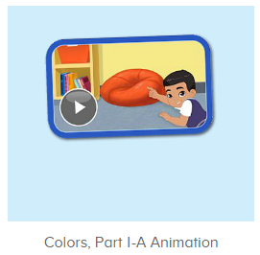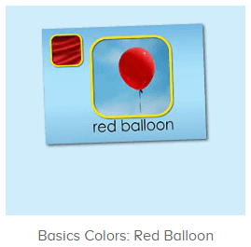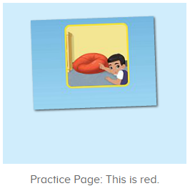
年龄段：中班下
教学目标：
- 能掌握red的发音，并能从口语视频中听出和跟读关键的词汇，句子。
- 能流利说出句子This is red.并能用This is...句型套用图书词汇造句。
- 能听出歌曲当中包含的关键词汇。
教具准备：1.图书词卡
使用游戏：1.Guessing game 2.TPR 3.look and find.
教学步骤： |  | 备注
- 成果公布及展示：  T: Hello kids,good morning.  S:Good morning Yama.  T:First,let's praise Andy,Jason...They have finished their activities.  S:Good,good,very very good!  T:Andy,come here please, show us your activities  J:Ok.  T:Well done!(请完成家庭活动的幼生上前自主操作网站，向其他幼生展示家庭活动成果)  Everybody look,how many activities have Andy finished?  S:Four.  T:Wow,very good thank you Andy.  Coco come here, please show us your pet.  C:OK.  T:Everybody look,what is this?  S:This is my pet park.  T:Good!Coco,please introduce your pet park.  C:OK.Look,this is my pet park.This is my dog,Doggy.He is yellow.He can run fast.He likes to eat puppy food.I feed him everyday.  T:Very good,Coco.Let's praise.  T&S:Good,good,very very good! |  | 成果公布及展示我的宠物(单个幼生展示)
- 集体学习活动：  趣味口语  T:Now please enjoy the video.  This time,you will be the children,listen and repeat.(请幼生扮演视频的孩子，跟读发音)  S:Red,this is red...  T:Very nice.  Once again.  S:Red,this is red...  趣味复读机  T:Great job!Now listen and repeat.（教师依次打开图2-图4素材，请幼生跟读发音）  S:Red/This is red./Red balloon..(跟读2-3遍)  T:Great job!What is this?(教师指向图卡的气球询问幼生)  S:Balloon.  T:What color is the balloon?  S:Red.  T:So this is a....  S:Red balloon.  T:So what is this?  S:This is a red balloon.  T:Nice job!Now let's record our voice.  Ready go!  S:Red balloon.  趣读图书  T:Now let's read a book.First,listen and no voice.（教师点击进入图5图书素材，请幼生先听不跟读）  What is the name of this book?(播放完图书名称后点击暂停，询问幼生)  S:Rina's red world.  T:Right?Let's check.Listen and repeat.  S:Rina's red world.  T:Good job!So what is the name of this book?  S:Rina's red world.  T:Nice!Let's continue.Shh....（图书播放完毕询问幼生所听到或看到的图书内容）  What can you hear/see?  S:Red parrot/tomatoes/cherries...  T:Right,let's check,listen again.  Good job!  What else can you hear?  S:Red strawberries/ladybug...  T:Well done.Now listen and repeat.  S:This is Rina.She likes the color red.(教师点击暂停，询问幼生问题)  T:Who is this?  S:This is Rina.  T:What color does she like?  S:She likes the color red.  T:Good job!Let's continue.  S:Red bricks/stop sign....（跟读2-3次，可加入分组跟读或竞赛机制）  T:Now look,what is this?（选择适合句型this is...套用的词汇进行造句）  S:This is red parrot/red ladybug/red stop sign...  冰山一角  T:Good job!Now let's play a game,are you ready?|(教师准备图书图卡进行冰山一角互动游戏，如遇不会读的词汇，及时切换平台跟读)  S:Yes.  T:Now guess,what is in the picture?  S:Red bricks/strawberries...  T:Right?Let's check.  Wow,so good!/Oh,no...What is in the picture?  S:Red parrot....  T:Let's continue.  拼一拼，说一说  T:Now let's play a puzzle game.Who can try?（点击进入图6素材）  S:Let me try.  T:Kelly/Lily/Lucy...please.  Everybody listen and repeat.  S:Red/tomato/heart....  T:Terrific!  So what is this?  S:This is heart.  T:What color is it?  S:Red.  T:So this is red heart.  What about this?  S:This is red tomato/red ladybug...  快乐唱吧  T:Awesome job!Now let's sing a song,first listen.（点击进入图7素材，请幼生仔细听并说出听到的内容）  What can you hear/see?  S:Color/red apple/blue/yellow...  T:Good job!Listen again.  What else can you hear?  S:Look at....  T:This time,you can sing with the video.  Listen and sing.  S:Look at all the...  趣味大扫描  T:Nice job!Now let's read the book again..  S:Rina's red world....  T:Nice job!Now let's count our tickets.  Who can try?  S:Let me try.  T:Candy please.  T:How many tickets do we have today?  Let's count with ABCmouse.  S&ABCmouse:One,two,three...  T:So How many tickets do we have today?  S:We have ten tickets today.  T:Candy,how many tickets do we have today?  C:We have ten tickets today.  T:Thank you Candy.Very good! |  | 图1：  图2：  图3：  图4  图5  图6  图7
- 家庭活动布置：
T:Now I'll show you the activities.（将已放入功课的作业界面打开）
T: Look,how many activities do you need to do?
S:....
T:Very well.Now I will show you how to do it.Please listen carefully.
Jason come here and show us how to do the activities.
Good job!Thank you Jason!
Please finish the activities and show me tomorrow,ok?
S:OK!
T:Class is over, Goodbye everyone.
S:Goodbye Yama.

