ABCmouse中班下Letters Review r-s-t&Colors,Part1课时7
复习素材：  - Practice Page:Blue. | 新授素材内容：  - Practice Page:This is blue.  - Basics Colors:Blue sky.  - Brandon's blue world.  - Blue All Round Cutout Puzzle.  - Look at all the colors I can see video.
素材截图：
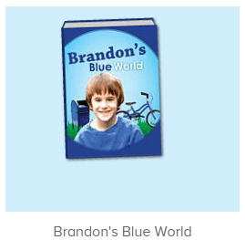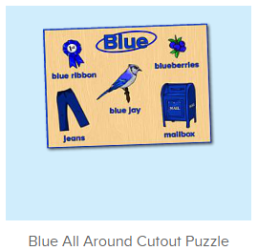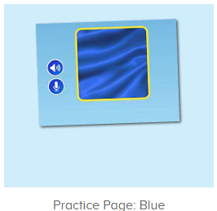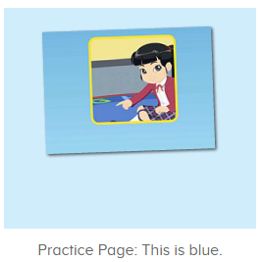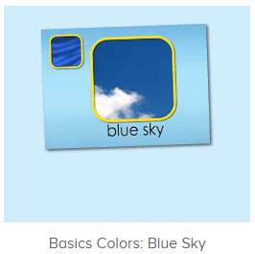
年龄段：中班下
教学目标：
- 能掌握blue的发音.
- 能流利说出句子This is blue.并能用This is...句型套用图书词汇造句。
- 学会歌曲第1-5句。
教具准备：1.图书词卡
使用游戏：1.Guessing game 2.TPR 3.look and find.
教学步骤： |  | 备注
- 成果公布及展示：  T: Hello kids,good morning.  S:Good morning Yama.  T:First,let's praise Andy,Jason...They have finished their activities.  S:Good,good,very very good!  T:Andy,come here please, show us your activities  J:Ok.  T:Well done!(请完成家庭活动的幼生上前自主操作网站，向其他幼生展示家庭活动成果)  Everybody look,how many activities have Andy finished?  S:Four.  T:Wow,very good thank you Andy.  Coco come here, please show us your pet.  C:OK.  T:Everybody look,what is this?  S:This is my pet park.  T:Good!Coco,please introduce your pet park.  C:OK.Look,this is my pet park.This is my dog,Doggy.He is yellow.He can run fast.He likes to eat puppy food.I feed him everyday.  T:Very good,Coco.Let's praise.  T&S:Good,good,very very good! |  | 成果公布及展示我的宠物(单个幼生展示)
- 集体学习活动：  快乐唱吧  T:Now let's sing a song,listen and sing.(教师点击进入图1素材，请幼生跟唱)  S:Look at all the colors I can see.I see big red apples in the tree.  T:Good job!Once again.（重复播放第1-5句）  S:Look at all the colors I can see.I see big red apples in the tree.I can see my yellow cat.I can see my big blue hat.Oh,look at all the colors I can see.  T:Once again.  S:Look at all the colors I can see.I see big red apples in the tree.I can see my yellow cat.I can see my big blue hat.Oh,look at all the colors I can see.(重复播放第1-5句，请幼生跟唱3-4遍)  T:Now stand up and dance with me.（加上动作）  T&S:Look at all the colors I can see.I see big red apples in the tree.I can see my yellow cat.I can see my big blue hat.Oh,look at all the colors I can see.  趣味复读机  T:Great job!Now listen and repeat.（教师依次打开图2-图4素材，请幼生跟读发音）  S:Blue/This is blue./blue sky.(跟读2-3遍)  T:Great job!What is this?(教师指向图卡的气球询问幼生)  S:Blue sky.  T:So what is this?  S:This is blue sky.  T:Nice job!Now let's record our voice.  Ready go!  S:Blue sky.  趣读图书  T:Now let's read a book.First,listen and no voice.（教师点击进入图5图书素材，请幼生先听不跟读）  What is the name of this book?(播放完图书名称后点击暂停，询问幼生)  S:Brandon's blue world.  T:Right?Let's check.Listen and repeat.  S:Brandon's blue world.  T:Good job!So what is the name of this book?  S:Brandon's blue world.  T:Nice!Let's continue.Shh....（图书播放完毕询问幼生所听到或看到的图书内容）  What can you hear/see?  S:Blue sky/blue bicycle helmet/blue bicycle...  T:Right,let's check,listen again.  Good job!  What else can you hear?  S:Blue car/blue backpack...  T:Well done.Now listen and repeat.  S:This is Brandon.He likes the color blue.(教师点击暂停，询问幼生问题)  T:Who is this?  S:This is Brandon.  T:What color does he like?  S:He likes the color blue.  T:Good job!Let's continue.  S:Blue sky/blue bicycle helmet/blue bicycle...（跟读2-3次，可加入分组跟读或竞赛机制）  T:Now look,what is this?（选择适合句型this is...套用的词汇进行造句）  S:This is Blue sky/blue bicycle helmet/blue bicycle...  冰山一角  T:Good job!Now let's play a game,are you ready?(教师准备图书图卡进行冰山一角互动游戏，如遇不会读的词汇，及时切换平台跟读)  S:Yes.  T:Now guess,what is in the picture?  S:Blue sky/blue bicycle...  T:Right?Let's check.  Wow,so good!/Oh,no...What is in the picture?  S:Blue car....  T:Let's continue.  拼一拼，说一说  T:Now let's play a puzzle game.Who can try?（点击进入图6素材）  S:Let me try.  T:Kelly/Lily/Lucy...please.  Everybody listen and repeat.  S:Blue/jeans/mailbox...  T:Terrific!  So what is this?  S:This is mailbox/blue..  T:What color is it?  S:Blue  T:So this is blue mailbox.  What about this?  S:This is blue jay/blue ribbon..  趣味大扫描  T:Awesome job!Now let's sing again.  S:Look at all the colors I can see.I see big red apples in the tree.I can see my yellow cat.I can see my big blue hat.Oh,look at all the colors I can see.  T:Add your actions.  S:Look at all the colors I can see.I see big red apples in the tree.I can see my yellow cat.I can see my big blue hat.Oh,look at all the colors I can see.  T:Nice job!Now let's read the book again.  S:Brandon's blue world....  T:Nice job!Now let's count our tickets.  Who can try?  S:Let me try.  T:Candy please.  T:How many tickets do we have today?  Let's count with ABCmouse.  S&ABCmouse:One,two,three...  T:So How many tickets do we have today?  S:We have ten tickets today.  T:Candy,how many tickets do we have today?  C:We have ten tickets today.  T:Thank you Candy.Very good! |  | 图1：  图2：  图3：  图4  图5  图6
- 家庭活动布置：
T:Now I'll show you the activities.（将已放入功课的作业界面打开）
T: Look,how many activities do you need to do?
S:....
T:Very well.Now I will show you how to do it.Please listen carefully.
Jason come here and show us how to do the activities.
Good job!Thank you Jason!
Please finish the activities and show me tomorrow,ok?
S:OK!
T:Class is over, Goodbye everyone.
S:Goodbye Yama.

